# **HTML Editors**

[❮ Previous](https://www.w3schools.com/html/html_intro.asp)[Next ❯](https://www.w3schools.com/html/html_basic.asp)

A simple text editor is all you need to learn HTML.

## Learn HTML Using Notepad or TextEdit

Web pages can be created and modified by using professional HTML editors.

However, for learning HTML we recommend a simple text editor like Notepad (PC) or TextEdit (Mac).

We believe that using a simple text editor is a good way to learn HTML.

Follow the steps below to create your first web page with Notepad or TextEdit.

## Step 1: Open Notepad (PC)

**Windows 8 or later:**

Open the **Start Screen** (the window symbol at the bottom left on your screen). Type **Notepad**.

**Windows 7 or earlier:**

Open **Start** >**Programs >** **Accessories >** **Notepad**

## Step 1: Open TextEdit (Mac)

Open **Finder > Applications > TextEdit**

Also change some preferences to get the application to save files correctly. In **Preferences > Format >**choose**"Plain Text"**

Then under "Open and Save", check the box that says "Display HTML files as HTML code instead of formatted text".

**Then open a new document to place the code.**

## Step 2: Write Some HTML

Write or copy the following HTML code into Notepad:

<!DOCTYPE html>  
<html>  
<body>  
  
<h1>My First Heading</h1>  
  
<p>My first paragraph.</p>  
  
</body>  
</html>

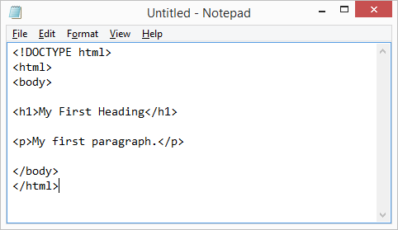

## Step 3: Save the HTML Page

Save the file on your computer. Select **File > Save as** in the Notepad menu.

Name the file **"index.htm"** and set the encoding to **UTF-8** (which is the preferred encoding for HTML files).

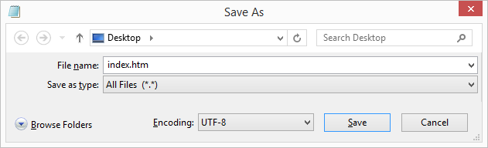

**Tip:** You can use either .htm or .html as file extension. There is no difference; it is up to you.

## Step 4: View the HTML Page in Your Browser

Open the saved HTML file in your favorite browser (double click on the file, or right-click - and choose "Open with").

The result will look much like this:

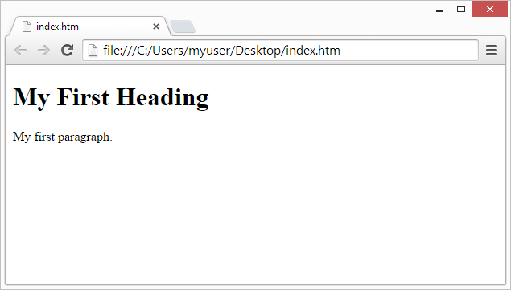

## W3Schools Online Editor - "Try it Yourself"

With our free online editor, you can edit the HTML code and view the result in your browser.

It is the perfect tool when you want to **test** code fast. It also has color coding and the ability to save and share code with others:

### **Example**

<!DOCTYPE html>  
<html>  
<head>  
<title>Page Title</title>  
</head>  
<body>  
  
<h1>This is a Heading</h1>  
<p>This is a paragraph.</p>  
  
</body>  
</html>