HOTEL ROOM BOOKING SYSTEM
REQUIREMENTS AND DESIGN SPECIFICATION
STAGE 1 - ANALYSIS & SPECIFICATION
STAGE 2 - DESIGN
Scope: Hotel Room Booking System
Document language: English - presented clearly and suitable as a basis for task assignment and implementation

1. PROJECT OVERVIEW

A Hotel Room Booking System is a system that assists customers in searching for and booking hotel rooms, while also supporting front desk staff and administrators in managing rooms, bookings, customers, payments, and reporting.

1.1 System Objectives
- Replace or reduce manual booking steps with a system-based process.
- Clearly display room availability and prevent double booking.
- Allow customers to search for rooms, create bookings, and track their bookings.
- Help staff process check-in/check-out and manage centralized data.
- Provide data for administrators to monitor business operations.

2. STAGE 1 - REQUIREMENTS ANALYSIS AND SPECIFICATION

2.1 System Scope

In Scope
- Account and authorization management.
- Search/view rooms by date, number of guests, and room type.
- Create, confirm, track, and cancel bookings.
- Process booking payments and store transaction history.
- Manage rooms, room types, and room statuses.
- Manage customers, check-in, and check-out.
- Basic management of additional services (e.g., breakfast, laundry).
- Basic reports on revenue, room occupancy, and bookings.

Out of Scope for the Initial Version
- Manage multiple hotels within one system.
- Direct synchronization with OTAs such as Booking.com/Agoda.
- Manage inventory, personnel, and overall hotel accounting.
- AI-based dynamic pricing.

2.2 Stakeholders and Roles
Actor | Purpose | Main rights
Customer | Search for and book rooms independently | Register/log in, search for rooms, make bookings, make payments, and view/cancel bookings.
Receptionist / Staff | Daily operations | Log in, manage bookings, rooms, customers, check-in/out, and services.
Administrator | System administration | Manage accounts, roles, room types, prices, data, and reports.
Payment Gateway | Process transactions | Receive payment requests and return success/failure results.
Email Service (optional) | Notifications | Send booking confirmations, reminders, and cancellation notifications.

2.3 General Business Process
- The customer enters the check-in date, check-out date, and number of guests.
- The system finds suitable rooms with no scheduling conflicts.
- The customer selects a room, enters information, and creates a booking.
- The system calculates the amount based on the number of nights + services/taxes/fees (if applicable).
- The customer pays online or chooses payment at the counter, depending on the policy.
- The system updates the booking status and prevents conflicting bookings for the room.
- Staff use the booking to perform check-in.
- At check-out, staff finalize service/fee charges and perform check-out.
- After check-out, the room changes to CLEANING or AVAILABLE according to the actual process.

2.4 Functional Requirements
ID | Function | Description | Conditions/Outputs
FR-01 | Account Registration | The customer provides their full name, email or phone number, and password so the system can create a new account. | Successful when the data is valid and the account does not already exist.
FR-02 | Login/Logout | The user enters a username/email and password so the system can authenticate the identity and create the corresponding login session. | If the information is incorrect, an error is displayed and no session is created.
FR-03 | Search Rooms | The customer enters the check-in date, check-out date, number of guests, room type, and price range so the system can return a list of available and suitable rooms. | Only rooms that meet the conditions and are available are displayed.
FR-04 | View Room Details | The customer selects a room from the search results to view its name, room type, capacity, price, amenities, and current status. | Information must be clear, and the price is calculated based on the number of nights.
FR-05 | Create Booking | The customer selects an available room and enters guest information so the system can create a new booking. | The booking is created with a unique code.
FR-06 | Payment | The customer chooses to pay for the booking through an online payment gateway or directly at the counter so the system can record the transaction. | Store the transaction and update the payment status.
FR-07 | View/Cancel Booking | The customer can view their booking history and cancel a booking if it still meets the cancellation conditions defined by the system policy. | Cancellation is allowed only when the booking meets the conditions.
FR-08 | Manage Bookings | Receptionists view the booking list and confirm or update booking statuses according to the defined business workflow. | All status changes must be valid according to the workflow.
FR-09 | Manage Rooms | Staff or administrators can add, edit, delete, or unlock rooms and update the status of each room in the system. | Rooms with related bookings cannot be deleted according to the policy.
FR-10 | Check-in | The receptionist verifies the booking information against the guest's identification documents and performs the check-in procedure. | Only valid bookings and suitable rooms can be checked in.
FR-11 | Check-out | The receptionist finalizes the room charges and additional services to complete the check-out procedure and end the guest's stay. | The booking changes to COMPLETED and the room changes to CLEANING/AVAILABLE.
FR-12 | Customer Management | Staff search for and update customer profiles when contact information or identification documents change. | Information must not be duplicated according to the defined identifying fields.
FR-13 | Manage Room Types/Pricing | Administrators manage the room type name, capacity, base price, and description of each room type. | Price must be non-negative and capacity must be greater than 0.
FR-14 | Manage Services | Administrators add or edit additional services and their corresponding prices. | Negative prices are not allowed; discontinued services must retain their history.
FR-15 | Reports | The administrator selects a time range so the system can calculate and display revenue, booking volume, and room occupancy. | Filter by time range and display data in an easy-to-read format.

2.5 Non-Functional Requirements
ID | Group | Specification
NFR-01 | Performance | 95% of normal operations respond within <= 2 seconds under the project's target load.
NFR-02 | Concurrency | Two users must not confirm the same room for overlapping periods.
NFR-03 | Security | Passwords must be hashed; plain text passwords must not be stored; authorization must be enforced server-side.
NFR-04 | Data Integrity | Use PK, FK, UNIQUE, CHECK/validation, and transactions for booking + payment.
NFR-05 | Availability | The system provides understandable error messages and does not lose data when an operation fails.
NFR-06 | Usability | The interface is simple, labels are clear, and forms display errors directly at the relevant fields.
NFR-07 | Maintainability | Separate UI/API/service/repository layers or use an equivalent architecture for easier maintenance.
NFR-08 | Logging | Log logins, system errors, and important changes made by staff/admins.
NFR-09 | Backup | Have a periodic database backup plan; the project may simulate this with a backup script.
NFR-10 | Scalability | Allow multi-hotel, coupon, and OTA/API features to be added without rewriting the entire system.

2.6 Business Rules
BR-01: Stay dates: check_out must be after check_in.
BR-02: Schedule conflicts: Two bookings in reserved/confirmed/occupied states must not own the same room_id during overlapping periods.
BR-03: Pricing: Total room cost = applicable room price x number of nights; services are calculated as quantity x unit price.
BR-04: Room status: AVAILABLE -> RESERVED/OCCUPIED/CLEANING/MAINTENANCE depending on the business process; MAINTENANCE rooms cannot be booked.
BR-05: Cancellation: A booking can only be canceled before check-in; the refund amount depends on the configured policy.
BR-06: Check-in: There must be a valid booking, or staff must create a booking first for a walk-in guest.
BR-07: Check-out: Only bookings in the CHECKED_IN state can be checked out.
BR-08: Data deletion: Do not hard-delete transaction data that has already been generated; prefer INACTIVE status or soft delete.
BR-09: Authorization: Customers cannot access administrative APIs; staff cannot change admin privileges without permission.
BR-10: Currency: Use DECIMAL for prices; do not use FLOAT for monetary values.

2.7 Data Flow Diagram (DFD)
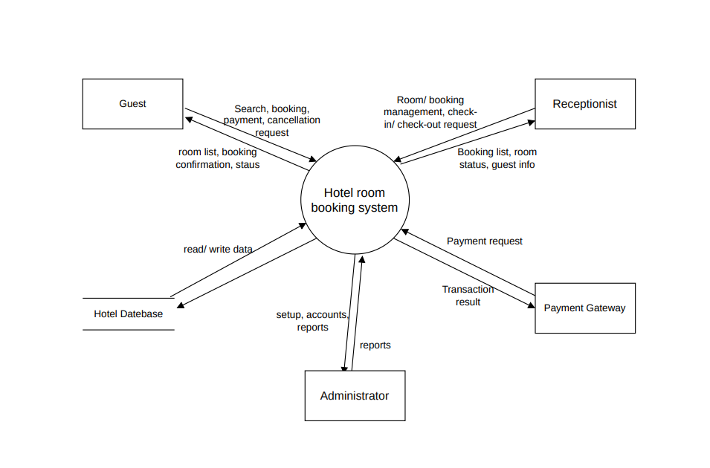
Figure 1. DFD Level 0 - Context Diagram
The system is the central process; customers, staff, administrators, and the payment gateway are external actors. The hotel database stores business data.

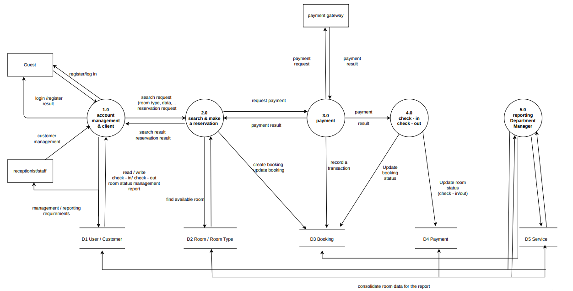
Figure 2. DFD Level 1 - Decomposition of Main Processes
At Level 1, the system is divided into 5 groups: account/customer management; room search and booking; payment; check-in/check-out; room management & reporting. This design is simple enough for the team to implement by module.

2.8 Use Case
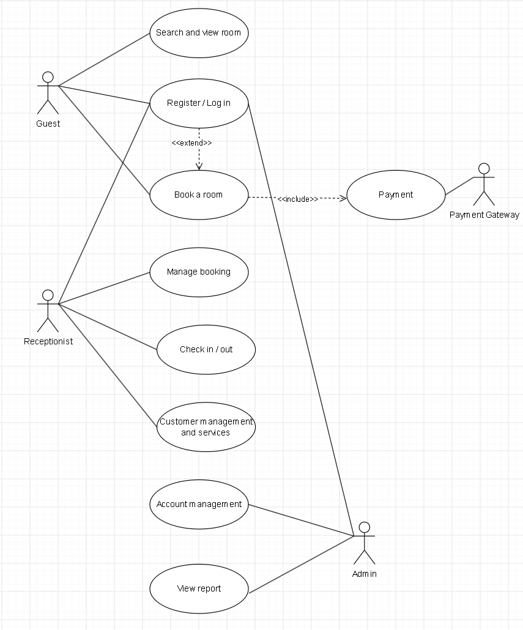
Figure 3. Use Case Diagram - Overview of Actors and Functions
Actors: The diagram contains 4 actors participating in the system. Guest is an external user, with or without an account, who wants to search for and book a hotel room. Receptionist is a hotel employee who directly handles customer-facing operations at the counter, such as booking confirmation and check-in/check-out. Admin is the higher-level system administrator responsible for managing user accounts and monitoring business activity reports. Payment Gateway is an external third-party system, not an actual user, that securely processes payment transactions.
Use Cases and Functions: For Guest, the system provides three functions: Search and view room, Register/Log in, and Book a room - the central function of the entire system. For Receptionist, there are three functions: Manage booking, Check in/out, and Customer management and services. For Admin, there are two functions: Account management and View report. There is also the Payment function, a shared function activated when the customer completes a booking and coordinated with the Payment Gateway to process the transaction.
Relationships Between Use Cases: The diagram shows two main types of relationships. First, there is an include relationship between Book a room and Payment, meaning that whenever a customer books a room, the payment step must also be performed and cannot be skipped. Second, there is an extend relationship between Register/Log in and Book a room, indicating that registration/login is an extension step; the customer only needs to log in the first time and does not need to log in again later. Besides these two special relationships, the remaining connections between actors and use cases are ordinary associations showing which actors are authorized to use which system functions.

2.7.1 Detailed Use Case Specifications
Each use case in Figure 3 is specified in detail in the table below, including actor, description, preconditions, main flow, exception flow, and postconditions.
UC-01 - Register / Log in
Actor | Guest
Description | Allows users to create a new account or log in using an existing account.
Precondition | The user is not logged in to the system.
Main Flow | 1) The user chooses registration or login. 2) Enter full name/email/phone number and password (registration), or username/email and password (login). 3) The system validates the data. 4) The system creates a new account or login session. 5) The user is redirected into the system.
Exception Flow | Invalid data, an existing account during registration, or incorrect login information: the system displays a general error message and does not create the account/session.
Postcondition | The user has a valid account in the system and/or has logged in successfully.

UC-02 - Search and view room
Actor | Guest
Description | Allows customers to search for and view detailed information about available rooms.
Precondition | Login is not required.
Main Flow | 1) The customer enters the check-in date, check-out date, number of guests, room type, and price range. 2) The system queries available rooms that meet the conditions. 3) The system displays the results. 4) The customer selects a room to view details (price, amenities, policies).
Exception Flow | No suitable room is found: the system displays a no-results message and suggests adjusting the search criteria.
Postcondition | The customer has the necessary room list or information to continue booking.

UC-03 - Book a room
Actor | Guest
Description | Allows customers to create a booking for the selected room.
Precondition | The customer has viewed the room details and the room is available for the desired date range.
Main Flow | 1) The customer selects "Book a room". 2) The customer enters guest information. 3) The backend re-checks availability and price at confirmation time. 4) The system creates a booking with a unique code and status PENDING or CONFIRMED depending on the policy. 5) The Payment use case is triggered (include) to complete payment.
Exception Flow | The room was just booked by another user during processing: the system rolls back the transaction and asks the customer to choose another room.
Postcondition | The booking is created successfully and changes to CONFIRMED if payment is completed.

UC-04 - Payment
Actor | Guest, Payment Gateway
Description | Processes payment for a booking through an online payment gateway or at the counter.
Precondition | The booking has been created and is awaiting payment.
Main Flow | 1) The customer selects a payment method. 2) For online payment, the system sends a request to the Payment Gateway. 3) The Payment Gateway processes and returns the transaction result. 4) The system records the payment and updates the corresponding booking status.
Exception Flow | Transaction failure: the system records the payment as FAILED, keeps the booking in the payment-pending state, and notifies the customer.
Postcondition | The payment is recorded as SUCCESS or FAILED; the booking is updated accordingly.

UC-05 - Manage booking
Actor | Receptionist
Description | Allows staff to view, confirm, and update booking statuses.
Precondition | Staff are logged in with Staff privileges.
Main Flow | 1) Staff search for a booking by code, guest name, or date. 2) Staff view booking details. 3) Staff confirm or update the booking status according to the workflow.
Exception Flow | Checked-out or canceled bookings cannot be edited like bookings that are still being processed.
Postcondition | Booking data is updated and consistent with the related room status.

UC-06 - Check in / out
Actor | Receptionist
Description | Performs check-in and check-out procedures for guests.
Precondition | The booking is in CONFIRMED status (for check-in) or CHECKED_IN status (for check-out).
Main Flow | Check-in: 1) Staff search for booking_code. 2) Verify the guest's identification documents. 3) Change the booking to CHECKED_IN and the room to OCCUPIED. Check-out: 1) Staff open the CHECKED_IN booking. 2) Calculate additional services. 3) Collect the remaining payment. 4) Change the booking to COMPLETED and the room to CLEANING/AVAILABLE.
Exception Flow | Invalid booking or mismatched date: the system rejects the operation and requests another check.
Postcondition | Booking and room statuses are updated according to the process; an audit log is recorded.

UC-07 - Customer management and services
Actor | Receptionist
Description | Manage customer profiles and additional services used during the stay.
Precondition | Staff are logged in.
Main Flow | 1) Staff search for or update customer profiles. 2) Staff add additional services (breakfast, laundry, etc.) to an active booking. 3) The system calculates service charges as quantity multiplied by unit price.
Exception Flow | Duplicate customer identification information: the system warns the user and requests confirmation before saving.
Postcondition | The customer profile and used-service list are fully updated.

UC-08 - Account management
Actor | Admin
Description | Manage user accounts, authorization, and related system configurations.
Precondition | The administrator is logged in with Admin privileges.
Main Flow | 1) The Admin searches for the account to process. 2) The Admin views or edits information, role, and account status (lock/unlock, reset password). 3) The system saves changes and records an audit log.
Exception Flow | Changing admin privileges is not allowed under BR-09: the system rejects the operation.
Postcondition | The account is updated according to the defined permissions.

UC-09 - View report
Actor | Admin
Description | View reports on revenue, booking volume, and room occupancy.
Precondition | The administrator is logged in.
Main Flow | 1) The Admin selects the reporting period. 2) The system queries and aggregates the relevant data. 3) The system displays the report as easy-to-read tables/charts.
Exception Flow | No data exists for the selected period: the system displays a "no data" message.
Postcondition | The administrator has sufficient information to make business decisions.

2.9 Class Diagram
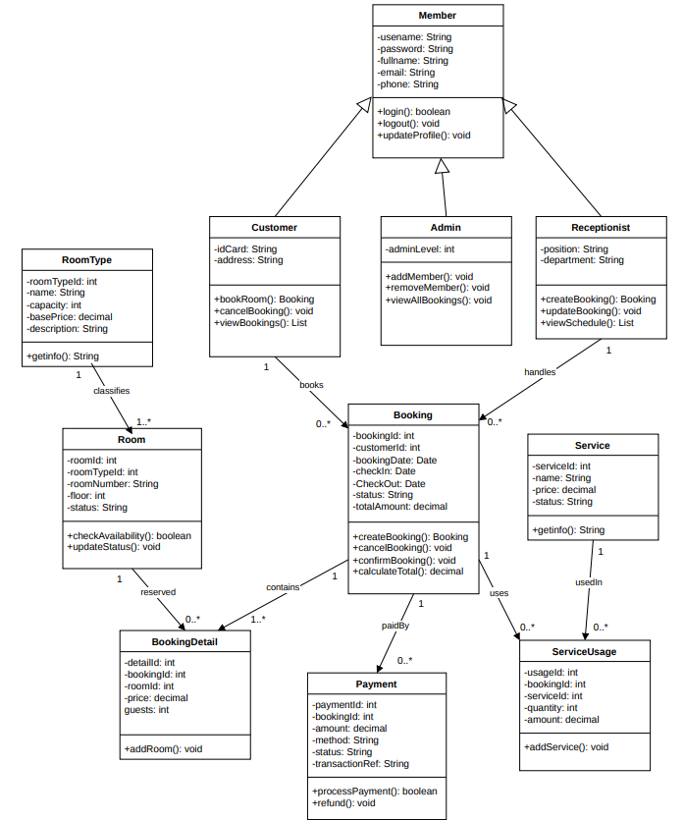
Hình 4. Class Diagram - Main Business Classes and Relationships
Relationship meanings: one Role has many Users; one User may be associated with one Customer; one RoomType has many Rooms; one Customer has many Bookings; each Booking has one or more BookingDetails; each Booking may have multiple Payments and ServiceUsages.

3. STAGE 2 - DESIGN

3.1 Proposed Architecture
A three-layer architecture can be used: Presentation (UI) -> Application/Service (business logic) -> Data Access/Repository -> Database. Payment Gateway and Email Service are external to the system and are called through APIs.
Floor | Responsibility | Module example
Presentation | Display UI, receive input, basic validation | Login, Search Room, Booking, Reception Dashboard
Service / Business | Business rules, transactions, price calculation | BookingService, PaymentService, RoomService
Repository / Data | CRUD, database queries | UserRepository, BookingRepository
Database | Data storage | MySQL/PostgreSQL
External API | Payment, email | Payment Gateway, Mail Service

3.2 Interface Design
General principles: each screen focuses on one primary action; primary buttons are prominent; booking/room statuses use readable labels; forms display errors directly below the relevant fields.
ID | Screen | Main components | Rules
UI-01 | Login Page | Email/Username, Password, Remember me (optional), Login button, Register/Forgot Password link. | Incorrect information -> show a general message; do not reveal whether the user exists.
UI-02 | Room Search Page | Check-in, Check-out, number of guests, room type, price range, Search Rooms button. Results are displayed as cards/table. | Display price/night, capacity, amenities, and number of suitable available rooms.
UI-03 | Room Details | Image (if available), room type name, capacity, amenities, price, policies, and Book Room button. | Booking is allowed only when the room is available.
UI-04 | Checkout / Booking Confirmation | Guest information, room, stay dates, number of nights, room charge, services, total amount, and payment method. | The total must be calculated by the server; do not trust the price sent by the client.
UI-05 | My Bookings | Booking list, booking code, dates, room, total amount, status, and View/Cancel buttons. | Bookings that have been checked in or completed cannot be canceled.
UI-06 | Receptionist - Dashboard | Statistics cards, today's check-ins, today's check-outs, available rooms, and maintenance rooms. | Filter by date/status.
UI-07 | Receptionist - Booking | Booking table + search + view details + update status. | Confirmation is required for important status changes.
UI-08 | Manage Rooms | Room list, room type, floor, status, and add/edit/maintenance actions. | Do not delete the history of rooms with transactions.
UI-09 | Administration - User/Role | List user, role, status, reset password, unlock/lock keys. | Only admins have right.
UI-10 | Reports | Revenue by day/month, number of bookings, occupancy, and best-selling rooms. | Includes a time filter and summary totals.

3.2 Detailed Screen Wireframes
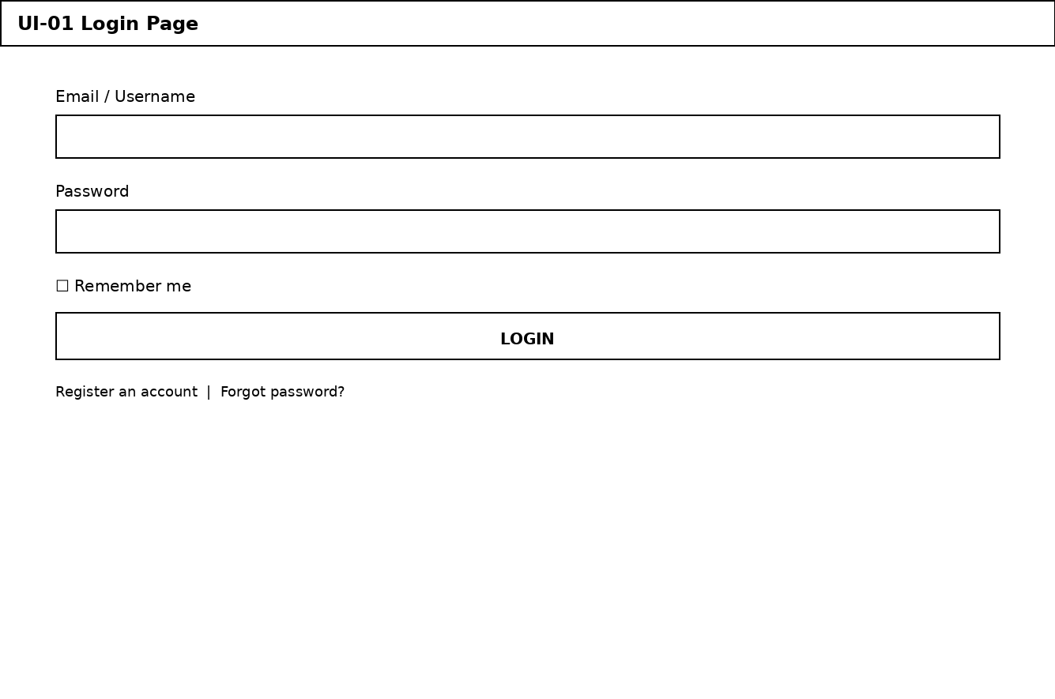
Wireframe UI-01 - Login Page
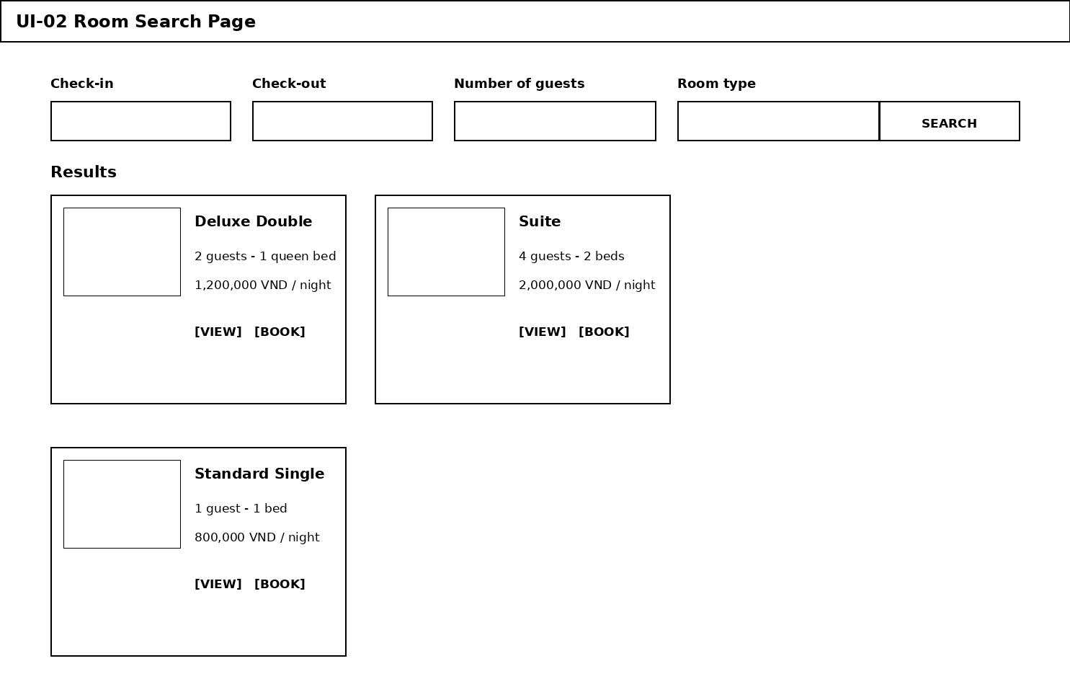
Wireframe UI-02 - Room Search Page
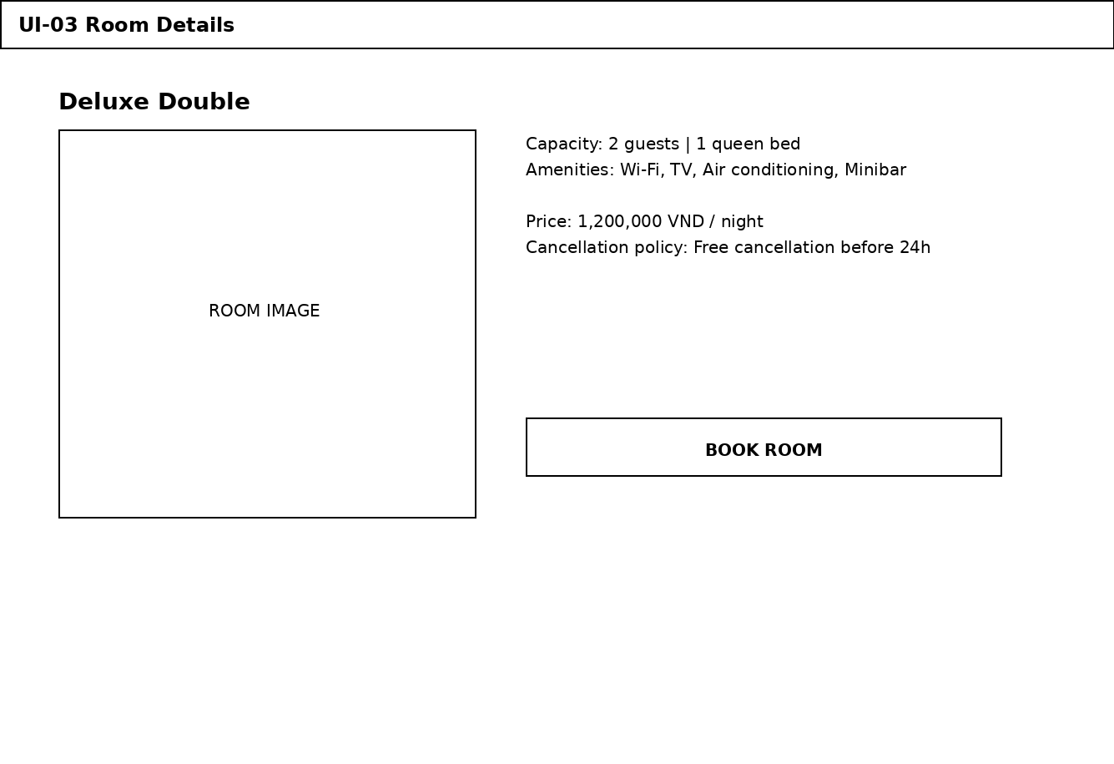
Wireframe UI-03 - Room Details
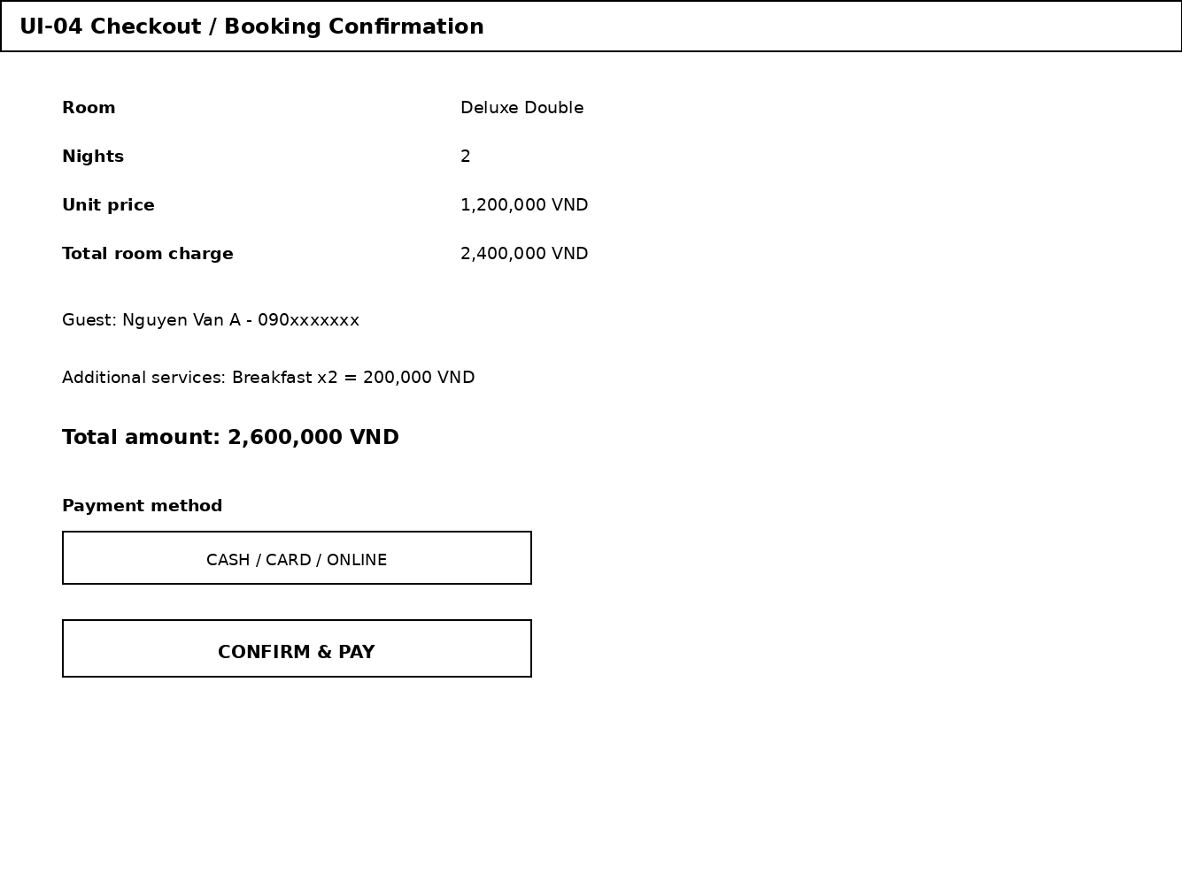
Wireframe UI-04 - Checkout / Booking Confirmation
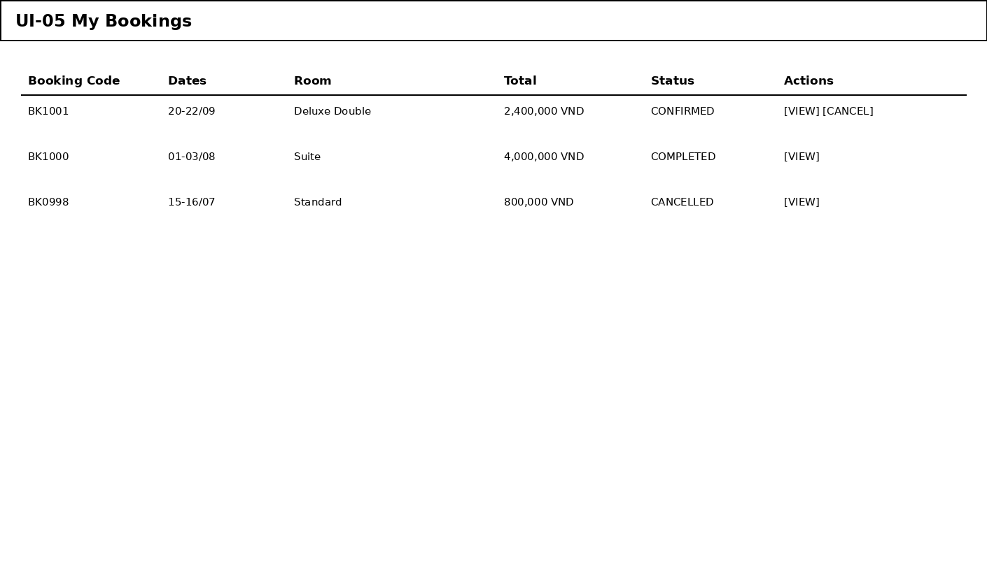
Wireframe UI-05 - My Bookings
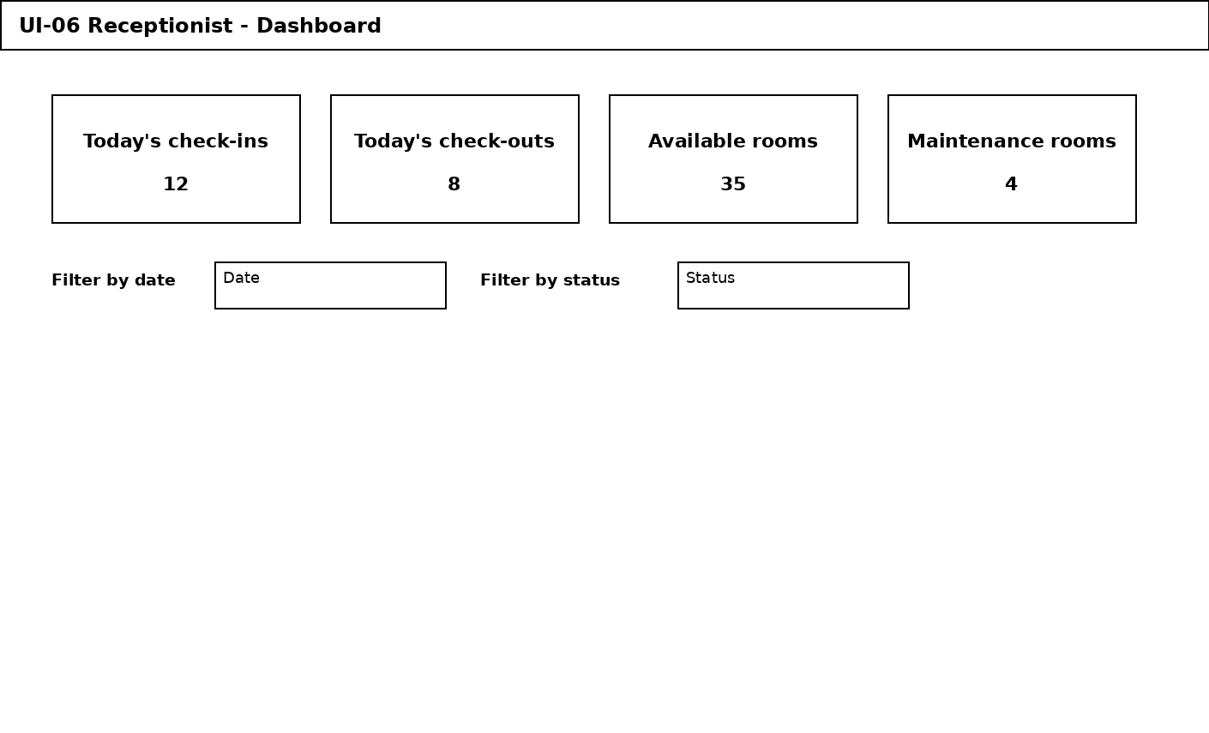
Wireframe UI-06 - Receptionist - Dashboard
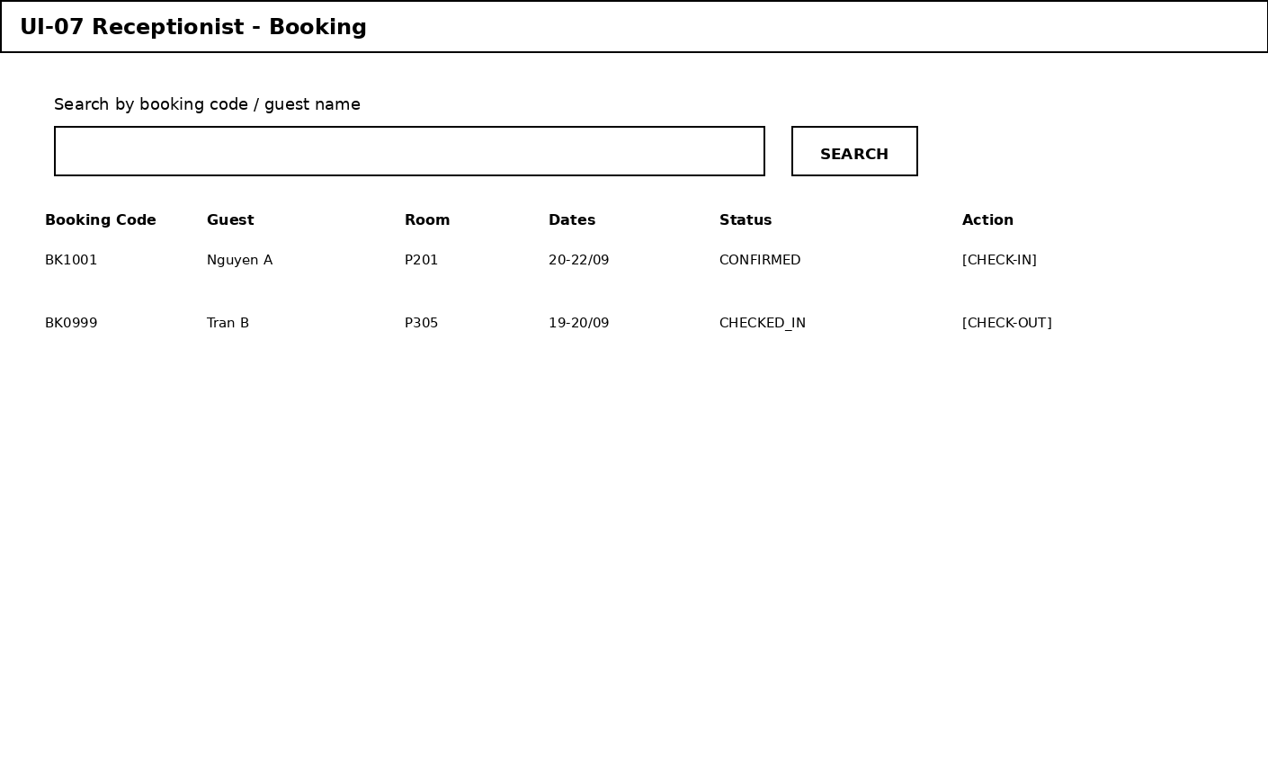
Wireframe UI-07 - Receptionist - Booking
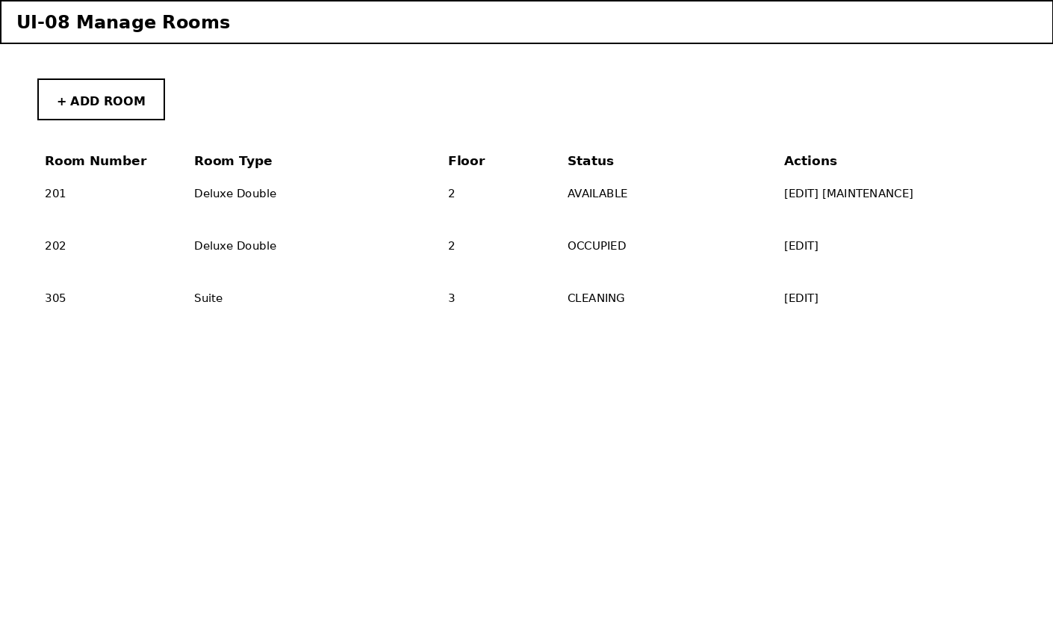
Wireframe UI-08 - Manage Rooms
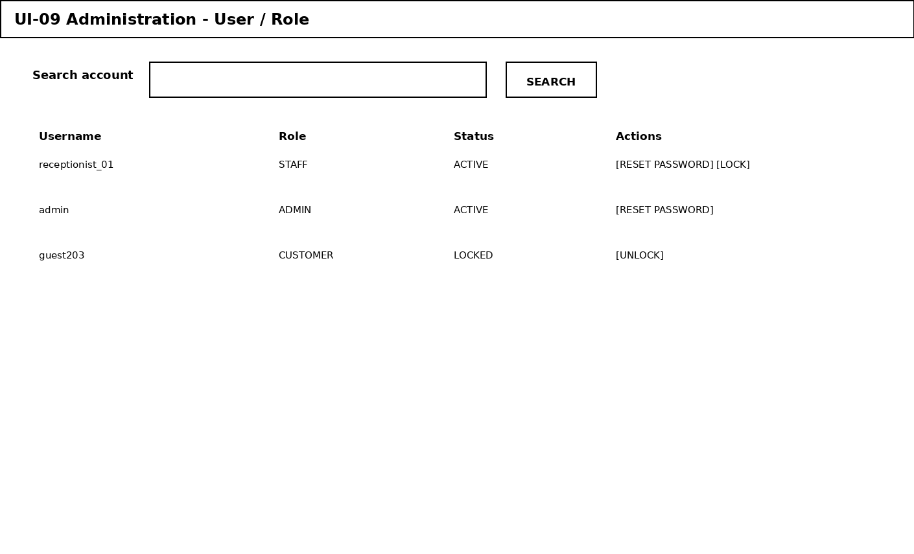
Wireframe UI-09 - Administration - User/Role
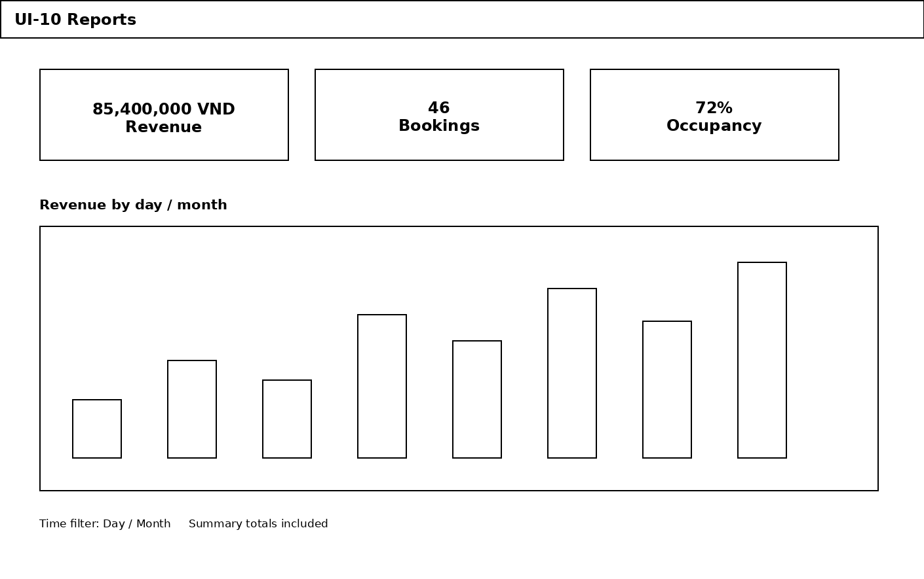
Wireframe UI-10 - Reports

3.3 Database Design
The following model prioritizes ease of coding, testing, and sufficient data for Stage 1. Table names use snake_case; primary keys are auto-incrementing integers. In a real deployment, they can be changed to UUIDs if the team needs a distributed system.

Board | Key / key column | Purpose
roles | role_id PK, role_name UNIQUE | List of roles: CUSTOMER, STAFF, ADMIN.
users | user_id PK, username UNIQUE, password_hash, role_id FK, status, created_at | Login account.
customers | customer_id PK, user_id FK NULL/UNIQUE, full_name, phone, email, id_number | Customer profile.
room_types | room_type_id PK, name UNIQUE, capacity, base_price, description, status | Room type.
rooms | room_id PK, room_type_id FK, room_number UNIQUE, floor, status | Individual physical room.
bookings | booking_id PK, customer_id FK, booking_code UNIQUE, booking_date, check_in, check_out, status, total_amount | Booking order.
booking_details | detail_id PK, booking_id FK, room_id FK, price_per_night, guests | Rooms belonging to a booking.
payments | payment_id PK, booking_id FK, amount, method, status, transaction_ref, paid_at | Payment transaction.
services | service_id PK, name, unit_price, status | Hotel service.
service_usages | usage_id PK, booking_id FK, service_id FK, quantity, unit_price, amount, used_at | Services used by the guest in a booking.
room_status_history | history_id PK, room_id FK, old_status, new_status, changed_by FK, changed_at, note | Room status change history.
audit_logs | log_id PK, user_id FK NULL, action, entity_type, entity_id, created_at, details | Audit log of important changes.

3.3.1 Primary Key / Foreign Key
PK | FK | Cardinality | Meaning
roles.role_id | users.role_id | 1 - N | One role has many users.
users.user_id | customers.user_id | 1 - 0..1 | A user may be associated with one customer profile.
room_types.room_type_id | rooms.room_type_id | 1 - N | One room type has many rooms.
customers.customer_id | bookings.customer_id | 1 - N | One customer has many bookings.
bookings.booking_id | booking_details.booking_id | 1 - N | One booking has one or more rooms.
rooms.room_id | booking_details.room_id | 1 - N | One room can have multiple bookings at different times.
bookings.booking_id | payments.booking_id | 1 - N | One booking can have multiple payments/refunds.
bookings.booking_id | service_usages.booking_id | 1 - N | One booking can have multiple service lines.
services.service_id | service_usages.service_id | 1 - N | One service can appear in many bookings.
rooms.room_id | room_status_history.room_id | 1 - N | Stores room status history.
users.user_id | room_status_history.changed_by | 1 - N | Who changed the room status.
users.user_id | audit_logs.user_id | 1 - N | Who performed the system operation.

3.3.2 Important Column Details
Board | Column | Proposed value/style | Note
bookings | status | PENDING / CONFIRMED / CHECKED_IN / COMPLETED / CANCELLED | Workflow status.
rooms | status | AVAILABLE / RESERVED / OCCUPIED / CLEANING / MAINTENANCE | Actual room status.
payments | status | PENDING / SUCCESS / FAILED / REFUNDED | Transaction status.
payments | method | CASH / CARD / BANK_TRANSFER / GATEWAY | Payment method.
users | status | ACTIVE / LOCKED / INACTIVE | Account status.
room_types | base_price | DECIMAL(12,2) | Do not use FLOAT.
bookings | total_amount | DECIMAL(12,2) | Total amount snapshot at the time of booking.
booking_details | price_per_night | DECIMAL(12,2) | Keeps the actual booking price so it does not change when room prices are updated later.

3.3.3 Recommended Indexes and Constraints
UNIQUE(users.username), UNIQUE(rooms.room_number), UNIQUE(bookings.booking_code).
Index bookings(check_in, check_out, status) to find bookings related to a time period.
Index booking_details(room_id, booking_id) to query room history.
Index payments(booking_id, status) to summarize payments.
CHECK (check_out > check_in) in the database if supported; also validate in the application.
CHECK (base_price >= 0), CHECK (quantity > 0), CHECK (amount >= 0) when supported by the database.
Use ON DELETE RESTRICT for transaction data to avoid accidentally deleting history.

3.3.4 Preventing Double Booking
This is the most important part of the system. When confirming a booking, the backend should perform the following in a transaction: (1) check whether the room is still suitable for the date range; (2) lock/control the necessary records; (3) create booking_detail; (4) update the status if applicable; (5) commit. If an error occurs or a conflict is detected, roll back and notify the user: "The room was just booked by another user. Please select another room."

3.4 Main Processing Flows

3.4.1 Online Booking Flow
- The customer selects dates and number of guests.
- The search API receives the request and checks Room + BookingDetail/Booking for the date range.
- The UI displays suitable rooms.
- The customer selects a room and enters information.
- The backend re-validates availability and the price from the server.
- Create a booking with status PENDING or CONFIRMED depending on the policy.
- For online payment: call the Payment Gateway.
- Receive the callback/result, record payments, and update the booking.
- Return the booking code + confirmation notification to the customer.

3.4.2 Check-in Flow
- Staff search for the booking_code.
- Check the check-in date and booking status.
- Verify the guest's identification/information according to policy.
- Assign/ensure a valid room_id.
- Change the booking to CHECKED_IN.
- Change the room to OCCUPIED.
- Record an audit log.

3.4.3 Check-out Flow
- Staff open the CHECKED_IN booking.
- The system calculates additional services and outstanding amounts.
- Receive payment or confirm that the outstanding balance has been fully settled.
- Change the booking to COMPLETED.
- Change the room to CLEANING (if the hotel has housekeeping) or AVAILABLE.
- Record an audit log and complete the payment record.

3.5 Authorization
Role | Allowed | Limit
Customer | Personal account, room search, booking creation, payment, and viewing/canceling own bookings. | Cannot view other customers; cannot administer rooms/users.
Staff | Bookings, rooms, customers, check-in/out, and services. | Cannot manage admin roles or sensitive system configurations.
Admin | All business processes + user/role + configuration + reports. | All sensitive operations should be audited and logged.

3.6 Some Technical Criteria
Topic | Proposed specification
API validation | Do not trust frontend data; the server always recalculates prices and checks authorization.
Authentication | Hash passwords using a standard algorithm (e.g., bcrypt/Argon2); sessions/JWTs must have an expiry.
Error handling | The API returns consistent error codes, e.g., 400 validation, 401 unauthorized, 403 forbidden, 404 not found, 409 conflict.
Time | Store datetime consistently and define the system timezone. For a project in Vietnam, Asia/Ho_Chi_Minh can be used.
Money | DECIMAL(12,2); format currency according to the UI locale.
Audit | Actions such as deleting/locking users, changing prices, and changing room statuses should have an audit log.
Testing | Unit tests for price calculation and booking rules; integration tests for booking/payment; UI tests for critical flows.
Deployment | Include an environment configuration file (.env), database migration/seed, and project run instructions.

4. FUNCTIONAL ACCEPTANCE CRITERIA
ID | Acceptance conditions
AT-01 | Customers can register/log in with valid data and are rejected when the data is invalid.
AT-02 | Room search returns the correct available rooms based on dates and number of guests.
AT-03 | Two valid bookings cannot be created for the same room over overlapping dates.
AT-04 | The server-side total matches the number of nights, prices, and services.
AT-05 | A successful payment creates a SUCCESS payment and sets the booking to the correct status.
AT-06 | Booking cancellation is blocked after check-in or completion.
AT-07 | Check-in changes the booking to CHECKED_IN and the room to OCCUPIED.
AT-08 | Check-out changes the booking to COMPLETED and returns the room to the post-stay process.
AT-09 | Customers cannot access admin/staff functions.
AT-10 | Booking/payment data remains available after room prices or room statuses are changed.

