Install Matlab

Your university may offer a free Matlab download. Please install Matlab and select the “Image Processing Toolbox” option when you install the Matlab.

Run ‘Cellcount.m’

1. Please copy all the images you need to process into **one folder** (e.g., c:\cellimage)**.**
2. Open ‘cellcount.m’
3. Update the folder_name to be the folder in step 1.



1. Click the ‘Run’ button 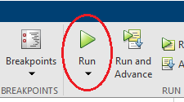
2. The result will be saved into an excel file ‘cell_count.xls’ in the same folder. The excel looks like following:

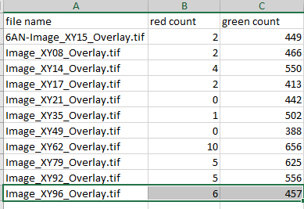

1. For each image, we will save a label image with a .png format. The labeled image is for QA purpose:

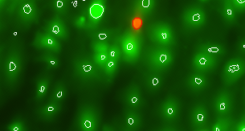

Tricks

Several parameters can be adjusted if the count does not correct.

1. ‘calibration’, this parameter is used to adjust more count or less count for green cells.

 Smaller ‘calibration’ value generates (e.g., 5) more counts and bigger ‘calibration value generates fewer counts (e.g., 20). If you think the program missing some green cells, you should lower the ‘calibration’ value.

My suggestion is to use some old images already labeled by students to calibrate this parameter.

2. Some images are blurring than others. My suggestion is to process those images separately with a different ‘calibration’ value.

3. ‘cell_count.xls’ will be renewed every time run the code if you use the same folder to process the image. Please make a copy as needed.