**LAB 07: JAVASCRIPT PHẦN 2**

**Bài tập 1: thanh điều hướng trượt động**

Viết trang web có giao diện như dưới đây

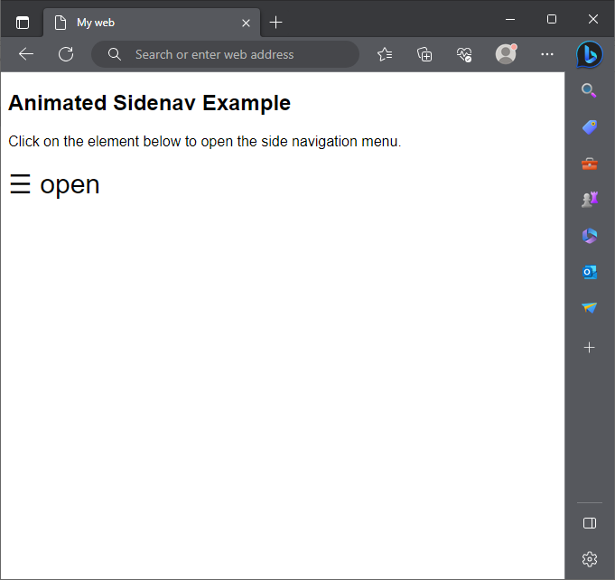

Khi nhấn vào nút open sẽ mở một menu liên kết như bên dưới

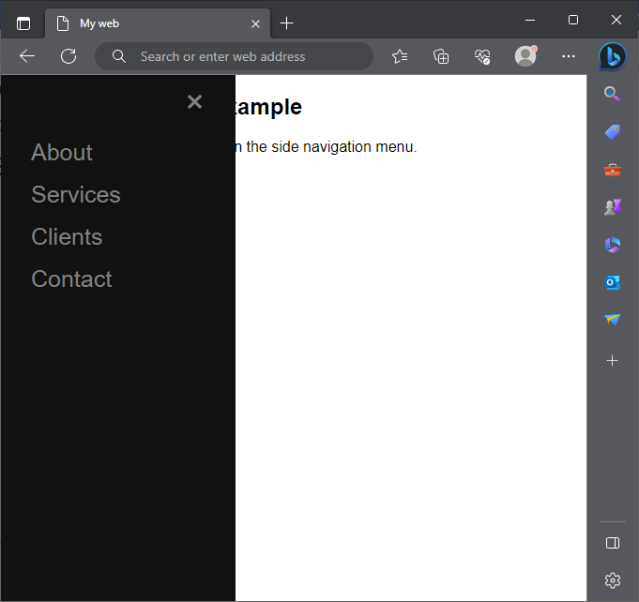

Khi nhấn nút x sẽ đóng menu lại

**Code mẫu:**

<!DOCTYPE html>

<html lang="en">

<head>

<meta charset="UTF-8">

<title>My web</title>

<meta name="viewport" content="width=device-width, initial-scale=1">

<style>

body {

    font-family: "Lato", sans-serif;

}

.sidenav {

    height: 100%;

    width: 0;

    position: fixed;

    z-index: 1;

    top: 0;

    left: 0;

    background-color: #111;

    overflow-x: hidden;

    transition: 0.5s;

    padding-top: 60px;

}

.sidenav a {

    padding: 8px 8px 8px 32px;

    text-decoration: none;

    font-size: 25px;

    color: #818181;

    display: block;

    transition: 0.3s;

}

.sidenav a:hover {

    color: #f1f1f1;

}

.sidenav .closebtn {

    position: absolute;

    top: 0;

    right: 25px;

    font-size: 36px;

    margin-left: 50px;

}

@media screen and (max-height: 450px) {

    .sidenav {padding-top: 15px;}

    .sidenav a {font-size: 18px;}

}

#nav {

    font-size:30px;

    cursor:pointer

}

</style>

</head>

<body>

<div id="mysidenav" class="sidenav">

    <a href="javascript:void(0)" class="closebtn" onclick="closeNav()">&times;</a>

    <a href="#">About</a>

    <a href="#">Services</a>

    <a href="#">Clients</a>

    <a href="#">Contact</a>

</div>

<h2>Animated Sidenav Example</h2>

<p>Click on the element below to open the side navigation menu.</p>

<span id="nav" onclick="openNav()">&#9776; open</span>

<script>

function openNav() {

    document.getElementById("mysidenav").style.width = "250px";

}

function closeNav() {

    document.getElementById("mysidenav").style.width = "0";

}

</script>

</body>

</html>

**Bài tập 2: Hiển thị khung trượt hình ảnh**

Viết trang web xuất hình ảnh trượt như bên dưới. Khi clcik vào mỗi hình con bên dưới sẽ xuất hiện hình trong khung lớn. Thay đổi hình xem bằng nút mũi tên hoặc click chọn hình nhỏ

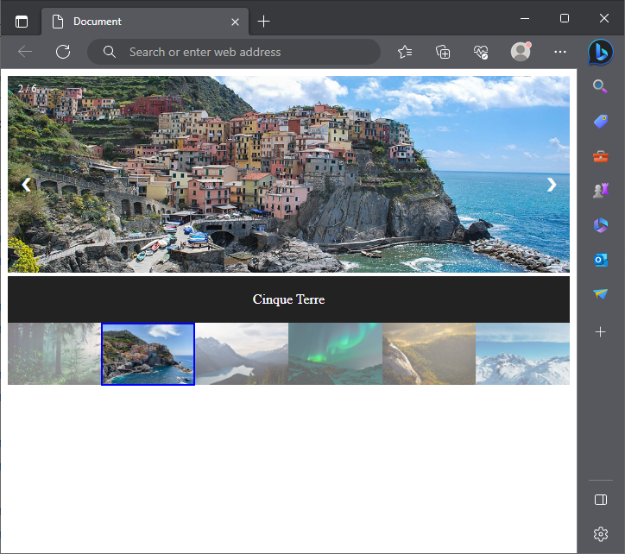

**Xem code mẫu:**

**Tập tin index.html**

<!DOCTYPE html>

<html lang="en">

<head>

    <meta charset="UTF-8">

    <meta name="viewport" content="width=device-width, initial-scale=1.0">

    <title>Document</title>

    <link rel="stylesheet" href="css/style.css">

</head>

<body>

 <!-- Container for the image gallery -->

 <div class="container">

    <!-- Full-width images with number text -->

    <div class="myslides">

      <div class="numbertext">1 / 6</div>

        <img src="images/img_woods_wide.jpg" alt="">

    </div>

    <div class="myslides">

      <div class="numbertext">2 / 6</div>

        <img src="images/img_5terre_wide.jpg" alt="">

    </div>

    <div class="myslides">

      <div class="numbertext">3 / 6</div>

        <img src="images/img_mountains_wide.jpg" alt="">

    </div>

    <div class="myslides">

      <div class="numbertext">4 / 6</div>

        <img src="images/img_lights_wide.jpg" alt="">

    </div>

    <div class="myslides">

      <div class="numbertext">5 / 6</div>

        <img src="images/img_nature_wide.jpg" alt="">

    </div>

    <div class="myslides">

      <div class="numbertext">6 / 6</div>

        <img src="images/img_snow_wide.jpg" alt="">

    </div>

    <!-- Next and previous buttons -->

    <a class="prev" onclick="plusSlides(-1)">&#10094;</a>

    <a class="next" onclick="plusSlides(1)">&#10095;</a>

    <!-- Image text -->

    <div class="caption-container">

      <p id="caption"></p>

    </div>

    <!-- Thumbnail images -->

    <div class="row">

      <div class="column">

        <img class="demo cursor" src="images/img_woods.jpg" onclick="currentSlide(1)" alt="The Woods">

      </div>

      <div class="column">

        <img class="demo cursor" src="images/img_5terre.jpg" onclick="currentSlide(2)" alt="Cinque Terre">

      </div>

      <div class="column">

        <img class="demo cursor" src="images/img_mountains.jpg" onclick="currentSlide(3)" alt="Mountains and fjords">

      </div>

      <div class="column">

        <img class="demo cursor" src="images/img_lights.jpg" onclick="currentSlide(4)" alt="Northern Lights">

      </div>

      <div class="column">

        <img class="demo cursor" src="images/img_nature.jpg" onclick="currentSlide(5)" alt="Nature and sunrise">

      </div>

      <div class="column">

        <img class="demo cursor" src="images/img_snow.jpg" onclick="currentSlide(6)" alt="Snowy Mountains">

      </div>

    </div>

  </div>

  <script src="js/script.js"></script>

</body>

</html>

**Tập tin css/style.css**

* {

    box-sizing: border-box;

}

img {

  width: 100%;

}

/* Position the image container (needed to position the left and right arrows) */

.container {

    position: relative;

}

/* Hide the images by default */

.myslides {

    display: none;

}

/* Add a pointer when hovering over the thumbnail images */

.cursor {

    cursor: pointer;

}

/* Next & previous buttons */

.prev,

.next {

    cursor: pointer;

    position: absolute;

    top: 40%;

    width: auto;

    padding: 16px;

    margin-top: -50px;

    color: white;

    font-weight: bold;

    font-size: 20px;

    border-radius: 0 3px 3px 0;

    -webkit-user-select: none;

    user-select: none;

}

/* Position the "next button" to the right */

.next {

    right: 0;

    border-radius: 3px 0 0 3px;

}

/* On hover, add a black background color with a little bit see-through */

.prev:hover,

.next:hover {

    background-color: rgba(0, 0, 0, 0.8);

}

/* Number text (1/3 etc) */

.numbertext {

    color: #f2f2f2;

    font-size: 12px;

    padding: 8px 12px;

    position: absolute;

    top: 0;

}

/* Container for image text */

.caption-container {

    text-align: center;

    background-color: #222;

    padding: 2px 16px;

    color: white;

}

.row:after {

    content: "";

    display: table;

    clear: both;

}

/* Six columns side by side */

.column {

    float: left;

    width: 16.66%;

}

/* Add a transparency effect for thumnbail images */

.demo {

    opacity: 0.6;

}

.demo:hover {

    opacity: 1;

}

.active {

    opacity: 1;

    border: 2px solid blue;

}

**Tập tin js/script.js**

let slideIndex = 1;

showSlides(slideIndex);

// Next/previous controls

function plusSlides(n) {

  showSlides(slideIndex += n);

}

// Thumbnail image controls

function currentSlide(n) {

  showSlides(slideIndex = n);

}

function showSlides(n) {

  let i;

  let slides = document.getElementsByClassName("myslides");

  let dots = document.getElementsByClassName("demo");

  let captionText = document.getElementById("caption");

  if (n > slides.length) {slideIndex = 1}

  if (n < 1) {slideIndex = slides.length}

  for (i = 0; i < slides.length; i++) {

    slides[i].style.display = "none";

  }

  for (i = 0; i < dots.length; i++) {

    dots[i].className = dots[i].className.replace(" active", "");

  }

  slides[slideIndex-1].style.display = "block";

  dots[slideIndex-1].className += " active";

  captionText.innerHTML = dots[slideIndex-1].alt;

}