



Báo cáo Assignment 2

Họ và tên: Nguyễn quốc cảnh

MSSV: PD01197

Môn học: Điện toán đám mây

Yêu cầu 1: Xây dựng database trên my.vertabelo.com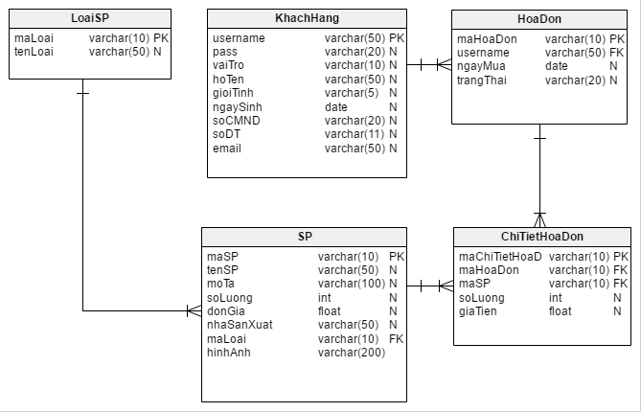

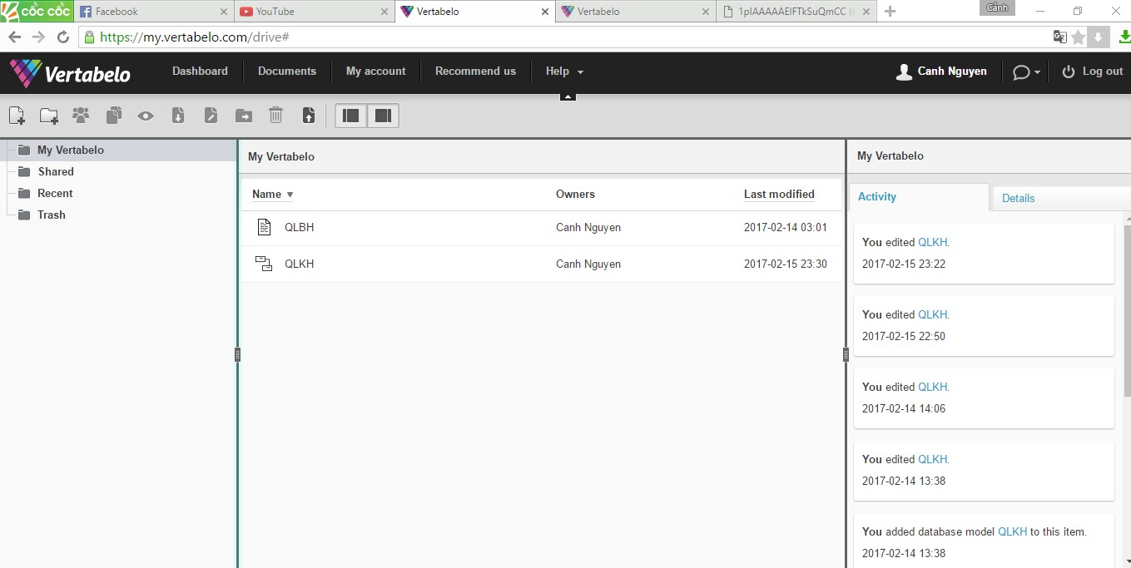

Tạo database và chèn dữ liệu

CREATE DATABASE QLBH;

USE QLBH;

CREATE DATABASE QLBH

;

USE QLBH;

CREATE TABLE ChiTietHoaDon (

maChiTietHoaDon varchar(10) NOT NULL,

maHoaDon varchar(10) NOT NULL,

maSP varchar(10) NOT NULL,

soLuong int NULL,

giaTien float NULL,

CONSTRAINT ChiTietHoaDon_pk PRIMARY KEY (maChiTietHoaDon)

);

-- Table: HoaDon

CREATE TABLE HoaDon (

maHoaDon varchar(10) NOT NULL,

username varchar(50) NOT NULL,

ngayMua date NULL,

trangThai varchar(20) NULL,

CONSTRAINT HoaDon_pk PRIMARY KEY (maHoaDon)

);

-- Table: KhachHang

CREATE TABLE KhachHang (

username varchar(50) NOT NULL,

pass varchar(20) NULL,

vaiTro varchar(10) NULL,

hoTen varchar(50) NULL,

gioiTinh varchar(5) NULL,

ngaySinh date NULL,

soCMND varchar(20) NULL,

soDT varchar(11) NULL,

email varchar(50) NULL,

CONSTRAINT KhachHang_pk PRIMARY KEY (username)

);

-- Table: LoaiSP

CREATE TABLE LoaiSP (

maLoai varchar(10) NOT NULL,

tenLoai varchar(50) NULL,

CONSTRAINT LoaiSP_pk PRIMARY KEY (maLoai)

);

-- Table: SP

CREATE TABLE SP (

maSP varchar(10) NOT NULL,

tenSP varchar(50) NULL,

moTa varchar(100) NULL,

soLuong int NULL,

donGia float NULL,

nhaSanXuat varchar(50) NULL,

maLoai varchar(10) NOT NULL,

hinhAnh varchar(200) NOT NULL,

CONSTRAINT SP_pk PRIMARY KEY (maSP)

);

-- foreign keys

-- Reference: HoaDon_ChiTietHoaDon (table: ChiTietHoaDon)

ALTER TABLE ChiTietHoaDon ADD CONSTRAINT HoaDon_ChiTietHoaDon

FOREIGN KEY (maHoaDon)

REFERENCES HoaDon (maHoaDon)

ON DELETE CASCADE

ON UPDATE CASCADE;

-- Reference: KhachHang_HoaDon (table: HoaDon)

ALTER TABLE HoaDon ADD CONSTRAINT KhachHang_HoaDon

FOREIGN KEY (username)

REFERENCES KhachHang (username)

ON DELETE CASCADE

ON UPDATE CASCADE;

-- Reference: SP_ChiTietHoaDon (table: ChiTietHoaDon)

ALTER TABLE ChiTietHoaDon ADD CONSTRAINT SP_ChiTietHoaDon

FOREIGN KEY (maSP)

REFERENCES SP (maSP)

ON DELETE CASCADE

ON UPDATE CASCADE;

-- Reference: SP_LoaiSP (table: SP)

ALTER TABLE SP ADD CONSTRAINT SP_LoaiSP

FOREIGN KEY (maLoai)

REFERENCES LoaiSP (maLoai)

ON DELETE CASCADE

ON UPDATE CASCADE;

-- End of file.

INSERT into KhachHang values('canh','canh123','AD','Nguyen Quoc Canh','Nam','1995/09/18','233213653','0911776579','canhnqpd01197@fpt.edu.vn'),

('lien','lien123','KH','Tran Thi Thuy Lien','Nu','1997/06/05','24585384','01658441001','lien@fpt.edu.vn'),

('gia','gia123','KH','Che Bong Gia','Nam','1997/12/12','234853541','01658552475','gia@fpt.edu.vn'),

('hoang','hoang123','KH','Nguyen Thi Hoang','Nam','1996/05/02','568975321','01665225775','hoang@fpt.edu.vn'),

('phuc','phuc123','KH','Le Van Phuc','Nam','1994/02/02','786945369','01663221521','phuc@fpt.edu.vn')

;

INSERT into LoaiSP values('l1','Sua Tam'),

('l2','Kem tri mun'),

('l3','Kem trang da'),

('l4','Kem tri nam'),

('l5','Kem tri tham')

;

INSERT into SP values('sp1','Sua tam Dove','Trang ngay lap tuc',50,120000,'Dove','l1','suatamdove.jpg'),

('sp2','Kem tri mun acnes','Het mun ngay lap tuc',50,200000,'Acnes','l2','acne.jpg'),

('sp3','Kem White doctors','Trang ngay lap tuc',50,500000,'White doctors','l3','white doctor.png'),

('sp4','Kem Kami skin','Het nam ngay lap tuc',50,300000,'Kami','l4','Kami skin.png'),

('sp5','Kem tri tham Nivea','Cho lan da min mang, mo vet tham',50,90000,'Nivea','l5','Nivea.jpg')

;

INSERT into HoaDon values('HD1','lien','2016/12/12','OK'),

('HD2','phuc','2016/11/12','OK'),

('HD3','hoang','2016/12/10','OK'),

('HD4','gia','2016/12/1','OK'),

('HD5','lien','2016/12/3','OK')

;

INSERT INTO ChiTietHoaDon values('CTHD1','HD1','SP1',2,240000),

('CTHD2','HD2','SP2',1,200000),

('CTHD3','HD3','SP3',1,50000),

('CTHD4','HD4','SP4',1,300000),

('CTHD5','HD5','SP5',3,270000)

;

1. Sơ đồ ERD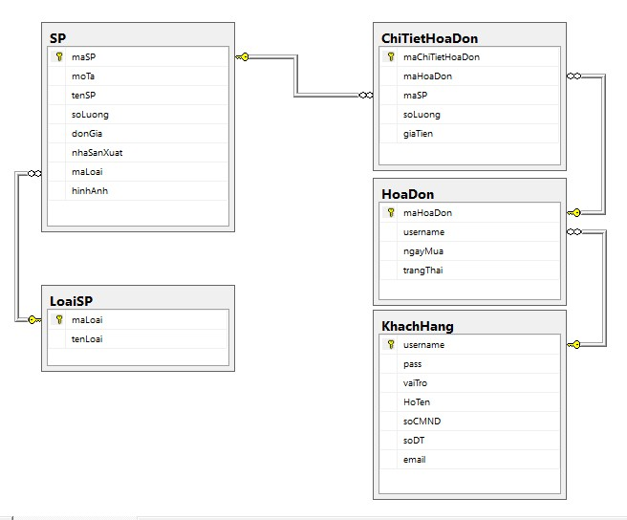

Yêu cầu 2: Xây dựng một ứng dụng web kết nối với database.

1. Trang chủ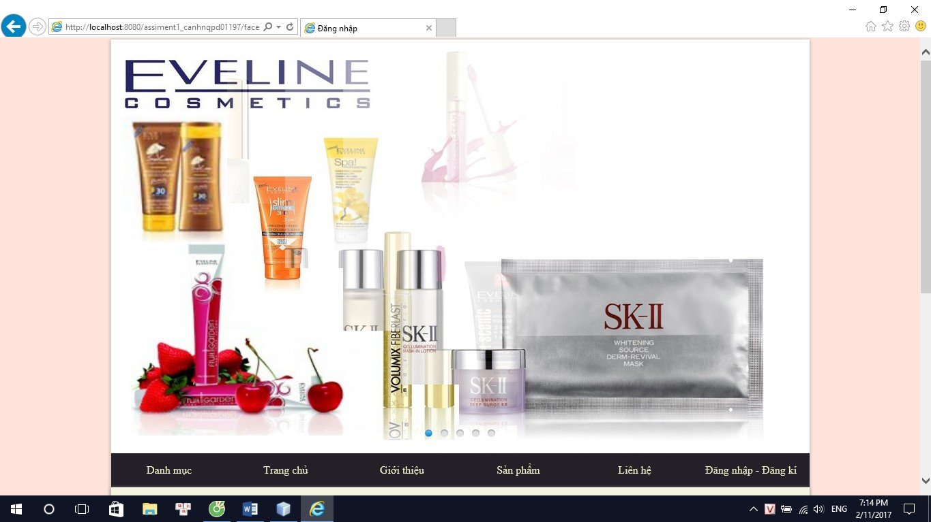
2. Trang truy xuất sản phẩm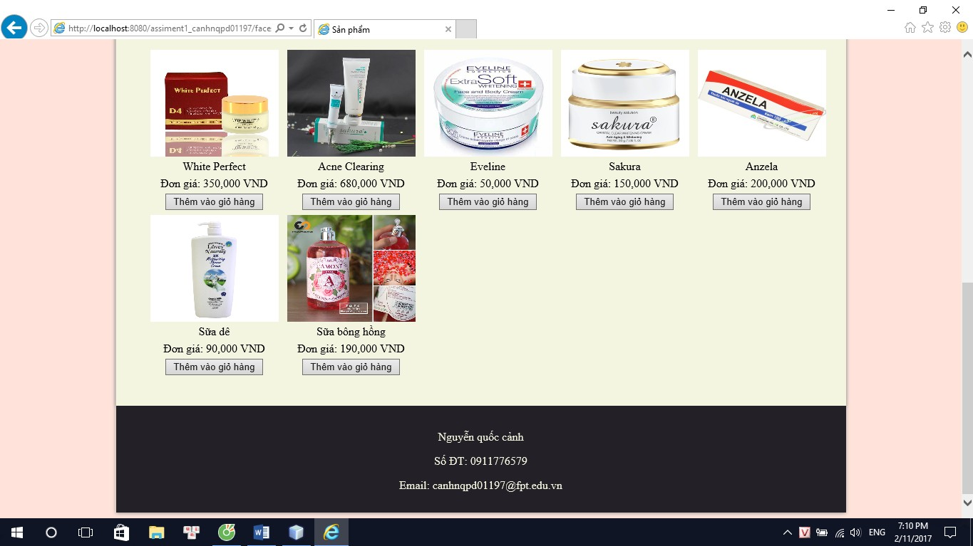
3. Trang đăng nhập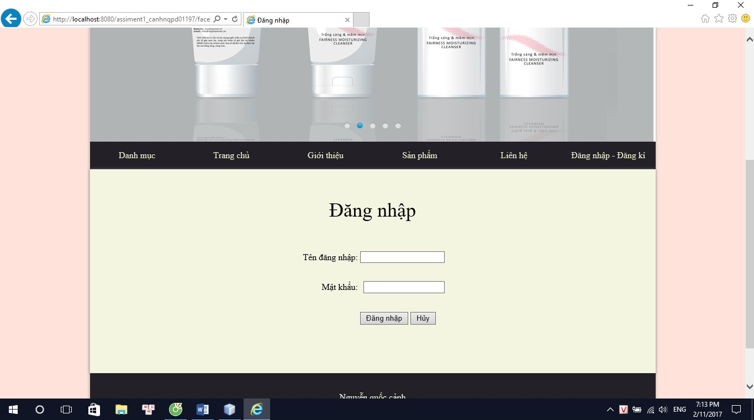
4. Trang quản trị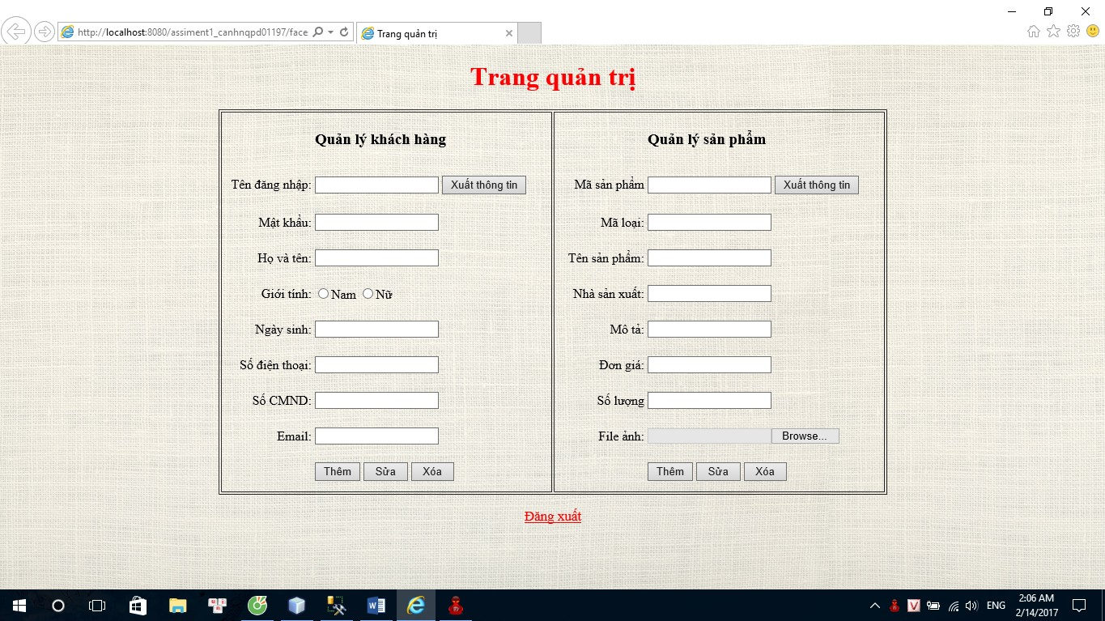
5. Trang liên hệ

