**Development notes**

**Dashboard**:

Use drupal page to make dashboard pages for user. It is flexible to create a dashboard based on design and easy to add content, set permission for accessing those content. Currently I have created two dashboards, one for Mentor, another for candidate.

admin/structure/pages/edit/page-user_dashboard

admin/structure/pages/edit/page-applicant_dashboard

We can set what role can access these pages, configure the information each roles can see on the page. Currently I have added the menus for each role mentor and candidate and some example information boxes.

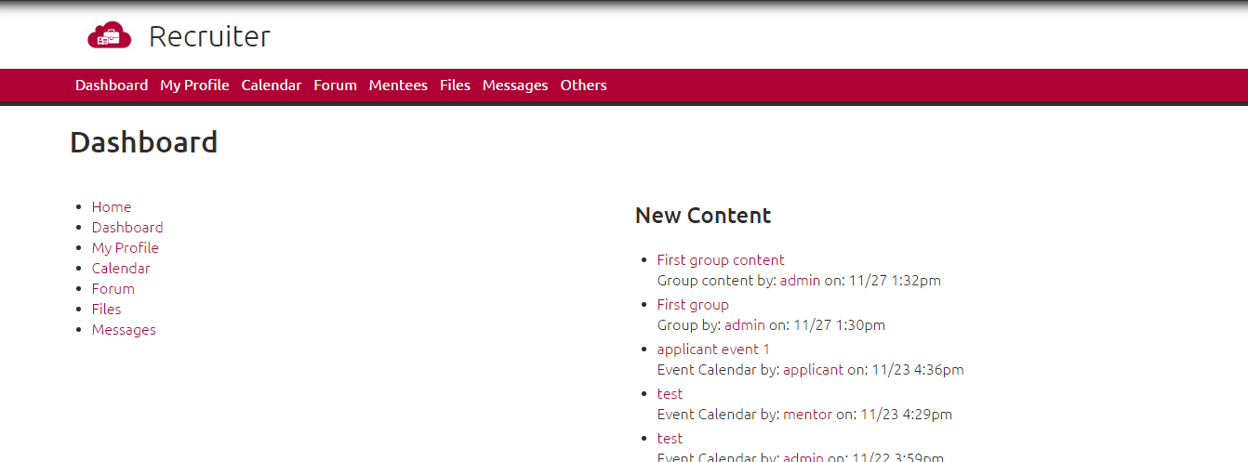

**Profile**:

Use ***profile2*** module. This module support very much features of the profile the website needed:

* With profile2 user account settings and user profiles are conceptually different things, e.g. with the "Profile pages" module enabled users get two separate menu links "My account" and "My profile".
* Profile2 allows for creating multiple profile types, which may be assigned to roles via permissions (e.g. a general profile + a customer profile)
* Profile2 supports private profile fields, which are only shown to the user owning the profile and to administrators.

Configuration/setting profile: Administration » Structure » Profile types (admin/structure/profiles)

Another module is used for profile is ***Profile Complete Percentage (PCP)***, it support us to calculate how many percent of profile user has completed. With PCP we can choose the fields in profile for calculating.

Configuration/setting:

* Administration » Structure >> Blocks: configure region to display PCP
* Administration » Configuration » People >> Profile Complete Percentages: configure for default profiles

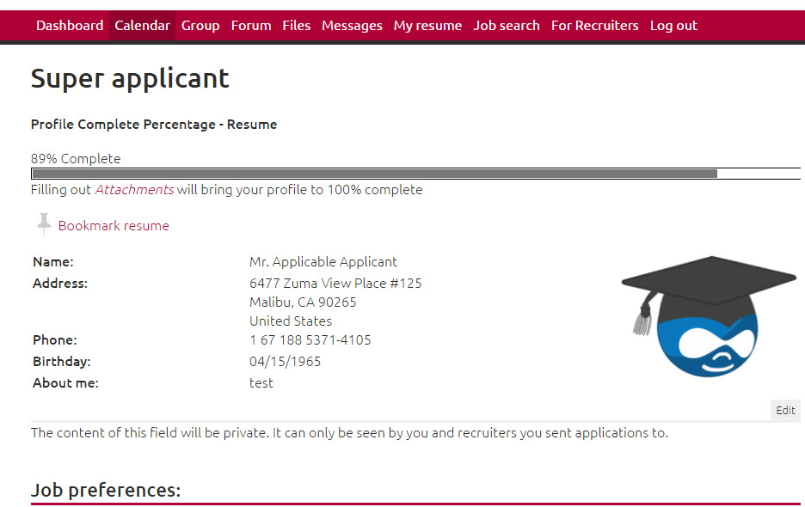

**Calendar**:

The ***Event Calendar*** module allows users to Add/Edit/View events in pop-up while clicking on a box in an “event calendar view”. This module uses the calendar display format of Calendar module and gives its own content type and views. This module also gives an Admin UI to change status (approval/denied) of events and a mailing system. It support calandar features of the website, however we need to make customization (code) to make it matched all calendar features which the website needed.

Configuration/setting: Administration » Configuration » Date API >> Events Settings (admin/config/date/event-settings)

Currently I have configured, set permission for Mentor and Candidate and make a small customization to display calendar events as readonly for Candidate.

Customized file: sites/all/themes/mytheme/templates/views-view-field--edit-node.tpl.php

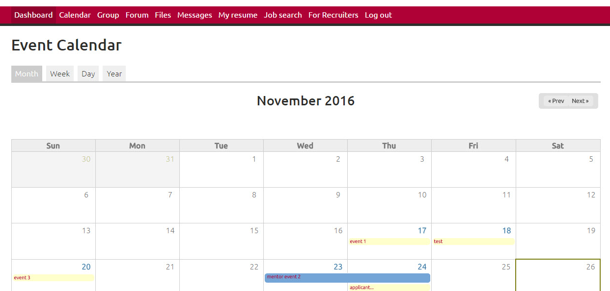

**Group**:

Currently, the system is using ***Group*** module (we should try to study and use ***Organic Groups*** module, it might support more features than ***Group*** module)

**Forum**:

Use module ***Forum*** (default module of drupal core) and installed ***Advanced Forum*** (to enable the look and feel of other popular forum software.)

Configuration:

Administration » Configuration » Content authoring >> Advanced Forum (admin/config/content/advanced-forum)

# General:

* "Advanced forum style directory" Select the style you are using.

See http://drupal.org/node/234042 for more information on this.

* "Use graphical buttons for links" Check this if you want links to use graphical

buttons (where available).

* "Treat all site comments like forum comments" If you would like advanced forum to

take over the theming of all comments, even those outside the forum, choose yes.

* "Use fields from taxonomy term in forum" Allows to use fields from taxonomy term

on the form of creation or editing of the forum. You can add your own fields into

taxonomy term from vocabulary "Forums" and these fields will be available on the

creation/editing form of the Forum if this option is active.

# Forum and topic lists

* "Hide the created column on the topic list" This option hides the created column

on the topic list page, which can't be done purely in theming due to the header

tablesort. If you hide this column, it is up to you to change the tenplate to

display the information elsewhere.

* "Get the number of new comments per forum on the forum list" Core forum shows the

number of new topics. If checked, Advanced Forum will get the number of new

comments as well and show it under "posts" on the forum overview. Slow query not

recommended on large forums.

* "Number of characters to display for the topic title" On the main forums page, the

title of the last topic is shown. Because this is a narrow column, it is

truncated. This option sets how many characters are shown.

* "Number of hours before switching to date posted in displays" In the forum / topic

listing, recent posts are shown like "1 day, 3 hours ago" and older posts will

have the actual date. You control the cutoff here.

# Topics

* "Use topic navigation" Core forum gets the next and previous topics and shows

links to them under the top post. This is turned off by default as the query has

performance issues and the placement of the links is poor.

* "User picture preset" You will only see this option if you have imagecache 2

enabled. If you choose a preset here, it will be used for the avatars in forum

posts. This can be used to give a more uniform appearance if people have many

different sizes for avatars. If you don't want to use a preset, just leave it

blank.

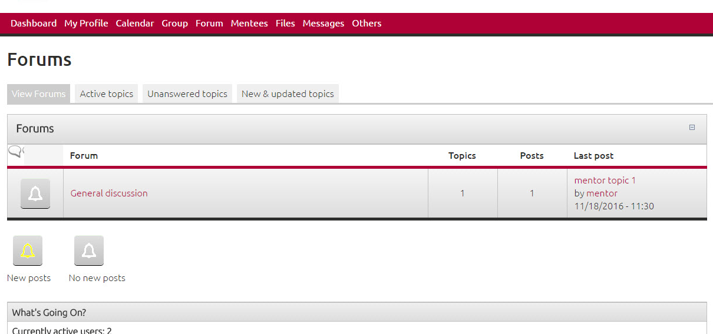

**Mentees**: ( the page Mentor can view his mentees)

Currently I created a simple view to list users to test. We can use Views for this page however we need to make some customization to match to the requirement of the website.

Configuration: admin/structure/views/view/mentees_view/edit/page?destination=mentees-view

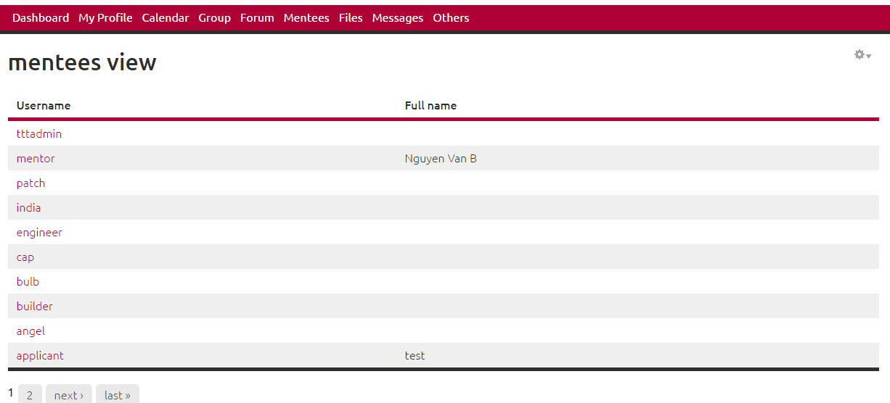

**Files**:

Use module ***Filedepot***. It has full featured document management module supporting role or user based security:

* Documents are saved to a directory under the Drupal Private file system to protect corporate documents for safe access and distribution.
* Flexible permission model allows you to delegate folder administration to other users.
* Define view, download and upload access for selected users, roles or groups (If OG module installed) - any combination of permissions can be setup per folder.

**install**:

install as normally then create two folders as below:

* sites/all/libraries/html_encoder
* sites/all/libraries/jquery.blockui

download content for these folders:

* http://www.strictly-software.com/scripts/downloads/encoder.js - SAVE FILE as: html_encoder/html_encoder.js
* http://jquery.malsup.com/block/#download - SAVE FILE as jquery.blockui/jquery.blockui.js

**Configuration**:

Configuration » Media >> Filedepot Settings (admin/config/media/filedepot)

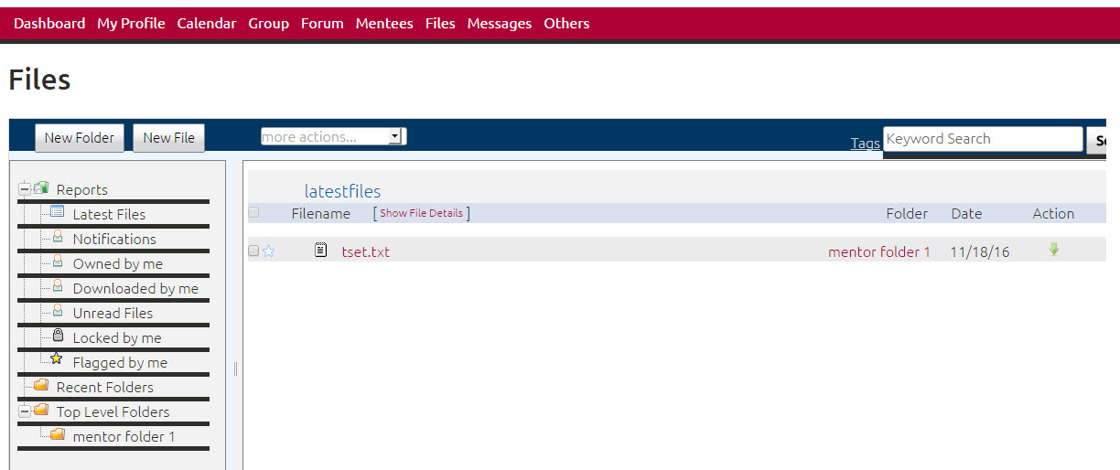

**Follow up a user**:

User module Flag Follow. It allow user follow up another user and see his activities under Favorites tab.

Configuration:

Administration » Structure » Flags (admin/structure/flags)

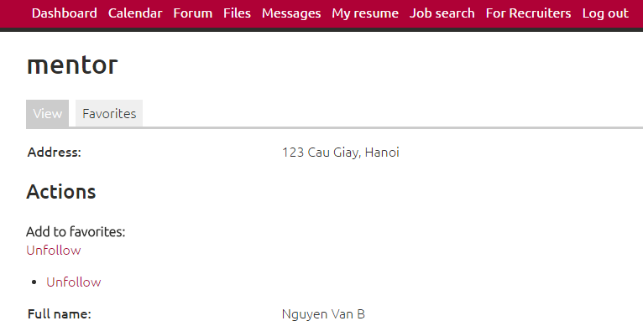

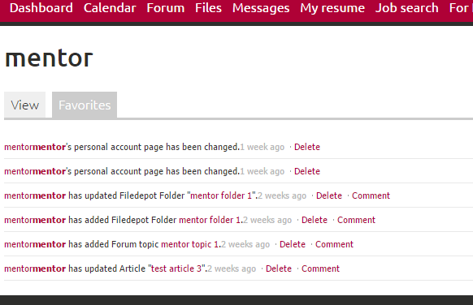

**Mitigates spam form submissions**:

Use module Honeypot. It limit submissions by require waiting a time after a submission. It allows admin choose protect all form or select specific form to protect.

Configuration:

Administration » Configuration » Content authoring >> Honeypot configuration (admin/config/content/honeypot)

