Some html css tricks

Author: Arturo Alatriste Trujillo

Description: in this doc we explain some common cases when working with html and css and how to fix them.

How to use flexbow container.
The container that have items that rearrange themselves!

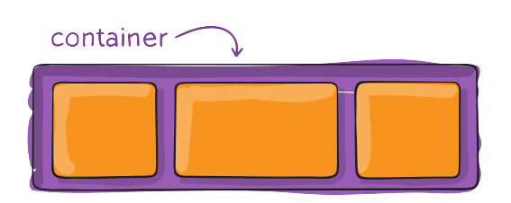

CSS Flexbox: A Complete Guide
https://sharkcoder.com/layout/flexbox

A Complete Guide to Flexbox
https://css-tricks.com/snippets/css/a-guide-to-flexbox/

