**ACS JGLCRM in Grand Rapids**

**SAVE THE DATE May 27-30, 2015**

**Joint Great Lakes – Central Regional** **Meeting**

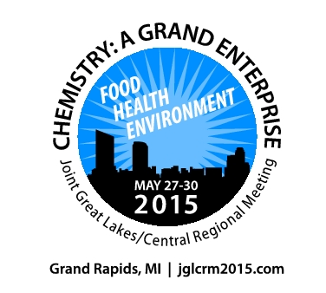

*The co-hosting Sections are the* ***Kalamazoo******Section*** *in the* ***Great Lakes Region*** *and the* ***Western Michigan******Section*** *in the* ***Central Region****.*

**Program co-chairs**

**James J. Kiddle**

Kalamazoo Section

[James.Kiddle@wmich.edu](mailto:James.Kiddle@wmich.edu)

and

**Mark Thomson**

Western Michigan Section

[MarkThomson@ferris.edu](mailto:MarkThomson@ferris.edu)

**General co-chairs**

**Lydia E. M. Hines**

Kalamazoo Section

[lemhwgh@gmail.com](mailto:lemhwgh@gmail.com)

and

**Neal Fox**

Western Michigan Section

[NealFox@comcast.net](mailto:NealFox@comcast.net)

**THEME:**

**Chemistry**

**A Grand Enterprise**

**Plenary Speaker:**

**Scott Denmark**

**11 a.m., May 27 (Wed)**

**Keynote Speakers:**

**Joan Brennecke (ENVN)**

**4:30 p.m., May 27 (Wed)**

**Dustin Mergot (HEALTH)**

**4:30 p.m., May 28 (Thu)**

**Focus Areas:**

**Food, Health, Environment**

***Plan to attend and/or be a part of the program***

***Contribute ideas for sessions!***

***Offer to organize a symposium!***

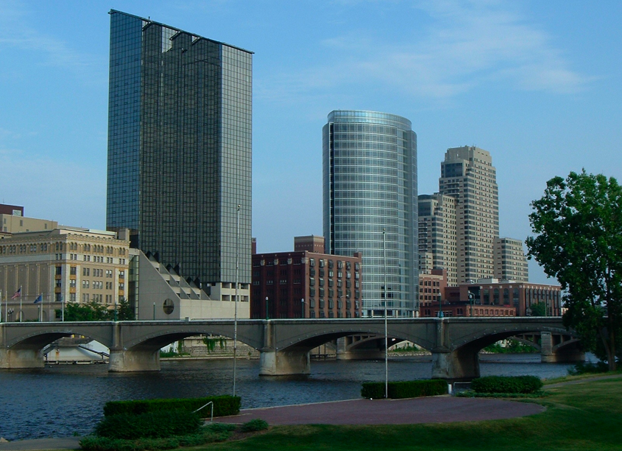

**jglcrm2015.com**