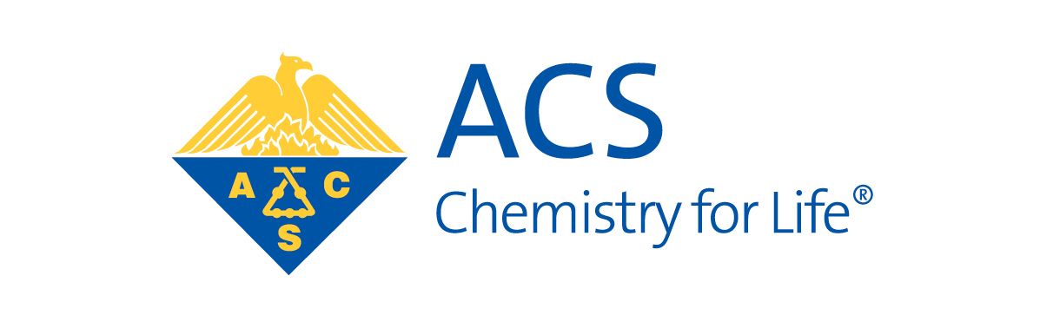

Dear Colleague:

On May 27-30 of 2015 the Great Lakes and Central Regions of the American Chemical Society have the privilege of hosting a Joint Regional Meeting at the Amway Grand Hotel and DeVos Place in downtown Grand Rapids, Michigan. Capitalizing on the interests in our geographic area, the three **focus themes** chosen for the meeting are **Food, Health, Environment**.

We would like to urge you to encourage your faculty and students to participate by organizing one or more symposia in any area of chemistry and/or based on one of our **focus themes,** andtoconsider presenting their research; these are wonderful ways to help your **students** in their professional growth, and your **junior and mid-career faculty** in the development of their professional networks. At our website <http://jglcrm2015.com> you will find a form for submitting symposium recommendations. Our co-program chairmen, Dr. James Kiddle at Western Michigan University ([james.kiddle@wmich.edu](mailto:james.kiddle@wmich.edu)) and Dr. Mark Thomson at Ferris State University ([markthomson@ferris.edu](mailto:markthomson@ferris.edu)), would be delighted to hear from you. Please check the website regularly for updates on the preliminary program, keynote speakers, and events that will make the Joint Great Lakes/Central Regional Meeting a Grand Enterprise.

Encompassing primarily the full states of Illinois, Indiana, Michigan, Minnesota, Ohio, North Dakota and Wisconsin this meeting offers affordable accessibility to faculty and students to present their research, hear lecturers of renown and to network with other science professionals. Our roster of speakers includes **Dr. Scott Denmark** of the University of Illinois in Urbana-Champaign, **Dr. Dustin Mergott** of Eli Lilly & Co. and **Dr. Joan Brennecke** of the University of Notre Dame.

We look forward to your cooperation for a successful meeting. If you would like to discuss this further, you may contact either of us by e-mail, or Lydia by telephone at 269-375-7349.

Lydia E. M. Hines, Ph.D. Neal M. Fox

[lemhwgh@gmail.com](mailto:lemhwgh@gmail.com) [nealmfox@comcast.net](mailto:nealfox@comcast.net)

Co-General Chairman Co-General Chairman

Kalamazoo Section ACS Western Michigan Section ACS

Great Lakes Region Central Region