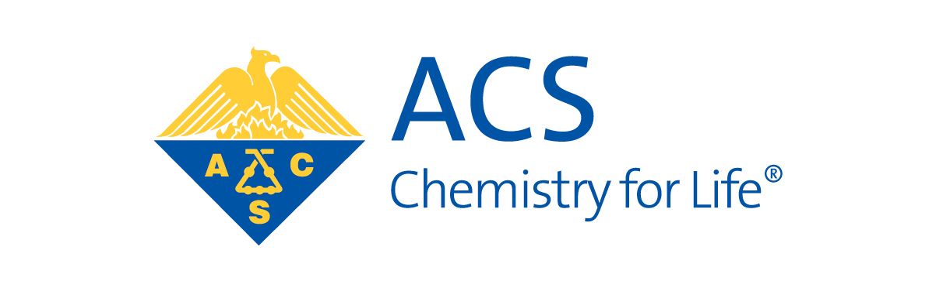

Dear Colleague:

On May 27-30 of 2015 the Great Lakes and Central Regions of the American Chemical Society have the privilege of hosting a Joint Regional Meeting at the Amway Grand Hotel and DeVos Place in downtown Grand Rapids, Michigan. Capitalizing on the interests in our geographic area, the three **focus themes** chosen for the meeting are **Food, Health, Environment**.

Encompassing primarily the full states of Illinois, Indiana, Michigan, Minnesota, Ohio, North and South Dakota and Wisconsin, this meeting offers affordable accessibility to ACS members to present their research, hear lecturers of renown and to network with other science professionals. Our roster of speakers includes **Dr. Scott Denmark** of the University of Illinois in Urbana-Champaign, **Dr. Dustin Mergott** of Eli Lilly & Co. and **Dr. Joan Brennecke** of the University of Notre Dame.

**Abstract submission** is now open (go to our website <http://jglcrm2015.com> ). We **urge you to encourage your colleagues** to participate by **presenting their research**; this is a wonderful way to help them in their professional growth and in the development of their professional networks. On our website you may also access the **Registration for the meeting**; there you will see that in addition to planned symposia we have poster sessions, social events as well as workshops available for your professional enrichment. Please check the website regularly for updates on the program, speakers, and other events that will make the Joint Great Lakes/Central Regional Meeting a Grand Enterprise.

We anticipate that our attendance will include a significant number of graduate and undergraduate students, and we will be hosting ACS’s Career Pathways with Resume’ Review. If you would like to **display/advertise at our exposition** you will find relevant information concerning sponsorship and costs at **our website under the “Expo” tab**. If you would prefer to sponsor an event or a symposium and not have a full display, such a donation to our program would also be welcome and would be recognized appropriately. Again, you may indicate your choice(s) on the form mentioned above.

We look forward to your cooperation for a successful meeting. If you would like to discuss this further, you may contact either of us by e-mail, or Lydia by telephone at 269-375-7349.

Lydia E. M. Hines, Ph.D. Neal M. Fox

[lemhwgh@gmail.com](mailto:lemhwgh@gmail.com) [nealmfox@comcast.net](mailto:nealfox@comcast.net)

Co-General Chairman Co-General Chairman

Kalamazoo Section ACS Western Michigan Section ACS

Great Lakes Region Central Region