**How to Set up DBeaver MongoDB Integration?**

Setting up DBeaver MongoDB Integration is a three step process. You can use a JDBC or ODBC Driver to set up DBeaver MongoDB Integration. For the purpose of this tutorial, we are going to use **Devart ODBC Driver** to connect to a MongoDB database from DBeaver Community Edition. Follow the steps given below to build the DBeaver MongoDB Integration:

**Step 1: Install the ODBC Driver**

The first step involved in setting up DBeaver MongoDB Integration involves installing the ODBC Driver.

* Click[here](https://www.devart.com/odbc/mongodb/download.html) to download the Devart ODBC Driver.
* Open the Downloads section of your browser and run the Installer for ODBC Driver.

[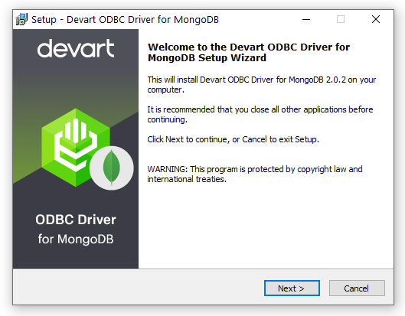](https://www.devart.com/odbc/mongodb/docs/installationwizard.png)

[Image Source](https://www.devart.com/odbc/mongodb/docs/dbeaver.htm)

* You will receive a warning if you already have the specified installation folder on your PC or if another Driver version is installed. Click on **Yes**to overwrite the old files with the current installation; however, it is recommended that you first completely uninstall the previous driver version before installing the new one.
* On the **Select Components** page, you can choose the driver based on your systems architecture(**32 bit or 64 bit**).

[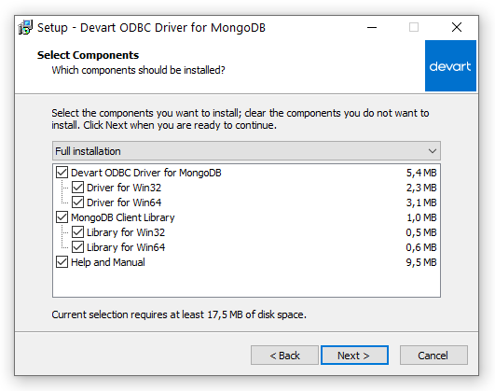](https://www.devart.com/odbc/mongodb/docs/installation-components.png)

[Image Source](https://www.devart.com/odbc/mongodb/docs/dbeaver.htm)

* Select the License Type and activate the product in the **License Information** dialogue box. If you do not have an activation key, you can choose **Trial** and use the driver for testing purposes.
* Click on**Next**and then install the ODBC Driver.

**Step 2: Create an ODBC Data Source**

Once the installation is complete, you need to configure the ODBC Driver by creating a **DSN (Data Source Name)** for MongoDB in the ODBC**Data Source Administrator**. It will help you to leverage MongoDB data in DBeaver and build the DBeaver MongoDB Integration. Follow the steps given below to do so:

* Navigate to the Search box of your workstation and type **ODBC Data Sources** and then select the ODBC Data Sources application that matches your system’s architecture(**32 bit or 64 bit**).
* Select **System DSN** if you want to configure a DSN name for all system users, or **User DSN** if you only want to configure DSN for your account.
* Now, select **Devart ODBC Driver for MongoDB** and then click on the **Finish** button.
* Fill in the Connection Information in the respective fields and click on the **Test Connection**button to test the connectivity.
* Once you have properly configured the DSN, click on the **OK** button to save the DSN.

[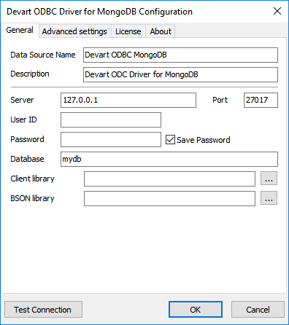](https://www.devart.com/odbc/mongodb/docs/connection_settings_mongo.png)

[Image Source](https://www.devart.com/odbc/mongodb/docs/dbeaver.htm)

**Step 3: Connecting to MongoDB Data from DBeaver**

* Navigate to the **Database** menu and select the **New Database Connection** option.

[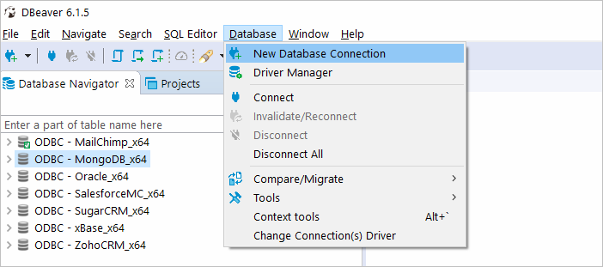](https://www.devart.com/odbc/mongodb/docs/dbbeaver_new_db_connection.png)

[Image Source](https://www.devart.com/odbc/mongodb/docs/dbeaver.htm)

* Select **ODBC** in the **Connect to Database** Wizard and then click on **Next**.

[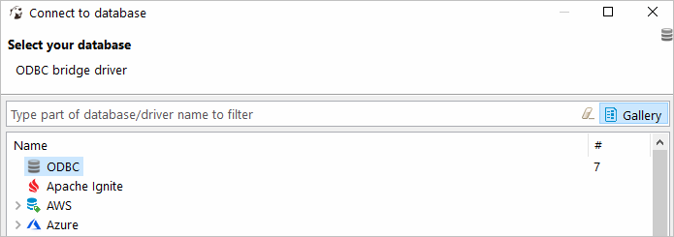](https://www.devart.com/odbc/mongodb/docs/dbeaver_select_odbc.png)

[Image Source](https://www.devart.com/odbc/mongodb/docs/dbeaver.htm)

* In the**Database/Schema** field, enter the previously configured DSN.

[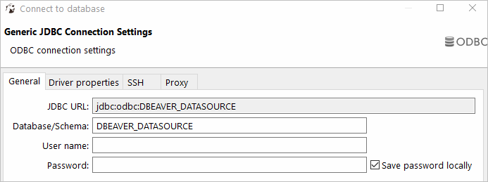](https://www.devart.com/odbc/mongodb/docs/dbeaver_odbc_connection_settings.png)

[Image Source](https://www.devart.com/odbc/mongodb/docs/dbeaver.htm)

* Once you have filled all the appropriate fields, click on **Test Connection** to build the DBeaver MongoDB Integration. Once everything is configured successfully, you will see a**successful connection** message on the screen.