Abstract

A number of recent studies have focused on the important issue of experimental design in fMRI, including our earlier work using a genetic algorithms. These papers focus on measures of design efficiency. Efficiency is closely related to experimental power, but several additional steps must be taken before efficiency can be translated into whether a design is “good enough”. However, given a reference signal to noise ratio, efficiency can be translated into experimental power. (Zarahn). In this paper, we extend our earlier work on optimization of experimental designs (Wager & Nichols) to provide measures of experimental power. We extend Zarahn’s earlier work to encompass power estimates at the individual subject and the group levels. Finally, as the validity of power analysis depends on the accuracy of the reference effect size, we provide reference effects from different task paradigms in four experiments: a visual-motor event-related experiment, a bimanual event-related motor experiment, a saccade experiment, and an emotion experiment. We can obtain valid reference effects for each of these experiments because there are clear a priori regions of interest within which to find experimental effects. Software for power estimation, incorporating our estimated reference effects, is integrated into our existing optimization software and made publicly available.

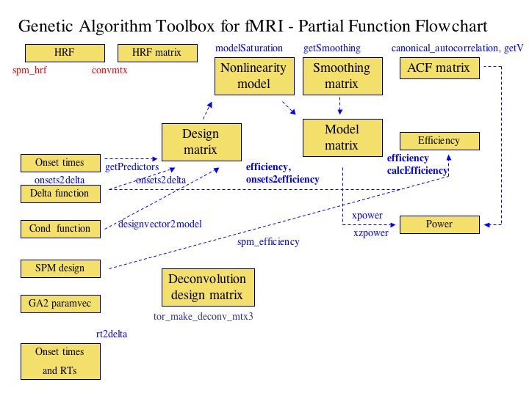

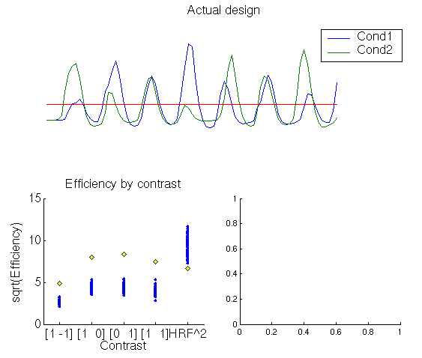
This is the first of two plots from onsets2efficiency.m. It shows a plot of the design matrix (top panel) and the square root of efficiency (bottom left) for each contrast in the design and for the HRF (squared for scaling purposes, rightmost column). The yellow diamond shows the target design, and blue dots shows a population of 100 random designs with the same experimental parameters. The file containing the input design is leftRhtSac, and the variable is sac. See example_script_onsets_to_power.m to get started!
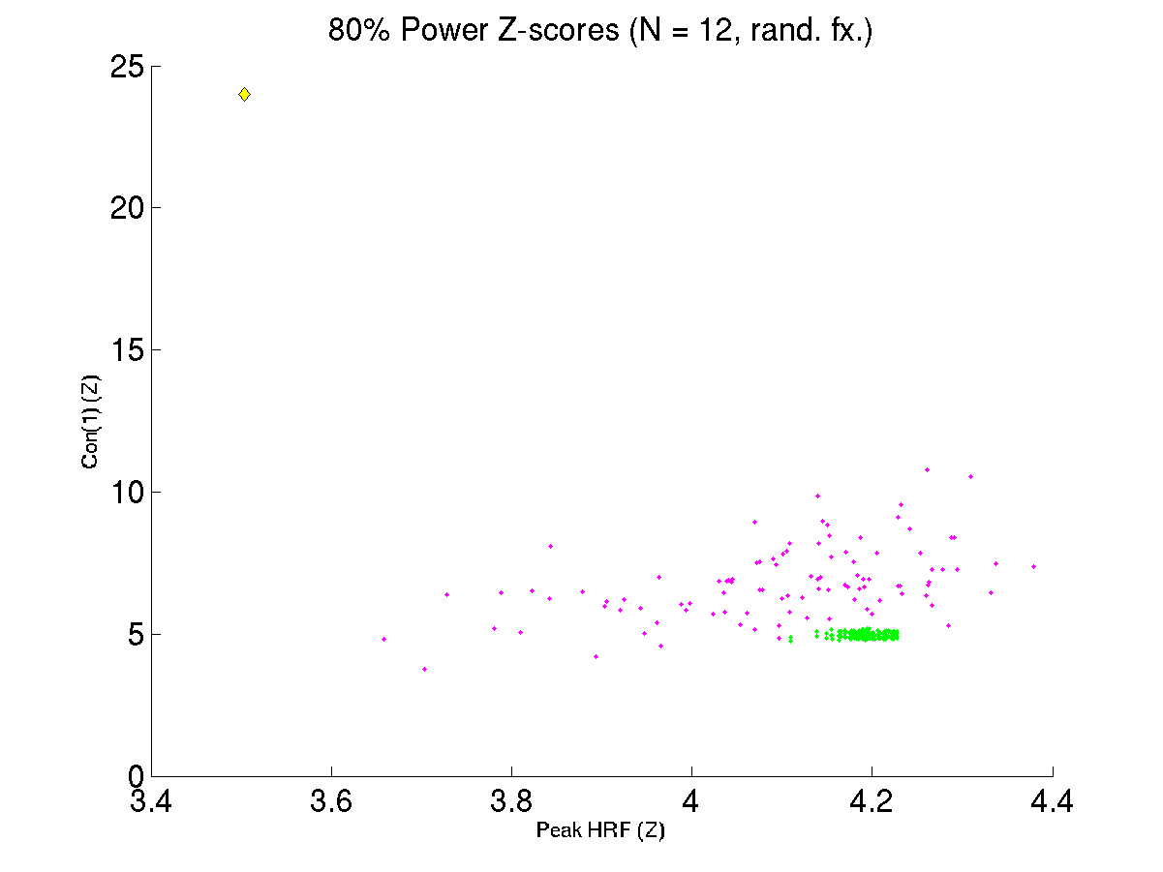
This figure shows the bivariate power (80% probability of achieving this Z-score in a random-effects analysis) for contrast estimates ([1 –1], y-axis) and for estimation of HRF shape (testing the HRF value at it’s expected peak against zero). The yellow diamond is a block design (approx. 32 s periodicity?), the magenta dots show random designs, and the green dots show results of truncated m-sequences. The question here is how some random designs can do better than m-sequences?

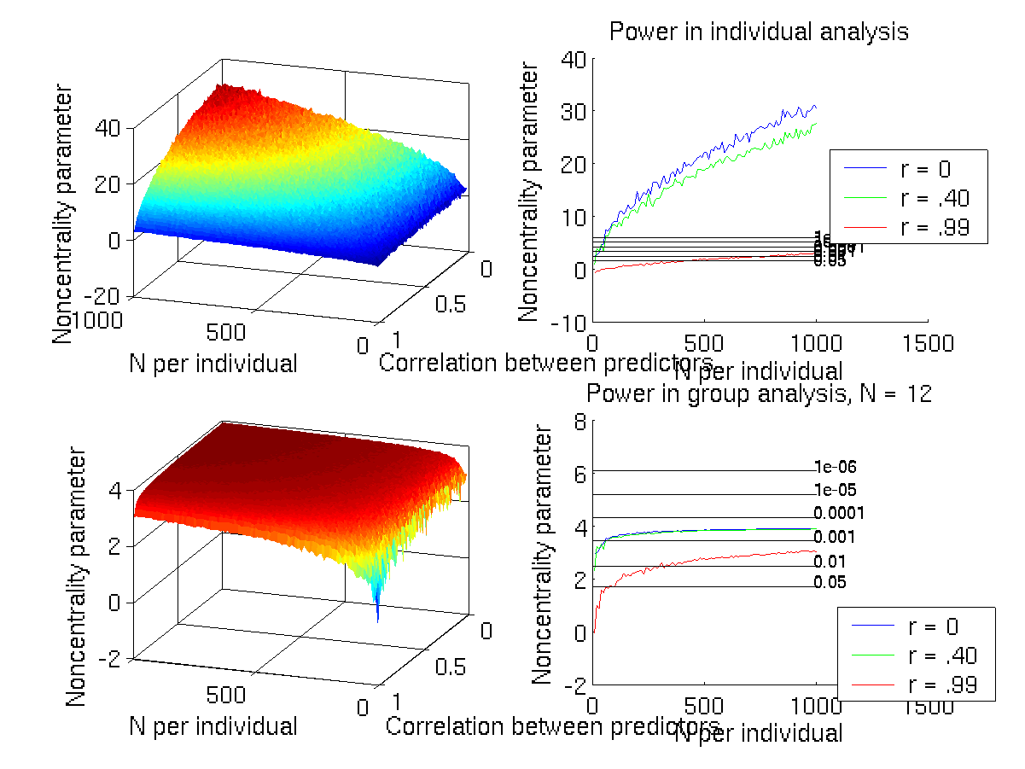
This plot shows power in the individual subject analysis (top panels) and group random-effects analysis (bottom panels) as a function of correlation between predictors and length of experiment (number of images collected). The group power level is limited by the true inter-subject variance, which is one of the inputs into the model (chosen by default if not specified in xpower.m and xzpower.m). The power seems high at r = .99 (severe multicolinearity!) although I think this is the correct prediction. This plot was created with power_map1.m.

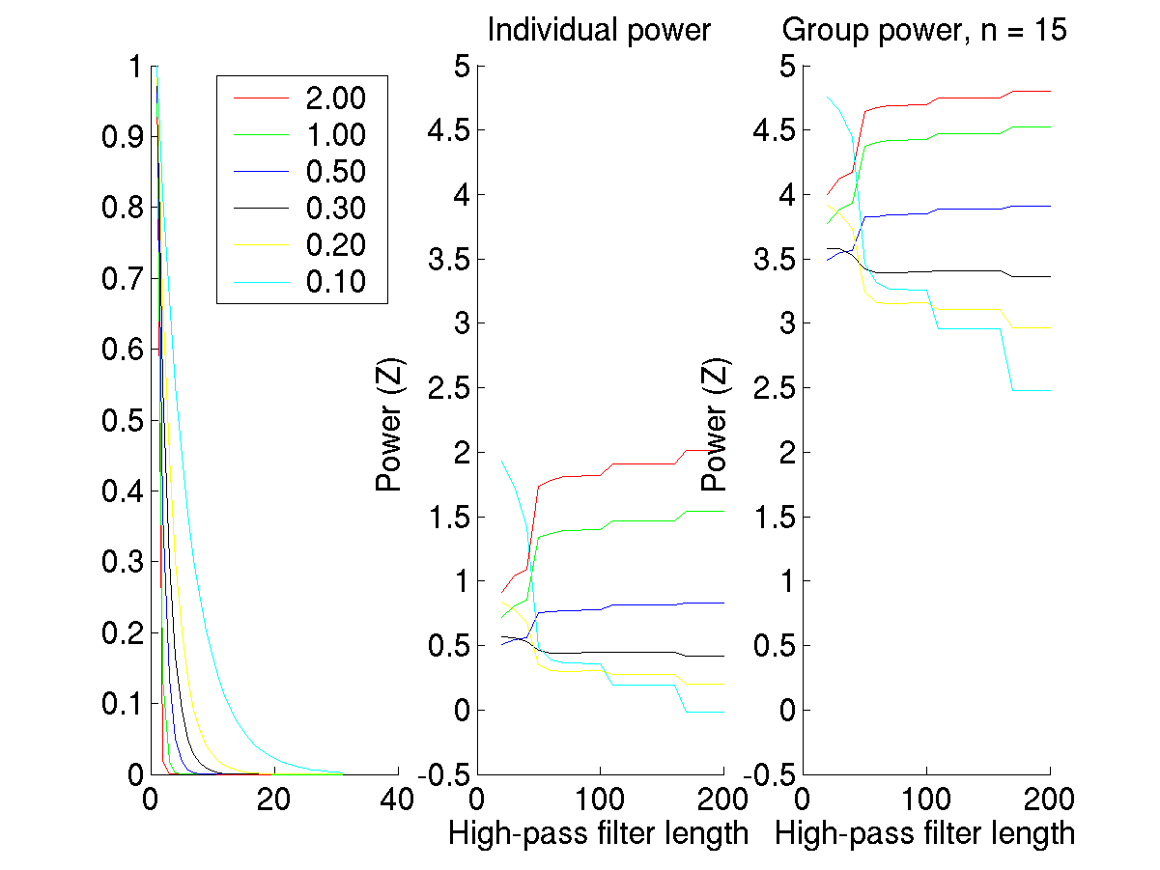

The plot above shows different autocorrelation functions (left) and power estimates for individual (center) and group (right) analyses as a function of high-pass filter length (s) and autocorrelation. The code for creating this plot is below. The expectation is that power will follow a u-shaped function at least sometimes, particularly when autocorrelation is high. With no autocorrelation, the filtering should remove as much or more design variance as noise variance, producing no increase in power. With high autocorrelation, the filter should remove more low-frequency noise, increasing power in the design. These results are never u-shaped! Very high power at high autocorrelations with lots of filtering (short filter length) should also not happen! The cyan line should be below the others always, I think.

TR = 2; hrf2 = spm_hrf(TR) ./ max(spm_hrf(TR));
HP = 20:10:200; acfscale = [2 1 .5 .3 .2 .1];
[Xactual,delta,delta_hires,hrf] = onsets2delta(sac,TR);
dhr = getRandom(delta_hires);
[tmp,d] = downsample_delta(dhr,16*TR); X=getPredictors(d,hrf2);
X(:,end+1) = 1;
[allxc,allip,allgp] = hp_filter_plot(HP,acfscale,X,TR);

To compare the “full simulation” with the statistical theory versions of power calculations, use the following instead. Those plots shown below. This indicates an additional problem. The individual plots match well for xpower and xzpower, but the group ones do not, indicating that there is something wrong with one of the group ways of calculating power (probably the theoretical one, xpower.m). I think the group estimates for simulated power using the Monte Carlo (xzpower.m) are shifted down a constant couple of whole values for the whole set of various autocorrelation and filter combinations.
[allxc,allip,allgp] = hp_filter_plot(HP,acfscale,X,TR,1);

Additional issues:

- I don’t think smoothing is taken into account in degrees of freedom calculation
- The formula from Zarahn’s paper and Friston to smooth or not has different formulae, I think, and the difference is that autocorrelation is V V’ or something in Z’s, but V only in Friston’s. I think the matrices are defined so that in Z’s way, the matrix is the square root of the Friston V matrix, but I want to be sure to get this right, and input the right matrix!
- The high-pass filtering just doesn’t seem to work the way I think it should!
- Something about the group intersubject variability estimate is probably off, because my theoretical and simulated results don’t match

