COVIPER pre-processing (see Fig. 1)

- Step 1: Use EC and motion correction toolbox to correct EC and motion artefacts for blip-up and blip-down data. The EC and motion corrected images will have a prefix “r”.
- Step 2: Use fieldmap or DiSCo toolbox to unwrap the registered blip-up and blip-down data (the voxel-displacement map has to be applied to each DTI image. The unwarped images will have a prefix “u”.
- Step 3 (only for fieldmap-based susceptibility correction): To refine the overlap between blip-up and blip-down DTI data, perform another 12-parameter affine registration (e.g. using spm_realign) between unwarped blip-up and blip-down image (use e.g. the first in each DTI data series). The registered images will have another prefix “r”.

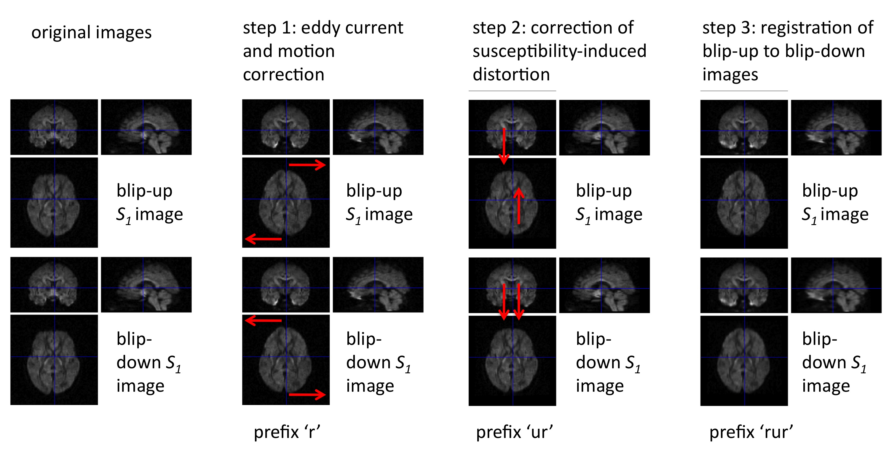
Fig. 1: The pre-processing steps for the COVIPER toolbox. For details see text.

Use COVIPER:
- Define in matlab the bvecs (3xN matrix) and bvals (1xN vector) variables before running the COVIPER toolbox, where “N” is the number of images in the DTI sequence. The “i-th” bvec column and bval component must correspond to the vector of the diffusion gradient and the b-value of the “i-th” image in the DTI dataset. If the b-value for the low-b-value images is unknown, type b=1, and if the diffusion gradient direction is unknown, type a random direction, which is normalised to 1.
- Load pre-processed blip-up und blip-down images, the bvecs, and bvals (defined in previous step).

Referencing
Please cite the following paper when using this toolbox:
Mohammadi S, Nagy Z, Hutton C, Josephs O, Weiskopf N. Correction of vibration artifacts in DTI using phase–encoding reversal (COVIPER). Magn Res Med 2012; 68: 882–889; doi: 10.1002/mrm.24467.

