Introduction
This FA-VBS Normalisation toolbox is preparing DTI data for VBM-style voxel-based statistics (VBS) of FA images (FA-VBS). It uses the “Statistical Parametric Mapping” (SPM8) package, a widely used software for analysing neuroimaging data (http://www.fil.ion.ucl.ac.uk/spm) written in MATLAB (version 7.1; Mathworks, Natick, MA, USA). It is based on the spm_normalise algorithm (Ashburner et al., 1999).

FA-VBS pre-processing
- Prior to estimation of normalization parameters, the images must be affine registered to the EPI template (e.g. via coregistration to the EPI template provided by SPM). The toolbox provides an initial import routine (Images2MNI) which uses mutual information coregistration to register the individual b0 images to the SPM EPI template using a 12-parameter affine transformation (Note that a 12 parameter transformation at this stage might be too much. To be sure that this step worked, have a look on the data.). Images2MNI also allows to apply the estimated transformation parameters to the corresponding FA images, averaged diffusion weighted image (meanDWI, as provided by the Tensor fit algorithm) and to other images of each subject as well (using the option “other images”).

Use FA-VBS:
- Select pre-processed FA images
- Select pre-processed b0 image (b0 = low-dffiusion weighting).
- Select mean over all diffusion-weighted images (this image will be automatically generated by the “Fit Diffusion Tensor” tools with the prefix: “meanDWI”).
- Select, whether you need to generate an FA and b0 template (customized template, see additional information: Template generation).
- Choose the contrast, by which the normalisation is driven. (We recommend b0(1), FA(2)).
- Choose the number of iteration (default: 2).
- Chose the Brain Mask parameter used for the FA-based normalisation (see additional information: Brain Mask parameters).

Additional information

Template generation
The customized template is recommended before starting a new study, because the customized template accounts for the specifics of each normalisation approach (e.g. brain tissue mask for the FA based normalisation).
Note that if you choose the customized template option, we do not recommend using multi-step normalisation (see Fig. 1 for what can go wrong). To use the multi-step normalisation, the recommended procedure is to first generate a customized template and then re-run your normalisation procedure using the “external template option”. For example, to use the multi-contrast normalisation (b0 + FA) you do first an FA-based normalisation using the “customized template” option, and then use the generated FA template (prefix “FA-template”), and based on the same normalised data calculate a mean b0 image. Finally, smooth the FA-template and the averaged b0 image (recommended 8 mm isotropic FWHM). These images you can use now as external b0 and FA template.
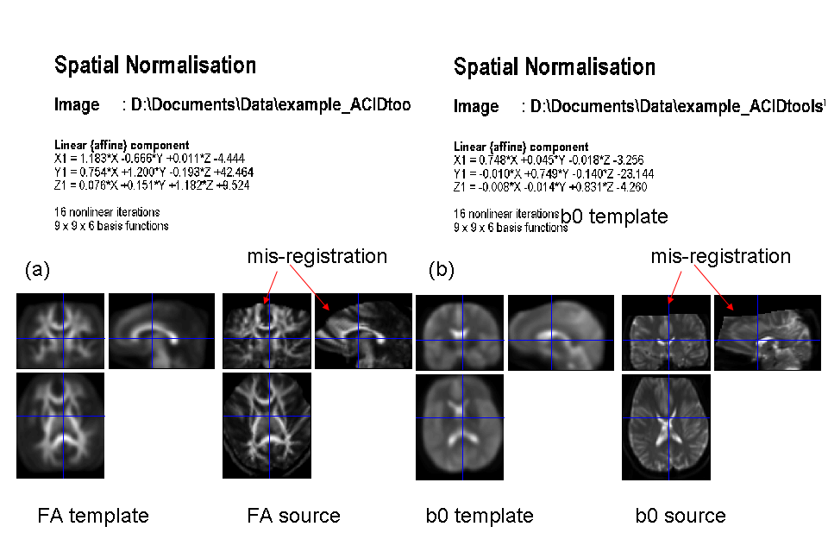
Fig. 1: What can go wrong if FA template is manually generated (from FA images, which still include the skull). For this example a multi-contrast normalisation was used (b0+FA).

Masking Parameter

Brain Mask parameter depends on signal-to-noise ratio of the DTI datasets and brain coverage of the field of view. To find the appropriate Brain Mask parameter, run the toolbox with for a small set of subjects (e.g. 3-5) and choose different parameters.
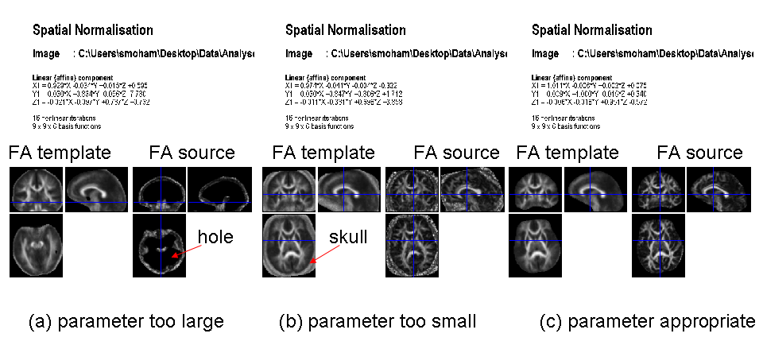
Fig. 2: Choice of Brain Mask parameter. An inappropriate parameters can lead to wholes in the brain (a) or to inclusion of the skull (b), whereas the appropriate parameter will remove the skull but leave the brain tissue.

Developer
- Volkmar Glauche
- Siawoosh Mohammadi (contact: Siawoosh.mohammadi_at_ucl.ac.uk)

Referencing
Please cite the following paper when using this toolbox:

Mohammadi S, Keller SS, Glauche V, Kugel H, Jansen A, et al. (2012) The Influence of Spatial Registration on Detection of Cerebral Asymmetries Using Voxel-Based Statistics of Fractional Anisotropy Images and TBSS. PLoS ONE 7(6): e36851. doi:10.1371/journal.pone.0036851

