# BACKGROUND ON WIRELESS MESH NETWORKS

Wireless Mesh Network (WMN) is multi-hop wireless networking type, designed as an alternative to traditional centralized wireless networking achieved by mesh routers [1]. Mesh routers and mesh clients form up WMNs. Each mesh node functions as a host and also as a router, relaying packets on behalf of other nodes, connecting nodes that are not located within the transmission range of each other. WMNs create ad-hoc networks, which are dynamically self-organized and self-configured. WMNs are easy to deploy and cost-effective systems, they are easy to maintain and provide robustness and reliable service coverage.

WMNs comprise of two types of nodes: mesh routers and mesh clients. A wireless mesh router provides mesh networking by using routing functions that do not exist in common wireless routers with gateway/repeater capabilities. Mesh routers have multiple wireless interfaces to expand flexibility of WMNs. Mesh routers in WMNs achieve wider coverage compared with conventional routers by using multi-hop technology with lower transmission power. Moreover it is possible to postulate improved scalability by optimizing the medium access control (MAC) protocol in a mesh router.

## Network Architecture

Three main groups depending on operation of the nodes could accomplish the categorization of WMNs.

*Infrastructure/Backbone WMNs:* The architecture is shown in Figure 1. Both wireless and wired networks comprise infrastructure WMNs, in Fig. 1 dash lines depict wireless connections whereas solid lines depict wired communications. Mesh routers establish an infrastructure to mesh clients to connect. The infrastructure is a cloud from the clients’ point of view. It is a black box that delivers packets originated from the clients to the gateways.

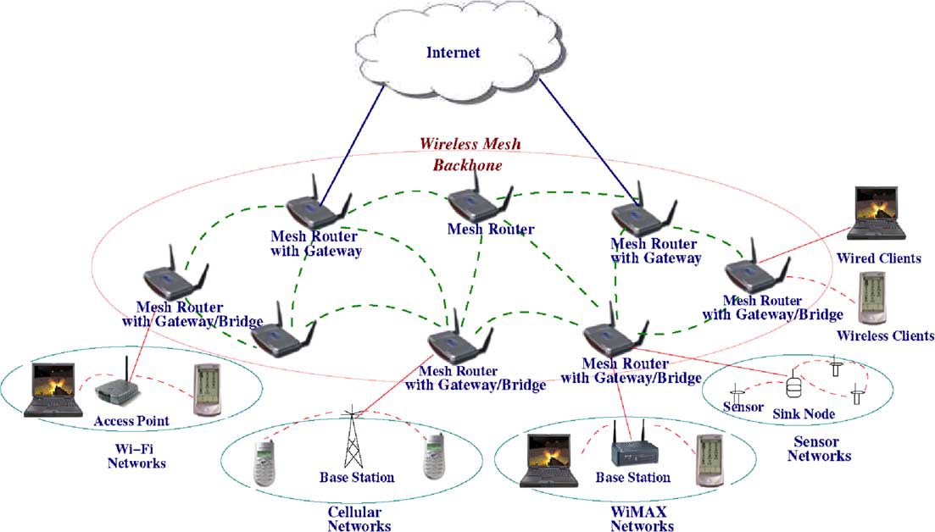

Figure 1. Infrastructure/backbone WMNs. [1]

The mesh routers are self-configured and self-healing. In a case of node addition or removal, mesh backbone configures itself by forming up neighborhood. Additionally, mesh routers could connect to the Internet with gateway functionality. Infrastructure meshing provides easy to access to Internet by forming up clouds for clients. Bridging and inter-networking functionalities of WMNs enable clients to connect to mesh backbone with conventional Wi-Fi or cellular devices and also via Ethernet links. As depicted in Figure 1 base stations could also connect to mesh backbones, which provides Internet connectivity for all the clients of base stations.

*Client WMNs:* Client meshing is a subset of Infrastructure meshing. As previously explained mesh routers establish a backbone for mesh clients, however in client meshing case the whole network is a backbone and whomever wants to join to the network has to be a part of the backbone and provide routing functionality. As shown in Figure 2 client meshing is a commune type of networking.

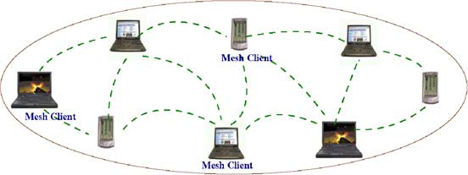

Figure 2. Client WMNs. [1]

In Client WMNs packet delivery is operated via multiple hops from the originated user until the destination. Nodes in Client WMNs usually operate with one type of radios. Consecutively the requirements of the mesh clients are increased in the case of client meshing.

*Hybrid WMNs:* This architecture is combination of two previously explained mesh architectures. Mesh clients can access Internet through mesh backbone whereas they can communicate within each other by using a simple ad-hoc network.

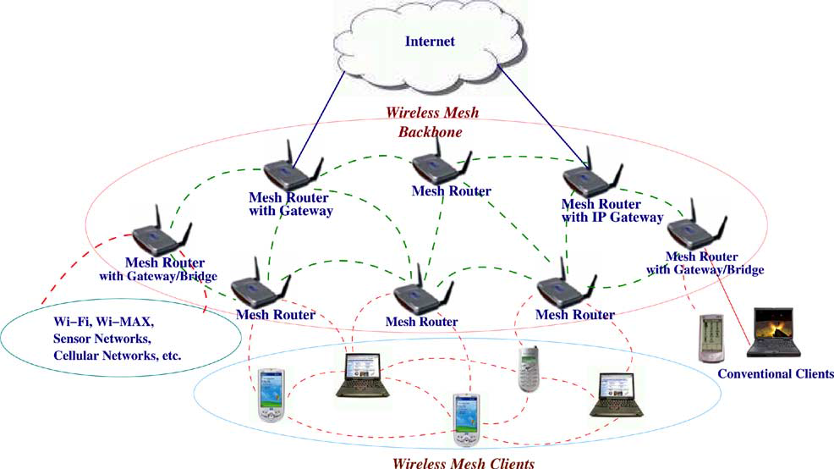

Figure 3. Hybrid WMNs [1]

As shown in Figure 3 mesh backbone provides Internet connectivity whereas Client WMNs provide connectivity to mesh backbone for far located mesh clients.

## Characteristics of Wireless Mesh Networks

Characteristics of WMNs are explained as follows:

*Multi-hop Wireless Network:* Main accomplishment of WMNs is providing extended wireless network coverage without increasing transmission power or additional antennas.

*Support for Ad-hoc Networking:* WMNs provide flexible networking, which has the abilities like self-configuring and self-healing. Deployment, node addition and removal are easy to accomplish since mesh routers form routing paths by themselves.

*Mobile Dependence on the Type of Mesh Nodes:* Mesh routers usually do not change their locations, whereas mesh clients are assumed to be mobile.

*Multiple Types of Network Access:* Mesh routers are accessible via IEEE 802.11 protocols and also peer-to-peer protocols. WMNs could be bridged with other types of wireless mesh network.

*Dependence of Power-Consumption Constraints on the Type of Mesh Nodes:* Mesh routers do not have power-consumption constraintsin common but it is advisable for mesh clients to have some forms of power consumption constraints.

*Compatibility and Interoperability with Existing Wireless Networks:* WMNs are compatible with IEEE 802.11 protocols [2,3], therefore WMNs could support for both mesh purposes and also conventional Wi-Fi connections. WiMax [4], ZigBee [5] and cellular networks could also inter-connect with WMN structure.

# References

1. Akyildiz, I. F., Wang, X., and Wang, W. (2005) Wireless mesh networks: a survey, *Computer Networks and ISDN Systems*, 47(4): 445-487.
2. Intel Inc., Multi-Hop Mesh Networks—a new kind of Wi-Fi network.
3. J. Walker, Wi-Fi mesh networks, the path to mobile ad-hoc. Available from [http://www.wi-fitechnology.com/ Wi-Fi_Reports_and_Papers/Mesh_Networks_References.html](http://www.wi-fitechnology.com/%20Wi-Fi_Reports_and_Papers/Mesh_Networks_References.html).
4. Vaughan-Nichols S.J., (2004) Achieving wireless broadband with WiMax, *IEEE* *Computer*, vol. 37, no.6, pp. 10-13.
5. The ZigBee Alliance. Available from: <http://www.zigbee.org>.