Project: Market Analysis Report for National Clothing Chain

- What is the correlation (R2 value) between sales and income?

The correlation between Sales and Income is 0.78.

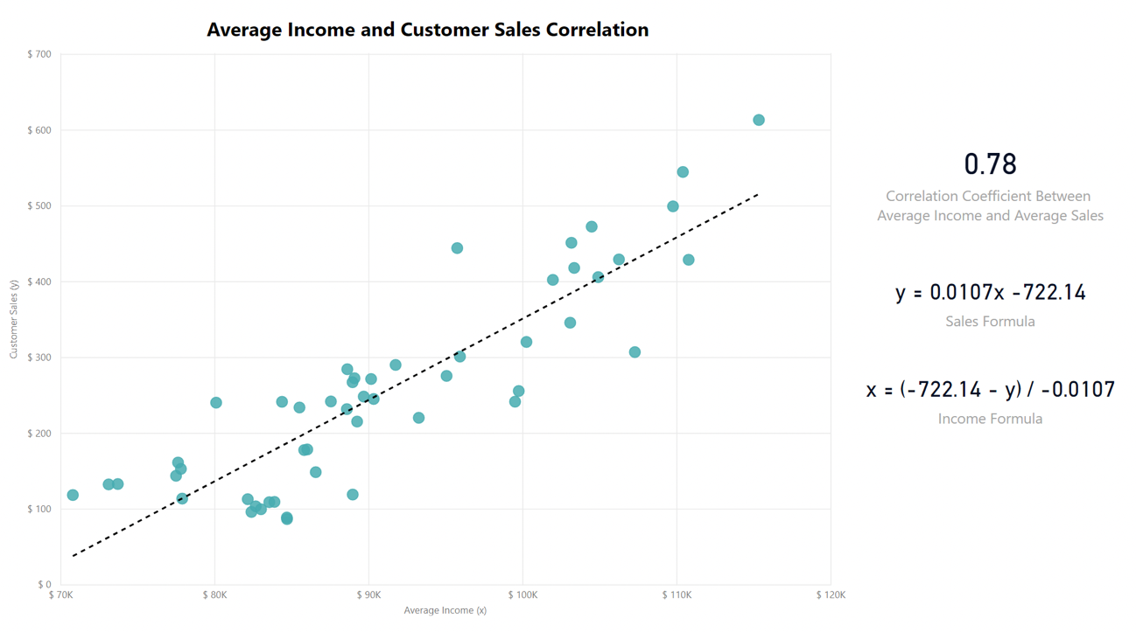

- What is the correlation (R2 value) between customer ratings and product return rate?

The correlation between Customer Ratings and product return rate is -0.83, which means that the return rates decrease when customer ratings increase.

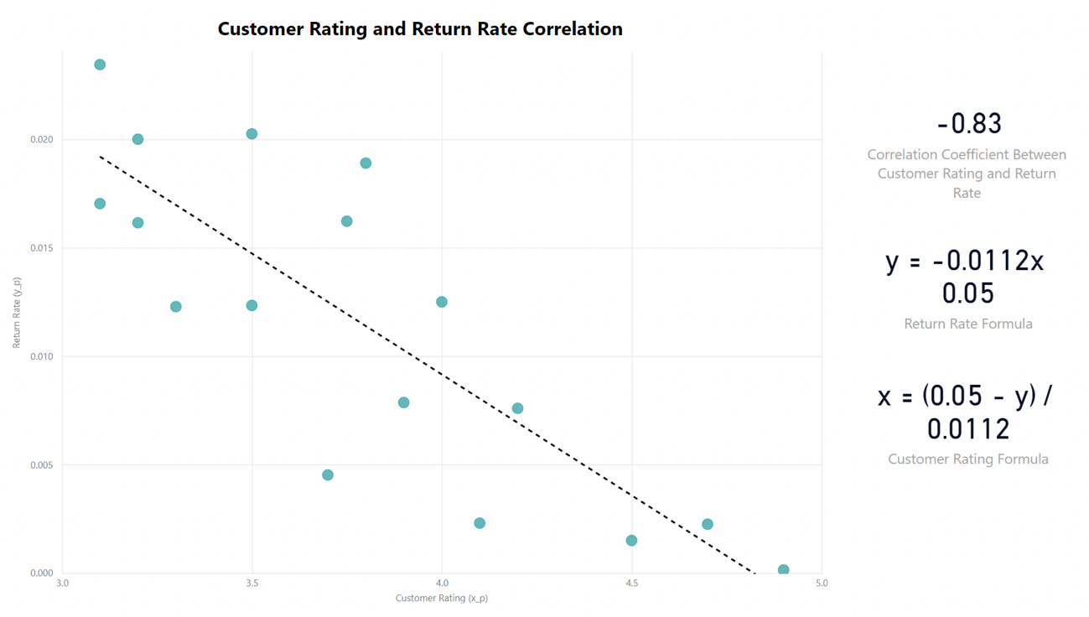

- What are the linear regression formulas to predict customer sales and customer incomes?

Sales Formula -> y = 0.0107x - 722.14
Income Formula -> x = (-722.14 – y) / -0.0107

- Which customer do you predict has the highest income?

The customer with the highest income is Jon Little, who made $5250 worth of purchases in the last 6 months, and his predicted income is $558143,93.

- Which product will be advertised the most?

The most advertised product is going to be the sweater with a $100 price. It is going to be recommended to 660 customers, representing 66% of the total.

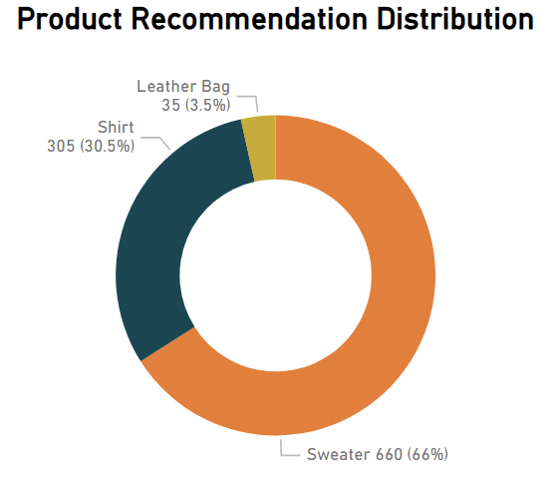

In addition to that, the chronograph watch has tremendous sales potential because it has the best customer rating and the lowest return rate of any product. According to its $350 price and stock of 65 units, it has the potential to make $22k in sales.

