A Framework for using Building Energy Data to Validate Urban Building Energy Models using FAIR principles
By: Jessica Webster, Brett Korteling, Ekaterina Alekhanova, Maya Papineau
Keywords
Urban building energy model validation; building energy field data; data access
Abstract
Urban building energy model (UBEMs) are increasingly used by municipalities to design housing retrofit programs to reduce greenhouse gas emissions, however a growing literature identifies shortfalls in energy model accuracy as barriers to cost-effective retrofit investments. The Canadian Energy End-use (CEE Map) UBEM model was developed for Kelowna, British Columbia to support low-rise residential retrofit planning. To assess CEE Map model accuracy, measured electricity and natural gas data from the local utility were used in an empirical validation test of the model’s energy consumption predictions. Using the Kolmogorov-Smirnov (K-S) test, we compare metered versus modelled consumption distributions. We find statistically significant differences between predicted and actual energy use across all dwelling types and vintages. A combined Normalized Mean Bias Error (NMBE) of ~-30.8% indicates significant consumption overestimation in the model. Single Detached dwellings have a bias of ~-11.2% for natural gas use and ~-39.2% for electricity. Duplex/Row dwellings showed the highest bias at ~-98.9% and ~-96.1% for electricity and natural gas respectively. These findings underscore the importance of calibrating and validating UBEMs using measured energy consumption, particularly as governments, utilities, and industry stakeholders increasingly rely on these models to plan housing retrofit strategies to address climate change mitigation and address housing affordability. To advance modeller access to Findable Accessible Interoperable and Reusable (FAIR) anonymized dwelling-scale distributions of measured energy data, workflows and scripts are made available as open source. Development of comprehensive heating fuel type data and reconciliation of building, unit and meter counts are areas identified for future research.
Acronyms
AF, Assessment Fabric; B.C., British Columbia; BCA, BC Assessment Authority; BIR, Building Information Report; BEM, Building Energy Model; Community Energy and Emissions Inventory; CEE Map, Canadian Energy End-use Mapping Project; CVRMSE, Coefficient of Variation of the Root Mean Squared Error; DHW, Domestic Hot Water; EBIR, Enhanced Building Information Report; EPC, Energy Performance Certificate; FAIR, Findable, Accessible, Interoperable, Reusable; FME, Feature Manipulation Engine; G.I.S., Geographic Information System; GJ, Gigajoule; K-S, Kolmogorov-Smirnov; kWh, kilowatt-hour; MH, Mobile Home; MU, Multi-Unit Residential Building; NMBE, Normalized Mean Bias Error; NRCan, Canadian Ministry of Energy and Natural Resources; PE, Percentage Error; SD, Single Detached; SH, Space Heat; SHEU, Survey of Household Energy Use; TaNDM, Tract and Neighbourhood Data Modelling; UBEM, Urban Building Energy Model; VHL, Virtual Home Labelling.

Introduction
Canadian municipalities are at the forefront of energy and climate action by developing local climate action plans, infrastructure projects and more recently, delivering housing energy retrofit programs. Community energy planners undertake or collaborate on research and development projects to develop emissions models that support long-term projections, evaluate trade-offs, and identify priority actions for energy plans and programs. To support municipal energy and climate decision-making, a variety of stakeholders from the public, private and academic sectors have developed spatial urban building energy models (UBEMs) and higher-level quantitative assessment tools [1], [2], [3]. More recently, virtual home labelling (VHL) platforms are being developed to support virtual labelling of homes in collaboration with municipalities [4]; typically spatialized and based on UBEMs, VHL platforms are incorporating big data and machine learning techniques and leveraging citizen science by engaging residents to confirm mechanical systems, occupancy and other variables influencing energy use. Community energy planners point to the need for further research on measuring the effectiveness of data and decision support tools to enable cost-effective energy transition planning, including VHL [5]. In this context, the question of UBEM model accuracy, together with reliable program outcome metrics, is critical to ensuring stretched municipal dollars can achieve optimal operational greenhouse gas (GHG) savings while maintaining affordable energy costs for households. Ultimately, occupants making retrofit decisions require accurate information to make welfare-enhancing investment decisions. Access to FAIR (Findable, Accessible, Interoperable and Reusable) building energy data for calibration and validation is key to UBEM accuracy, but remains an area under development in Canada [6], [7].

This paper develops and implements a validation method to evaluate to which extent the Canadian Energy End Use Mapping (CEE Map) model, a UBEM funded by the Canadian federal government, matches realized energy consumption by dwelling type, building vintage and energy source. The validation is conducted based on distributions of energy performance among housing archetypes for simulated versus actual energy consumption. Most importantly, our methodology embeds Findable Accessible Interoperable and Reusable (FAIR) data principles by providing an open-source approach for accessing privacy-compliant distributions of metered electricity and natural gas data. To our knowledge, this is the first example of a UBEM validation exercise using customer-level data consistent with FAIR data principles that includes all natural gas and electric low-rise residential utility customers across a city in Canada, with distributions of anonymized individual metered data grouped by dwelling type and vintage.

Prior studies have validated UBEMs typically using only one energy source such as electricity, natural gas or heat consumption [8] in isolation rather than a holistic set of sources in a given community; Another common approach is validating results using aggregated consumption data, such as postal code level consumption data [9], [10] or estimated provincial-scale survey data [11]. A limited number of studies demonstrate improved metered data access at the building scale for validation purposes however do not disclose how the data was accessed [12] [13].
The rest of our paper is organized as follows. In Section 2, we survey the building energy modelling (BEM) and UBEM literature, describe the challenge of unobserved heterogeneity and characterize the research gap and unique contribution of this study. In Section 3 we present the modelled and metered data used and literature-informed validation methods employed. In Section 4 we discuss the results and the study’s limitations. In Section 5 we conclude and offer recommendations to improve data quality towards enabling modeller access to fit-for-purpose data for UBEM calibration and validation.

Study Setting and Literature Review

Case Study Location
The City of Kelowna is in British Columbia’s (B.C.) south-central Okanagan Valley on the east shore of Okanagan Lake. With 3,715 heating degree days, the area falls in the National Energy Code for Buildings (NECB) Climate Zone 5. In 2021, it had a population of 144,576. 2021 property assessment records show 31,751 buildings and 72,551 units, including 58,253 residential dwellings (37,599 low-rise and 20,654 high-rise), 9,262 commercial and institutional, 4,115 mixed-use properties and 921 industrial buildings. In 2019, the City sought to understand the energy and GHG profile of its low-rise housing stock to inform its Community Energy Retrofit program [14]. A key question was, “which energy efficiency measures are most cost-effective in what dwellings, where?” In response, Natural Resources Canada (NRCan), via the Canadian Energy End-use Mapping (CEE Map) project, developed the CEE Map Model using property assessment data, building permits and housing energy modelling [15]. City staff and policymakers contemplating CEE Map compared to other UBEM offerings requested an analysis of its accuracy.

Prior literature
Previously, the CEE Map project reviewed UBEMs [15], helped develop reporting guidelines for building stock energy models [16] and applied them to assess energy mapping applications [1]. The project investigated the building energy mapping domain [17] and sponsored a standards-based testbed on building energy data interoperability [18]. A paper leveraging buildings data accessed from the City of Kelowna for CEE Map [11], developed a standards-based UBEM however validation was completed using provincial scale survey data; the approach presented here significantly improves on the spatial resolution of measured data for validation purposes. The measured data was accessed via the TaNDM research initiative, sought to improve the quality, structure and spatial resolution of B.C.’s Community Energy and Emissions Inventory (CEEI) reports [19]. TaNDM integrates parcel and building data which is then matched to individual meters spatially by the utility’s GIS department. These metered energy use data are then aggregated using spatial data automation techniques to produce privacy compliant building energy reports at the neighbourhood and city-wide scales. The TaNDM inventory method is described in a related working paper and a public GitHub repository [20] hosts the complete method for developing inventories in addition to the validation method scripts and Feature Manipulation Engine (FME) workspaces. Literature on BEM and UBEM validation informs our approach and supports identification of the research gaps and unique contributions of this study.
Judkoff et al. [21] describe three types of BEM validation: 1. Comparative, in which results of a simulation program are compared to itself or to other programs; 2. Analytic, in which a simulation program, algorithm or subroutine is compared with results from a known solution or accepted numerical method; and 3. Empirical, in which calculated results are compared to a real building monitoring data test cell, or a lab experiment. Barrio and Guyon [22] define empirical validation as comparing a system’s real behavior to model predictions in a way that reflects real-world complexity, builds user confidence, enhances understanding and supports model improvement. ANSI/ASHRAE Standard 140-2023 Method of Test for Evaluation of Building Performance Simulation Software addresses the industry’s need for model validation [23]. It uses comparative, analytical and empirical validation with individual building data. However, Standard 140 however lacks empirical validation test procedures to calibrate and validate models with anonymized metered building energy field data for multiple buildings with heterogenous characteristics. ASHRAE Guideline 14-2023 Measurement of Energy, Demand, and Water Savings [24] offers further context: the whole building prescriptive path approach is used when continuous monitoring data are available including for multiple buildings such as campuses and armed forces bases. It also specifies Normalized Mean Bias Error (NMBE) and Coefficient of Variation of Root-Mean-Square Error (CVRMSE) as metrics for evaluating energy model accuracy for calibration when finer temporal resolution hourly data is available with different acceptance thresholds. Broader BEM literature also describes calibration and validation at the building scale [25], [26] [27]. Prior work has found that building simulation models tend to overestimate baseline energy use, and a persistent wedge exists between ex-ante engineering predictions of retrofit energy savings and observed, or ex-post, savings, such that energy savings from retrofits are systematically overstated [28], [29], [30], [31], [32], [33], [34]. These shortfalls in realized energy savings compared to modelled predictions has important implications for occupant comfort, particularly among low-income demographic groups [35]. Another recent utility study attributes some of the discrepancy to errors in data collection processes [36]. However, while the literature describes validation of UBEMs with aggregated data, and validation of UBEMs individual buildings with matching metered energy data, these techniques cannot be applied to validate the CEE Map model for which only anonymized dwelling-scale metered data grouped by dwelling type and vintage could be accessed.
The accuracy of simulation results is critical for UBEMs to be useful for design and policy decisions [37]. Access to metered building energy field data for UBEM validation is a persistent challenge as evidenced by the range of approaches and spatiotemporal resolutions for measured data described in recent studies. Further to studies reviewed by Reinhard and Cerezo Davila [38], Table 1 presents more recent UBEM papers, their sample sizes, validation approaches, and error metrics together with their ranges. Ji et al [39] validate their model designed to prioritize building cooling upgrades in Wuhan, China with benchmark Energy Use Intensity (EUI) found in the literature. Sokol et al. [12] demonstrate probabilistic archetype assignment using a Bayesian method applicable to settings where building information is limited, and calibrate their monthly model for a group of dwellings in Cambridge, Massachusetts; validation was performed on 2,263 low-rise residential dwellings and calibration was shown to improve accuracy. Wang et al. [9] and Yang et al. [10] look at heating demand in the Netherlands and leverage postal code scale natural gas data published by the Central Bureau of Statistics (CBS) to validate large scale heating demand in Amsterdam and a residential space heating model for Leiden, respectively. Nageler et al. [8] validate their model of heating demand in 69 buildings in Gleisdorf, Austria with heating data for a one-year period, measured at hourly intervals, accessed from the city’s utility. Mohammadiziazi et al. [13] describe the importance of using real energy data and building characteristics to improve UBEM accuracy. They demonstrate using LIDAR to extract building height, a key parameter missing in property assessment records. They also demonstrate the two-sample Kolmogorov-Smirnov (K-S) test to explore the similarity of distributions of simulated versus actual EUI. Most recently, Li and Feng [40] developed a framework based on a geographic information system (GIS) and open data for evaluating building energy pathways to net zero. It leverages open energy data from Energy Star and B.C. Ministry of Finance for clean energy tax credits and pursued matching values from these sources to individual real-world buildings based on their characteristics. It performs validation on the building component level, assessing deviation of predicted and published results for insulation R-values, heating, ventilation and air conditioning (HVAC) system efficiency and occupancy density. All told, the evidence in the literature for validation of UBEMs with metered energy data, most importantly studies based on large samples representing whole populations of utility customers to accurately represent building stock heterogeneity, is scant. Reinhard and Cezaro Davila [30] advocate for modelers’ access to building energy audit data and measured energy use in audited buildings to achieve optimal policy outcomes.
The studies in Table 1 using building scale metered data do not detail how the data were accessed, which is inconsistent with FAIR principes. Therefore, an additional important gap includes developing and documenting approaches to accessing metered energy data for model validation. Our work uniquely leverages accessing metered energy data for both higher resolution baseline emissions inventory development as described in a working paper on the TaNDM building emissions inventory methodology. and, as presented here, a UBEM validation exercise. It also makes a significant contribution to utility data access following FAIR data principles by publishing an open source method inclusive of Python scripts and FME workspaces via Github [20]

Table 1. Recent UBEM validation study sample sizes, validation approaches and simulation error range
City | Author | Use Case | # of Buildings | # of Arche types | Spatial Scale(s) | Temporal Scale(s) | Simulation Outputs | Measured Data |  | Validation Approach | Error Range
Amsterdam, NL | Wang et al. (2020) [9] | Support policy & retrofit planning using urban-scale heating demand models | 2,178 | 18 | Postal Code, District | Annual | Heating Energy Use Intensity (EUI) | Annual gas use for 10 years, postal code scale | Bayesian calibration using 6 years of data; validated with 2 years of data |  | CVRMSE: 11.5% (2016), 13.2% (2017); Mean PE (with calibration) 8.3% (2016) & 7.7% (2017)
Cambridge, US | Sokol et al. (2017) [12] | Improve probabilistic parameter characterization & UBEM reliability w/ limited energy data | 2,663 | 8 | Building, Neighborhood, | Monthly, Annual | Annual and monthly EUI | Monthly electricity and gas for 1 year, building scale | Bayesian calibration w/ monthly & annual metered data; K-S test validation 2,263 dwellings |  | Deterministic PE 78%, CVRMSE 99% K-S 0.57; Probabilistic uncalibrated > monthly calibrated PE 69- 44%; CVRMSE 87-58%, K-S 0.41-0.10
Gleisdorf, AT | Nageler et al. (2017) [8] | Automated, GIS-based dynamic UBEM to support energy planning & D.H. design | 1,945 | n/a | Building, Town | Hourly, Annual | Automated simulation of SH DHW | Hourly substation data for 69 buildings, building scale | Comparison with substation heat metering for 69 buildings |  | Mean error: –0.98% for Single Family Homes space and hot water heating; Multi Family Homes -36.5%
Gothenburg, SE | Österbring et al. (2016) [41] | Improve SH/DHW modelling accuracy using real building data instead of archetypes | 433 | 22 | Building, City | Hourly, Annual | SH, DHW | EPC data, building scale | Model vs. EPC data comparison |  | <3% portfolio; 43% of buildings within 20%
Kelowna, CA | HosseiniHaghighi et al. (2022) [11] | Develop UBEM for heating demand assessment and retrofit scenario with PV and heat pump systems for net-zero planning | 2,950 | 8 | Building Neighbourhood, | Monthly, Annual | Heating Energy Use Intensity (HEUI), PV generation, CO2 | SHEU 2015 (BC), survey data, provincial scale | Comparison of simulated HEUI vs. SHEU-2015; archetype calibration |  | <2.5% deviation from SHEU survey data across vintages
Leiden, NL | Yang et al. (2020)[10] | Develop & validate a transferable GIS-archetype UBEM to assess residential energy use and hotspots | 14,321 | n/a | Building, Postal Code, City | Hourly, Annual | Natural gas demand for SH and DHW | Natural gas use, postal code scale | Comparison of simulated results to CBS natural gas data |  | MBE = -0.35 kWh/m²a; CV(RMSE) = 31%
Richmond, B.C. | Li and Feng (2025) [40] | Develop a physics-based methodology for Canadian cities to achieve net zero goals. | 55,272 | 9 | Building, neighbourhood |  | Archetype energy use x floor area | ENERGY STAR, B.C. Building Code, provincial scale | % deviation between simulated and observed EUI |  | Deviations for townhouses and single family dwellings were 3.84% and 4.01% from B.C. Ministry of Finance data and 2.93% to 32.81% from NRCan data.
Pittsburgh, US | Mohammadiziazi et al. (2021) [13] | Model and validate commercial UBEM strategy analysis in support of 2030 District goals | 209 | 20 | Building, City | Annual | EUI by use type; heating, cooling, lighting, ventilation, plug loads | Actual annual energy use data (2017), building scale | Comparison of simulated vs. actual EUI by use type; KS test |  | Overall, PE = 7%; PE by building type from 4–63%; KS test p > 0.05 for 7/8 building types
Borlänge & Uppsala, SE | Johari et al. (2023) [42] | Validate a scalable method using EPCs for archetype generation, energy simulation, and planning in Swedish residential stock​ | 2,050 & 3,500 | 15 | District, City | Monthly, Annual | Heating energy demand (kWh), EUI, and reduction potential | Georeferenced EPC data, building scale | Comparing archetype predicted demand with actual EPC heating demand; and by district heating data at city level |  | Borlänge: Overall NMBE 10%, MAPE 26%; PE simulated vs. EPC <1%  Uppsala: Overall MAPE 22%; simulated vs. EPC 7%
Wuhan, CN | Ji et al. (2022) [39] | Evaluate energy demand by building type & prioritize cooling energy efficiency improvements. | 219 | 5 | Building, Block District | Minute, Annual | Heating, Cooling, Hot Water, Lighting, Small Power, Ventilation | Benchmarks from literature; | Model outputs compared to benchmark EUI values in literature |  | Generally aligned; overestimation for residential buildings (163 vs. 60.1 kWh/m²)

Data and Methods

Buildings and metered electricity and natural gas data
As described in a recent working paper on the TaNDM building energy and emissions inventory datasets used include the Assessment Fabric (AF), the Building Information Report (BIR) accessed from the BC Assessment Authority via the City of Kelowna, Kelowna neighbourhood boundaries, referred to as growth nodes, also provided by the City. FortisBC worked internally with utility energy meter geocoded locations, and provided anonymized annual electricity and natural gas consumption data grouped by dwelling type and vintage, for the 2021 calendar year.
Briefly, the TaNDM inventory method enhances property assessment building attributes that are typically available from municipal property tax databases with additional building type, vintage and geographical classifications. An Enhanced Building Information Report (EBIR) was sent into the utility. The utility GIS department then assigned building attributes including types and vintages to parcels and meters located within parcels spatially using a combination of ArcGIS and FME workspaces. This enabled consumption data from electric and natural gas meters to be grouped and aggregated by dwelling type and vintage. Energy data for validation was provided for individual meters, grouped by dwelling type and vintage. A data quality issue identified in the buildings and utility meter data integration work, was discrepancies between building, unit and meter counts.
For this paper, the segment of the building stock under consideration was low-rise residential dwellings. A total of 37,599 dwelling units in Kelowna were present in 2021, comprised of 28,311 Single Detached (SD), 7,366 Duplex/Row (DR), 1,882 Mobile Homes (MH) and 40 small Multi-Unit residential apartments (MU). Vintages grouped by year-built were: 1977 and prior, 1978-1995, 1996-2012 and 2013 and later. These vintages were selected based on approximate building code changes and associated energy performance improvements in the housing stock. Originally, a larger set of vintages was used [15] however these were reduced to four vintages at the request of City of Kelowna. Table 2 and Table 3 list dwelling unit and meter counts based on dwelling type, vintage and energy source groupings analyzed in this paper.
  - CEE Map modelled housing energy method
Following established classifications [43], [44], [45], CEE Map is a bottom-up high spatial resolution 2.5D physics-based model using probabilistic archetyping to simulate housing energy use [46]. CEE Map leverages data from municipal property assessments, in-home audit evaluations from the Canadian federal government’s EnerGuide program, and municipal building and heating permit data to build a GIS- and Excel-based model described in Hosseinihaghighi et al. [15]. Modelled housing energy use was developed by Natural Resources Canada using its Housing Technology Assessment Platform (HTAP) [47]. Archetypes were defined based on dwelling type, vintage, size and assigned space and water heating fuel type. Dwellings were assigned a heating fuel source based on either known sources (EnerGuide, building permits) or by random allocation to match the estimated percentage split of 61% natural gas and 39% electric heating provided by FortisBC, the natural gas and electricity provider for the City of Kelowna. A key assumption was dwellings using the same fuel source for space heating and hot water. EnerGuide standard operating conditions, designed to evaluate dwellings on an asset basis, were used including historical weather file, assumed occupancy of two adults and two children 50% of the time, a fixed main floor temperature of 21°C, fixed hot water draws of 225 litres per day and lighting and appliance loads of 24 kWh per day. Simulated energy intensity values for space conditioning were assigned to dwellings corresponding to archetypes based on end-use intensity. Plug loads, lighting and appliances and hot water draws were assigned on a dwelling unit basis. Baseline model values are considered in the validation exercise described below.
  - Validation method
The K-S test was identified as the preferred statistical method for CEE Map Model validation. Running the K-S test is possible without identifying individual buildings, a requirement imposed by many natural gas utilities including FortisBC. Therefore, the calculation of distributions of energy use based on individual dwelling across a utility’s customer population is consistent with FAIR principles, particularly with respect to accessibility and reusability. Further, a distribution of simulated and metered energy use by source consistent with CEE Map dwelling types and vintages was defined as a further requirement from NRCan and the City of Kelowna. Average percentage error (PE) and NMBE were identified as supporting indicators of central tendency and overall accuracy, respectively.
As BC Assessment floor area was collected for the purpose of property assessment and represents assessed or finished floor area and due to a lack of supporting variables to calculate conditioned floor area, the floor area attribute was deemed unreliable. Buildings data was also missing heating fuel source consistently for all dwellings in the BC Assessment data. The validation exercise could therefore not be run on the same archetypes as CEE Map. A refined focus on dwelling type and vintage combinations by energy source was required to effectively compare and validate the range of modelled performance with metered field data.
The exercise was completed based on annual natural gas and electricity use for SD and DR dwelling types, grouped by four vintages: 1977 and prior, 1978-1995, 1996-2012 and 2013 and later. The vintages were established in the CEE Map model to reflect approximate changes in building codes and associated energy performance. Since high-rise residential and commercial and institutional properties were out of scope for CEE Map due to the City’s focus on low-rise part 9 residential dwelling for it’s energy retrofit program, the city-wide building stock data used to develop the TaNDM inventory was clipped and an enhanced building information report (EBIR) containing low-rise residential housing exclusively was provided to FortisBC. A Python script was developed to enable the utility to report annual metered electricity and natural gas by dwelling type and vintage, organized by consumption from mallest to largest. The script was expanded to automate the process for each dwelling type and vintage for both electricity and gas. A spreadsheet pre-populated with CEE Map modelled annual electricity and natural gas values was provided to the utility. FortisBC entered the annual consumption from individual customer accounts removing identifying variables including meter numbers, civic address and building IDs. For each dwelling type, vintage and energy source combination, the spreadsheet calculated descriptive statistics (min, max, total, mean and median). PE of mean values was calculated using Equation 1:
 | $$PE= \frac{y\text{ - }\hat{y}}{\hat{y}}× 100$$ | (1)
where $y$ and $\hat{y}$ were the arithmetic mean of the measured and modelled energy use, respectively. The spreadsheet template also generated histograms showing modelled and metered annual natural gas to visualize the respective distributions. These are shown in Figure 1. Panels A through H depict the distribution of metered and modelled data for eight energy source and vintage groupings of single detached dwellings.
The two-sample K-S test is a nonparametric test used to assess whether two samples follow the same probability distribution. The null hypothesis is that the samples follow the same distribution, and the level of statistical significance typically applied to reject the hypothesis is ≤ 0.05. For this exercise, we will identify where the larger differences lie in the results to understand what might be driving the difference. While inferences about the aggregate distributions cannot be applied to a characterization of individual dwellings, they are accurate indicators of the population-level dispersion of housing characteristics based on a comparison between the modelled and actual data.
Following ASHRAE Guideline 14-2023 [24], an overall indicator of model accuracy we also calculate is NMBE, which evaluates whether model predictions systematically over or under-estimate measured values. This is described in Equation 2:
 | $$NMBE= \frac{\sum_{i=1}^{n}{\left(y_{\text{i}}\text{ - }{\hat{y}}_{\text{i}}\right)}}{\left(n -p\right) × \overline{y}}× 100$$ | (2)

Where $y_{\text{i}}$ and ${\hat{y}}_{\text{i}}$ were the total measured and modelled energy use for vintage $i$, respectively, $\overline{y}$ is the arithmetic mean of the measured energy use, $n$ is the total number of vintages considered for each dwelling type (i.e., $n=4$), and $p$ is the number of parameters used in the baseline model. Note that in this case, $p=0$ as the data were uncalibrated.

Results and Discussion
Comparisons of metered and modelled data for electricity and natural gas (Table 3) across sixteen dwelling type, vintage and heating fuel source combinations show consistent statistical differences. Two-sample K-S tests yielded $p$-values outside the range of statistical significance in all cases, confirming that modelled and metered distributions are statistically dissimilar. Histograms in Figure 1 illustrate these discrepancies. Misalignment between dwelling units and meters emerged as a major source of error, as one meter may serve one or many units. Modelled electricity distributions were bimodal, the result of conflation of electrically and natural gas-heated dwellings. In contrast, metered data were normally distributed suggesting that realized energy consumption did not conform to assumed operating conditions in the modelled data. Modelled natural gas use was systematically overestimated, whereas measured data skewed lower, while displaying long right tails possibly associated with meters serving multiple dwelling units. Of note in these results, are the discrepancies between counts of units and meters, which are more closely aligned for electric meters with larger differences between units and natural gas meter counts.

 |  |  |  |  | Modelled |  |  |  |  | Measured |  |  |  |  |  | Validation
Dwelling Type |  | Vintage | Unit Count | Meter Count | Min (kWh) | Max (kWh) | Total (kWh) | Average (kWh) | Median (kWh) | Min (kWh) | Max (kWh) | Total (kWh) | Average (kWh) |  | Median (kWh) | PE Mean | K-S Test | P-Value | NMBE
SD | 1977 & prior |  | 9,836 | 10,128 | 1,628 | 159,753 | 173,522,514 | 17,642 | 7,274 | 3 | 318,240 | 125,185,176 |  | 12,360 | 10,515 | -43 | 0.08 | 0.00
SD | 1978-95 |  | 7,139 | 6,968 | 2,716 | 101,260 | 123,441,178 | 17,291 | 8,514 | 1 | 329,279 | 82,994,165 |  | 11,911 | 10,177 | -45 | 0.24 | 0.00 | -39.2
SD | 1996-2012 |  | 8,474 | 8,516 | 2,018 | 114,275 | 175,764,767 | 20,742 | 9,166 | 20 | 249,280 | 122,562,934 |  | 14,392 | 12,006 | -44 | 0.30 | 0.00
SD | 2013 & later |  | 2,862 | 3,293 | 2,254 | 91,662 | 52,771,173 | 18,438 | 9,012 | 3 | 251,950 | 46,690,911 |  | 14,179 | 11,844 | -30 | 0.23 | 0.00
DR | 1977 & prior |  | 1,416 | 1,565 | 3,026 | 108,880 | 20,730,527 | 14,640 | 6,914 | 115 | 112,774 | 1,654,522 |  | 10,572 | 9,301 | -38 | 0.28 | 0.00 | -98.9
DR | 1978-95 |  | 2,604 | 2,749 | 3,725 | 80,933 | 37,052,229 | 14,229 | 8,882 | 1 | 93,535 | 22,353,080 |  | 8,131 | 6,944 | -75 | 0.36 | 0.00
DR | 1996-2012 |  | 1,918 | 1,701 | 3,324 | 90,566 | 28,842,794 | 15,038 | 8,812 | 8 | 962,700 | 16,550,112 |  | 9,730 | 7,787 | -55 | 0.42 | 0.00
DR | 2013 & later |  | 1,427 | 1,355 | 3,775 | 40,315 | 18,920,404 | 13,259 | 8,483 | 27 | 130,980 | 12,500,049 |  | 9,225 | 8,319 | -44 | 0.23 | 0.00
Table 2 TaNDM CEE Map validation exercise results for electricity use in 2021 in eight dwelling type and vintage combinations in Kelowna, B.C.
 |  |  |  |  |  |  |  | Modelled |  |  |  |  |  | Measured |  |  |  | Validation
Dwelling Type | Vintage | Unit Count |  | Meter Count |  | Min (GJ) |  |  | Max (GJ) | Total (GJ) | Average (GJ) | Median (GJ) | Min (GJ) |  | Max  (GJ) | Total (GJ) | Average (GJ) |  | Median (GJ) | PE Mean | K-S Test | P-Value |  | NMBE
SD | 1977 & prior | 6,381 |  | 8,476 |  | 37.2 |  |  | 636.5 | 955,942.1 | 149.8 | 134.2 | 0.0 |  | 10,796.8 | 690,723.5 | 81.5 |  | 73.4 | -84 | 0.85 | 0.00 |  | -11.2
SD | 1978-95 | 4,990 |  | 6,482 |  | 50.1 |  |  | 536.0 | 788,618.9 | 158.0 | 141.6 | 1.2 |  | 918.7 | 593,046.2 | 91.5 |  | 83.7 | -73 | 0.43 | 0.00
SD | 1996-2012 | 4,794 |  | 7,895 |  | 30.4 |  |  | 559.2 | 642,930.4 | 134.1 | 119.8 | 0.5 |  | 1,289.9 | 750,949.7 | 95.1 |  | 84.1 | -41 | 0.39 | 0.00
SD | 2013 & later | 1,686 |  | 2,691 |  | 27.9 |  |  | 497.2 | 186,339.3 | 110.5 | 100.1 | 0.6 |  | 1,916.5 | 280,931.2 | 104.4 |  | 81.8 | -6 | 0.37 | 0.00
DR | 1977 & prior | 913 |  | 1,052 |  | 54.3 |  |  | 691.3 | 107,512.6 | 117.8 | 106.2 | 0.6 |  | 216.5 | 61,136.5 | 58.1 |  | 56.1 | -103 | 0.75 | 0.00 |  | -96.1
DR | 1978-95 | 1,997 |  | 1,986 |  | 56.8 |  |  | 323.5 | 273,853.0 | 137.1 | 134.9 | 0.5 |  | 1,071.3 | 124,487.0 | 62.7 |  | 58.8 | -119 | 0.83 | 0.00
DR | 1996-2012 | 1,385 |  | 1,460 |  | 40.2 |  |  | 336.5 | 164,787.4 | 119.0 | 111.6 | 1.0 |  | 1,945.9 | 89,509.3 | 61.3 |  | 57.4 | -94 | 0.75 | 0.00
DR | 2013 & later | 1,029 |  | 1,097 |  | 38.1 |  |  | 273.1 | 79,898.4 | 77.6 | 78.9 | 0.6 |  | 1,907.1 | 44,099.3 | 40.2 |  | 34.1 | -93 | 0.60 | 0.00
Table 3 TaNDM CEE Map validation exercise results for natural gas use in 2021 in eight dwelling type and vintage combinations in Kelowna, B.C.

Note: Overall Normalized Mean Bias Error (NMBE) for all dwelling type, vintage and energy source combinations is -30.8%.

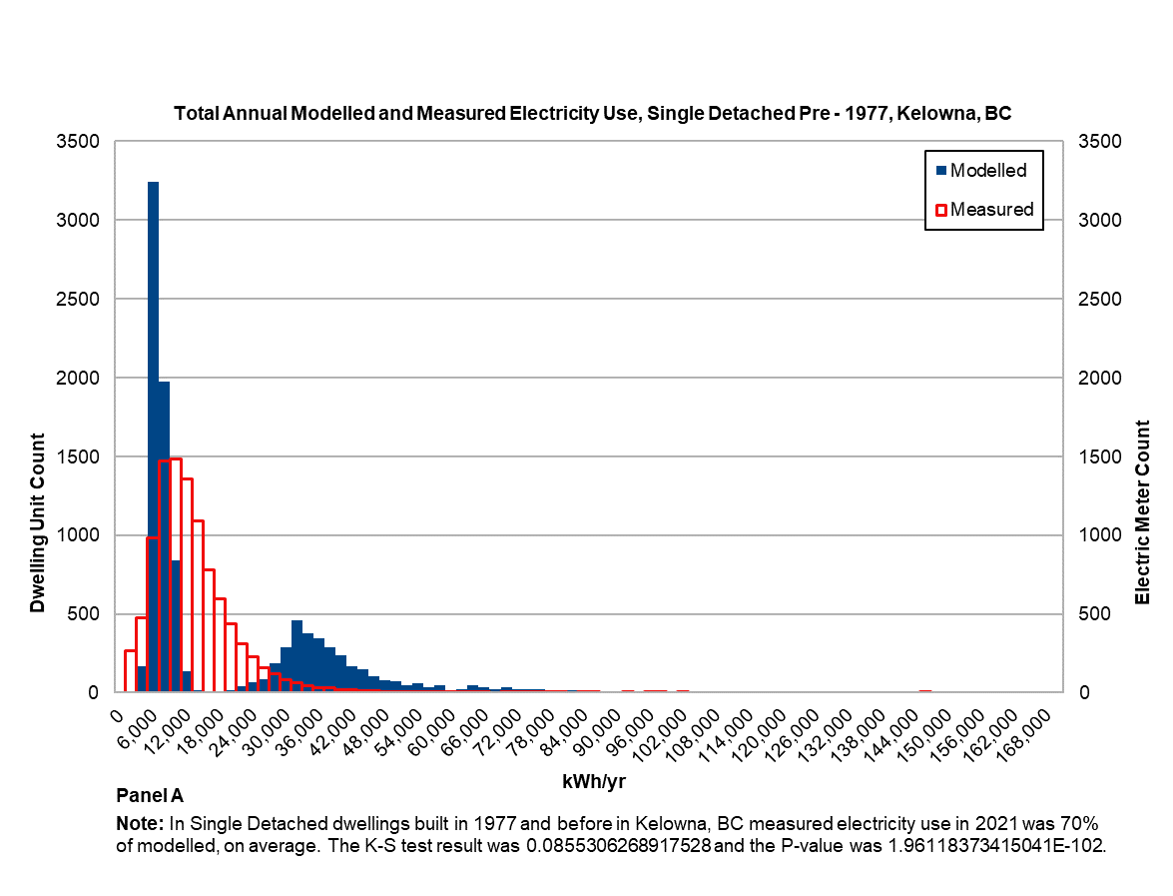
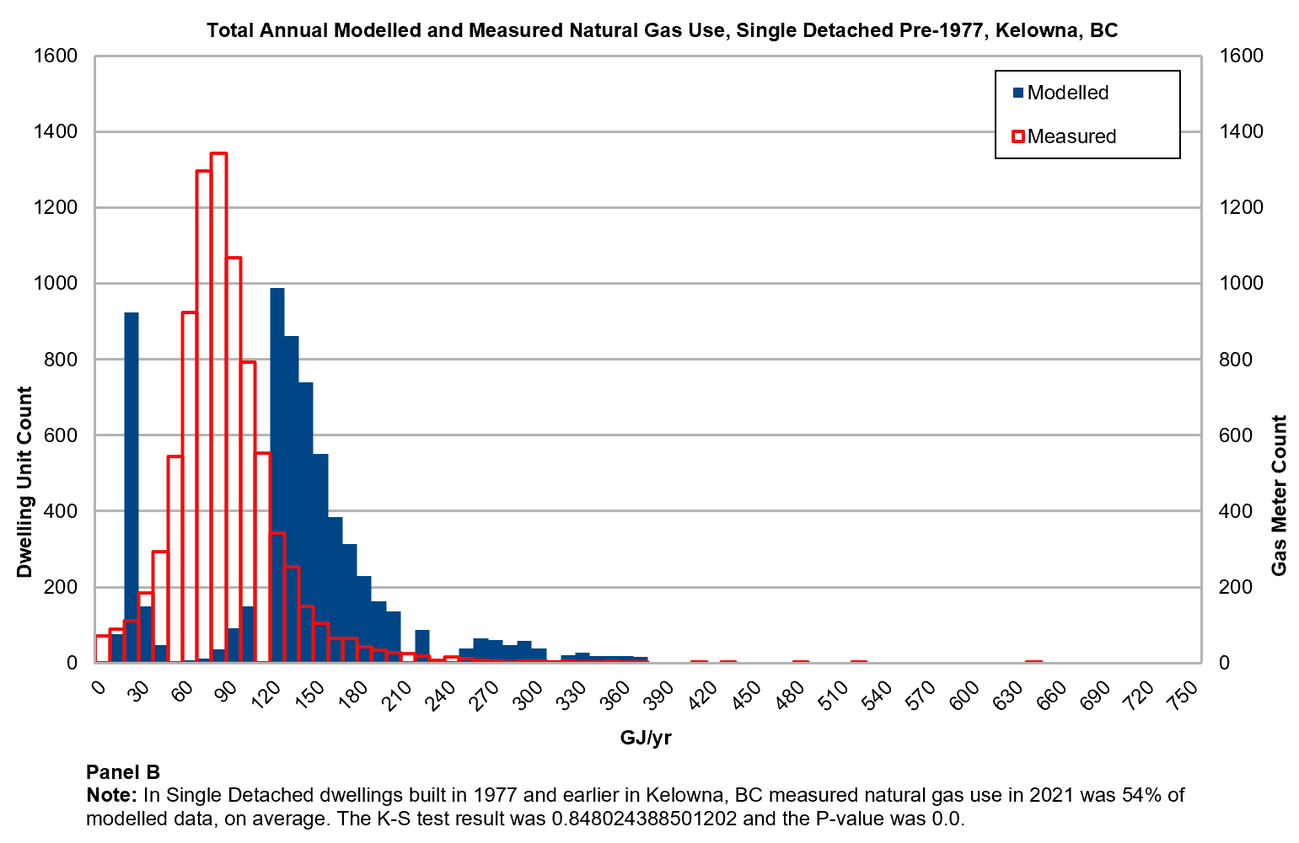

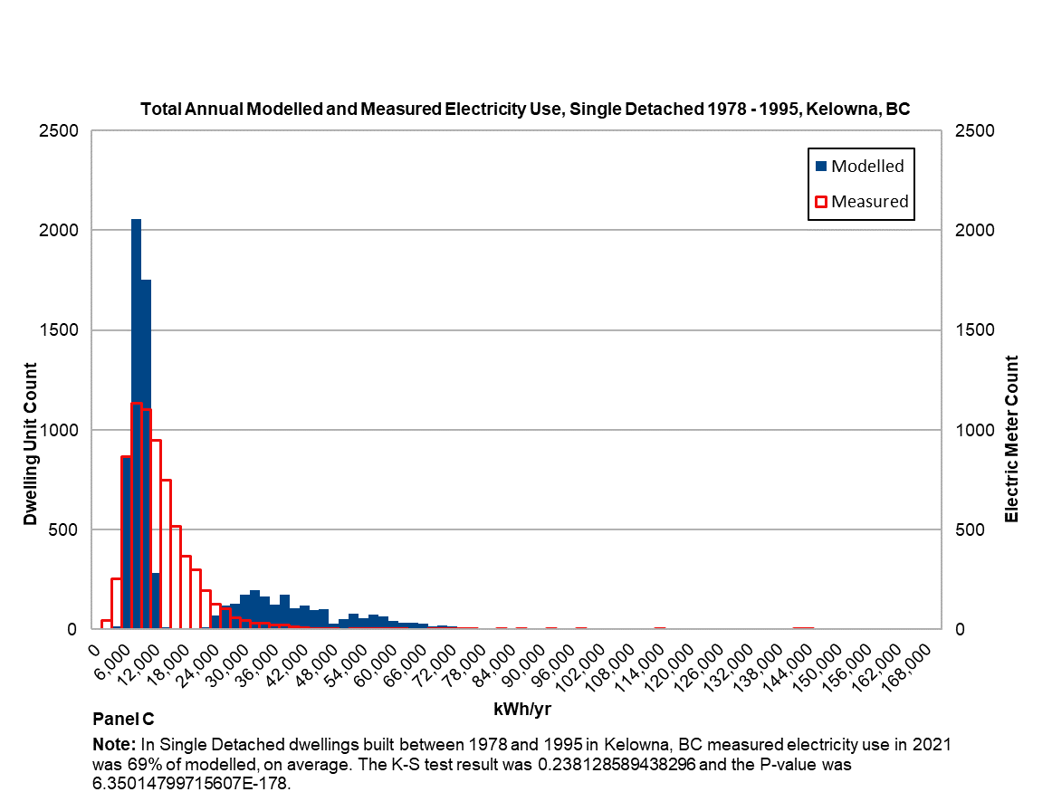

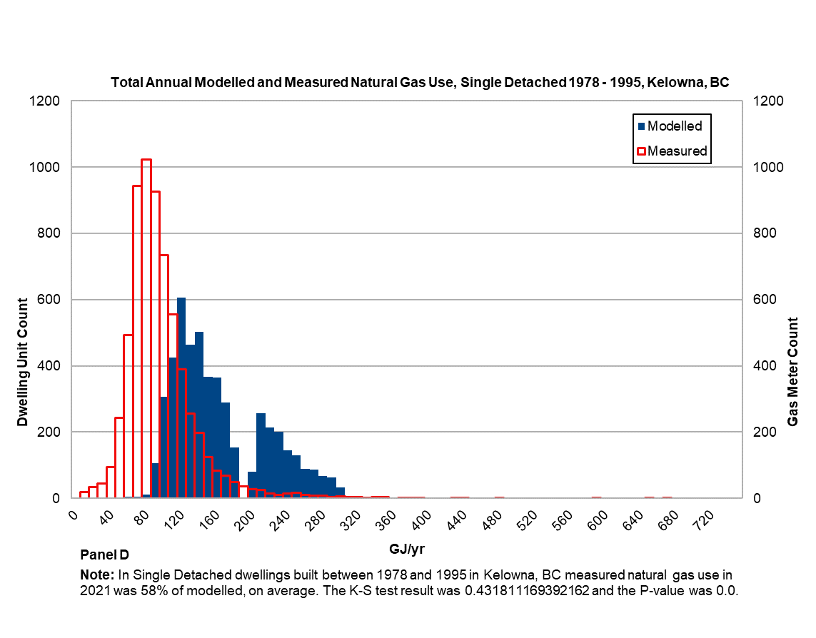

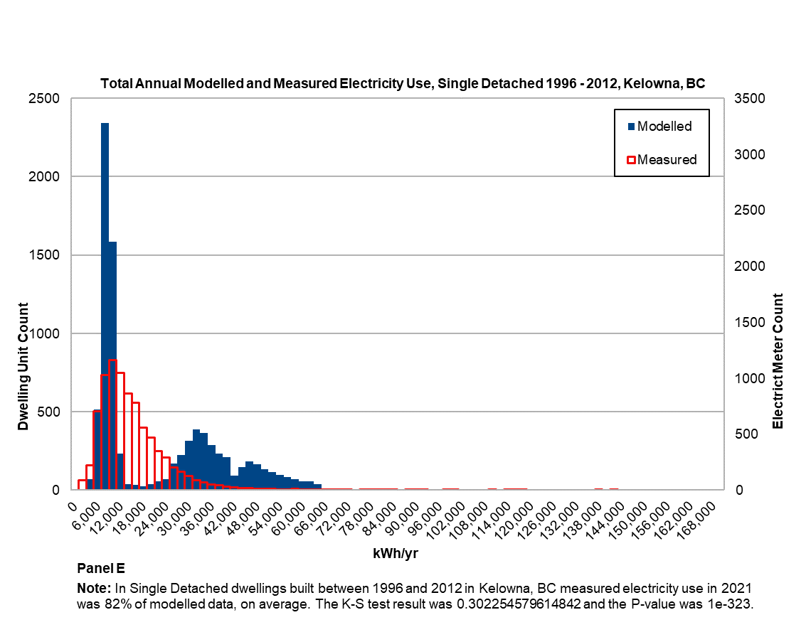

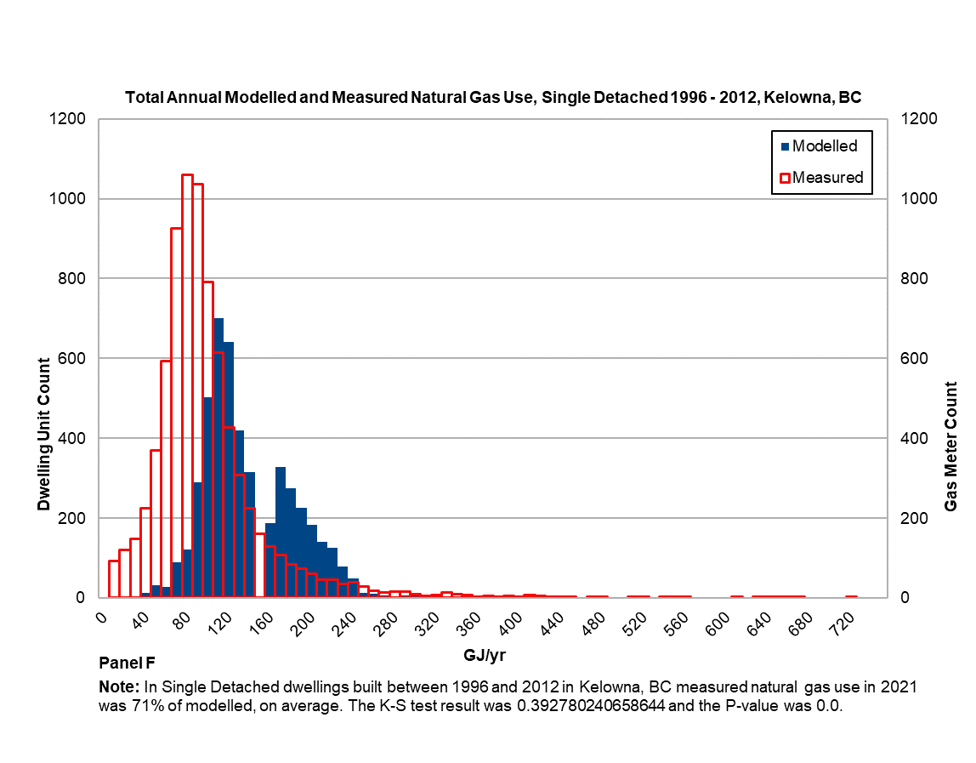

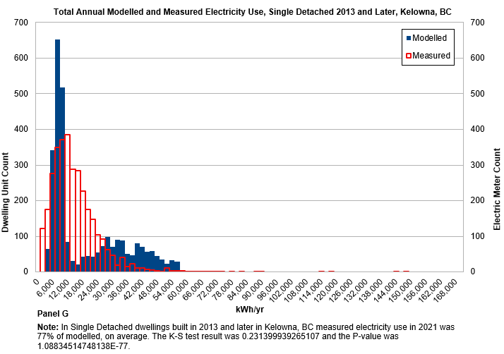

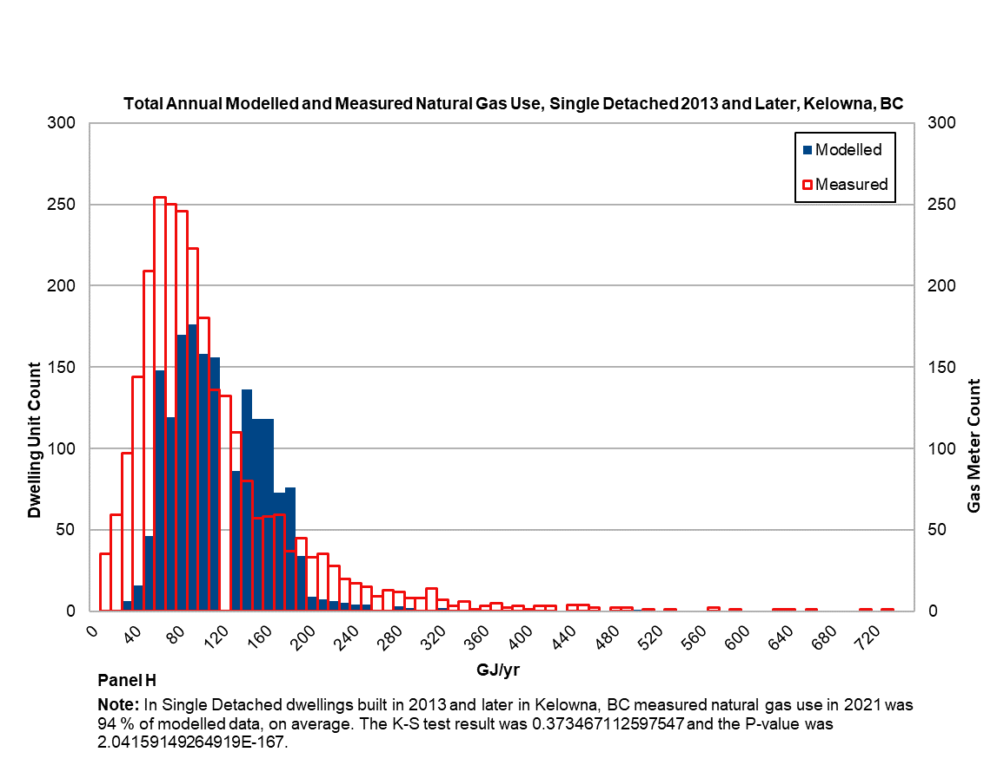
Figure 1. Histograms of measured and modelled distributions for Single Detached (SD) dwellings across four vintages for electricity and natural gas, Kelowna, B.C. 2021
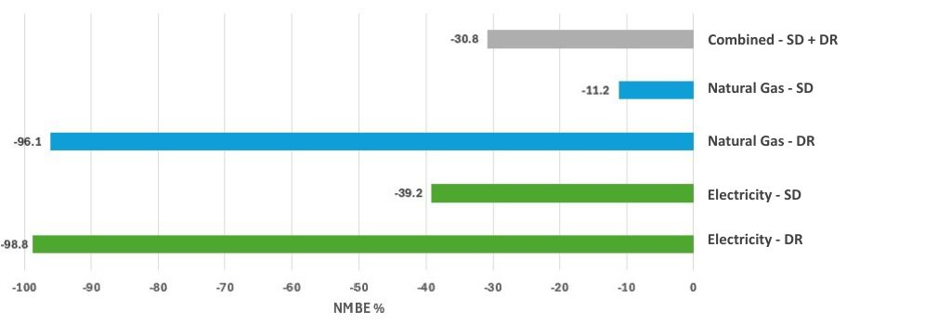
Figure 2. Comparison of NMBE results for dwelling types, and energy sources, combined and separately.

Limitations
Results for mobile home and multi-unit dwelling types were withheld due to small sample sizes and large discrepancies between dwelling unit and meter counts. Two data gaps were the absence of conditioned floor area and a full characterization of heating fuel source at the dwelling scale. As discussed, the BIR provided assessed rather than conditioned floor area, which would bias EUI estimates; therefore, validation relied on annual energy use by source. Heating fuel assignments were incomplete, with city-wide ratios likely overestimating electric heating and underestimating natural gas heating. Consequently, validation grouped electricity use by dwelling type and vintage only, conflating electrically and non-electrically heated buildings, which was unavoidable due to lack of heating fuel type data associated with either dwelling units or energy meters.
While the CEE Map model leverages property assessment data, it does not incorporate 3D modelling, LiDAR, Bayesian calibration or machine learning limiting building stock data accuracy on attributes including conditioned floor area, height and number of storeys. Use of EnerGuide standard operating conditions, designed for asset-based home energy labelling, and pandemic-related occupancy changes also contributed to discrepancies. Finally, mismatches between unit and meter counts also contributed to statistically dissimilar distributions. While these sources of error can be identified, their effects cannot be quantified due to unobserved heterogeneity stemming from the absence of metered data directly linked to modelled results for the same dwelling.

Unobserved heterogeneity
Biases associated with making inferences about individual units based on aggregated data, known as the ecological fallacy, have long been highlighted by authors in the natural sciences and economic geography, among other disciplines [48], [49], [50]. The validation exercise in our study avoids the ecological fallacy by comparing probability distributions of model-predicted versus actual consumption of a full population of individual anonymized utility meters across a city, grouped by building type, vintage and energy source. Nevertheless, we caution that UBEM models in general may make erroneous predictions for the most cost-effective investments to undertake in each residential building, if it’s not possible to reconcile building-level modelled results with metered energy data from the same dwelling.

Conclusions & Recommendations
The exercise to validate the CEE Map model for across the population of low-rise residential dwellings in Kelowna, B.C. revealed significant differences between modelled and metered energy use. The model was found to consistently overestimate natural gas and electricity use, limiting the reliability of baseline and scenario predictions. These findings highlight the critical need for access to fit-for-purpose metered energy data for UBEM calibration and validation to support energy policy goals in Canada. The study demonstrates a novel utility collaboration, advances privacy-compliant data sharing methods that comports with FAIR principles and provides insights to improve UBEM accuracy.
To support accurate energy modelling for policy, planning and program design by municipalities and community energy planners, modellers should have access to metered energy data for BEM and UBEM calibration and validation. Complimentary to and leveraging guidance already developed for Energy Star® Portfolio Manager® (ESPM) [51] users pertaining to Part 3 commercial and institutional buildings, relevant standards should be extended or developed to support modeller access to privacy compliant metered energy data across all building types. Notably, guidance recently offered on data access for ESPM recommends implementing a utility-led process to identify all meters/accounts at a property to be included in aggregated reported consumption, identifying this as “...the most difficult (and arguably the most important) aspect of a utility data access solution.” Spatial data integration approaches developed in TaNDM to align building, unit and meter data on a parcel basis, should be further developed to ensure robust whole building energy reporting, useful for modellers seeking data to validate models, those reporting and benchmarking via ESPM and energy efficiency stakeholders more broadly.
Utilities could strengthen analytical capacity for building energy use and be better enabled to produce fit for purpose metered data for municipal emissions inventories and model calibration and validation by associating building attributes (e.g., type, year built/vintage, conditioned floor area and heating fuel type) with parcels and meters spatially in their GIS systems. To this end, a gap analysis should be performed on existing utility data interoperability standards notably the Common Information Model and associated International Electrotechnical Commission Standards (IEC 61970, IEC 61968 and IEC 62325) [52] to assess if any are candidates for extension to accommodate building attributes. Existing buildings data standards such as Industry Foundation Classes (ISO 16739) [53] and CityGML[54], as well as energy-related housing data standard hpXML [55] could undergo an interoperability assessment in relation to CIM standards, to support utilities in onboarding buildings data in a standardized way. To aid in efficient buildings data integration, utilities would also benefit from standardized national building stock data. Recognized limitations in property assessed building attributes for energy analysis including assessed versus conditioned floor area could be addressed for a national buildings dataset with 3D geospatial data, imagery and machine learning techniques; spatial analysis of imagery could also be used to identify and exclude major non-building loads such as for pools. Reliable dwelling scale heating fuel type data, a significant limitation in this study, should also be developed and made accessible through a standardized national building stock data set. Improved methods are also needed to reconcile dwelling unit, building and meter counts. UBEMs for Virtual Home Labelling (VHL) should model building energy individually and not on an archetype basis, to avoid the ecological fallacy.
Finally, future VHL research should explore both calibration and validation and the use of building-level high temporal resolution data to account for unobserved heterogeneity and improve VHL accuracy vis a vis metered energy consumption to improve cost savings estimates enhancing benefits to occupants beyond GHG emission reduction.

Acknowledgements
This work was supported by the Program of Energy Research and Development via the Canadian Energy End-use (CEE Map) project (CEO-4006) and the Canada Green Buildings Strategy. TaNDM was originally developed via the Integrated Community Energy Modelling project supported by NRCan’s Clean Energy Fund (0078CE). The authors gratefully acknowledge the CEE Map model developers including Guy Buller, Rory McAlpine and Gemma Ceasar for GIS and Julia Purdy for housing energy simulation. Support for Carleton University’s participation in the validation article and the drafting of this paper was through the Social Sciences and Humanities Research Council grant number 890-2020-0099.
The authors would also like to acknowledge City of Kelowna staff including Chris Ray and Kevin Stehle for access to Kelowna building stock and building permit data and Ted Norcott of FortisBC for FME model development and energy field data preparation. Also informing the process were current and former TaNDM 2022-2024 Steering Committee members: James Allen, Jaime-Ann Lew, Matthew Wood, Max Mathies, and Sharan Mahli from FortisBC; Tamara Sears from B.C. Assessment; Nairn Albrecht, Prabatha Hewa from B.C. Ministry of Energy, Mines and Low Carbon Innovation; Kenneth Porter Elizabeth Lytviak from the B.C. Ministry of Environment and Climate Strategy; Gurdeep Singh and Ysabel Garcia from GeoBC; Joe Wang from NRCan’s Demand and Policy Analysis Division; Yuill Herbert from Sustainability Solutions Group and Aaron Licker from Licker Geospatial.

CRediT authorship contribution statement
Jessica Webster: Conceptualization, Funding Acquisition, Supervision, Project administration, Method, Investigation, Writing - original draft, Writing - review and editing. Brett Korteling: Method, Software, Data curation, Visualization, Writing – original draft. Ekaterina Alekhanova: Method, software (Python), model validation: calculation (K-S test, NMBE), Writing - original draft, Writing - review and editing. Maya Papineau Review, Editing, Supervising the analytical approach, Methodological consulting, Conceptualization.
Declaration of generative AI and AI-assisted technologies in the writing process
During the preparation of this work the authors used ChatGPT to develop Table 1. After using this tool/service, the authors reviewed and edited the content as needed and take full responsibility for the content of the published article.

Data and method availability
The TaNDM demonstration for Kelowna, B.C. was made possible with support of the BC Assessment Authority in assisting with interpretation of the BIR data. Raw microdata including the Building Information Report is proprietary, belonging to BC Assessment Authority. It is made available to British Columbia municipalities upon request. The Enhanced Building Information Report is also raw micro data and is not available for proprietary reasons. The EBIR is not a product from BC Assessment. Utility energy meter and consumption data are proprietary, belonging to FortisBC. Housing energy simulations were prepared using NRCan’s Housing Technology Assessment Platform which may be found on GitHub https://github.com/canmet-energy/HTAP. Anonymized EnerGuide evaluations at the postal code scale may be accessed from the Open Data repository: https://open.canada.ca/data/dataset/0a7619fd-2ffe-44b5-9027-3dfcec0866fd
The complete TaNDM method including FME workspaces supporting the validation exercise is open source and available on GitHub https://github.com/canmet-energy/tandm under GNU Lesser General Public License V. 3.

References[1] P. Claudino, A. Swanson, J. Webster, Scan of Building Energy Mapping Applications, Posterity Group, 2021. https://energyepidemiology.org/wp-content/uploads/2022/02/scan_building_energy_mapping-final_20211222.pdf (accessed July 30, 2024).
[2] Sustainability Solutions Group, TransformTO Climate Action for a Healthy, Equitable and Prosperous Toronto: Result of Modelling Greenhouse Gas Emissions to 2050, 2017. https://www.toronto.ca/wp-content/uploads/2018/02/9490-TransformTO-Report-2-Attachment-B-Results-of-Modelling-GHG-Emissions-to-2050-Apr17-Revised-Compressed.pdf (accessed July 30, 2024).
[3] Community Energy Association, Climate Action Planner, (2025). https://www.communityenergy.ca/climate-action-planner/ (accessed December 15, 2025).
[4] R. Charron, Development of a residential modelling verification test suite for assessment of virtual audit and labelling services, Natural Resources Canada, 2024.
[5] K. Calvert, A. Kantamneni, I. McVey, The Emergence of Community Energy Planning in Canada: introduction to a special issue, Can. Policy Plan. J. (2021). https://doi.org/https://doi.org/10.24908/cpp-apc.v2021i2.13934.
[6] G.E.S. Therrien, Urban building energy modelling (UBEM) in data limited environments, University of Victoria, 2022. https://dspace.library.uvic.ca/bitstreams/a7a87857-e4e3-4a93-a080-59e6f59d39d0/download.
[7] S. Dabirian, Stochastic Occupant-centric Archetype Modeling for Urban Building Energy Simulation, Concordia, 2023. https://spectrum.library.concordia.ca/id/eprint/993490/1/Dabirian_PhD_S2024.pdf.
[8] P. Nageler, G. Zahrer, R. Heimrath, T. Mach, F. Mauthner, I. Leusbrock, H. Schranzhofer, C. Hochenauer, Novel validated method for GIS based automated dynamic urban building energy simulations, Energy 139 (2017) 142–154. https://doi.org/10.1016/j.energy.2017.07.151.
[9] C.-K. Wang, S. Tindemans, C. Miller, G. Agugiaro, J. Stoter, Bayesian calibration at the urban scale: a case study on a large residential heating demand application in Amsterdam, J. Build. Perform. Simul. 13 (2020) 347–361. https://doi.org/10.1080/19401493.2020.1729862.
[10] X. Yang, M. Hu, N. Heeren, C. Zhang, T. Verhagen, A. Tukker, B. Steubing, A combined GIS-archetype approach to model residential space heating energy: A case study for the Netherlands including validation, Appl. Energy 280 (2020) 115953. https://doi.org/10.1016/j.apenergy.2020.115953.
[11] S. HosseiniHaghighi, P.M.Á. De Uribarri, R. Padsala, U. Eicker, Characterizing and structuring urban GIS data for housing stock energy modelling and retrofitting, Energy Build. 256 (2022) 111706. https://doi.org/10.1016/j.enbuild.2021.111706.
[12] J. Sokol, C. Cerezo Davila, C.F. Reinhart, Validation of a Bayesian-based method for defining residential archetypes in urban building energy models, Energy Build. 134 (2017) 11–24. https://doi.org/10.1016/j.enbuild.2016.10.050.
[13] R. Mohammadiziazi, S. Copeland, M.M. Bilec, Urban building energy model: Database development, validation, and application for commercial building stock, Energy Build. 248 (2021) 111175. https://doi.org/10.1016/j.enbuild.2021.111175.
[14] City of Kelowna, Energy, (2024). https://www.kelowna.ca/our-community/environment/energy.
[15] S. Hosseinihaghighi, K. Panchabikesan, S. Dabirian, J. Webster, M. Ouf, U. Eicker, Discovering, processing and consolidating housing stock and smart thermostat data in support of energy end-use mapping and housing retrofit program planning, Sustain. Cities Soc. 78 (2022) 103640. https://doi.org/10.1016/j.scs.2021.103640.
[16] C. Nageli, C. Camarasa, M. Delghurst, P. Fennell, I. Hamilton, M. Jakob, J. Langevin, J. Laverge, J. L. Reyna, N. Holck Sandberg, J. Webster, Best practice reporting guideline for building stock energy models, Energy Build. 260 (2022). https://doi.org/https://doi.org/10.1016/j.enbuild.2022.111904.
[17] Open Geospatial Consortium, Building Energy Mapping and Analytics Concept Development Study, 2021. http://www.opengis.net/doc/PER/BEMA-CDS (accessed January 22, 2025).
[18] Leigh St. Hilaire, Aiden Brookson, Eds., Testbed-18 Building Energy Data Interoperability Engineering Report, Open Geospatial Consortium, 2023. http://www.opengis.net/doc/PER/T18-D012.
[19] British Columbia Ministry of Energy and Climate Solutions, Community Energy and Emissions Inventory - Province of British Columbia, (2025). https://www2.gov.bc.ca/gov/content/environment/climate-change/data/ceei (accessed January 14, 2025).
[20] TaNDM Github Repository, (2025). https://github.com/canmet-energy/tandm.
[21] R. Judkoff, D. Wortman, B. O’Doherty, J. Burch, A Methodology for Validating Building Energy Analysis Simulations, National Renewable Energy Laboratory, 1983. https://www.nrel.gov/docs/fy08osti/42059.pdf.
[22] E. Palomo Del Barrio, G. Guyon, Theoretical basis for empirical model validation using parameters space analysis tools, Energy Build. 35 (2003) 985–996. https://doi.org/10.1016/S0378-7788(03)00038-0.
[23] Method of Test for Evaluating Building Performance Simulation Software, (2023).
[24] ASHRAE. (2023). ASHRAE Guideline 14-2023: Measurement of Energy, Demand, and Water Savings., (2023). https://webstore.ansi.org/standards/ashrae/ashraeguideline142023.
[25] R. Judkoff, J. Neymark, Model validation and testing: The methodological foundation of ASHRAE Standard 140, (2006).
[26] P. Im, J. Joe, Y. Bae, J.R. New, Empirical validation of building energy modeling for multi-zones commercial buildings in cooling season, Appl. Energy 261 (2020) 114374. https://doi.org/10.1016/j.apenergy.2019.114374.
[27] E.M. Ryan, T.F. Sanquist, Validation of building energy modeling tools under idealized and realistic conditions, Energy Build. 47 (2012) 375–382. https://doi.org/10.1016/j.enbuild.2011.12.020.
[28] M. Papineau, K. Yassin, G. Newsham, S. Brice, Conditional demand analysis as a tool to evaluate energy policy options on the path to grid decarbonization, Renew. Sustain. Energy Rev. 149 (2021) 111300. https://doi.org/10.1016/j.rser.2021.111300.
[29] M. Fowlie, M. Greenstone, C. Wolfram, Do Energy Efficiency Investments Deliver? Evidence from the Weatherization Assistance Program, Q. J. Econ. 133 (2018) 1597–1644. https://econpapers.repec.org/article/oupqjecon/v_3a133_3ay_3a2018_3ai_3a3_3ap_3a1597-1644..htm.
[30] M. Papineau, N. Rivers, K. Yassin, Household benefits from energy efficiency retrofits: Implications for net zero housing policy, Energy Econ. 143 (2025) 108245. https://doi.org/10.1016/j.eneco.2025.108245.
[31] F. Burlig, C. Knittel, D. Rapson, M. Reguant, C. Wolfram, Machine Learning from Schools about Energy Efficiency, J. Assoc. Environ. Resour. Econ. 7 (2020) 1181–1217. https://doi.org/10.1086/710606.
[32] P. Christensen, P. Francisco, E. Myers, M. Souza, Decomposing the Wedge between Projected and Realized Returns in Energy Efficiency Programs, Rev. Econ. Stat. 105 (2023) 798–817. https://doi.org/10.1162/rest_a_01087.
[33] Y. Chuang, M.A. Delmas, S. Pincetl, Are Residential Energy Efficiency Upgrades Effective? An Empirical Analysis in Southern California, J. Assoc. Environ. Resour. Econ. 9 (2022) 641–679. https://doi.org/10.1086/718529.
[34] E. Alekhanova, M. Papineau, K. Yassin, Realized Savings from Canada’s Building Energy Codes, (2023). https://ideas.repec.org/p/car/carecp/23-06.html.
[35] P. Nojedehi, B. Gunay, W. O’Brien, M. Papineau, E. Azar, M. Schweiker, G. Ulukavak Harputlugil, N. Ganiç Saglam, Examining disparities in energy poverty and indoor environmental quality satisfaction among Canadian households, Energy Policy 194 (2024) 114319. https://doi.org/10.1016/j.enpol.2024.114319.
[36] Econoler, Narrative Research, 2022/2023 Total Home Program Impact and Process Evaluation New Brunswick Power, 2023.
[37] C. Cerezo Davila, Building archetype calibration for effective urban building energy modeling, Massachusetts Institute of Technology, 2017. http://hdl.handle.net/1721.1/111487.
[38] C.F. Reinhart, C. Cerezo Davila, Urban building energy modeling – A review of a nascent field, Build. Environ. 97 (2016) 196–202. https://doi.org/10.1016/j.buildenv.2015.12.001.
[39] Q. Ji, Y. Bi, M. Makvandi, Q. Deng, X. Zhou, C. Li, Modelling Building Stock Energy Consumption at the Urban Level from an Empirical Study, Buildings 12 (2022) 385. https://doi.org/10.3390/buildings12030385.
[40] Y. Li, H. Feng, Pathways to urban net zero energy buildings in Canada: A comprehensive GIS-based framework using open data, Sustain. Cities Soc. 122 (2025) 106263. https://doi.org/10.1016/j.scs.2025.106263.
[41] M. Österbring, É. Mata, L. Thuvander, M. Mangold, F. Johnsson, H. Wallbaum, A differentiated description of building-stocks for a georeferenced urban bottom-up building-stock model, Energy Build. 120 (2016) 78–84. https://doi.org/10.1016/j.enbuild.2016.03.060.
[42] F. Johari, F. Shadram, J. Widén, Urban building energy modeling from geo-referenced energy performance certificate data: Development, calibration, and validation, Sustain. Cities Soc. 96 (2023) 104664. https://doi.org/10.1016/j.scs.2023.104664.
[43] L.G. Swan, V.I. Ugursal, Modeling of end-use energy consumption in the residential sector: A review of modeling techniques, Renew. Sustain. Energy Rev. 13 (2009) 1819–1835. https://doi.org/10.1016/j.rser.2008.09.033.
[44] M. Ferrando, F. Causone, T. Hong, Y. Chen, Urban building energy modeling (UBEM) tools: A state-of-the-art review of bottom-up physics-based approaches, Sustain. Cities Soc. 62 (2020) 102408. https://doi.org/10.1016/j.scs.2020.102408.
[45] J. Langevin, J.L. Reyna, S. Ebrahimigharehbaghi, N. Sandberg, P. Fennell, C. Nägeli, J. Laverge, M. Delghust, É. Mata, M. Van Hove, J. Webster, F. Federico, M. Jakob, C. Camarasa, Developing a common approach for classifying building stock energy models, Renew. Sustain. Energy Rev. 133 (2020) 110276. https://doi.org/10.1016/j.rser.2020.110276.
[46] Natural Resources Canada, Canadian energy end-use mapping, (2021). https://natural-resources.canada.ca/energy/offices-labs/canmet/ottawa-research-centre/the-built-environment/canadian-energy-end-use-mapping/23534 (accessed May 5, 2024).
[47] Natural Resources Canada, Housing Technology Assessment Platform, (2020). https://github.com/NRCan-IETS-CE-O-HB.C./HTAP.
[48] E. G. Nasif, Hamad Al-Daeaj, Bahman Ebrahimi, Mary S. Thibodeaux, Methodological Problems in Cross-Cultural Research: An Updated Review, MIR Manag. Int. Rev. 31 (1991) 79–91. https://www.jstor.org/stable/40228333.
[49] P. Sedgwick, Understanding the ecological fallacy, Br. Med. J. 351 (2015). https://www.jstor.org/stable/26521956.
[50] S. Beugelsdijk, The Regional Environment and a Firm’s Innovative Performance: A Plea for a Multilevel Interactionist Approach, Econ. Geogr. 83 (2007) 181–199. https://www.jstor.org/stable/30033111.
[51] Natural Resources Canada, Guidance for Utilities on Providing Whole-Building Energy Data to Enable Benchmarking in ENERGY STAR® Portfolio Manager®, (2025). https://natural-resources.canada.ca/energy-efficiency/energy-star/guidance-utilities-providing-whole-building-energy-data-enable-benchmarking-energy-starr-portfolio-managerr.
[52] EPRI, Chapter 3: CIM Background, in: Common Inf. Model Primer, 11th ed., 2024. https://msites.epri.com/rd/research/062333/common-information-model-primer/chapter-3-cim-background.
[53] ISO 16739-1:2024, (2024). https://www.iso.org/standard/84123.html.
[54] Open Geospatial Consortium, CityGML, (n.d.). https://www.ogc.org/standards/citygml/.
[55] xpXML, (n.d.). https://www.hpxmlonline.com/.

The TaNDM building emissions inventory methods paper is available upon request. J. Webster et. al. “Collaborative Development of High-Resolution Building Emissions Inventories for Sustainable Cities: The TaNDM Method and Demonstration” unpublished working paper.
The TaNDM building emissions inventory methods paper is available upon request J. Webster et. al. “Collaborative Development of High-Resolution Building Emissions Inventories for Sustainable Cities: The TaNDM Method and Demonstration” unpublished working paper.

