Does Machine Learning Improve Trend Following? A Stage-by-Stage, Multi-Asset Walk-Forward Evaluation of 39 Rule-Based Strategies
[Author Name]¹ — Corresponding author: kirannandi2412@gmail.com
¹ [Affiliation, City, Country]
Manuscript version: October 2026
Abstract
We quantify how much machine learning (ML) adds to 39 established trend-following rules and identify the conditions under which the improvement is statistically robust. ML is inserted at five separately evaluated stages of the trading pipeline (trade filtering, regime gating, position sizing, exit timing and parameter adaptation), with five model families per stage selected on a validation block that precedes each test year in a purged, expanding walk-forward design. On 174 instruments (equity indices, futures, currencies, cryptocurrencies and ETFs) traded out of sample from January 2006 to October 2026 with next-open execution, asset-class transaction costs and volatility targeting, the rule-based baselines earn a mean Sharpe ratio of 0.01. ML trade filtering and ML position sizing raise it by 0.47 and 0.44 on average, with significant improvements for 31 and 33 of the 39 strategies after Benjamini–Hochberg correction. ML exits add 0.28, parameter adaptation 0.16 and a strategy-agnostic regime gate nothing. The gains survive a random-prediction placebo, a random-walk null experiment, alternative validation designs, every five-year sub-period and zero to triple transaction costs. They are absent for G10 currencies and, for position sizing, at intraday cryptocurrency frequencies. A feature ablation shows that the improvement does not require technical indicators: a model that sees only volatility and the state of the open trade matches a model given 56 indicators. ML therefore acts as a learned trade-management layer rather than as an extractor of indicator information. The improvements are statistically robust, but most ML-enhanced rules remain only marginally profitable on their own.
Keywords: trend following; technical trading rules; machine learning; meta-labelling; walk-forward validation; backtest overfitting; multiple hypothesis testing; placebo test.
JEL classification: G11, G14, G17, C12, C45, C53.

1. Introduction
Trend following is among the oldest and best-documented systematic investment styles. Its building blocks (moving-average crossovers, channel breakouts, volatility stops and time-series momentum) are simple, public and, in most cases, several decades old (Donchian 1960; Wilder 1978; Brock et al. 1992; Moskowitz et al. 2012; Hurst et al. 2017). Over the past decade it has become routine to bolt machine learning onto such rules: classifiers filter signals, regime models switch strategies on and off, and predicted probabilities set position sizes (López de Prado 2018; Lim et al. 2019; Joubert 2022). The value of doing so is, however, rarely measured against the rule itself under one controlled protocol. Academic studies typically report the profitability of an ML strategy in isolation, and practitioner evidence usually consists of a filter that “helped” on the instrument on which it was tuned. Neither answers the question that matters to someone who already trades a trend rule: what does ML add to it, and can that addition be trusted?
This paper asks that question directly:
How much does ML improve established trend-following strategies over their original rule-based implementations, and under what market, instrument, strategy, indicator, model and validation conditions does the improvement remain statistically significant and robust?
We answer it with a controlled, stage-by-stage design. Thirty-nine published or widely used trend-following rules are implemented faithfully as baselines. ML is then inserted at five distinct points of the trading pipeline (trade selection, trend-regime detection, position sizing, exit timing and parameter adaptation), and each insertion is evaluated on its own against the same baseline on identical days. At every stage, five model families compete (regularised logistic regression, random forest, extremely randomised trees, gradient boosting and a neural network); the winner is chosen only on a validation block that precedes each out-of-sample year, and every alternative is reported as well. The test bed is a public multi-asset daily panel of 174 instruments across equity indices, futures, currencies, cryptocurrencies and ETFs, with robustness panels at one-hour and four-hour frequency and a deliberately survivorship-biased single-stock universe that is labelled as such.
Because the design involves many comparisons (39 strategies × 5 stages × 5 models, plus backtest variants), the inference accounts explicitly for the size of the search: paired block-bootstrap and HAC tests of Sharpe-ratio differences, Holm and Benjamini–Hochberg adjustment across the 195 strategy–stage tests, Hansen’s test of superior predictive ability and White’s Reality Check within each strategy, Romano–Wolf stepdown p-values, the probability of backtest overfitting and the deflated Sharpe ratio. We add three controls that are, to our knowledge, rarely used together in this literature: (i) a placebo that applies each ML decision rule with random numbers instead of model predictions, which isolates the information contributed by the model from the mechanical effect of intervening; (ii) a null experiment that runs the entire pipeline unchanged on synthetic random-walk markets as a screen for look-ahead leakage; and (iii) a feature ablation that asks which inputs carry the improvement.
Our main findings are as follows. First, where ML is inserted matters more than which model is used. Trade filtering (meta-labelling) and position sizing raise the out-of-sample Sharpe ratio of the average rule by 0.47 and 0.44, from a baseline of essentially zero, and the improvement is significant for 31 and 33 of the 39 rules after false-discovery-rate control. ML exits help less reliably (+0.28), parameter adaptation little (+0.16), and a strategy-agnostic trend-regime gate does not help at all. Second, the improvements are not an artefact of trading less: the placebo is negative or null at every stage, and the random-walk experiment produces no broad improvement. Third, the gains are robust to the validation design, the time period and the backtest assumptions, but not to the sampling frequency or to the most efficiently priced market (G10 currencies). Fourth, ML mainly repairs weak rules: the benefit falls sharply with the rule’s own Sharpe ratio. Fifth, and most importantly for interpretation, the improvement does not depend on the technical indicators at all. A model that sees only recent volatility and the state of the open trade performs as well as one that sees 56 indicators. Finally, a statistically robust improvement is not the same as a profitable strategy: the absolute Sharpe ratio of the best ML configuration survives deflation for only 9 of the 39 rules.
The paper makes four contributions. (1) It provides a controlled, stage-by-stage measurement of the incremental value of ML for a large, diverse set of published trend rules, under one protocol and with honest out-of-sample model selection. (2) It reports the full search (every model, every stage, every backtest variant) together with multiple-testing and overfitting diagnostics, rather than only the best configuration. (3) It introduces a placebo control and a feature ablation that separate learned information from mechanical intervention and identify the source of the gain. (4) It releases a modular, tested framework in which each experiment is recorded in a registry that links strategy, indicators, market, instrument, dataset, ML stage, model, validation design and backtest configuration to its result.
The remainder of the paper is organised as follows. Section 2 reviews the related literature. Section 3 describes the data and Section 4 the methodology. Section 5 presents the main results, Section 6 the controls that test whether the improvement reflects learned information, and Section 7 the robustness experiments. Section 8 answers the research question and discusses the implications, Section 9 states the limitations and Section 10 concludes.

2. Related literature
Trend following and technical rules. Systematic trend following has a long empirical record. Donchian’s channel-breakout rule (1960) and the moving-average and trading-range-break rules tested by Brock et al. (1992) are the canonical technical rules. Moskowitz et al. (2012) document time-series momentum across 58 futures and forward contracts, and Hurst et al. (2017) extend the evidence to more than a century of data. Levine and Pedersen (2016) show that moving-average crossovers and time-series momentum are closely related, weighting past returns differently. Simple tactical rules such as Faber (2007)’s ten-month moving-average filter and Antonacci (2014)’s absolute momentum are widely followed by practitioners. Sullivan et al. (1999) showed that the apparent profitability of a universe of technical rules must be judged against the data snooping implied by searching over it, a point that applies with greater force when ML is layered on top.
Machine learning in trading. Gu et al. (2020) document substantial gains from tree ensembles and neural networks in predicting the cross-section of returns under strict train/validation/test separation. Krauss et al. (2017) and Fischer and Krauss (2018) apply deep networks, gradient boosting and random forests to statistical arbitrage. Closer to our setting, Lim et al. (2019) learn trend-following positions and sizes end-to-end with deep networks. López de Prado (2018) proposed meta-labelling: a secondary classifier that decides whether to act on a primary model’s signal and how much to bet, and Joubert (2022) formalises the framework. Our stage S1 is a meta-labelling filter and stage S3 a meta-labelling sizer; the contribution here is not the technique but its controlled evaluation against 39 primary rules, alongside other insertion points.
Backtest overfitting and multiple testing. White (2000)’s Reality Check and Hansen (2005)’s test of superior predictive ability (SPA) test whether the best of many models beats a benchmark. Romano and Wolf (2005) provide stepdown family-wise error control. Benjamini and Hochberg (1995) and Benjamini and Yekutieli (2001) control the false discovery rate. Ledoit and Wolf (2008) provide robust tests of Sharpe-ratio differences. Bailey and López de Prado (2014) propose the deflated Sharpe ratio, and Bailey et al. (2017) the probability of backtest overfitting (PBO) estimated by combinatorially symmetric cross-validation. Harvey et al. (2016) argue for higher significance hurdles in factor research, and Arnott et al. (2019) set out a backtesting protocol for the ML era. We apply this toolkit to a search of 39 strategies × 5 stages × 5 models.
The gap. What is missing is a controlled, stage-by-stage measurement. The question is not whether an ML trading model can be profitable, but how much ML adds to a given, published trend rule, at which point in the pipeline, and with what statistical confidence once the search over models and configurations is accounted for.

3. Data

3.1 Universe
The benchmark universe consists of 174 instruments with daily bars, totalling 1,100,307 instrument-days. It covers 34 equity indices across five regions; 37 continuous futures contracts (equity, interest rates, energy, metals, agriculture, softs, livestock and currencies); 7 G10 currency majors, 21 G10 crosses and 11 emerging-market currency pairs; 15 large-capitalisation cryptocurrencies; and 49 US-listed ETFs (equity, country, sector, rates, credit, commodity, real estate and currency). The universe deliberately avoids constituent selection: indices, continuous futures, currencies, ETFs and long-lived cryptocurrencies are not chosen because they survived, which limits survivorship bias.
Two further panels are kept out of the benchmark. Binance spot cryptocurrency data at one-hour and four-hour bars are used to test sensitivity to the sampling frequency. Single stocks from the current S&P 100 and NIFTY 50 constituents are survivorship-biased by construction and are used only as a labelled robustness run. Over all panels and frequencies we use 259 cleaned series with 2,670,334 bars (Table 1). Data come from Yahoo Finance, the Binance public API and FRED.
Table 1. Data coverage by instrument group.
Group | Bars | Instr. | From | Bars (total) | Source | Use
Equity indices | daily | 34 | 1985 | 284,573 | Yahoo | Benchmark
Continuous futures | daily | 37 | 2000 | 229,210 | Yahoo | Benchmark
FX majors | daily | 7 | 1996 | 42,846 | Yahoo | Benchmark
FX crosses | daily | 21 | 1999 | 126,494 | Yahoo | Benchmark
FX emerging markets | daily | 11 | 2003 | 64,354 | Yahoo | Benchmark
Cryptocurrencies | daily | 15 | 2014 | 49,208 | Yahoo | Benchmark
ETFs | daily | 49 | 1993 | 313,490 | Yahoo | Benchmark
Crypto (Binance spot) | 4h | 12 | 2017 | 216,493 | Binance | Robustness only
Crypto (Binance spot) | 1h | 12 | 2017 | 865,205 | Binance | Robustness only
Crypto (Binance spot) | daily | 12 | 2017 | 36,104 | Binance | Robustness only
US stocks (current S&P 100) | daily | 30 | 1985 | 310,597 | Yahoo | Robustness only (survivorship-biased)
Indian stocks (current NIFTY 50) | daily | 19 | 1996 | 131,760 | Yahoo | Robustness only (survivorship-biased)
Notes: “From” is the earliest start date in the group; all series end in September or October 2026. Instruments enter the panel when their history begins. Daily Binance bars are used only for cross-source validation.

3.2 Cleaning and validation
Cleaning is mechanical and identical for all instruments. Duplicate dates and missing or non-positive closes are dropped. Isolated bad prints, defined as log returns larger than 12 robust (MAD-based) standard deviations that are immediately reversed on the next bar, are removed (625 cases). Inconsistent bars in which the high or low lies inside the open–close range are widened to include the open and close (16,962 cases, mostly in Yahoo currency data). Series with holes longer than one month are trimmed to the segment after the last hole. Three requested series could not be used: sugar futures (no usable history), the US dollar index future and one Indian stock that is no longer listed on the data source.
We validate the data by comparing overlapping series from different sources (Appendix Table C1). Daily Yahoo and Binance bitcoin returns correlate at 0.99; the S&P 500 index and the SPY ETF at 0.985 (0.995 weekly); and domestic index–ETF pairs between 0.96 and 0.99. Currency spot rates and currency futures correlate weakly at the daily frequency (about 0.4) because of differing fixing times, but at 0.86 at the weekly frequency. These checks confirm that the series are usable for a comparative study. Because the rule-based baseline and every ML variant are evaluated on the same bars, data imperfections affect both sides of each comparison.

4. Methodology

4.1 Rule-based baselines
We implement 39 published or widely used trend-following rules spanning eight families: moving-average crossovers (7 rules), price-versus-moving-average filters (2), adaptive moving averages (6), channel breakouts (5), volatility stops (4), time-series momentum (4), oscillator-based trend rules (6) and directional-movement systems (5). Appendix Table A1 lists every rule with its reference and parameters. Each rule maps the OHLC history up to the close of bar $t$ to a target position $p_{t}∈[−1,1]$, using the originator’s default parameters. Rules are long/short (stop-and-reverse, or with a flat state where the original has one); the two long-only exceptions, Faber (2007)’s ten-month moving average and Antonacci (2014)’s absolute momentum, follow their sources. For parameter adaptation (stage S5) each rule also has a slow variant, with all lookbacks doubled, and a fast variant, with lookbacks halved.

4.2 Features
The ML models see 56 features drawn from ten indicator families (Appendix Table A2). They include momentum over 5 to 252 bars; five volatility estimators (close-to-close, Parkinson (1980), Garman and Klass (1980), Rogers and Satchell (1991) and Yang and Zhang (2000)); ADX/DMI, Aroon, RSI, MACD, stochastics, CCI, TRIX and Vortex; Kaufman’s efficiency ratio and the choppiness index; regression-slope t-statistics and $R^{2}$; distances to SMA, KAMA, Parabolic SAR, SuperTrend and Ichimoku levels; Bollinger, Keltner and Donchian channel positions; the variance ratio of Lo and MacKinlay (1988) and the first-order autocorrelation; higher moments; drawdown state; and four volume features. Every feature is dimensionless (a ratio, a bounded oscillator or a volatility-scaled distance), so a single pooled model can serve all instruments.
The rule-specific stages (S1, S3, S4) additionally receive six trade-state features: the current position’s sign and size, the log age of the current trade, the volatility-scaled open profit or loss, and the volatility-scaled result and log length of the previous completed trade. These are causal functions of prices and of the rule’s own signals, but they are not technical indicators. Stage S5 receives the current positions of the three variants instead, and the regime model (S2) receives indicators only.
Causality. For every one of the 56 features and 39 rules, a unit test verifies that the value at bar $t$ is identical whether it is computed on the full history or on the history truncated at $t$. This test caught one subtle look-ahead during development: a month-end rebalancing flag set on the last available bar caused a truncated series to rebalance on a day on which the full series would not. The flag is now derived from the calendar.

4.3 ML enhancement stages
ML is inserted at five clearly separated points. Each stage is evaluated on its own against the same rule-based baseline, so that its incremental effect is identified. Table 2 summarises the stages.
Table 2. ML enhancement stages, model targets and decision rules.
Stage | Pipeline role | Model target | Decision rule
S1 Filter | Trade selection (meta-labelling) | $P$(trade’s net open-to-open return $>0$), features at entry | Skip a new trade if its probability is below a validation-quantile threshold; stay flat until the next signal
S2 Regime | Trend-regime detection (strategy-agnostic) | $P$(forward 20-bar efficiency ratio $>$ training median) | Hold the rule’s position only while the trending-regime probability exceeds the threshold
S3 Sizing | Position sizing | $P$(current position direction is right over the next 10 bars) | Scale the position by $2\hat{F}({\hat{s}}_{t})$, where $\hat{F}$ is the empirical CDF of validation predictions
S4 Exit | Exit timing | As S3 | Exit an open trade when the probability falls below the threshold; re-enter only on the next rule signal
S5 Params | Parameter adaptation | Which of slow/base/fast variants has the best net return over the next 21 bars (3 classes) | Each month, trade the variant with the highest predicted probability
Bar-level predictions ${\hat{π}}_{t}$ (stages S2–S4) are smoothed by a causal five-bar exponential moving average before any decision,
$${\hat{s}}_{t}=α {\hat{π}}_{t}+(1−α) {\hat{s}}_{t−1}, α=2/6, (1)$$
a setting fixed before the study because unsmoothed day-to-day prediction noise churned positions and multiplied turnover. The S1 and S2 decisions compare the prediction with the $τ$-quantile of the validation-period predictions, $τ∈\{0.20,0.35,0.50\}$; S4 uses $τ∈\{0.10,0.20,0.30\}$. For S3 the multiplier
$$m_{t}=2 {\hat{F}}_{\text{val}}({\hat{s}}_{t})∈[0,2] (2)$$
has a mean close to one, so sizing redistributes exposure without changing its average level. The intensity $τ$ is the only decision parameter tuned, and only on validation data.

4.4 Models
Every stage trains five models whose hyper-parameters are fixed a priori: L2-regularised logistic regression; a random forest (Breiman 2001) of 100 bagged trees of depth 7 with 15% of features per tree; extremely randomised trees (Geurts et al. 2006); LightGBM gradient boosting (Ke et al. 2017) with 200 trees, 15 leaves and a learning rate of 0.03; and a two-layer perceptron (32 and 16 units) with early stopping. Minimum leaf sizes scale with the size of the training set. Models are pooled across all instruments of a panel, with one model per strategy, stage and fold. Training rows are sub-sampled at the label horizon so that labels from the same instrument do not overlap.

4.5 Walk-forward validation with purging
Test years run from 2006 to 2026, with one fold per calendar year. For test year $Y$:
- models are trained on all data before $Y−2$ (expanding window);
- the model and the intervention intensity are selected on the validation block $[Y−2,Y)$;
- the frozen choice is applied to year $Y$.
A training row is admitted only if its label is fully realised, including a five-bar embargo, before the validation block starts, and validation labels must be realised before the test year begins (López de Prado 2018). The selected configuration is the (model, intensity) pair with the highest validation-period portfolio Sharpe ratio. Each alternative model keeps its own validation-chosen intensity, so all five models are also reported out of sample, but nothing out of sample feeds back into any choice. The out-of-sample (OOS) record is the concatenation of the test years, from 2 January 2006 to 6 October 2026. Two alternative designs are run separately: a rolling ten-year training window and a single 2013 hold-out split with no retraining.

4.6 Execution, costs and portfolio construction
A target position decided at the close of bar $t$ is executed at the open of bar $t+1$. The overnight gap is earned by the previous position, so a signal never earns the price jump that created it. With $h_{t}=q_{t−1}$ the position held during bar $t$, open $O_{t}$ and close $C_{t}$, the net return of an instrument on bar $t$ is
$$r_{t}=h_{t−1}\left(\frac{O_{t}}{C_{t−1}}−1\right)+h_{t}\left(\frac{C_{t}}{O_{t}}−1\right)−κ |h_{t}−h_{t−1}|, (3)$$
where $κ$ is the per-side cost plus slippage of the asset class: 2 bp for indices and ETFs, 3 bp for futures, 1 to 6 bp for currency majors, crosses and emerging-market pairs, and 12.5 bp for cryptocurrencies.
At the instrument level, rules trade unit notional as in their original specifications ($q_{t}=p_{t}$). At the portfolio level, each instrument’s position is scaled to 10% annualised volatility,
$$q_{i,t}=p_{i,t} min​\left(\frac{0.10}{{\hat{σ}}_{i,t}}, 3\right), (4)$$
where ${\hat{σ}}_{i,t}$ is a causal exponentially weighted volatility estimate (60-day span). Instruments receive equal capital, and the portfolio return on a date is the average of the returns of the $N_{t}$ instruments live on that date, Rt=Nt−1i​ri,t. We additionally report costs at 0× and 3×, next-close execution (one extra bar of delay), same-close execution (the optimistic textbook convention) and unit sizing.

4.7 Performance measures
Returns are returns on notional exposure, following the excess-return convention of the managed-futures literature, so no risk-free rate is subtracted. The annualised Sharpe ratio is $SR=\sqrt{A} \overset{‾}{R}/{\hat{σ}}_{R}$, with $A$ the number of bars per year. The quantity of interest is the paired difference
$$ΔSR=SR(\text{ML})−SR(\text{rule}), (5)$$
computed on identical days. We also report CAGR, total return, volatility, the Sortino and Calmar ratios, maximum drawdown, trade win rate, profit factor, annual turnover, cost drag, exposure, the share of positive calendar years and a stability measure (the signed $R^{2}$ of log equity on time).

4.8 Statistical inference
For each strategy and stage we test $H_{0}​:SR(\text{ML})=SR(\text{rule})$ on the paired daily OOS returns. At the portfolio level we use a paired circular block bootstrap (Politis and Romano 1992) with 20-day blocks and 2,000 resamples, which preserves both the serial dependence and the cross-correlation of the two return series. At the instrument level we use the HAC test of Ledoit and Wolf (2008). The headline family consists of the 39 × 5 = 195 portfolio-level tests, reported raw and with Holm (family-wise) and Benjamini–Hochberg (false discovery rate) adjustment. Within each strategy, Hansen’s SPA test and White’s Reality Check ask whether any of the 25 stage × model configurations beats the baseline, and Romano–Wolf stepdown p-values are computed. To diagnose selection overfitting we compute the probability of backtest overfitting across each strategy’s 26 configurations (combinatorially symmetric cross-validation with 16 blocks) and the deflated Sharpe ratio of the ex-post best configuration. Finally, an ordinary least squares regression with instrument-clustered standard errors relates instrument-level $ΔSR$ to the stage, model, strategy family, asset class and the baseline’s own Sharpe ratio.

4.9 Controls: placebo, random-walk null and feature ablation
Placebo. Removing trades or resizing positions can change a Sharpe ratio even without any information. Each decision rule is therefore re-run with the same validation-chosen intensity but with uniform random numbers in place of the model predictions (20 draws per strategy and stage). The difference between the ML and placebo results measures what the model learns.
Random-walk null. If any component leaked future information, ML would “improve” rules even where there is nothing to predict. The whole pipeline is run unchanged on 60 synthetic random-walk instruments with GARCH-$t$ returns and the same costs, for 8 representative strategies.
Feature ablation. Stages S1, S3 and S4 are re-run with the feature set restricted to one indicator family at a time (momentum, volatility, trend, oscillator/channel, other) and to no indicator at all (“context only”: vol_20 plus the trade-state features). For computational reasons the ablation uses a lighter protocol (two models, logistic regression and LightGBM, retraining every three years) on 15 representative strategies covering all eight families, so the blocks are compared with each other and with a full-feature reference run under the same protocol.

4.10 Reproducibility and experiment registry
Every experiment writes rows to an SQLite registry that links strategy → indicators → market → instrument → dataset hash → ML stage → ML model (with per-fold selection counts) → validation design → backtest configuration → metrics → stored return series, together with a hash of the source code that produced it. All tables in this paper are generated from that registry. Data downloads, cleaning, experiments, statistics and the paper itself are reproduced by scripts, and every component (universe, data source, frequency, features, strategies, models, stages, validation scheme, execution, costs and sizing) can be swapped through configuration.

5. Results
All results in this section are out of sample, from January 2006 to October 2026, on 174 instruments with next-open execution and 1× costs, unless stated otherwise. $Δ$SR is the annualised Sharpe ratio of the ML-enhanced strategy minus that of its own rule-based baseline on identical days. The selected model is the validation winner, never the ex-post best.

5.1 The rule-based baselines
After costs, the 39 published rules earn an average portfolio Sharpe ratio of 0.01 (median −0.01) over 2006–2026, and only 18 of the 39 have a positive Sharpe ratio (Appendix Table B1). The best rules are slow, long-only or monthly: Faber (2007)’s ten-month moving average reaches 0.85 and absolute momentum 0.84. The worst is the fractal adaptive moving average at −0.83. This is consistent with the well-documented weak decade for trend following after 2009. Fast crossovers and adaptive moving averages pay substantial costs for whipsaw trades: the fastest rules have annual portfolio turnover of 50 to 95 times their capital. Each instrument is scaled to 10% volatility, but the equal-capital portfolio of 174 weakly correlated instruments has a realised volatility of only 2–3% a year. CAGRs are therefore small in absolute terms and scale linearly with any leverage applied; the Sharpe, Sortino and Calmar ratios are the comparable quantities.

5.2 How much does ML improve the rules?
Table 3 reports the headline result: the out-of-sample $Δ$SR of the validation-selected model at each stage, across the 39 strategies.
Table 3. Improvement in Sharpe ratio from ML, by stage (benchmark, validation-selected model, 39 strategies).
Stage | Mean ΔSR | Median ΔSR | Improved (%) | Sig.+ raw | Sig.+ Holm | Sig.+ BH | Sig.− BH | ΔMaxDD (pp) | ΔTurnover | Sign test p
S1 Filter | +0.47 | +0.50 | 97 | 34 | 10 | 31 | 0 | +8.7 | −14.33 | <0.001
S2 Regime | −0.01 | −0.01 | 46 | 1 | 0 | 1 | 0 | +6.4 | −4.36 | 0.749
S3 Sizing | +0.44 | +0.48 | 97 | 35 | 16 | 33 | 0 | +5.0 | +6.76 | <0.001
S4 Exit | +0.28 | +0.30 | 95 | 21 | 1 | 15 | 1 | +7.3 | −6.30 | <0.001
S5 Params | +0.16 | +0.16 | 85 | 7 | 0 | 4 | 0 | +3.8 | −2.82 | <0.001
Notes: “Sig.+” counts strategies with a significant improvement (two-sided paired circular block bootstrap, $α=5\%$), raw and after Holm and Benjamini–Hochberg (BH) adjustment over all 195 strategy × stage tests; “Sig.− BH” counts significant deteriorations. ΔMaxDD is the change in maximum drawdown in percentage points (positive = shallower). ΔTurnover is the change in annual portfolio turnover. The sign test is across strategies.
The answer depends sharply on where ML is inserted. Trade selection (S1) and position sizing (S3) give the largest and most reliable improvements: mean $Δ$SR of +0.47 and +0.44, with 38 of the 39 strategies improved in both cases, and significant improvements for 31 and 33 strategies after BH adjustment (10 and 16 after the stricter Holm correction). Both also reduce maximum drawdowns. ML exits (S4) help on average (+0.28), but less reliably individually: 15 strategies are significant after BH and one after Holm. Parameter adaptation (S5) adds little (+0.16; four strategies significant after BH, none after Holm).
The strategy-agnostic trend-regime gate (S2) does not help: its mean $Δ$SR is −0.01 and only 46% of strategies improve. Predicting that a market will trend is not the same as predicting that a given rule’s current position will pay; only the latter, strategy-specific target produced gains. S2 is also the only stage at which validation-based selection actively hurts. Every individual model except the MLP has a slightly positive mean OOS $Δ$SR (Table 5), but the fold-by-fold validation winner does not: the gate’s effects are too small and unstable for a two-year validation block to rank them reliably.
Across all 195 tests, 27 improvements survive the Holm correction and 84 survive BH, while only one significant deterioration survives BH. Within each strategy, Hansen’s SPA test rejects the hypothesis that no ML configuration beats the rule for 38 of the 39 strategies (38 after Holm adjustment across strategies); White’s Reality Check rejects it for 37. Figure 1 shows the full strategy × stage grid and Figure 2 the distribution across strategies.
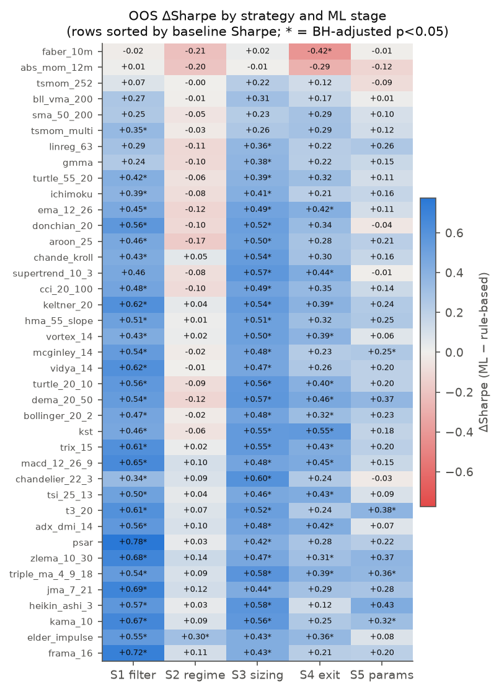
Figure 1. Out-of-sample ΔSR for every strategy × stage (validation-selected model). Rows are sorted by the baseline Sharpe ratio; an asterisk marks BH-adjusted p < 0.05.
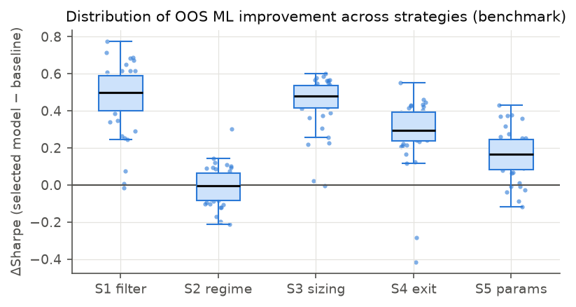
Figure 2. Distribution of ΔSR across the 39 strategies, by stage.

5.3 A diversified view: the 39-strategy composite
An investor would rarely trade a single rule. Table 4 reports an equal-weight composite of all 39 strategies. The rule-based composite has a Sharpe ratio of 0.01. With ML trade selection it reaches 0.60 ($Δ$SR +0.59, 95% confidence interval [0.24, 0.96], $p=0.003$), and with ML sizing 0.57 ($p=0.001$). The maximum drawdown falls from −9.5% to −4.1% with S1, and the share of positive calendar years rises from 52% to 71% (S1) and 81% (S3). The regime gate leaves the composite unchanged ($p=0.93$). Because the composite is highly diversified across instruments and rules, its volatility is low (2.2% for the baseline), so Sharpe ratios rather than raw CAGRs are the meaningful comparison. Figure 3 shows cumulative returns.
Table 4. Equal-weight composite of all 39 strategies: rule-based versus each ML stage (benchmark).
Configuration | CAGR (%) | Vol. (%) | Sharpe | Sortino | Calmar | MaxDD (%) | Pos. years (%) | ΔSR | 95% CI | p
Rule-based | 0.01 | 2.17 | 0.01 | 0.02 | 0.00 | −9.5 | 52 | – | – | –
S1 Filter | 0.97 | 1.63 | 0.60 | 0.82 | 0.24 | −4.1 | 71 | +0.59 | [0.24, 0.96] | 0.003
S2 Regime | 0.02 | 1.12 | 0.03 | 0.03 | 0.01 | −3.8 | 52 | +0.01 | [−0.27, 0.30] | 0.934
S3 Sizing | 1.45 | 2.57 | 0.57 | 0.78 | 0.23 | −6.2 | 81 | +0.56 | [0.26, 0.87] | <0.001
S4 Exit | 0.51 | 1.33 | 0.39 | 0.54 | 0.11 | −4.6 | 71 | +0.38 | [0.09, 0.67] | 0.008
S5 Params | 0.47 | 2.08 | 0.24 | 0.33 | 0.09 | −5.4 | 57 | +0.22 | [0.06, 0.40] | 0.012
Notes: ΔSR, its 95% confidence interval and p-value come from the paired circular block bootstrap (20-day blocks, 2,000 resamples). “Pos. years” is the share of calendar years with a positive return.
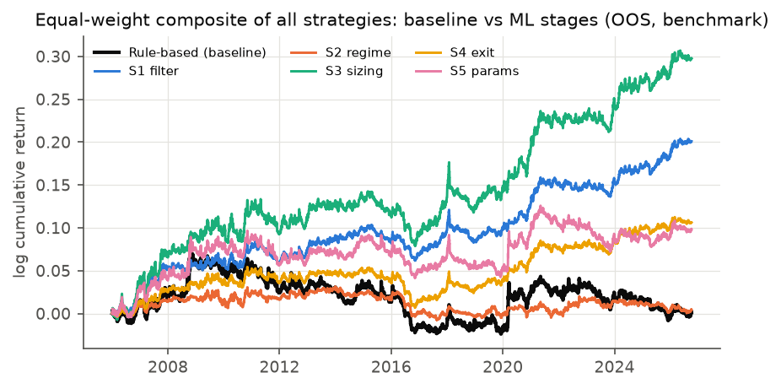
Figure 3. Cumulative out-of-sample log return of the 39-strategy composite: rule-based versus each ML stage.

5.4 Portfolio versus single instruments
At the instrument level, where the rules trade unit size exactly as published, the improvements are real but much smaller. Across the 6,786 strategy–instrument pairs, S1 raises the Sharpe ratio by +0.12 on average and improves 77% of pairs, but only 86 pairs (1.3%) are individually significant after BH adjustment. S3 gives +0.12 (76% improved, 264 significant), S4 +0.08, S5 +0.04 and S2 +0.01, with 12 significant deteriorations for S2. Single-instrument Sharpe ratios are noisy over twenty years, and the portfolio-level gains arise because small, consistent per-instrument improvements accumulate across 174 weakly correlated instruments. A practitioner who trades one market should expect the instrument-level effect, not the portfolio-level one.

5.5 Which model, and does validation-based selection work?
Table 5 reports the OOS $Δ$SR of every model at every stage, how often each was selected on validation, and how the validation-selected configuration compares with the alternatives.
Table 5. Mean ΔSR by model and stage; in parentheses, the share of the 819 fold × strategy choices in which validation selected the model.
Model | S1 Filter | S2 Regime | S3 Sizing | S4 Exit | S5 Params
Logistic regression | +0.43 (12%) | +0.07 (22%) | +0.36 (16%) | +0.26 (18%) | +0.17 (18%)
Random forest | +0.51 (17%) | +0.03 (22%) | +0.46 (18%) | +0.34 (16%) | +0.18 (14%)
Extra trees | +0.54 (51%) | +0.09 (23%) | +0.48 (41%) | +0.36 (30%) | +0.17 (20%)
LightGBM | +0.44 (11%) | +0.04 (20%) | +0.41 (16%) | +0.30 (21%) | +0.19 (30%)
MLP | +0.35 (9%) | −0.00 (13%) | +0.29 (10%) | +0.19 (15%) | +0.15 (18%)
Validation-selected | +0.47 | −0.01 | +0.44 | +0.28 | +0.16
Average of five models | +0.45 | +0.04 | +0.40 | +0.29 | +0.17
Best model ex post | +0.56 | +0.11 | +0.48 | +0.39 | +0.21
Worst model ex post | +0.34 | −0.03 | +0.28 | +0.17 | +0.13
Tree ensembles are the most useful models. Extremely randomised trees lead at S1 (+0.54), S3 (+0.48) and S4 (+0.36), and are the most frequently selected model at these stages; random forests follow closely, and gradient boosting is competitive (and best at S5). The MLP is the weakest model at every stage, and logistic regression lies in between. The instrument-level regression (Section 5.7) confirms this ordering: relative to logistic regression, extra trees add +0.025 and random forests +0.015 to the Sharpe ratio, while the MLP subtracts 0.026.
Validation-based selection is honest but imperfect. At S1 and S3 it does slightly better than the average model (+0.47 against +0.45; +0.44 against +0.40) and clearly worse than the best model ex post (+0.56; +0.48). At S4 and S5 it is slightly below the average model, and at S2 it does worse than every individual model. The gap between “selected” and “best ex post” is the price of honest model selection: reporting the ex-post best model would overstate the benefit of ML trade selection by about 0.09 Sharpe. The models’ average validation scores rank their OOS results consistently (Spearman correlation 0.95 at S3 and 0.75 at S1). This is partly mechanical, because the two-year validation block of one fold covers calendar years that are test years of earlier folds; no fold ever uses its own test year.
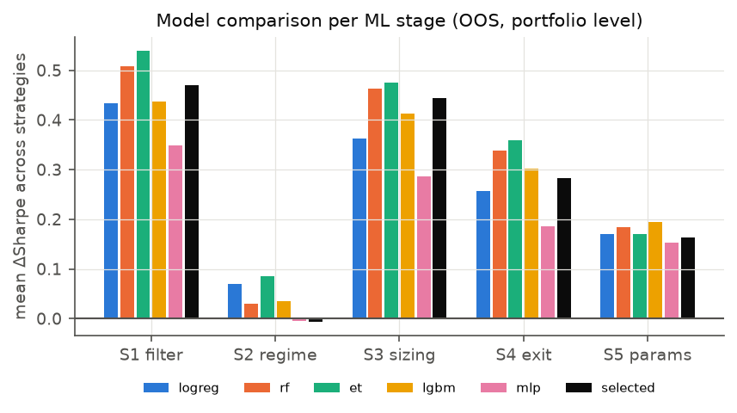
Figure 4. Mean out-of-sample ΔSR by model and stage; “selected” denotes the validation winner.

5.6 Markets
Table 6 breaks the results down by market group. The gains are broad but not universal. Equity indices, ETFs, emerging-market currencies and cryptocurrencies benefit from S1 and S3 for nearly every strategy, and continuous futures benefit somewhat less. G10 currencies are the exception: currency majors show no ML benefit at all, with S3 and S4 slightly reducing the Sharpe ratio (S3: −0.07), and currency crosses show only a small S1 gain (+0.10). G10 currencies are the most efficiently priced and cheapest-to-trade market in the sample, and the rules appear to offer little conditional structure to exploit there. The regime gate hurts in cryptocurrencies (−0.28) and futures (−0.14).
Table 6. Mean ΔSR by market group and stage (39 strategies per group); in parentheses, the number of strategies significant after BH adjustment within the stage.
Market group | Base SR | S1 Filter | S2 Regime | S3 Sizing | S4 Exit | S5 Params
Equity indices | 0.10 | +0.35 (6) | +0.11 (0) | +0.43 (28) | +0.29 (0) | +0.15 (0)
ETFs | 0.01 | +0.37 (21) | +0.03 (0) | +0.36 (31) | +0.25 (0) | +0.17 (0)
Futures | −0.12 | +0.29 (10) | −0.14 (0) | +0.25 (8) | +0.16 (1) | +0.16 (0)
FX emerging | −0.10 | +0.47 (23) | −0.14 (0) | +0.25 (19) | +0.12 (1) | +0.07 (1)
FX crosses (G10) | −0.31 | +0.10 (2) | −0.02 (0) | −0.00 (0) | +0.02 (0) | −0.04 (0)
FX majors (G10) | −0.08 | −0.00 (0) | +0.01 (0) | −0.07 (0) | −0.07 (0) | +0.02 (0)
Crypto | 0.92 | +0.22 (5) | −0.28 (0) | +0.40 (32) | +0.13 (0) | +0.04 (0)
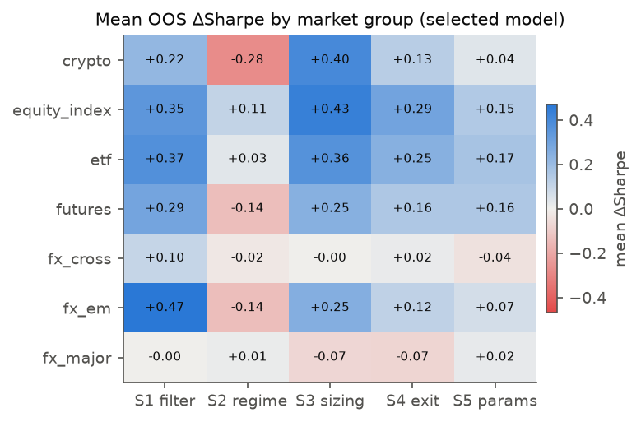
Figure 5. Mean ΔSR by market group and stage.

5.7 Strategies: when does ML help most?
The strongest single predictor of the ML benefit is how good the rule already is. Table 7 regresses instrument-level $Δ$SR on design factors. The coefficient on the baseline’s own Sharpe ratio is −0.19 ($t=−11.7$): every additional unit of baseline Sharpe ratio reduces the ML gain by about a fifth of a unit. Conditional on the other factors, the regime and parameter stages add significantly less than S1, the tree ensembles significantly more than logistic regression, and currencies and futures gain 0.12 and 0.09 less than equities.
Table 7. Determinants of the instrument-level ML benefit: OLS regression of ΔSR on design factors (all stages × models; n = 169,650; R² = 0.190).
Term | Coef. | SE | t | p
Intercept (S1, logistic regression, MA crossover, equity) | 0.169 | 0.011 | 15.97 | <0.001
Stage: S2 Regime | −0.093 | 0.008 | −11.10 | <0.001
Stage: S3 Sizing | −0.010 | 0.006 | −1.81 | 0.070
Stage: S4 Exit | −0.035 | 0.005 | −7.63 | <0.001
Stage: S5 Params | −0.075 | 0.005 | −14.65 | <0.001
Model: Extra trees | 0.025 | 0.003 | 7.92 | <0.001
Model: LightGBM | −0.000 | 0.003 | −0.16 | 0.871
Model: MLP | −0.026 | 0.003 | −8.39 | <0.001
Model: Random forest | 0.015 | 0.003 | 4.90 | <0.001
Family: Adaptive MA | −0.003 | 0.003 | −1.20 | 0.228
Family: Channel breakout | 0.001 | 0.003 | 0.48 | 0.628
Family: Directional movement | −0.009 | 0.002 | −3.88 | <0.001
Family: Oscillator trend | −0.003 | 0.003 | −1.27 | 0.204
Family: Price vs MA | −0.053 | 0.005 | −9.73 | <0.001
Family: Time-series momentum | −0.034 | 0.004 | −7.86 | <0.001
Family: Volatility stop | −0.005 | 0.002 | −2.03 | 0.043
Asset class: Crypto | 0.009 | 0.020 | 0.44 | 0.659
Asset class: ETF | −0.019 | 0.014 | −1.39 | 0.165
Asset class: Futures | −0.085 | 0.014 | −5.95 | <0.001
Asset class: FX | −0.120 | 0.011 | −10.63 | <0.001
Baseline Sharpe ratio of the instrument | −0.193 | 0.016 | −11.74 | <0.001
Notes: Standard errors are clustered by instrument. Reference categories: stage S1, logistic regression, moving-average crossover family, equity asset class.
Table 8 shows the same pattern by strategy family. The slow and already profitable price-versus-moving-average rules (mean baseline Sharpe 0.65) gain only +0.12 from S1, and time-series momentum (baseline 0.48) gains +0.18. The fast adaptive moving averages (baseline −0.25) gain +0.61. ML mostly repairs weak rules, largely by removing trades it expects to lose: S1 reduces annual portfolio turnover by 14 units on average. It improves established, strong rules much less. Section 6.1 tests whether this benefit survives a placebo with the same kind of turnover reduction.
Table 8. Mean ΔSR by strategy family and stage (families sorted by baseline Sharpe ratio).
Strategy family | n | Base SR | S1 Filter | S2 Regime | S3 Sizing | S4 Exit | S5 Params
Adaptive MA | 6 | −0.25 | +0.61 | +0.04 | +0.49 | +0.25 | +0.27
Oscillator trend | 6 | −0.19 | +0.54 | +0.05 | +0.49 | +0.43 | +0.14
Directional movement | 5 | −0.06 | +0.48 | −0.02 | +0.49 | +0.28 | +0.19
Volatility stop | 4 | −0.05 | +0.50 | +0.02 | +0.53 | +0.31 | +0.09
MA crossover | 7 | −0.02 | +0.49 | −0.01 | +0.45 | +0.34 | +0.25
Channel breakout | 5 | 0.05 | +0.53 | −0.05 | +0.50 | +0.35 | +0.15
Time-series momentum | 4 | 0.48 | +0.18 | −0.08 | +0.21 | +0.09 | +0.04
Price vs MA | 2 | 0.65 | +0.12 | −0.11 | +0.16 | −0.13 | +0.00

5.8 Time periods
Table 9 splits the OOS period into four sub-periods. $Δ$SR is positive for S1, S3, S4 and S5 in every sub-period. It is largest in 2021–2026 (S1: +0.84), a period in which the rules themselves lost money (mean baseline Sharpe −0.18), and smallest in 2006–2010, the strong trend-following years around the global financial crisis (baseline 0.32; S1 +0.33). This is the time-series counterpart of Section 5.7: ML helps most when the rule struggles. The regime gate changes sign across sub-periods. Sub-period tests have far fewer observations, so only the 2021–2026 improvements are individually significant for most strategies.
Table 9. Mean ΔSR by sub-period and stage; in parentheses, the number of strategies with a significant improvement (raw, 5%).
Period | Base SR | S1 Filter | S2 Regime | S3 Sizing | S4 Exit | S5 Params
2006–2010 | 0.32 | +0.33 (8) | −0.10 (0) | +0.34 (12) | +0.15 (1) | +0.20 (4)
2011–2015 | −0.32 | +0.34 (3) | +0.19 (2) | +0.21 (0) | +0.15 (1) | +0.14 (2)
2016–2020 | 0.09 | +0.41 (5) | −0.27 (0) | +0.46 (8) | +0.24 (1) | +0.14 (0)
2021–2026 | −0.18 | +0.84 (34) | +0.16 (5) | +0.79 (35) | +0.61 (23) | +0.16 (0)

5.9 Backtest mechanics: costs, execution and sizing
Table 10 repeats the evaluation under alternative backtest assumptions. S1 and S3 remain the two most valuable stages, and S2 the least valuable, under every assumption.
Table 10. Mean ΔSR under alternative backtest assumptions; in parentheses, the numbers of strategies with significant improvements / deteriorations (raw, 5%).
Backtest assumption | Base SR | S1 Filter | S2 Regime | S3 Sizing | S4 Exit | S5 Params
Benchmark: next open, 1× costs, 10% vol target | 0.01 | +0.47 (34/0) | −0.01 (1/2) | +0.44 (35/0) | +0.28 (21/1) | +0.16 (7/1)
Zero costs | 0.27 | +0.41 (32/0) | +0.11 (2/0) | +0.49 (35/0) | +0.35 (30/1) | +0.16 (6/0)
3× costs | −0.52 | +0.58 (36/0) | −0.24 (0/15) | +0.36 (30/1) | +0.14 (3/2) | +0.17 (13/2)
Next-close execution (one bar later) | −0.05 | +0.44 (35/0) | −0.05 (0/2) | +0.43 (34/0) | +0.27 (21/1) | +0.17 (12/0)
Same-close execution (optimistic) | 0.05 | +0.47 (32/0) | +0.02 (2/2) | +0.42 (34/0) | +0.29 (21/1) | +0.14 (7/0)
Unit sizing (no vol targeting) | 0.15 | +0.45 (33/0) | +0.03 (1/2) | +0.51 (37/0) | +0.37 (30/1) | +0.09 (3/2)
Costs. Without costs, the baselines look far better (mean Sharpe 0.27) and the S1 gain shrinks to +0.41, so part of S1’s value is cost avoidance, but most of it is not. At 3× costs the S1 advantage grows to +0.58, while the regime gate becomes clearly harmful (−0.24, with significant deteriorations for 15 strategies). Execution. Executing one bar later or at the signal close leaves the gains essentially unchanged (S1: +0.44 and +0.47), so the improvement does not depend on fragile fill assumptions. The optimistic same-close convention flatters the baselines only mildly (mean Sharpe 0.05, against 0.01 for next-open and −0.05 for next-close). Sizing. Unit sizing without volatility targeting gives the same picture (S1 +0.45, S3 +0.51).
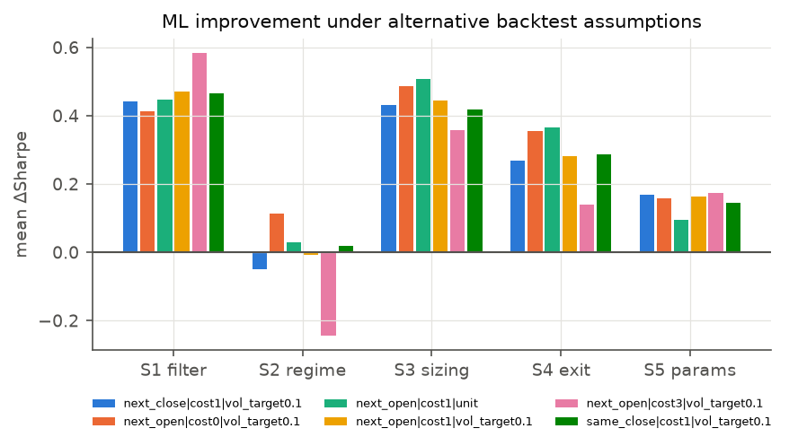
Figure 6. Mean ΔSR per stage under alternative cost, execution and sizing assumptions.

5.10 Overfitting diagnostics
Across each strategy’s 26 OOS configurations (baseline plus 5 stages × 5 models), the probability of backtest overfitting is low: the median PBO is 0.009 and no strategy exceeds 0.5 (Appendix Table B2). The ex-post best configuration is almost always an S3 or S1 model. However, the absolute Sharpe ratio of the best configuration survives deflation for 25 trials (deflated Sharpe ratio above 0.95) for only 9 of the 39 strategies. ML makes weak rules markedly better, but most ML-enhanced rules are still not convincingly profitable on their own after costs over 2006–2026. The improvement is significant; the resulting stand-alone strategy usually is not.

6. Is the improvement learned information?

6.1 Placebo control
Table 11 compares each stage with its placebo, which applies the same decision rule at the same intensity using random numbers instead of model predictions.
Table 11. ML ΔSR versus random-prediction placebo ΔSR (benchmark, selected model, 20 placebo draws per strategy and stage).
Stage | ΔSR, ML | ΔSR, placebo | ML − placebo | ML > placebo mean (%) | ML > placebo 95th pct. | Same, BH
S1 Filter | +0.47 | −0.02 | +0.49 | 100 | 37 | 37
S2 Regime | −0.01 | −0.66 | +0.66 | 100 | 39 | 39
S3 Sizing | +0.44 | −0.56 | +1.01 | 100 | 39 | 39
S4 Exit | +0.28 | −0.32 | +0.60 | 97 | 38 | 38
S5 Params | +0.16 | −0.06 | +0.22 | 92 | 33 | 33
Notes: “ML > placebo 95th pct.” counts strategies whose ML ΔSR exceeds the 95th percentile of their own placebo draws; “Same, BH” applies the Benjamini–Hochberg adjustment to these comparisons.
The mechanical effect of intervening is negative or null, so the ML gains are not an artefact of trading less. At S1 the placebo $Δ$SR is −0.02, against +0.47 for ML, and ML beats the 95th percentile of its own placebo for 37 of the 39 strategies. At S3, random sizing is strongly harmful (−0.56) whereas model-based sizing helps (+0.44). S4 and S5 show the same pattern. Even at S2, where the selected $Δ$SR is about zero, the placebo is clearly negative (−0.66): gating on random numbers removes profitable exposure, so the regime models do carry information, just too little to improve on the rule.

6.2 Random-walk null experiment
Table 12 reports the same pipeline run on synthetic random-walk markets. No stage shows broad, significant improvement: $Δ$SR is +0.11 (S1), −0.20 (S2), −0.33 (S3), +0.04 (S4) and +0.07 (S5), small and mixed in sign, in contrast with gains of +0.16 to +0.47 on real data. The instrument-level false-positive rate is 2.5% at S1 and 1.0% at S3, below the nominal 5%.
Table 12. Null experiment on 60 synthetic random-walk instruments (8 strategies, GARCH-t returns, same costs).
Stage | ΔSR selected | ΔSR all models | Improved (%) | Sig.+ | Sig.− | Instr. false-pos. (%) | ΔSR 0× cost | ΔSR 3× cost
S1 Filter | +0.11 | +0.10 | 50 | 2 | 0 | 2.5 | −0.01 | +0.35
S2 Regime | −0.20 | −0.24 | 0 | 0 | 2 | 1.7 | +0.03 | −0.65
S3 Sizing | −0.33 | −0.35 | 0 | 0 | 7 | 1.0 | −0.03 | −0.94
S4 Exit | +0.04 | −0.02 | 62 | 0 | 0 | 2.9 | +0.06 | −0.01
S5 Params | +0.07 | +0.03 | 75 | 0 | 0 | 2.9 | +0.05 | +0.11
Two features of the null results sharpen the interpretation of the real-data results. First, what remains at S1 on random walks is cost avoidance, not prediction: with zero costs S1’s $Δ$SR is −0.01, and it rises to +0.35 at 3× costs, because skipping trades saves money even when nothing is predictable. Part of S1’s benefit on real data is therefore this mechanical saving, which is why the placebo, which also skips trades at random, is the cleaner test of what the models learn. Second, on noise, model-based sizing and gating hurt: S3 is significantly negative for 7 of the 8 strategies. Models fitted to noise produce confident but meaningless position sizes, so the positive S3 result on real markets is evidence of genuine structure rather than of a leak. This experiment is a screen against gross leakage, not a proof of its absence: it covers 8 strategies, and leakage that requires real market structure to bite would not show up.

6.3 Which inputs carry the improvement? Feature ablation
Table 13 reports the ablation. Every block always sees vol_20 (needed to scale the trade-state features) and the trade-state features themselves.
Table 13. Feature ablation: mean ΔSR of the selected model when ML sees one indicator family, all 56 indicators, or no indicators (15 strategies, lighter protocol); in parentheses, strategies with a significant improvement / strategies.
Feature set seen by the model | S1 Filter | S3 Sizing | S4 Exit
All 56 indicators | +0.43 (13/15) | +0.37 (12/15) | +0.28 (9/15)
Momentum only | +0.48 (14/15) | +0.38 (13/15) | +0.26 (9/15)
Volatility only | +0.46 (13/15) | +0.35 (12/15) | +0.25 (6/15)
Trend only | +0.47 (14/15) | +0.39 (13/15) | +0.29 (9/15)
Oscillator/channel only | +0.48 (13/15) | +0.34 (12/15) | +0.28 (10/15)
Other only | +0.46 (12/15) | +0.38 (13/15) | +0.31 (10/15)
No indicators (context only) | +0.48 (13/15) | +0.36 (12/15) | +0.23 (9/15)
Notes: All blocks use the same lighter protocol (logistic regression and LightGBM, retraining every three years), so they should be compared with each other rather than with Table 3. Every block includes vol_20 and the six trade-state features.
The result is clear, and it is not what the indicator-heavy framing of the study would suggest. No indicator family is necessary: each of the five single-family blocks retains the full S1 gain (+0.46 to +0.48, against +0.43 with all 56 indicators). No indicator at all is needed either: with only vol_20 and the trade-state features, the gains are +0.48 (S1), +0.36 (S3) and +0.23 (S4), against +0.43, +0.37 and +0.28 with the full library, and the number of strategies with a significant improvement is the same (13 of 15 at S1). The broader indicator set adds no detectable value beyond volatility and the state of the open trade (Figure 7).
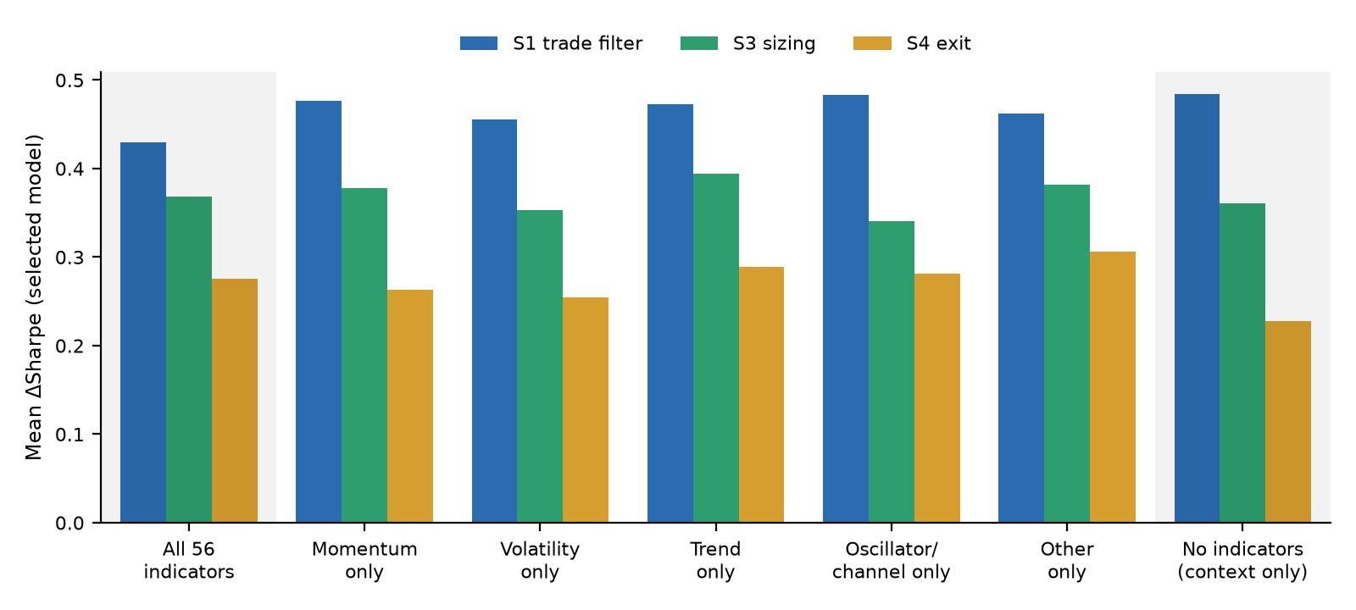
Figure 7. Mean ΔSR (selected model) when ML sees one indicator family, all 56 indicators, or no indicators at all. All blocks use the same lighter protocol.
The mechanism is not tested here. A plausible reading is that the models learn state-dependent trade management: cut trades that are losing relative to their volatility, let older winning trades run, and avoid re-entering immediately after a loss. In effect this is a learned stop-and-trail rule. This reading is consistent with the S1, S3 and S4 results, with the finding that weak, high-turnover rules gain most, and with the placebo evidence, but it remains a hypothesis. A comparison against hand-written volatility-scaled trailing stops is the natural next experiment.

7. Robustness: validation design, frequency and survivorship
Table 14 repeats the experiment under alternative validation designs and universes.
Table 14. Mean ΔSR of the validation-selected model under alternative validation designs and universes; in parentheses, the numbers of strategies with significant improvements / deteriorations after BH adjustment within run.
Run | Base SR | S1 Filter | S2 Regime | S3 Sizing | S4 Exit | S5 Params
Benchmark (expanding WF, daily) | 0.01 | +0.47 (31/0) | −0.01 (1/0) | +0.44 (33/0) | +0.28 (15/1) | +0.16 (4/0)
Rolling 10-year window | 0.01 | +0.44 (30/0) | −0.05 (0/0) | +0.42 (33/0) | +0.31 (23/1) | +0.14 (3/0)
Single hold-out (2013) | −0.08 | +0.62 (32/0) | +0.12 (0/2) | +0.39 (20/0) | +0.30 (16/1) | +0.19 (2/0)
Single stocks (survivorship-biased) | −0.05 | +0.95 (37/0) | +0.09 (5/1) | +0.80 (37/0) | +0.70 (34/1) | +0.34 (26/0)
Crypto, 4-hour bars | 0.17 | +0.35 (6/0) | −0.07 (0/2) | −0.09 (0/0) | +0.05 (0/0) | +0.18 (2/0)
Crypto, 1-hour bars | −2.52 | +1.15 (32/0) | −0.60 (2/32) | −0.47 (2/21) | +0.04 (1/2) | +0.91 (22/1)
Validation design. A rolling ten-year training window gives +0.44 (S1) and +0.42 (S3), and a single 2013 hold-out with no retraining gives +0.62 and +0.39. The conclusions do not depend on the expanding walk-forward design. In every daily design, S1 and S3 have a mean $Δ$SR of at least +0.39, improve at least 94.9% of the strategies and are significant for 20 to 37 strategies after BH adjustment. S2 never helps materially, and S5 is small but positive.
Frequency. At intraday cryptocurrency frequencies the picture changes. At four-hour bars ML sizing no longer helps (−0.09); S1 survives (+0.35, significant for 6 strategies) and S5 is positive on average (+0.18) but significant for only 2. At one-hour bars every baseline loses heavily after costs (mean Sharpe −2.52). S1 and S5 improve them (+1.15 and +0.91) while S2 and S3 make them worse: S3 is significantly negative for 21 strategies. The S1 gain at this frequency is mostly avoided trading cost, and almost all ML variants remain unprofitable: only 79 of the 1,209 strategy × stage × model configurations have a positive Sharpe ratio, against 4 of the 39 baselines. The sizing effect in particular appears specific to daily bars.
Survivorship. On the survivorship-biased single-stock universe (current S&P 100 and NIFTY 50 members), the gains are the largest of any run: S1 +0.95, S3 +0.80 and S4 +0.70, from a mean baseline Sharpe of −0.05. Because these stocks are in the sample because they survived, these larger gains are an upper bound that does not generalise, and we exclude them from the conclusions.

8. Discussion

8.1 Answer to the research question
How much? It depends on the stage. Out of sample over 2006–2026, ML that selects trades raises the Sharpe ratio of the average trend rule by 0.47, and ML position sizing by 0.44, from a baseline of 0.01. ML exits add 0.28 and parameter adaptation 0.16, while a strategy-agnostic regime gate adds nothing. In a diversified composite of all 39 rules the Sharpe ratio rises from 0.01 to 0.60 (S1) or 0.57 (S3), and the maximum drawdown falls from −9.5% to −4.1%.
Is it statistically significant? Yes for S1 and S3, and partly for S4. After BH adjustment over the 195 strategy × stage tests, 31 (S1), 33 (S3) and 15 (S4) of the 39 strategies improve significantly; after Holm adjustment, 10, 16 and 1. Hansen’s SPA test rejects “no ML configuration beats the rule” for 38 of 39 strategies, the probability of backtest overfitting is low, the random-prediction placebo is negative or null, and the random-walk experiment shows no broad improvement.
Under what conditions is it robust? The improvement is robust to the validation design (expanding, rolling, single hold-out), to the time period (positive in every five-year sub-period for S1, S3, S4 and S5), and to costs, execution timing and sizing. It holds for equity indices, ETFs, emerging-market currencies, cryptocurrencies and, less strongly, futures. It is largest for weak, high-turnover rules and smallest for slow, already-profitable rules. Tree ensembles are the best models and the neural network the weakest.
Where it is not robust. The improvement does not transfer to intraday frequencies for position sizing, it is absent for G10 currencies, and regime detection does not help in any daily design. Part of the trade-filtering gain is cost avoidance. Most importantly, the gain does not come from the technical indicators: a model that sees no indicator, only volatility and the state of the open trade, obtains the same improvement as one given 56 indicators.

8.2 Interpretation and implications
Three implications follow. First, for practitioners, the most productive use of ML on a trend rule is rule-specific: deciding whether to take a given trade and how large to make it. Strategy-agnostic forecasts of whether a market will trend did not help, even though the regime models carry some information (their placebo is strongly negative). The economically relevant target is the payoff of the rule’s own position.
Second, the evidence that ML “improves trend following” should be read as evidence that a learned trade-management layer improves it, not as evidence that the indicator library has predictive content. This matters both for the design of such systems (a parsimonious state representation suffices) and for the interpretation of the many studies that attribute ML gains to elaborate indicator sets. It also suggests that part of what the models learn might be replicable by simpler, hand-written rules, which is the most important open question left by this study.
Third, statistical and economic significance diverge. A robust improvement of 0.4–0.5 in Sharpe ratio, measured against baselines that earn about zero, still leaves most individual ML-enhanced rules short of convincing stand-alone profitability once the search is deflated. The improvement is largest precisely where the rules are weakest. The case for ML is strongest in diversified portfolios of rules and instruments, where small, consistent per-instrument gains accumulate, and weakest for a single rule on a single market.

9. Limitations
Data quality. The data come from free vendors. Continuous futures are not roll-adjusted, indices exclude dividends, currency returns exclude carry and cryptocurrency prices are cross-venue aggregates. These affect the baseline and the ML variants identically, so the differences are less exposed than the levels, but absolute Sharpe ratios should be read with these caveats.
Costs. Costs are per-asset-class assumptions. Market impact is not modelled, which matters for large capital in the less liquid futures and emerging-market currencies.
Fixed hyper-parameters. Each model family is represented by one a-priori configuration. Tuning on validation data could change the model ranking, but would also enlarge the search that the multiple-testing corrections must cover.
Mechanism. The ablation shows that the gains do not require technical indicators, but it cannot establish what the models learn from the trade state and volatility. We did not compare the models with hand-written volatility-scaled trailing stops or re-entry rules.
Ablation scope. The single-family and context-only blocks use a lighter protocol (S1, S3 and S4; two models; three-year retraining; 15 representative strategies).
Pooled models. One model is fitted per strategy and stage across all instruments. Per-asset-class models are a natural extension.
History. The OOS period starts in 2006. Longer histories (pre-1990 futures, century-long index series) would cover more trend regimes.
Survivorship. The benchmark universe avoids constituent selection. The single-stock run is survivorship-biased by construction and is reported only as such.

10. Conclusion
We measured how much machine learning improves 39 established trend-following rules, stage by stage, on a multi-asset panel with purged walk-forward validation, realistic execution and costs, and inference that accounts for the size of the search. ML that selects trades or sizes positions improves the average rule by 0.44–0.47 in Sharpe ratio, significantly for most rules, robustly across validation designs, periods and backtest assumptions, and beyond what a random-prediction placebo achieves. ML exits help less, parameter adaptation little, and strategy-agnostic regime detection not at all. The gains concentrate in weak rules, fail at intraday frequencies for position sizing and are absent for G10 currencies. Most importantly, they do not depend on technical indicators: volatility and the state of the open trade suffice. The natural next step is to test whether hand-written trade-management rules can recover the learned improvement, which would tell us whether ML adds something genuinely new to trend following or rediscovers rules that traders could write down themselves.

Declarations
Data availability. Market data were obtained from Yahoo Finance, the Binance public API and FRED. Vendor terms may not permit redistribution of the raw data; the repository contains scripts that download and clean the identical data set and record file hashes, so that the data set used here can be verified.
Code availability. All code (data pipeline, 39 strategies, 56 features, ML stages, backtester, statistical tests, experiment registry and the scripts that generate every table and figure) is available at [repository URL to be inserted].
Use of AI tools. [Authors to complete according to the target journal’s policy. For example: “Generative AI tools (Anthropic Claude) were used to assist with software implementation, running experiments and drafting text. The author designed the study, reviewed all code, outputs and text, and takes full responsibility for the content.”]
Funding. [To be completed.]
Competing interests. [To be completed.]

References
Antonacci, Gary. 2014. Dual Momentum Investing: An Innovative Strategy for Higher Returns with Lower Risk. McGraw-Hill.
Appel, Gerald. 1979. The Moving Average Convergence-Divergence Trading Method. Signalert.
Arnott, Rob, Campbell R. Harvey, and Harry Markowitz. 2019. “A Backtesting Protocol in the Era of Machine Learning.” Journal of Financial Data Science 1 (1): 64–74.
Bailey, David H., Jonathan Borwein, Marcos López de Prado, and Qiji Jim Zhu. 2017. “The Probability of Backtest Overfitting.” Journal of Computational Finance 20 (4): 39–69.
Bailey, David H., and Marcos López de Prado. 2014. “The Deflated Sharpe Ratio: Correcting for Selection Bias, Backtest Overfitting, and Non-Normality.” Journal of Portfolio Management 40 (5): 94–107.
Benjamini, Yoav, and Yosef Hochberg. 1995. “Controlling the False Discovery Rate: A Practical and Powerful Approach to Multiple Testing.” Journal of the Royal Statistical Society: Series B 57 (1): 289–300.
Benjamini, Yoav, and Daniel Yekutieli. 2001. “The Control of the False Discovery Rate in Multiple Testing Under Dependency.” Annals of Statistics 29 (4): 1165–88.
Bollinger, John. 2001. Bollinger on Bollinger Bands. McGraw-Hill.
Breiman, Leo. 2001. “Random Forests.” Machine Learning 45 (1): 5–32.
Brock, William, Josef Lakonishok, and Blake LeBaron. 1992. “Simple Technical Trading Rules and the Stochastic Properties of Stock Returns.” Journal of Finance 47 (5): 1731–64.
Chande, Tushar S. 1992. “Adapting Moving Averages to Market Volatility.” Technical Analysis of Stocks & Commodities 10 (3).
Chande, Tushar S., and Stanley Kroll. 1994. The New Technical Trader. Wiley.
Clenow, Andreas F. 2015. Stocks on the Move: Beating the Market with Hedge Fund Momentum Strategies. Equilateral Capital Management.
Donchian, Richard D. 1960. “High Finance in Copper.” Financial Analysts Journal 16 (6): 133–42.
Ehlers, John F. 2005. “FRAMA: Fractal Adaptive Moving Average.” Technical Analysis of Stocks & Commodities 23 (10).
Elder, Alexander. 2002. Come into My Trading Room: A Complete Guide to Trading. Wiley.
Faber, Mebane T. 2007. “A Quantitative Approach to Tactical Asset Allocation.” Journal of Wealth Management 9 (4): 69–79.
Faith, Curtis M. 2007. Way of the Turtle. McGraw-Hill.
Fischer, Thomas, and Christopher Krauss. 2018. “Deep Learning with Long Short-Term Memory Networks for Financial Market Predictions.” European Journal of Operational Research 270 (2): 654–69.
Garman, Mark B., and Michael J. Klass. 1980. “On the Estimation of Security Price Volatilities from Historical Data.” Journal of Business 53 (1): 67–78.
Geurts, Pierre, Damien Ernst, and Louis Wehenkel. 2006. “Extremely Randomized Trees.” Machine Learning 63 (1): 3–42.
Gu, Shihao, Bryan Kelly, and Dacheng Xiu. 2020. “Empirical Asset Pricing via Machine Learning.” Review of Financial Studies 33 (5): 2223–73.
Hansen, Peter Reinhard. 2005. “A Test for Superior Predictive Ability.” Journal of Business & Economic Statistics 23 (4): 365–80.
Harvey, Campbell R., Yan Liu, and Heqing Zhu. 2016“... And the Cross-Section of Expected Returns.” Review of Financial Studies 29 (1): 5–68.
Hurst, Brian, Yao Hua Ooi, and Lasse Heje Pedersen. 2017. “A Century of Evidence on Trend-Following Investing.” Journal of Portfolio Management 44 (1): 15–29.
Jegadeesh, Narasimhan, and Sheridan Titman. 1993. “Returns to Buying Winners and Selling Losers: Implications for Stock Market Efficiency.” Journal of Finance 48 (1): 65–91.
Joubert, Jacques Francois. 2022. “Meta-Labeling: Theory and Framework.” Journal of Financial Data Science 4 (3): 31–44.
Kaufman, Perry J. 1995. Smarter Trading: Improving Performance in Changing Markets. McGraw-Hill.
Ke, Guolin, Qi Meng, Thomas Finley, et al. 2017. “LightGBM: A Highly Efficient Gradient Boosting Decision Tree.” Advances in Neural Information Processing Systems 30.
Krauss, Christopher, Xuan Anh Do, and Nicolas Huck. 2017. “Deep Neural Networks, Gradient-Boosted Trees, Random Forests: Statistical Arbitrage on the S&P 500.” European Journal of Operational Research 259 (2): 689–702.
Ledoit, Olivier, and Michael Wolf. 2008. “Robust Performance Hypothesis Testing with the Sharpe Ratio.” Journal of Empirical Finance 15 (5): 850–59.
Levine, Ari, and Lasse Heje Pedersen. 2016. “Which Trend Is Your Friend?” Financial Analysts Journal 72 (3): 51–66.
Lim, Bryan, Stefan Zohren, and Stephen Roberts. 2019. “Enhancing Time-Series Momentum Strategies Using Deep Neural Networks.” Journal of Financial Data Science 1 (4): 19–38.
Lo, Andrew W., and A. Craig MacKinlay. 1988. “Stock Market Prices Do Not Follow Random Walks: Evidence from a Simple Specification Test.” Review of Financial Studies 1 (1): 41–66.
López de Prado, Marcos. 2018. Advances in Financial Machine Learning. Wiley.
Moskowitz, Tobias J., Yao Hua Ooi, and Lasse Heje Pedersen. 2012. “Time Series Momentum.” Journal of Financial Economics 104 (2): 228–50.
Parkinson, Michael. 1980. “The Extreme Value Method for Estimating the Variance of the Rate of Return.” Journal of Business 53 (1): 61–65.
Politis, Dimitris N., and Joseph P. Romano. 1992. “A Circular Block-Resampling Procedure for Stationary Data.” In Exploring the Limits of Bootstrap, edited by Raoul LePage and Lynne Billard. Wiley.
Rogers, L. C. G., and S. E. Satchell. 1991. “Estimating Variance from High, Low and Closing Prices.” Annals of Applied Probability 1 (4): 504–12.
Romano, Joseph P., and Michael Wolf. 2005. “Stepwise Multiple Testing as Formalized Data Snooping.” Econometrica 73 (4): 1237–82.
Sullivan, Ryan, Allan Timmermann, and Halbert White. 1999. “Data-Snooping, Technical Trading Rule Performance, and the Bootstrap.” Journal of Finance 54 (5): 1647–91.
White, Halbert. 2000. “A Reality Check for Data Snooping.” Econometrica 68 (5): 1097–126.
Wilder, J. Welles. 1978. New Concepts in Technical Trading Systems. Trend Research.
Yang, Dennis, and Qiang Zhang. 2000. “Drift-Independent Volatility Estimation Based on High, Low, Open, and Close Prices.” Journal of Business 73 (3): 477–91.

Appendix A. Strategy and feature definitions
Table A1. The 39 rule-based trend-following strategies.
ID | Rule | Family | Reference | Parameters | Direction
sma_50_200 | SMA 50/200 crossover (golden/death cross) | MA crossover | Brock, Lakonishok & LeBaron (1992); Gartley (1935) | fast=50, slow=200, kind=sma | long/short
ema_12_26 | EMA 12/26 crossover | MA crossover | Appel (1979); standard EMA crossover | fast=12, slow=26, kind=ema | long/short
dema_20_50 | DEMA 20/50 crossover | MA crossover | Mulloy (1994) | fast=20, slow=50, kind=dema | long/short
zlema_10_30 | Zero-lag EMA 10/30 crossover | MA crossover | Ehlers & Way (2010) | fast=10, slow=30, kind=zlema | long/short
jma_7_21 | Jurik MA 7/21 crossover (repository baseline) | MA crossover | Jurik Research; this repository’s JMA signal family | fast=7, slow=21 | long/short
triple_ma_4_9_18 | Triple MA 4/9/18 | MA crossover | Allen (1972) 4-9-18 day method | a=4, b=9, c=18 | long/short
gmma | Guppy multiple moving average | MA crossover | Guppy (2004) | scale=1.0 | long/short
bll_vma_200 | Price vs 200-day MA with 1% band | Price vs MA | Brock, Lakonishok & LeBaron (1992) | n=200, band=0.01 | long/short
faber_10m | Faber 10-month SMA timing (long/cash) | Price vs MA | Faber (2007) | months=10 | long/cash
kama_10 | Price vs KAMA(10,2,30) | Adaptive MA | Kaufman (1995) | n=10, fast=2, slow=30 | long/short
frama_16 | Price vs FRAMA(16) | Adaptive MA | Ehlers (2005) | n=16 | long/short
vidya_14 | Price vs VIDYA(14, CMO 9) | Adaptive MA | Chande (1992) | n=14, kind=vidya | long/short
mcginley_14 | Price vs McGinley Dynamic(14) | Adaptive MA | McGinley (1990) | n=14, kind=mcginley | long/short
t3_20 | Price vs Tillson T3(20) | Adaptive MA | Tillson (1998) | n=20, kind=t3 | long/short
hma_55_slope | Hull MA(55) slope | Adaptive MA | Hull (2005) | n=55 | long/short
donchian_20 | Donchian 20-day channel breakout (stop-and-reverse) | Channel breakout | Donchian (1960); 4-week rule | n=20 | long/short
turtle_20_10 | Turtle System 1 (20/10) | Channel breakout | Dennis & Eckhardt; Faith (2007) | entry=20, exit=10 | long/short
turtle_55_20 | Turtle System 2 (55/20) | Channel breakout | Dennis & Eckhardt; Faith (2007) | entry=55, exit=20 | long/short
bollinger_20_2 | Bollinger band breakout, exit at mid | Channel breakout | Bollinger (2001) | n=20, k=2.0 | long/short
keltner_20 | Keltner channel breakout, exit at mid | Channel breakout | Keltner (1960); Raschke ATR version | n=20, atr_n=10, k=2.0 | long/short
supertrend_10_3 | SuperTrend(10,3) | Volatility stop | Seban (SuperTrend); ATR bands | n=10, mult=3.0 | long/short
psar | Parabolic SAR (0.02/0.2) | Volatility stop | Wilder (1978) | af=0.02, af_max=0.2 | long/short
chandelier_22_3 | Chandelier exit stop-and-reverse (22,3) | Volatility stop | LeBeau & Lucas (1992) | n=22, mult=3.0 | long/short
chande_kroll | Chande-Kroll stop (10,1,9) | Volatility stop | Chande & Kroll (1994) | p=10, x=1.0, q=9 | long/short
tsmom_252 | Time-series momentum 12m | Time-series momentum | Moskowitz, Ooi & Pedersen (2012) | n=252 | long/short
tsmom_multi | Multi-horizon TSMOM (1/3/12m) | Time-series momentum | Hurst, Ooi & Pedersen (2017) | n1=21, n2=63, n3=252 | long/short
abs_mom_12m | Absolute momentum vs T-bills (long/cash) | Time-series momentum | Antonacci (2014) | n=252 | long/cash
linreg_63 | 63-day regression slope sign | Time-series momentum | Clenow (2015); regression trend | n=63 | long/short
macd_12_26_9 | MACD signal-line crossover | Oscillator trend | Appel (1979) | fast=12, slow=26, signal=9 | long/short
trix_15 | TRIX(15) signal crossover | Oscillator trend | Hutson (1983) | n=15, signal=9 | long/short
kst | Know Sure Thing signal crossover | Oscillator trend | Pring (1992) | scale=1.0 | long/short
tsi_25_13 | True Strength Index signal crossover | Oscillator trend | Blau (1991) | r=25, s=13, signal=7 | long/short
cci_20_100 | CCI(20) +/-100 trend rule | Oscillator trend | Lambert (1980) | n=20, level=100.0 | long/short
elder_impulse | Elder Impulse system | Oscillator trend | Elder (2002) | ema_n=13, fast=12, slow=26, signal=9 | long/short
adx_dmi_14 | ADX/DMI (ADX>25, DI direction) | Directional movement | Wilder (1978) | n=14, threshold=25.0 | long/short
aroon_25 | Aroon up/down crossover | Directional movement | Chande (1995) | n=25 | long/short
vortex_14 | Vortex indicator crossover | Directional movement | Botes & Siepman (2010) | n=14 | long/short
ichimoku | Ichimoku cloud + TK cross | Directional movement | Hosoda (1969) | tenkan=9, kijun=26, senkou=52 | long/short
heikin_ashi_3 | Heikin-Ashi 3-candle trend | Directional movement | Heikin-Ashi (Homma tradition) | n=3 | long/short
Table A2. The 56 indicator features (all dimensionless).
Feature | Family | Definition
mom_5 | momentum | 5-bar log return / (vol*sqrt(5))
mom_21 | momentum | 21-bar vol-scaled log return
mom_63 | momentum | 63-bar vol-scaled log return
mom_126 | momentum | 126-bar vol-scaled log return
mom_252 | momentum | 252-bar vol-scaled log return (Moskowitz et al. 2012)
mom_252_21 | momentum | 12-1 momentum, vol-scaled (Jegadeesh & Titman 1993)
vol_20 | volatility | 20-bar realised vol (annualised)
vol_ratio | volatility | realised vol 20 / realised vol 120
vol_of_vol | volatility | std of 20-bar vol over 60 bars / mean
parkinson_ratio | volatility | Parkinson (1980) vol / close-close vol
gk_ratio | volatility | Garman-Klass (1980) vol / close-close vol
rs_ratio | volatility | Rogers-Satchell (1991) vol / close-close vol
yz_ratio | volatility | Yang-Zhang (2000) vol / close-close vol
atr_pct | volatility | ATR(14) / close (Wilder 1978)
adx | trend strength | ADX(14) / 100 (Wilder 1978)
di_diff | trend direction | (+DI - -DI)/(+DI + -DI)
aroon_osc | trend direction | (Aroon up - down)/100, n=25 (Chande 1995)
rsi | oscillator | RSI(14)/100 - 0.5 (Wilder 1978)
macd_hist | trend direction | MACD(12,26,9) histogram / ATR (Appel)
macd_line | trend direction | MACD line / ATR
stoch_k | oscillator | Stochastic %K(14)/100 - 0.5 (Lane)
cci | oscillator | CCI(20)/100 (Lambert 1980)
trix | trend direction | TRIX(15) z-scored by 252-bar std (Hutson 1983)
vortex_diff | trend direction | VI+ - VI- (Botes & Siepman 2010)
er_10 | trend strength | Kaufman efficiency ratio, 10 bars
er_63 | trend strength | Kaufman efficiency ratio, 63 bars
chop | trend strength | Choppiness index(14)/100 (Dreiss)
lr_tstat_63 | trend strength | t-stat of 63-bar log-price regression slope / 10
lr_r2_63 | trend strength | R^2 of 63-bar log-price regression
lr_r2_126 | trend strength | R^2 of 126-bar log-price regression
dist_sma50 | trend direction | (close - SMA50)/ATR
dist_sma200 | trend direction | (close - SMA200)/ATR
sma50_200 | trend direction | SMA50/SMA200 - 1, vol-scaled
bb_pctb | channel | Bollinger %b(20,2) - 0.5
bb_width | volatility | Bollinger bandwidth / its 252-bar median
donch_pos_20 | channel | position in 20-bar Donchian channel - 0.5
donch_pos_55 | channel | position in 55-bar Donchian channel - 0.5
keltner_pos | channel | (close - EMA20)/(2*ATR10)
ichimoku_dist | trend direction | (close - cloud mid)/ATR (Hosoda)
psar_dist | trend direction | (close - PSAR)/ATR (Wilder 1978)
supertrend_dist | trend direction | (close - SuperTrend line)/ATR
kama_dist | trend direction | (close - KAMA(10,2,30))/ATR (Kaufman)
hma_slope | trend direction | 5-bar change of HMA(55)/ATR (Hull)
tsi | momentum | TSI(25,13)/100 (Blau 1991)
kst | momentum | KST - signal, z-scored (Pring)
var_ratio_5 | serial dependence | variance ratio VR(5) over 126 bars - 1 (Lo & MacKinlay 1988)
autocorr_1 | serial dependence | lag-1 return autocorrelation over 63 bars
skew_63 | distribution | 63-bar return skewness
kurt_63 | distribution | 63-bar return excess kurtosis / 10
dd_252 | drawdown | close / 252-bar max close - 1, vol-scaled
days_since_high | drawdown | bars since 252-bar high / 252
ulcer_14 | drawdown | Ulcer index(14) / vol
vol_z | volume | log-volume z-score (20); 0 if no volume
obv_slope | volume | 20-bar OBV change / 20-bar volume sum
cmf | volume | Chaikin money flow(20)
mfi | volume | MFI(14)/100 - 0.5

Appendix B. Per-strategy results
Table B1. Out-of-sample performance of the rule-based baselines (benchmark portfolio level, 2006–2026, after costs), sorted by Sharpe ratio.
Strategy | CAGR (%) | Vol. (%) | Sharpe | Sortino | Calmar | MaxDD (%) | Win rate (%) | Profit factor | Turnover | Trades | Pos. years (%)
faber_10m | 2.34 | 2.8 | 0.85 | 1.15 | 0.34 | −7.0 | 37 | 4.67 | 3.8 | 3,481 | 71
abs_mom_12m | 2.29 | 2.7 | 0.84 | 1.14 | 0.37 | −6.2 | 45 | 5.31 | 3.1 | 2,517 | 76
tsmom_252 | 1.51 | 3.2 | 0.49 | 0.67 | 0.16 | −9.6 | 35 | 1.80 | 14.1 | 22,210 | 71
bll_vma_200 | 1.42 | 3.2 | 0.46 | 0.63 | 0.18 | −8.1 | 22 | 1.61 | 7.7 | 12,147 | 67
sma_50_200 | 1.31 | 3.2 | 0.42 | 0.57 | 0.10 | −13.1 | 33 | 1.80 | 5.8 | 5,217 | 71
tsmom_multi | 0.83 | 2.5 | 0.35 | 0.49 | 0.15 | −5.5 | 33 | 1.29 | 26.3 | 58,570 | 67
linreg_63 | 0.74 | 3.1 | 0.25 | 0.35 | 0.09 | −8.4 | 34 | 1.22 | 9.8 | 13,715 | 48
gmma | 0.63 | 2.9 | 0.23 | 0.32 | 0.07 | −9.4 | 29 | 1.21 | 18.8 | 34,098 | 67
turtle_55_20 | 0.54 | 2.7 | 0.21 | 0.30 | 0.07 | −7.8 | 36 | 1.26 | 7.7 | 12,164 | 48
ichimoku | 0.50 | 2.8 | 0.19 | 0.27 | 0.05 | −10.9 | 30 | 1.13 | 21.6 | 40,572 | 52
ema_12_26 | 0.56 | 3.2 | 0.19 | 0.27 | 0.05 | −11.2 | 31 | 1.22 | 17.6 | 30,101 | 57
donchian_20 | 0.29 | 3.0 | 0.11 | 0.15 | 0.03 | −10.0 | 35 | 1.25 | 12.3 | 19,948 | 48
aroon_25 | 0.28 | 3.1 | 0.10 | 0.15 | 0.03 | −10.7 | 37 | 1.17 | 19.7 | 34,380 | 48
chande_kroll | 0.24 | 3.1 | 0.09 | 0.13 | 0.02 | −11.7 | 35 | 1.14 | 26.1 | 46,518 | 48
supertrend_10_3 | 0.23 | 3.0 | 0.09 | 0.13 | 0.02 | −10.0 | 36 | 1.24 | 15.4 | 27,183 | 48
cci_20_100 | 0.11 | 3.1 | 0.05 | 0.07 | 0.01 | −13.1 | 35 | 1.12 | 19.4 | 33,505 | 43
keltner_20 | 0.05 | 2.3 | 0.03 | 0.05 | 0.01 | −8.0 | 34 | 1.13 | 11.3 | 22,587 | 48
hma_55_slope | 0.03 | 3.1 | 0.02 | 0.04 | 0.00 | −13.4 | 35 | 1.07 | 24.3 | 43,704 | 33
vortex_14 | −0.06 | 3.1 | −0.00 | −0.01 | −0.00 | −16.1 | 38 | 1.14 | 45.8 | 88,470 | 43
mcginley_14 | −0.07 | 3.0 | −0.01 | −0.01 | −0.00 | −14.7 | 34 | 1.78 | 50.7 | 96,736 | 48
vidya_14 | −0.08 | 3.1 | −0.01 | −0.02 | −0.01 | −13.4 | 32 | 1.16 | 43.7 | 85,367 | 48
turtle_20_10 | −0.09 | 2.8 | −0.02 | −0.03 | −0.01 | −13.6 | 35 | 1.10 | 14.4 | 26,352 | 43
dema_20_50 | −0.27 | 3.1 | −0.07 | −0.10 | −0.01 | −18.6 | 34 | 1.10 | 18.7 | 31,499 | 38
bollinger_20_2 | −0.22 | 2.5 | −0.08 | −0.11 | −0.02 | −13.4 | 34 | 1.13 | 17.0 | 31,488 | 38
kst | −0.33 | 3.1 | −0.09 | −0.13 | −0.02 | −16.3 | 40 | 1.01 | 26.8 | 48,803 | 43
trix_15 | −0.38 | 3.1 | −0.11 | −0.15 | −0.02 | −15.7 | 39 | 1.02 | 23.7 | 42,483 | 43
macd_12_26_9 | −0.39 | 3.1 | −0.11 | −0.16 | −0.03 | −12.0 | 37 | 1.04 | 37.6 | 70,418 | 43
chandelier_22_3 | −0.39 | 3.0 | −0.12 | −0.16 | −0.03 | −15.5 | 36 | 1.00 | 30.0 | 64,993 | 38
tsi_25_13 | −0.53 | 3.1 | −0.16 | −0.23 | −0.04 | −12.9 | 36 | 1.01 | 40.1 | 75,959 | 43
t3_20 | −0.56 | 3.1 | −0.17 | −0.24 | −0.03 | −17.1 | 33 | 1.03 | 46.3 | 88,763 | 43
adx_dmi_14 | −0.40 | 2.0 | −0.19 | −0.28 | −0.03 | −13.1 | 34 | 1.05 | 13.1 | 25,421 | 19
psar | −0.83 | 2.9 | −0.27 | −0.38 | −0.05 | −17.5 | 38 | 1.01 | 41.7 | 78,696 | 38
zlema_10_30 | −0.92 | 3.1 | −0.28 | −0.40 | −0.05 | −18.1 | 38 | 0.99 | 45.5 | 87,094 | 33
triple_ma_4_9_18 | −0.86 | 2.7 | −0.31 | −0.43 | −0.04 | −20.1 | 36 | 1.04 | 38.7 | 76,700 | 29
jma_7_21 | −1.02 | 3.1 | −0.32 | −0.45 | −0.05 | −20.0 | 37 | 1.00 | 55.9 | 109,470 | 38
heikin_ashi_3 | −1.16 | 2.9 | −0.38 | −0.53 | −0.05 | −21.9 | 36 | 0.99 | 43.0 | 84,081 | 33
kama_10 | −1.52 | 3.0 | −0.50 | −0.70 | −0.05 | −28.2 | 35 | 0.98 | 64.5 | 127,304 | 14
elder_impulse | −1.81 | 2.5 | −0.72 | −1.02 | −0.06 | −32.5 | 36 | 0.99 | 95.4 | 193,782 | 10
frama_16 | −2.36 | 2.8 | −0.83 | −1.15 | −0.06 | −39.7 | 37 | 0.95 | 88.9 | 177,886 | 14
Table B2. Per-strategy ΔSR of the validation-selected model at each stage, Hansen SPA p-value across the 25 ML configurations, probability of backtest overfitting (PBO) and deflated Sharpe ratio (DSR) of the ex-post best configuration. An asterisk marks BH-adjusted p < 0.05.
Strategy | Base SR | S1 Filter | S2 Regime | S3 Sizing | S4 Exit | S5 Params | SPA p | PBO | DSR
faber_10m | 0.85 | −0.02 | −0.21 | +0.02 | −0.42* | −0.01 | 0.009 | 0.004 | 1.00
abs_mom_12m | 0.84 | +0.01 | −0.20 | −0.01 | −0.29 | −0.12 | 0.095 | 0.010 | 1.00
tsmom_252 | 0.49 | +0.07 | −0.00 | +0.22 | +0.12 | −0.09 | 0.015 | 0.000 | 0.99
bll_vma_200 | 0.46 | +0.27 | −0.01 | +0.31 | +0.17 | +0.01 | 0.004 | 0.000 | 0.99
sma_50_200 | 0.42 | +0.25 | −0.05 | +0.23 | +0.29 | +0.10 | 0.005 | 0.003 | 0.99
tsmom_multi | 0.35 | +0.35* | −0.03 | +0.26 | +0.29 | +0.12 | 0.004 | 0.000 | 0.99
linreg_63 | 0.25 | +0.29 | −0.11 | +0.36* | +0.22 | +0.26 | <0.001 | 0.049 | 0.92
gmma | 0.23 | +0.24 | −0.10 | +0.38* | +0.22 | +0.15 | 0.002 | 0.007 | 0.97
turtle_55_20 | 0.21 | +0.42* | −0.06 | +0.39* | +0.32 | +0.11 | 0.004 | 0.006 | 0.93
ichimoku | 0.19 | +0.39* | −0.08 | +0.41* | +0.21 | +0.16 | 0.001 | 0.001 | 0.95
ema_12_26 | 0.19 | +0.45* | −0.12 | +0.49* | +0.42* | +0.11 | 0.004 | 0.000 | 0.98
donchian_20 | 0.11 | +0.56* | −0.10 | +0.52* | +0.34 | −0.04 | 0.004 | 0.009 | 0.79
aroon_25 | 0.10 | +0.46* | −0.17 | +0.50* | +0.28 | +0.21 | 0.002 | 0.006 | 0.80
chande_kroll | 0.09 | +0.43* | +0.05 | +0.54* | +0.30 | +0.16 | 0.001 | 0.014 | 0.90
supertrend_10_3 | 0.09 | +0.46 | −0.08 | +0.57* | +0.44* | −0.01 | <0.001 | 0.003 | 0.79
cci_20_100 | 0.05 | +0.48* | −0.10 | +0.49* | +0.35 | +0.14 | 0.002 | 0.011 | 0.85
keltner_20 | 0.03 | +0.62* | +0.04 | +0.54* | +0.39* | +0.24 | <0.001 | 0.019 | 0.92
hma_55_slope | 0.02 | +0.51* | +0.01 | +0.51* | +0.32 | +0.25 | <0.001 | 0.005 | 0.88
vortex_14 | −0.00 | +0.43* | +0.02 | +0.50* | +0.39* | +0.06 | 0.002 | 0.004 | 0.74
mcginley_14 | −0.01 | +0.54* | −0.02 | +0.48* | +0.23 | +0.25* | <0.001 | 0.000 | 0.91
vidya_14 | −0.01 | +0.62* | −0.01 | +0.47* | +0.26 | +0.20 | <0.001 | 0.001 | 0.92
turtle_20_10 | −0.02 | +0.56* | −0.09 | +0.56* | +0.40* | +0.20 | <0.001 | 0.001 | 0.86
dema_20_50 | −0.07 | +0.54* | −0.12 | +0.57* | +0.46* | +0.37 | <0.001 | 0.237 | 0.69
bollinger_20_2 | −0.08 | +0.47* | −0.02 | +0.48* | +0.32* | +0.23 | <0.001 | 0.109 | 0.74
kst | −0.09 | +0.46* | −0.06 | +0.55* | +0.55* | +0.18 | <0.001 | 0.079 | 0.75
trix_15 | −0.11 | +0.61* | +0.02 | +0.55* | +0.43* | +0.20 | <0.001 | 0.068 | 0.73
macd_12_26_9 | −0.11 | +0.65* | +0.10 | +0.48* | +0.45* | +0.15 | 0.001 | 0.040 | 0.83
chandelier_22_3 | −0.12 | +0.34* | +0.09 | +0.60* | +0.24 | −0.03 | <0.001 | 0.001 | 0.65
tsi_25_13 | −0.16 | +0.50* | +0.04 | +0.46* | +0.43* | +0.09 | <0.001 | 0.022 | 0.73
t3_20 | −0.17 | +0.61* | +0.07 | +0.52* | +0.24 | +0.38* | <0.001 | 0.063 | 0.77
adx_dmi_14 | −0.19 | +0.56* | +0.10 | +0.48* | +0.42* | +0.07 | <0.001 | 0.036 | 0.50
psar | −0.27 | +0.78* | +0.03 | +0.42* | +0.28 | +0.22 | <0.001 | 0.002 | 0.65
zlema_10_30 | −0.28 | +0.68* | +0.14 | +0.47* | +0.31* | +0.37 | <0.001 | 0.062 | 0.66
triple_ma_4_9_18 | −0.31 | +0.54* | +0.09 | +0.58* | +0.39* | +0.36* | <0.001 | 0.074 | 0.44
jma_7_21 | −0.32 | +0.69* | +0.12 | +0.44* | +0.29 | +0.28 | <0.001 | 0.048 | 0.64
heikin_ashi_3 | −0.38 | +0.57* | +0.03 | +0.58* | +0.12 | +0.43 | <0.001 | 0.085 | 0.31
kama_10 | −0.50 | +0.67* | +0.09 | +0.56* | +0.25 | +0.32* | <0.001 | 0.028 | 0.41
elder_impulse | −0.72 | +0.55* | +0.30* | +0.43* | +0.36* | +0.08 | <0.001 | 0.043 | 0.05
frama_16 | −0.83 | +0.72* | +0.11 | +0.43* | +0.21 | +0.20 | <0.001 | 0.009 | 0.08

Appendix C. Data validation
Table C1. Cross-source validation of overlapping series (daily and weekly return correlations and annualised tracking error).
Comparison | Overlap (days) | Corr. daily | Corr. weekly | Tracking error (%/yr)
BTC: Yahoo aggregate vs Binance spot | 3,331 | 0.99 | 1.00 | 7.6
ETH: Yahoo aggregate vs Binance spot | 3,247 | 0.99 | 1.00 | 8.2
XRP: Yahoo aggregate vs Binance spot | 3,071 | 1.00 | 1.00 | 6.3
S&P 500 index vs SPY ETF (dividend-adjusted) | 8,478 | 0.98 | 1.00 | 3.2
S&P 500 index vs E-mini continuous future (unadjusted) | 6,547 | 0.97 | 0.98 | 4.6
NASDAQ Composite vs QQQ | 6,936 | 0.96 | 0.98 | 7.2
Dow index vs DIA | 7,220 | 0.99 | 1.00 | 2.9
Russell 2000 vs IWM | 6,627 | 0.99 | 1.00 | 3.5
EURUSD spot vs Euro FX future | 5,728 | 0.40 | 0.86 | 9.9
USDJPY spot vs Yen future (inverse quote) | 6,468 | 0.44 | 0.86 | 10.5
AUDUSD spot vs AUD future | 5,122 | 0.41 | 0.86 | 13.5
Gold future vs GLD | 5,492 | 0.89 | 0.98 | 8.7
Silver future vs SLV | 5,137 | 0.90 | 0.98 | 15.7
WTI future vs USO | 5,148 | 0.91 | 0.95 | 17.3
Natural gas future vs UNG | 4,896 | 0.84 | 0.91 | 32.5
T-Bond future vs TLT | 6,075 | 0.90 | 0.92 | 6.7
Nikkei 225 vs EWJ (USD, different index) | 7,234 | 0.43 | 0.72 | 24.8
Sensex vs NIFTY 50 | 4,666 | 0.99 | 0.99 | 2.6

