PROJECT L.M.A.O.

The Laura Mood Assessment Output draws on a weather API to grab weather data from Worcester or Ledyard (depending on a switch). Depending on current conditions (primarily amount of sun / rain) it calculates a mood percentage. This percentage is then fed to a servo-controlled smiley face as shown in figures below.

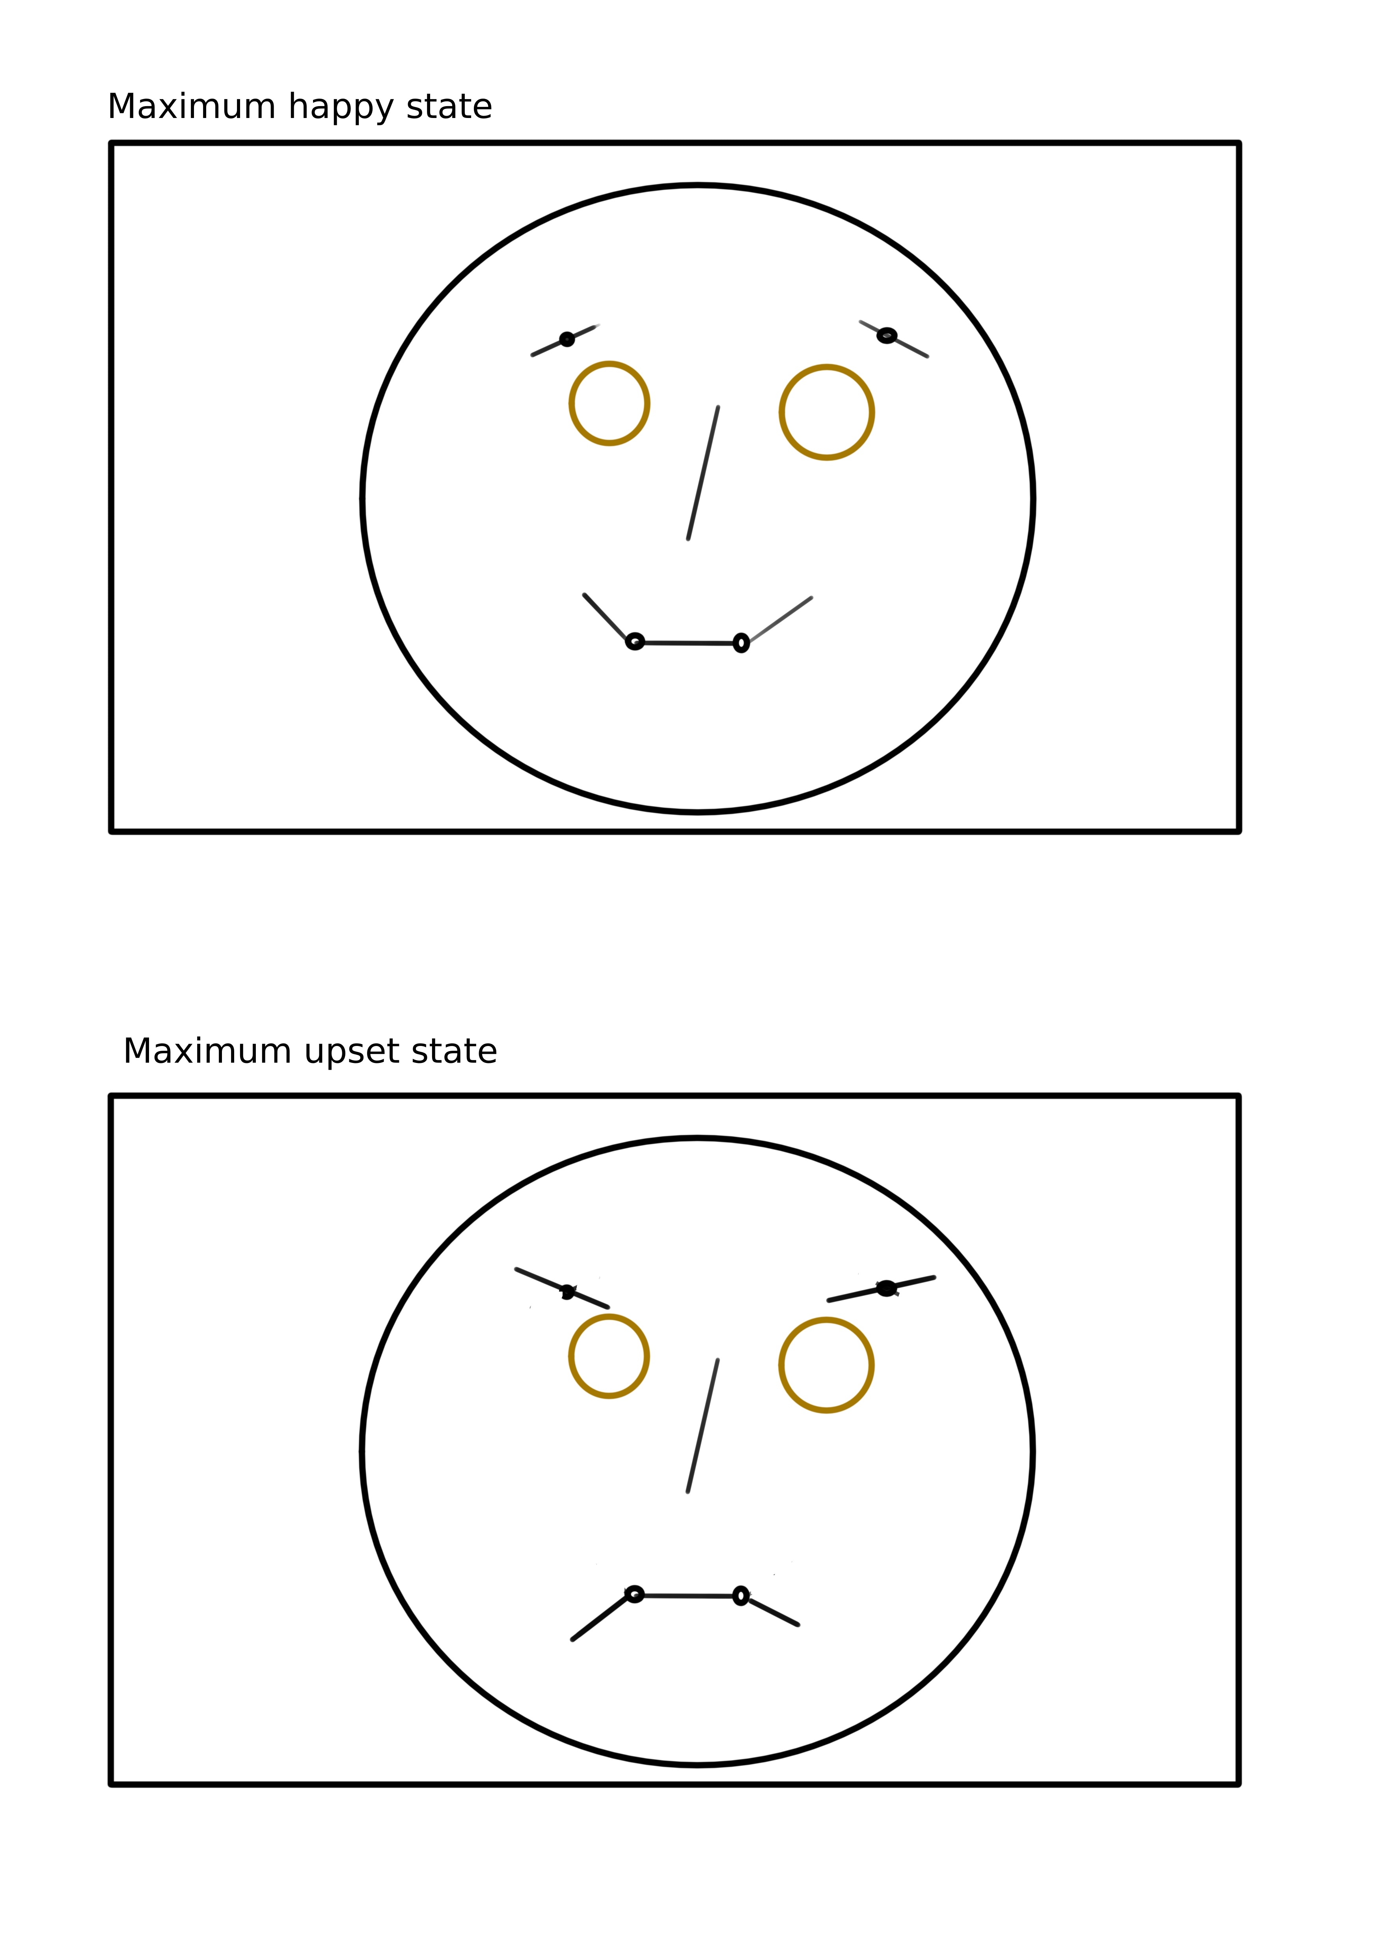As shown in the diagram (left) the system is made up of 4 servos: 2 controlling the eyebrows and 2 on the edges of the mouth. The eyebrow servos are using dual-sided control arms fixed at 180 degrees from each other around the servo hub. The mouth servos are single-sided control arms. The assembly will be mounted on a cardboard backplane with the other face details drawn on it. A raspberry pi 3b+ with servo HAT will be mounted on the reverse side of the backplane.