AI-Powered Email Subject Line Generator
- OpenAI API or Hugging Face kullanilabilir
- Ara yuzde basligin yanina bir link koyulacak.
- Tiklandiginda asagidaki gorsel acilacak
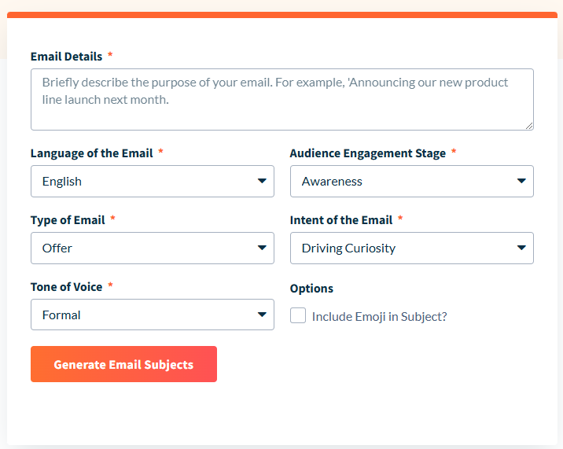

Language  English  Spanish  Mandarin  Arabic  Portuguese  Greek  Japanese  Italian  Hindi  Turkish  Korean  Dutch | Audience Engagement Stage  Awareness  Acquistion  Engagement  Sales  Retention
Type of Email  Offer  Transactional  Milestone  Promotional  Newsletter  New Collection  Product Update  Product Launch  Survey Email  New Feature Launch  Other | Intent of Email  Driving Curiosity  Asking Question  Make it Actionable
Tone of Voice  Formal  Informal  Humorus  Serious  Optimistic  Motivating  Respectful  Assertive  Conversational | Options Include Emoji in Subject?

Alternatif

