[1]

Comparing the homomorphic filtering and gray levels’ linear transformation

Jianeng XU,Rui Zhang*

*Abstract*—Enhancing an image provides better contrast and a more detailed image as comparing to non enhanced image. In this paper, several gray scale images were selected to be processed by using homomorphic filtering and gray levels’ linear transformation. By comparing these two methods of processing, we can get the conclusions as follows. 1. The result-image of homomorphic filtering would be much brighter than the original one. The slowly varing thing would disappear in the result-image. 2. Processed by gray levels’ linear transformation, if parameter b is big enough to contain nearly all gray levels in the histogram, it could show more information, but will not show clearly in details of the dark area. If b is small, but still contain many gray levels in the histogram, it will show clearly in details of the dark area, but will lose some important information in bright place. 3. We should choose different methods to deal with our image by its characteristic. If it varys abruptly, homomorphic filtering will work better. If the distribution of this image's histogram is concentrated, gray level s’linear transformation should be your choice.

*Index Terms*—Image enhancement, homomorphic filtering, linear transformation

# INTRODUCTION

A

s we all know, the visual quality of a gray level image could be improved by homomorphic filtering , gray levels’ linear transformation and other image enhancement methods.

In many applications signals are combined in a rather complicated way. Convolved signals are encountered in seismic signal processing, digital speech processing, digital echo removal and digital image restoration. Signals combined in a nonlinear way are encountered in digital signal processing for communication systems and in digital image filtering. Classical linear processing techniques are not so useful in those cases because the superposition property does not hold any more. Therefore, a special class of filters has been developed for the processing of convolved and nonlinearly related signals. They are called homomorphic filters. Their basic characteristic is that they use nonlinearities (mainly the logarithm) to transform convolved or nonlinearly related signals to additive signals and then to process them by linear filters. The output of the linear filter is transformed afterwards by the inverse nonlinearity. Homomorphic filtering has found many applications in digital image processing. It is recognized as one of the oldest nonlinear filtering techniques applied in this area.

The transformation function has been given as s = T (r) where r is the pixels of the input image and s is the pixels of the output image. T is a transformation function that maps each value of r to each value of s. Image enhancement can be done through gray levels’ transformations.

# Homomorphic filtering

Homomorphic filtering is a generalized technique for signal and image processing, involving a nonlinear mapping to a different domain in which linear filter techniques are applied, followed by mapping back to the original domain. This concept was developed in the 1960s by [Thomas Stockham](http://en.wikipedia.org/wiki/Thomas_Stockham), [Alan V. Oppenheim](http://en.wikipedia.org/wiki/Alan_V._Oppenheim), and [Ronald W. Schafer](http://en.wikipedia.org/wiki/Ronald_W._Schafer) at [MIT](http://en.wikipedia.org/wiki/MIT).

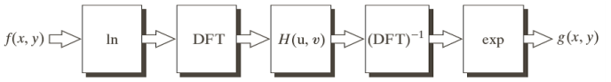

Fig. 2.1. Homomorphic Filtering Block Diagram

An image can be expressed as the product of illumination and reflectance:

 (1)

Now define:

 (2)

 (3)

We then apply a filter to G:

 (4)

In the spatial domain:

 (5)

We then exponentiate s(x, y) to get the enhanced image:

 (6)

Nowand are the illumination and reflectance of the “enhanced” image. The illumination component tends to vary slowly across the image. The reflectance tends to vary rapidly, particularly at junctions of dissimilar objects. Therefore, by applying a frequency domain filter of the form

 (7)

we can reduce intensity variation across the image while highlighting detail.

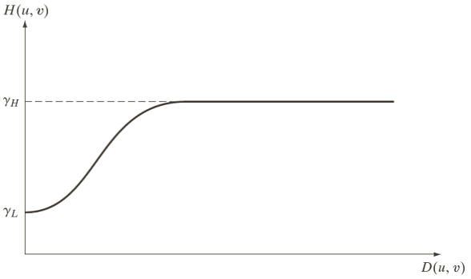

Fig. 2.2. Cross section of a spherically symmetric homomorphic filter

Although homomorphic filtering in the spectral domain is conceptually simple, its implementation becomes unwieldy when dealing with large images. The second problem encountered with spectral domain homomorphic filtering is circular convolution.

# gray levels’ linear transformation

A linear transformation of an image is a function that maps each pixel gray level value into another gray level at the same position according to a linear function. The input (argument) is a gray level f = f(m,n) at location (m,n) and the output is a new gray level g = g(m,n) defined at the same position (m,n). Linear mappings have the form g(m,n) = T[f(m,n)] such that

 (8)

However, affine transformations are more useful and they are just a linear transformation followed by a translation, such as the equation of a line, y = ax + b, where a is the slope and b is the y-intercept. These are often called linear and so we will also. For images gray level transformations these take the form

 (9)

Fig. 3.1 presents a linear transformation that maps the gray levels of an input image {f(m,n)} into the gray levels of an output image {g(m,n)}. In this case the transformation dilates the input domain from a min max min subinterval of minimum to maximum gray levels for the original image,  , onto the full interval  = [0, 255] for the output image. This stretches the contrast to the boundaries of the grayscale.

A min max min max linear transformation of the input gray level interval  onto the output interval has the form of Equation (2.1b) above, where the slope a is defined as usual. Thus

 (10)

 (11)

at each min min location (m,n). When  we desire that  , so we can substitute into Equation (7) the point to solve for b .

Upon substituting for b in Equation (11) and collecting terms, we obtain

 (12)

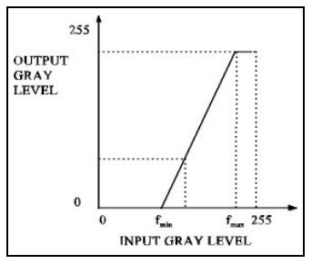

Fig. 3.1. Dilating Linear Transformation

Equation (12) maps  into  ,  into , and everything else to its proportion p of the way between min max min max f and f into that proportion p of the way between g and g . This transformation may be used to map a smaller interval of gray values into a larger one (contrast stretching), but also may be used to map a larger interval into a smaller one (contrast compression).

A related transformation breaks the range of gray levels into subintervals and uses a linear transformation on each subinterval. Fig. 3.2 shows such a piecewise linear transformation. The only min max min max requirement is that the conditions and  are met. The equation for the linear mapping must be defined appropriately on each subinterval.

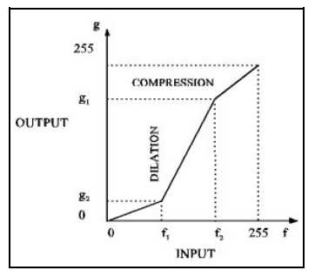

Fig. 3.2. Piecewise Linear Transformation

# experimental results and analysis

## Results of homomorphic filtering

We have implemented the homomorphic filtering using Matlab. As we can see from the Fig. 4.1, The image “baboon.bmp” is read into the program and we can describe the spectrogram and histogram as (c) and (e). Then, we use the homomorphic filter to process the original image. The result is shown in the (b),(d) and (f). It looks that the image gets a higher contrast after homomorphic filtering .

|  |  |
| --- | --- |
| (a) | (b) |
| (c) | (d) |
| (e) | (f) |

Fig. 4.1. (a) is the original image, (c) shows the spectrogram of the original image, (e) shows the histogram the original image, (b) shows the effect of homomorphic filter, (d) and (f) are the spectrogram and histogram respectivel

## Results of gray levels’ linear transformation

Of course, We have also implemented the gray levels’ linear transformation using Matlab. As we can see from the Fig. 4.2, The image “couple.bmp” is read into the program and we can describe the spectrogram and histogram as (c) and (e). Then, we use the gray levels’ linear transformation to process the original image with Fa=2. The result is shown in the (b),(d) and (f). It looks that mbient light is improved and the image gets a higher contrast after gray levels’ linear transformation compared with the original image.

|  |  |
| --- | --- |
| (a) | (b) |
| (c) | (d) |
| (e) | (f) |
| Fig. 4.2. (a), (c),(e)shows the original image and spectrogram and histogram, (b) shows the effect of gray levels’ linear transformation, (d) and (f) are the spectrogram and histogram respectively  Then, we try to change the parameter Fa to observe the effect of gray levels’ transformation. In the last sentence, we set the Fb=2, here, we set Fb=1 and Fb=4 respectively. As we can see from the Fig. 4.3, the image becomes darker when Fb is lower and the image becomes brighter when Fb is higher. That is to say, the value of Fb is an important parameter we should notice when we use gray levels’ linear transformation. A favourable value of Fb is the key of gray levels’ linear transformation. | |
| (a) | (b) |
| (c) | (d) |
| (e) | (f) |
| Fig. 4.3. (a), (c) and (e) show the effect of gray levels’ linear transformation with Fa=1, (b), (d) and (f) show the effect of gray levels’ linear transformation with Fa=4 | |

# Comparison

Here we compare the difference between homomorphic filtering and gray level's linear transformation. The results are shown as follws.

|  |  |
| --- | --- |
| (a) | (b) |
| (c) | (d) |
| (e) | (f) |

Fig. 5.1. (a),(b)shows the original image, (c) ,(d) show the effect of homomorphic filter, (e),(f) show the effect of gray levels’ linear transformation

Homomorphic filtering in the frequency domain can enhance the high-frequency parts of the image while retaining the low-frequency ones. So it can enhance the image contrast effect, and compress the dynamic range of gray scale image. If an image vary slowly, it will not work very well.

Gray levels’ linear transformation can expand the dynamic range and enhance the contrast, while homomorhpic filter compress the dynamic gray level range. If the distribution of an image's histogram is near normality or not concentrated, it will not work well.

# Conclusion

we should choose different methods to deal with our image by its characteristic. If it varys not slowly, homomorphic filtering will be better. If the distribution of an image's histogram is concentrated, gray leves’l linear transformation should be your choice.

References

1. *Frei W. Image enhancement by histogram hyperbolization[J]. Computer Graphics and Image Processing, 1977, 6(3): 286-294.*
2. *Kramer H P, Bruckner J B. Iterations of a non-linear transformation for enhancement of digital images[J]. Pattern recognition, 1975, 7(1): 53-58.*
3. *Sternberg S R. Grayscale morphology[J]. Computer Vision, Graphics, and Image Processing, 1986, 35(3): 333-355.*
4. *Guerra C F, Snijders J G, Te Velde G, et al. Towards an order-N DFT method[J]. Theoretical Chemistry Accounts, 1998, 99(6): 391-403.*
5. *Voicu L I, Myler H R, Weeks A R. Practical considerations on color image enhancement using homomorphic filtering[J]. Journal of Electronic Imaging, 1997, 6(1): 108-113.*
6. *Oppenheim A V. Speech Analysis‐Synthesis System Based on Homomorphic Filtering[J]. The Journal of the Acoustical Society of America, 1969, 45(2): 458-465.*
7. *Adelmann H G. Butterworth equations for homomorphic filtering of images[J]. Computers in Biology and Medicine, 1998, 28(2): 169-181.*
8. *Cole E R. The removal of unknown image blurs by homomorphic filtering[R]. UTAH UNIV SALT LAKE CITY COMPUTER SCIENCE DIV, 1973.*
9. *Gross R, Brajovic V. An image preprocessing algorithm for illumination invariant face recognition[C]//Audio-and Video-Based Biometric Person Authentication. Springer Berlin Heidelberg, 2003: 10-18.*
10. *Chen Z Y, Abidi B R, Page D L, et al. Gray-level grouping (GLG): an automatic method for optimized image contrast Enhancement-part I: the basic method[J]. Image Processing, IEEE Transactions on, 2006, 15(8): 2290-2302.*
11. *Jain A K, Farrokhnia F. Unsupervised texture segmentation using Gabor filters[C]//Systems, Man and Cybernetics, 1990. Conference Proceedings., IEEE International Conference on. IEEE, 1990: 14-19.*
12. *Raji A, Thaibaoui A, Petit E, et al. A gray-level transformation-based method for image enhancement[J]. Pattern Recognition Letters, 1998, 19(13): 1207-1212.*

1. Manuscript received XXX; revised XXX; accepted XXX. This work just is the project assigned by the teacher(Digital Image Processing).

   The authors are with the School of Electronic Information and Electrical

   Engineering, Shanghai Jiao Tong University, Shanghai 200240, China (e-mail:canonxu@yeah.net).