University of Science and Technology Houari Boumediene
Department of Computer Science
Mission and Equipment Dispatch Management System
with JSON export and QR-code traceability
Module: Project Management
Methodology: Kanban | Tool: Jira Software
Team:
- Product Owner – Selmani – sarah.4univ@gmail.com
- Flow Manager – Kadri Khodja – kamikkhodja@gmail.com
- Backend Developer – Guellil – souheilsouhil1@gmail.com
- Frontend Developer – Rezig – 2000pilard@gmail.com
- Integration Developer – Guerguadj – nazimguerguadj@gmail.com
- QA / Documentation – Razem – Razemikram96@gmail.com
Academic year: 2025 – 2026

1. Introduction
As part of the Project Management module, our six-member team developed a mini-project titled Mission and Equipment Dispatch Management System. The idea came from a simple observation: in many industrial companies, the preparation of equipment deployment missions is still a largely manual process, prone to errors and wasted time.
Our system addresses this need by offering an integrated solution that allows the user to:
- Create a complete mission (location, dates, driver, technicians, equipment)
- Automatically generate a JSON file for tracking systems
- Produce a logistics document (PDF) for the warehouse
- Create a QR code for quick traceability in the field
The project was completed in 5 days following the Kanban methodology, with full tracking through Jira Software. This report presents the idea we implemented, our choices and their justifications, the work breakdown, the difficulties encountered, and the contribution of the AI tools used.

2. Project Idea and Reasons for the Choice

2.1. Project Description
The Mission and Equipment Dispatch Management System is a system that covers the full lifecycle of a deployment mission:
- The user fills in a mission form (ID, location, dates, driver, technicians, equipment, notes)
- The system stores this data in a structured way
- With a single click, the system generates three operational outputs:
  - A JSON file containing all the mission data
  - An Excel/PDF document containing only the logistics information needed by the warehouse
  - A QR code containing the mission identifier for quick verification in the field

2.2. Data Model
The system is built on three main entities linked together:
- Mission: contains the general information (ID, location, dates, driver, notes, status)
- Personnel: the technicians and drivers assigned to a mission
- Equipment: the material required for each mission
Each mission can contain several technicians and several pieces of equipment. The system checks the availability of personnel and equipment before assignment, thereby avoiding scheduling conflicts.
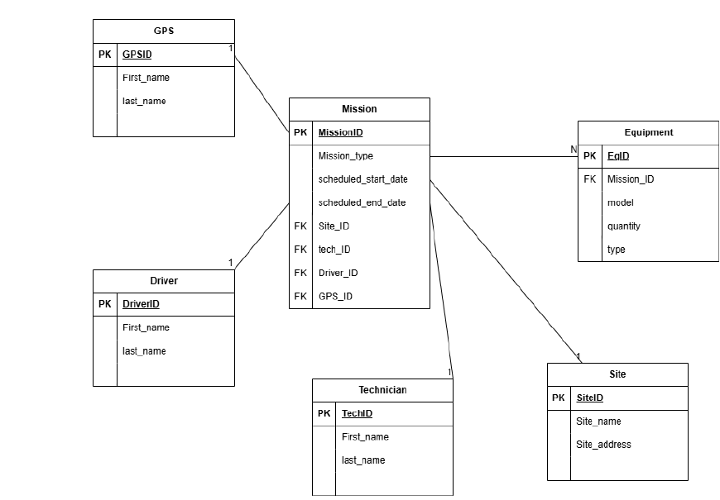
Figure 1 – System data model
Entity | Key attributes | Relations
Mission | ID, Location, Dates, Driver, Notes, Status | Contains Personnel + Equipment
Personnel | Name, Role, Contact, Availability | Assigned to a Mission
Equipment | Name, Type, Quantity, Availability | Used in a Mission
Table 1 – Summary of entities and relations
All of this data is then used to automatically generate the three operational outputs (JSON, PDF, QR code).

2.3. Why This Project?
We chose this idea for several reasons:
Reasons for the choice
- Real problem: manual mission management is a concrete problem in industry. Our solution has a direct usefulness.
- Combination of skills: the project combines data management, automation, structured exports, logistics, and QR traceability, which lets each member contribute according to their strengths.
- Professional nature: unlike a purely academic exercise, this project resembles a real industrial product, which strengthens its credibility.
- Feasibility: the functional scope is realistic for 6 people over 5 days, while still being rich enough to demonstrate our skills.

2.4. Usefulness and Impact
From our team's point of view, this project has a concrete impact on several levels:
Project impact
- Time savings: automating the exports (JSON, PDF, QR) eliminates manual re-entry of data and reduces mission preparation time from several hours to a few minutes.
- Fewer errors: single, validated data entry removes inconsistencies between the different documents.
- Traceability: the QR code allows instant verification in the field, without needing access to an IT system.
- Standardization: the JSON format ensures easy integration with other tracking or administration systems.
- Educational value: this project allowed us to put agile project management into practice in a realistic context.

3. Kanban Methodology and Work Breakdown

3.1. Why Kanban and Not Scrum?
We deliberately chose Kanban over Scrum for the following reasons:
Criterion | Kanban (our choice) | Scrum (rejected)
Timeline | Continuous flow, ideal for 5 days | 1–2 day sprints are too short
Ceremonies | None mandatory | Costly planning, review, retro
Responsiveness | Immediate changes | Changes only between sprints
Simplicity | Simple visual board | Heavier formal framework
Productive time | 100% development | 20–30% spent in ceremonies
Table 2 – Kanban vs Scrum comparison for our context
Kanban was the natural choice because:
- Over 5 days, organizing formal sprints with all the Scrum ceremonies would have consumed precious time
- WIP (Work In Progress) limits allowed us to maintain quality by forcing the team to finish each task before starting a new one
- Responsiveness was essential: when a bug was discovered, it was addressed immediately, without waiting for the next sprint
- The Kanban board on Jira provided real-time visibility into project progress

3.2. Organization of the Kanban Board on Jira
Our Jira board was structured into 6 columns:
Column | Role | WIP limit
Backlog | All tasks to be completed | –
To Do | Priority tasks ready to be picked up | –
In Progress | Currently in development | 3 max
Code Review | Peer verification | 2 max
Testing | Functional tests by QA | 2 max
Done | Completed and validated | –
Table 3 – Kanban board columns
The operating principle was simple: each member pulls the highest-priority task from the To Do column as soon as they finish the previous one. The WIP limits prevent tasks from piling up in progress and guarantee a steady flow.
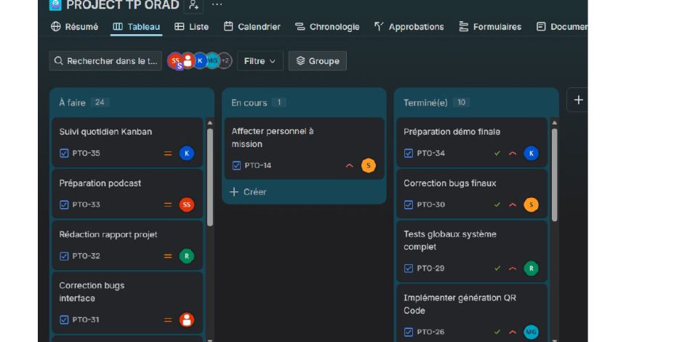
Figure 2 – Kanban board on Jira

3.3. Role Assignment
Member | Role | Concrete responsibilities
Sarah | Product Owner | Prioritize the backlog, validate deliverables
Kamil | Flow Manager | Monitor the Kanban flow, unblock the team
Souheil | Backend Developer | Business logic, saving, JSON export
Nacera | Frontend Developer | Forms, interfaces, field validation
Nazim | Integration Developer | Excel/PDF generation, QR code
Ikram | QA / Documentation | Tests, report, podcast, documentation
Table 4 – Team role assignment

3.4. Detailed Task Breakdown
The backlog contained 35 tickets split into 4 Epics and 31 Tasks. Breakdown by member:
Member | Nb. tasks | Main tasks
Sarah (PO) | 5 | Workflow, validation, prioritization, podcast
Kamelia (FM) | 4 | Jira configuration, daily follow-up, demo
Souheil (Back) | 7 | Data model, modules, JSON, bugs
Nacera (Front) | 7 | Forms, interfaces, buttons, UI bugs
Nazim (Integ) | 6 | PDF, QR code, integration
Ikram (QA) | 6 | Tests, validation, report, documentation
Table 5 – Quantitative task breakdown
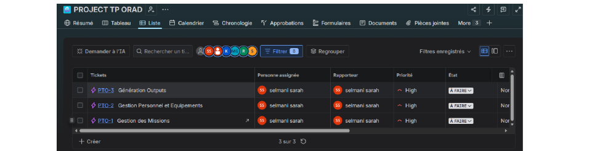
Figure 3 – The project's 4 Epics on Jira

3.5. Day-by-Day Progress
Day | Focus | Who worked | Deliverable
1 | Analysis, design | Sarah, Kamelia, Souheil | Workflow, model, Jira
2 | Mission module | Nacera, Souheil, Ikram | Form, saving
3 | Personnel, equipment | Souheil, Nacera, Nazim | Modules, assignments
4 | JSON, PDF, QR | Souheil, Nazim, Ikram | All exports
5 | Tests, report, demo | Whole team | Final product
Table 6 – Day-by-day plan
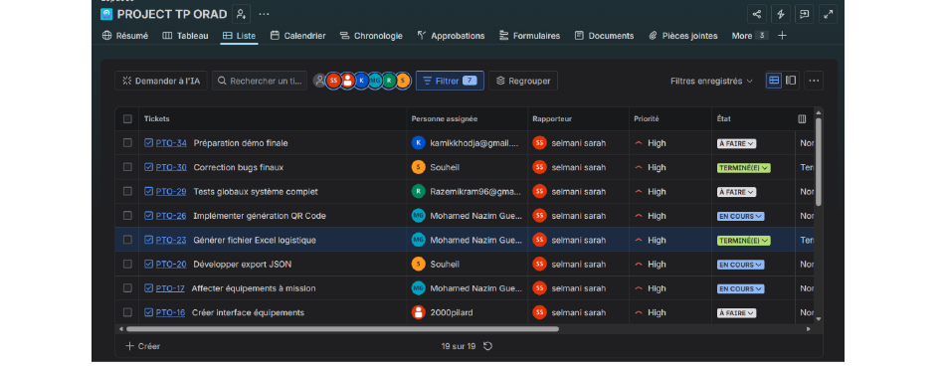
Figure 4 – Kanban board mid-project

4. Difficulties Encountered

4.1. Organizational Difficulties
Organizational difficulties
- Remote coordination: some members worked at different times. We solved this by using the Kanban board as the central communication point: every member could see the state of the tasks in real time.
- Initial prioritization: it was difficult to decide which tasks to tackle first. The Product Owner resolved this by ranking tasks by technical dependency (data model before forms, forms before exports).
- Balanced distribution: some members had more complex tasks than others. The Flow Manager rebalanced the workload by reassigning certain tasks during the project.

4.2. Technical Difficulties
Technical difficulties by phase
- Phase 1 – Design: hesitation over which technology to use. After discussion, we chose the one that best matched the team's skills.
- Phase 2 – Forms: date fields accepted inconsistent formats. Solved with strict format validation. In addition, encoding of special characters (accents) caused problems in the JSON; solved by forcing UTF-8 encoding.
- Phase 3 – Exports: the QR code became unreadable when too much data was encoded. Solved by encoding only the mission identifier. The PDF layout also required adjustments.
- Phase 4 – Integration: the full flow (creation, assignment, export) revealed data inconsistencies between modules. Solved by refactoring the data flow.

Advantage of Kanban when facing problems
Thanks to Kanban, every problem detected was addressed immediately by placing it as high priority on the board. With Scrum, we would have had to wait for the next sprint or disrupt the current one. This responsiveness was a decisive advantage.

4.3. Summary
Phase | Nb. issues | Major issue | Resolved
1 | 3 | Technology choice | Yes
2 | 3 | JSON encoding | Yes
3 | 3 | Unreadable QR code | Yes
4 | 3 | Module integration | Yes
Total: 12 |  | All resolved | 100%
Table 7 – Summary of difficulties

5. Project Screenshots
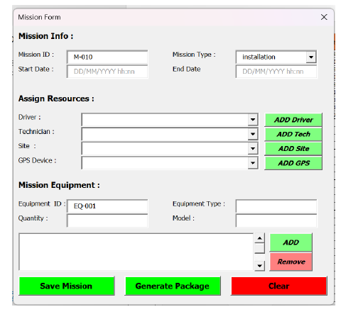
Figure 5 – Mission creation form
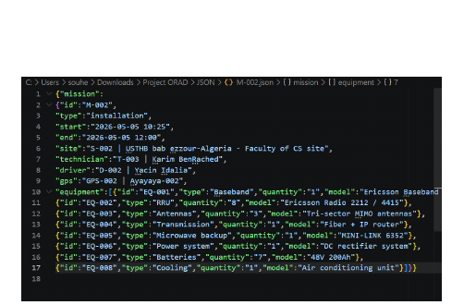
Figure 6 – Generated JSON file
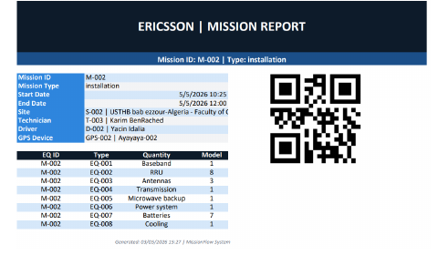
Figure 7 – Logistics PDF document

Figure 8 – Generated QR code

6. Use of AI Tools
In accordance with the guidelines, we declare that we used artificial intelligence tools during the project. Details below:
AI tool | Use | Level of assistance
ChatGPT / Claude | Structuring the Jira backlog | Organizational help
ChatGPT / Claude | Generating the CSV file for Jira | Time savings
ChatGPT / Claude | Help drafting the report | Structure and wording
ChatGPT / Claude | Advice on the Kanban methodology | Theoretical understanding
Table 8 – AI tools used

6.1. Why These Tools?
- Time savings: generating the Jira import CSV file (35 tickets) manually would have taken several hours. AI let us do it in a few minutes.
- Structuring: AI helped us structure the backlog professionally (Epics, Stories, Tasks) while following best practices.
- Drafting: AI helped with the wording and structure of the report, but the technical content and the choices are entirely our own.
Limits of AI
AI does not replace the team's work. It cannot:
- Develop the application in our place
- Make the technical decisions
- Solve problems specific to our context
- Manage coordination between team members
AI was an accelerator, not a substitute.
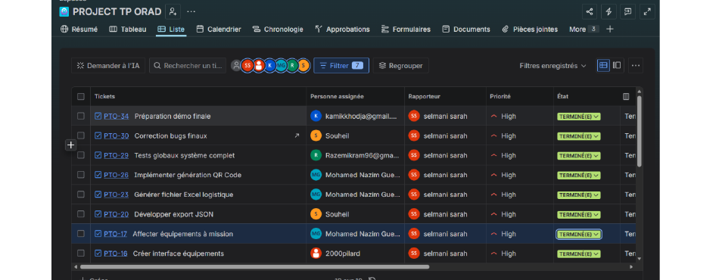
Figure 9 – Final Kanban board on Jira

7. Conclusion
The Mission and Equipment Dispatch Management System project was successfully completed in 5 days by our six-member team.
Project summary
- Functional application covering the full mission lifecycle
- 3 types of automated exports (JSON, PDF, QR code)
- 35 Jira tickets, all completed (4 Epics + 31 Tasks)
- 12 technical problems identified and 100% resolved
- Balanced workload distribution among the 6 members
The choice of Kanban proved relevant to our context: the continuous flow, the WIP limits, and real-time visualization through Jira allowed us to deliver a complete product in a very short timeframe. Responsiveness to problems, made possible by the absence of fixed sprints, was a decisive advantage.
This project allowed us to gain concrete experience in agile project management, structured teamwork, and product-oriented software development. The system we developed is a solid foundation that could evolve into a web or mobile version in a real industrial context.

