RoundApp
Application Development
Project Proposal & Plan
IOS & Android Versions
Monday, July 14, 2014

Table of Contents
1 Overview 3
1.1 Project Objectives 3
1.2 Project Constraints 4
1.3 Project Risks 4
2 Proposed Solution 4
2.1 Development 6
2.2 Testing 6
2.3 Milestone and Deployment 6
3 Project Resources 7
3.1 Roles and Responsibilities 7
3.2 Issue Escalation 8
3.3 Project Materials 8
4 Project Approach 9
4.1 Development Model 9
4.2 Communication Management 9
4.3 Change Management 9
4.4 Testing 9
4.5 Documentation 9
5 Schedule 10

Overview
The intent of this document is to provide Project Proposal and Developement plan for RoundApp (SpinTrix) Mobile Application. The scope of this document covers the project planning phase and demonstrates how a Work Breakdown Structure (WBS) and associated Resource Breakdown Structure might be incorporated into key project documents. This document also provides a possible structure for presenting:

- Project deliverables
- Project risks and opportunities
- Estimates
- Project resource information
- Project delivery method
- Configuration and change management

Need for project
Some of the primary reasons for undertaking this Project are:

- Competitive advantage
- Cost Benefit
- Benefit to the customer
- Building long term customer relationship

Challenges
What known challenges will impact project planning and execution? These might include:

- Unresolved disparity in stakeholder requirements or expectations
- Unknown lead/delivery timeframe for a key project component (this would directly impact the scheduling critical path)
- Unknown technical or other method of implementation (e.g. the technology required for the project is new or as of yet fully developed)

Project Objectives
RoundApp is an innovative mobile application cum social network that allows the users to take a picture while standing in a circle or half circle (depending on how many people would be working together) at a staged location and connects the user’s phone to a “master” phone simultaneously and then the pictures are transferred to the “master” phone. The app then puts all the pictures together to create a spinning effect photo.
- There will be 2 versions of the application full (paid) and free (semi/simple) version.
- A phone has to purchase the full version in order to work as a master.
- A free version can be installed on other phones but with this the device can only work in slave mode.
- Master will control combining of all the photos that are taken from slave phones simultaneously and share them.
- App can also work with only one phone in single mode. This can be done with a still object like a car, a standing person, statue etc. The user takes the 360 degree photos of the object and then the app will be able to put the photos together to create the spinning effect.
- The spinning effect can be created by swiping the screen left or right.
- Ability to share the pictures
- Ability to capture the videos as well and create the spinning effects of the video.

Project Constraints
- IOS device compatibility: The app will be compatible with the mentioned IOS devices.
- IOS device screen resolution: IOS devices have different resolution; hence the graphics will have to be provided in the correct resolution for each device.
- Android device screen resolution: Android devices are heterogeneous in screen resolution and based on the manufactures but there are still graphics resource standards that needs to be followed while providing designs for android version of the app, there are various resolutions such as LDPI, HDPI, MDPI, XHDPI, which needs to be taken care.
- Network connectivity is required for sharing the photos on social networks.
- IOS camera API: IOS native camera and gallery will be launched for taking the video or photo for taking the photos through master of slave devices.
- The videos have to be of limited length for each capture, the recommended for the overall spinning video will be 15-20 seconds due to the large size and making it easy to upload it to cloud
- Master and slave devices must be in the same network and physically in the same location to properly sync, capture and transfer photos to the master device.
- The application must meet the app store and google play store guidelines to be successfully approved on the respective market places.

Project Risks

- Event Risk –
  - If Apple store approval policy changes.
- Risk Probability –
  - It happens and the probability is low but there is always a chance the apple may change their policy with a specific feature.
- Risk Impact – Apple may ask to remove some feature or implement it in some other way.
- Risk Mitigation – All the features can be reviewed to make sure the functionality and features are abiding with the app store policy.
- Contingency Plan – Implement the functionality according to the guidelines.

Proposed Solution

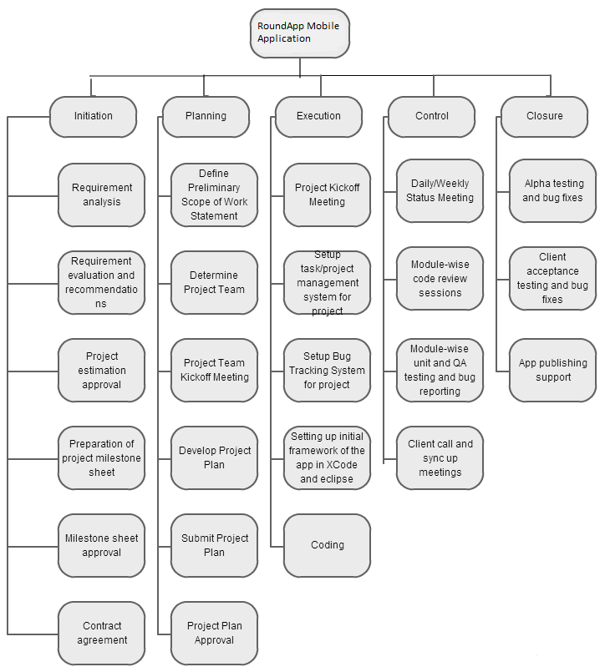

Web Page with posted spin image or video

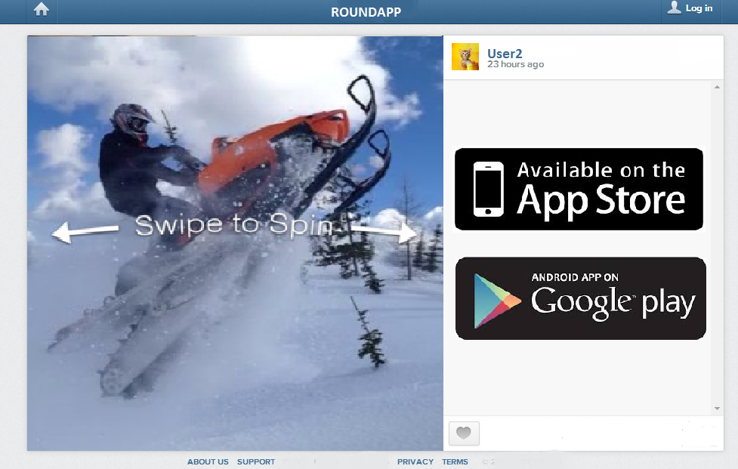

Functional Specifications
http://www.intlartdesign.com/RoundApp
https://www.dropbox.com/s/25u0n22f6kw6jir/Roundapp%20Map.jpg

Technical Specifications

Platform specifications:
- Native IOS Platform
- Native Android Platform
Development languages:
- IOS Platform – Objective C
- Android Platform - Java
IDEs:
- XCode IDE
- Eclipse IDE
SDKs:
- IOS 7 SDK
- Latest Android SDK and ADT plugin
Devide Side Storage:
- Core Data for IOS app
- Device Caching technique will also be used for caching the contents for quick loading
Third Party Libraries:
- NA
Supported Devices:
- IOS – iPhone5, iPhone5S, iPhone5C Devices
- Android – Android devices

Security Specifications
- TBD

Development
This section of the document would describe the features to be included in each release or phase of the development process. In this case please refer to section 2.3 for details.

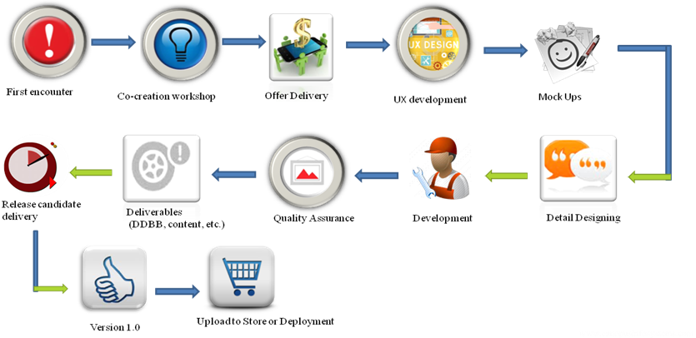

Testing
- Each module will be tested by internal QA and the bugs will be reported and assigned to the developer.
- The bugs will be reported electronically and internal bug tracking system will be used for tracking all the bugs and reports.
- At any point of time a detailed bug reports can be provided with the status of the bugs resolved and pending during the development phase.
- The bugs will be fixed and retested by the internal QA team after which if the build is bug free it will be released to client for testing.
- Bugs reported by client will also be inserted in the bug tracking tool for tracking and addressing priority wise.

Milestone and Deployment

Major Milestones

SN | Milestone Deliverables | Payment percentage
1 | - Upfront Payment on project kickoff | 25%
2 | - Basic UI and navigation flow  - Development of the project framework and architecture  - Camera functionality implementation  - Web service framework implementation  - Login functionality | 20%
3 | - Web Service development  - Single phone spin photo capturing feature (Free version)  - Slave mode implementation  - Master mode implementation  - Connectivity between devices  - Controlling the slave devices | 20%
4 | - Taking pictures simultaneously  - Merging the picture  - Creating the spinning effect  - Taking videos simultaneously  - Merging the video  - Sharing the image to social network. FB, email, Twitter  - In app purchase feature to upgrade the app to paid version | 20%
5 | - Posting the image or video  - Like/unlike the image or video  - Web page similar to instagram that displays the image posted and user name | 15%
6 | Post deployment support for 30 days | Free

Project Resources

Roles and Responsibilities
1 | Project Manager
1 | Technical Lead
1 | Senior IOS Developer
1 | Junior IOS Developer
1 | Senior Android Developer
1 | Junior Android Developer
1 | QA

Issue Escalation
Project problems will be resolved based on the priority and severity, if the problem is still not resolved then same should be escalated to project manager and at second level to the Senior manager for quick resolution.

Project Materials
- Designs and graphics will be provided by client
- Web APIs needs to be developed.
- Internal IOS and Android devices will be involved for the internal QA process
- Project tracking and bug fixing tool will be used.
- Subversion repository will be used for source controlling

Project Approach

Development Model
We will be using Agile development methodology.

It is important to also describe the various stages or phases of development and detail which components or milestones will be delivered during each phase.

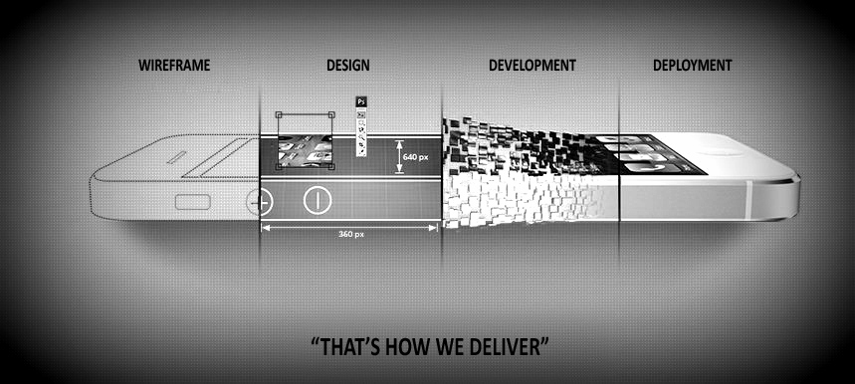

Communication Management
Communication will be driven by Project Manager and it will also involve the developers directly.
Skype and email will be the primary channels for communication. Contact numbers will also be provided to handle the emergency needs.

Change Management
Following change management policy will be involved, if there are any change requests come across during the development of the project:

- Name of change initiator
- Documentation regarding the nature of the change
- Change impact analysis
- Change rejection / approval

Testing
A testing plan is usually developed as part of the functional specification phase of the development project. This provides for a detailed test plan, as the analysts developers understand more about the components that will require testing. Testing should be done both in a test environment and also within the intended production environment. This will minimize issues associated with configuration variances.

This section should provide details associated with the test process: the project role (and individual, if a specific person has been identified) responsible for testing, other human resource requirements and a schedule for testing (or associated milestones).

If an application will be used to track bugs or provide testing feedback to the development and management group, then this should be documented here as well. Otherwise, feedback documentation should be provided in the project plan.

Documentation
This section details what documentation will be delivered during both the course of the project and at project end. Clients are usually most interested in system administrator and user documented. It is important to document how the information will be provided – in electronic, physical media format or perhaps both.

Documentation is a project deliverable, just like the User Interface. Expect to provide clients with several versions for review.

Schedule
The project schedule can be completed only after all project tasks have been defined and prioritized. The schedule is one of the last components of a project plan to be completed.

