|  |  |  |  |
| --- | --- | --- | --- |
| **CS102** | **Fall 2016/2017** | Project Group | 3/7 |
| Instructor: | **Öznur Taştan Okan** |
| Assistant: | Mohammad Mobayen |

|  |  |  |
| --- | --- | --- |
| **Criteria** | **TA/Grader** | **Instructor** |
| Presentation |  |  |
|  |  |  |
|  |  |  |
|  |  |  |
| Overall |  |  |

~ Music Time ~

**Hi-5**

Group Members:

Aslı ALPMAN 21501747

Cansu Canan CEYHAN 21400998

**Giray Baha KEZER 21301937**

**Kenan ŞAHİN 21301469**

**Semih TEKER 21300964**

|  |
| --- |
| Project Report  (User Interface Part)  5 November 2016 |

# Introduction

The purpose of this project is developing a music quiz application. Briefly, players are asked for singer name, speaker name and song name and scored by a default scoring system in this application. Program includes a huge music archive which is composed of songs from different music genres. Besides containing songs from different genres, historical speeches take place in this archive, too. Furthermore, multiplayer function of application provides users to play with an opponent and challenge themselves.

We have provided a basis for our application in this user-interface report. While designing the application, we placed importance on clarity and simplicity and designed interfaces as simpler and natural as we can. We tried to give reader an insight regarding what our music quiz application will look like by diagrammatizing actual sequence of operations the user will experience. Afterwards, we examined separately every operation, every screen that user will see.

# Details

Our pop-up quiz application allows people to test themselves about their music knowledge. Our program provides a plenty of music from large scope to players.

The program provides the following facilities:

## Scoring System

Our program has its own scoring system. Each player is going to score in proportion to the correct answers. One wrong answer will lead to finish the game. Threshold system which is similar to Who Wants to Be a Millionaire will be used in application [1]. Once you get the passing point which is called threshold, you will guarantee taking at least threshold score until you reach a new threshold score. In order to keep scores, every user needs to create an account in the beginning. The points which he collected will be stored in these accounts.

## Ranking System

We designed our ranking system similarly to existing music trivia games [2] [3]. Similar applications rank users with level systems. However, we prefer using ranking system instead of level systems to appeal all age groups since it provides ease of use According to this ranking system, users will be risen in specific ranks according to the point that they collect and the categories that they specialized. Ranks will be given as apprentice, master-builder, master and expert. A new user starts with apprentice rank.

## Question Classification System

Sound records are categorized according to their types. Songs belonging to a shared tradition will be on the same subgroup such as rock, pop, jazz, classic etc. To exemplify, Pearl Jam and Oasis will be sharing the same category. When it comes to historical speeches it will be form a new class without subclasses. For one who cannot decide category to play, random category will be available. Furthermore, there will be a hierarchy among the questions determined by the level of difficulty. Users are going to encountered relatively more difficult questions as they give right answers. In other words, the more questions answered by users, the more difficult questions will be asked.

## Additional Playing Features

Our application offers people to have fun together different from common ones [4]. Thanks to the multiple players function in our program, players can have a chance to examine their knowledge. Moreover, joker options will be available in application. One joker which is called double-answer will enable users answer again even though first one was wrong. Second one is half-and-half joker. It disposes two of the answers which are wrong. The last one is called replay joker that allows listening the record again. Jokers will be gained by allocating points.

**Project Map**

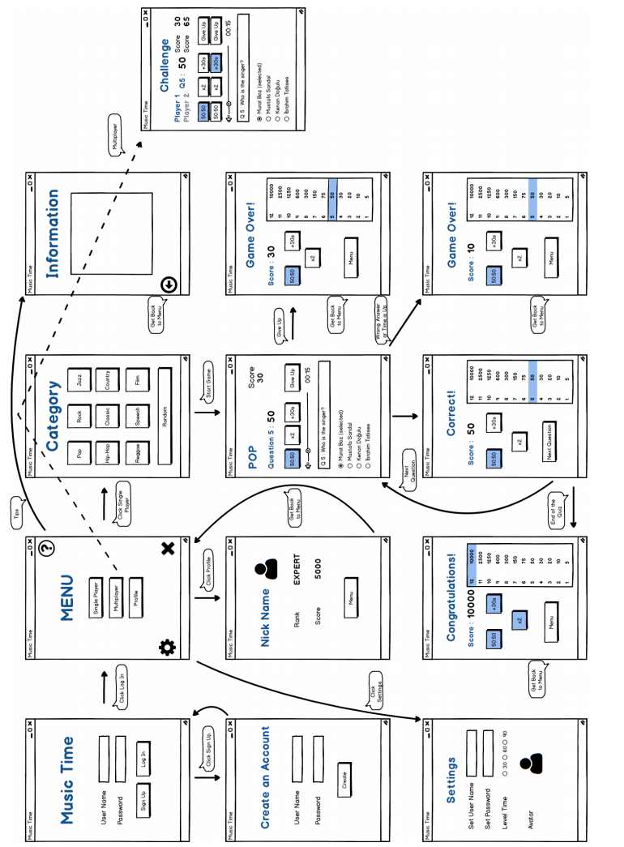

**Login Screen**

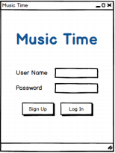

This is the first screen that user will see when application is opened. Music Time, which is the name of application, will appear on the top of the screen. There will be two boxes which require entering information of users’ accounts. If they have already registered to application, they will enter username and password. If information of user are valid, they can easily access their accounts. If they do not have an account, they ought to create a new account by clicking “sign up” button.

**Sign Up Screen**

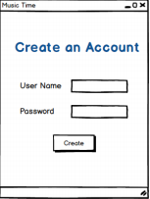

This screen is merely used to create account. Users are going to pick their username and password to log into the account.

**Menu Screen**

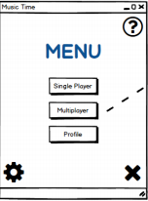

Menu includes three major and three minor functions. Major ones are single player, multiplayer, profile options. Single player option allows users to select category to solo-play. Multiplayer option enables users to compete with other players. Profile option let users view their own accounts. Minor ones are log out, settings help options. Log out options will end the session of account. Users will be able to view setting by clicking settings options. If users click help option, hints will be visible.

**Profile Screen**

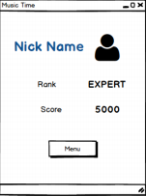

Nick name and avatar which is selected by user appear on the top of the profile screen. Furthermore, users can check their rank and the score. Also, there will be an option to return menu.

**Information Screen**

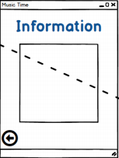

If users need an information about how to play the game and click on the question mark button from the menu screen, they can see all the information about game on this screen. An option to get back menu is available on the screen.

**Setting Screen**

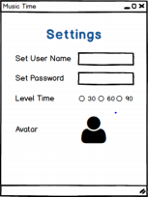

In this page, the user can do some changings about the music quiz application. To start the game we already ask the user choose a user name and a password. Now, the user can set again these and change the default avatar from the list of the avatar icons. Also, users can certain a time for the difficulty level of the game. When select one of the three time-options as second, in the game all questions will take in this certain time.

**Category Screen**

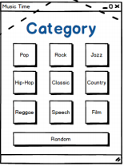

Ten different categories will be available on this screen. Categories include pop, rock, jazz, hip-hop, classic, country, reggae, speech, film and random. Users can start to play game by choosing the category wanted to play.

**Game Screen**

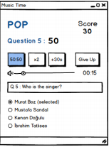

After choosing the category, game starts. Here, users can see the category written on the top of the screen and their scores chancing according to correct answers. The question number and its point has been written under category. Joker buttons are seen on the screen and the ones which are used before are shown in a different colour than the others. There is an option which is “Give Up” to finish the game. Users also can turn the volume up or down if they want. Time to answer the question shown under the give up button. Finally, we have the question and options under that. According to the song and question, users will choose their option.

**Success Screen**

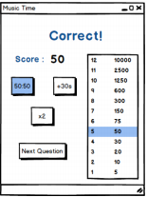

This page comes when the questions are answered correctly. Step by step point chart with its question numbers and users' score itself appears through our 'correct page', thus we can show the point thresholds every time to users. Whether jokers were used by contestant or not can be seen easily at the left side of this page. Lastly, there will be next question button to pass the page and then take another question.

**Failure Screen**

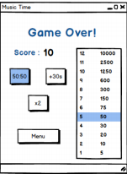

The game over page comes as it can be guessed when the game is over. At the top, contestant's total score is seen and joker buttons are located below this score line. At the right side, point chart and questions' point thresholds are shown like the previous 'correct page'. Lastly, there will be a menu button to go back to main menu so as to play it again or close the application or etc.

**Give up Screen**

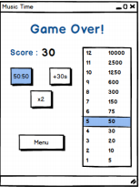

Users are allowed to withdraw from game. When users willingly terminated the game, a give up screen which is similar to failure screen will appear.

**Greeting Screen**

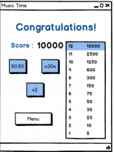

At the end of the game, this greeting page will appear. It shows the users total score in the game both as in the table and top of the page. Also, it shows the wasted joker options. Besides these, it allows to user get back to main menu with a button.

**Challenge Screen**

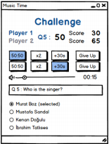

When the users choose multiplayer option in the menu, this page will appear. In this page allows two users to compete each other. When they start the quiz, different questions come one after another by turns. When the first user’s turn to come, other user’s information will be faint. During the quiz, they can see the both scores, both joker options and the value of questions. At the end of the quiz, the player who gets the higher score than the other will be winner.

# Summary & Conclusions

During the user-interface design stage, we tried to create interfaces as simple as possible for the users. The main focus was on users’ needs. We have already defined things which users will be able to do in the requirement specification step. At this stage, our purpose was finding the easiest way for users to accomplish these things. Complicated functions were simplified by our design since we are aware of the fact that we ought to have uncomplicated interfaces to achieve good designing. We did not sacrificed clarity and use minimal number of user-interface elements. In this report, we tried to explain the sequence of actions which users will experience to accomplish a chosen specific function. We diagrammatized the possible scripts that user can experience. Thereby, we provide a basis for our next works.

Our main concern was about multiplayer option. We were undecided about whether multiplayer options can be available or not. If we would make multiplayer option available, we should have create a new design schema which includes multiplayer option since playing with an opponent creates totally new scenario. Furthermore, it leads to more complicated interfaces compared to single player. However, we decided to design our program with multiplayer option and create challenge screen.

References

1."Who Wants To Be A Millionaire Official Site ..." *Who Wants To Be A Millionaire*. N.p., n.d. Web. 21 Oct. 2016. official rules.

2.“ Music Quiz Duel.” *Mangoo-games.* Posted 19 October 2015, [http://www.mangoogames.com/en/games. Accessed 20 October 2016](http://www.mangoogames.com/en/games.%20Accessed%2020%20October%202016).

3. “Music Trivia and Games.” *FunTrivia,* <http://www.funtrivia.com/quizzes/music/>. Accessed 18 October 2016.

4. “ Best Music Quiz Applications.”*AppCrawlr*, [http://appcrawlr.com/android-apps/best-appsmusic-quiz. Accessed 20 October 2016](http://appcrawlr.com/android-apps/best-appsmusic-quiz.%20Accessed%2020%20October%202016)

5. “Songpop.” *FreshPlanet*, http://freshplanet.com/games/songpop-2/[. Accessed 2 November 2016](http://appcrawlr.com/android-apps/best-appsmusic-quiz.%20Accessed%2020%20October%202016).