The autoreload extension is already loaded. To reload it, use:

%reload_ext autoreload

Training data shape: (50000, 32, 32, 3)

Training labels shape: (50000,)

Test data shape: (10000, 32, 32, 3)

Test labels shape: (10000,)

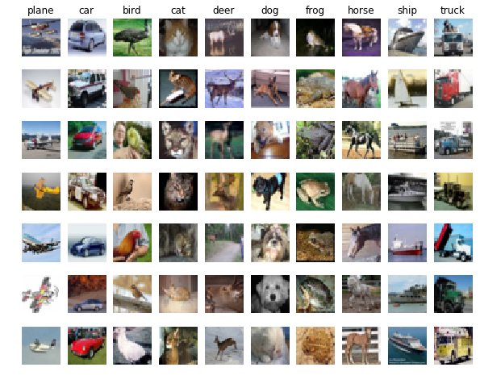

CIFAR10数据集，一共10个类，一共有60000张32*32的图片

训练集的大小，测试集的大小

(5000, 3072) (500, 3072)

距离矩阵的大小

(500, 5000)

可视化距离矩阵

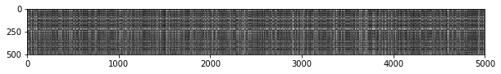当k=1时，有 137 / 500 个正确的数据 => accuracy: 0.274000

当k=5时，有 139 / 500 个正确的数据 => accuracy: 0.278000

Difference was: 0.000000

Good! The distance matrices are the same

Difference was: 0.000000

Good! The distance matrices are the same

Two loop version took 48.605712 seconds

One loop version took 88.179184 seconds

No loop version took 0.299814 seconds

分别用3种方法计算距离矩阵，三种方法中分别用了两层循环，一层循环，和没有用循环，比较了运算的效率

k = 1, accuracy = 0.526000

k = 1, accuracy = 0.514000

k = 1, accuracy = 0.528000

k = 1, accuracy = 0.556000

k = 1, accuracy = 0.532000

k = 3, accuracy = 0.478000

k = 3, accuracy = 0.498000

k = 3, accuracy = 0.480000

k = 3, accuracy = 0.532000

k = 3, accuracy = 0.508000

k = 5, accuracy = 0.496000

k = 5, accuracy = 0.532000

k = 5, accuracy = 0.560000

k = 5, accuracy = 0.584000

k = 5, accuracy = 0.560000

k = 8, accuracy = 0.524000

k = 8, accuracy = 0.564000

k = 8, accuracy = 0.546000

k = 8, accuracy = 0.580000

k = 8, accuracy = 0.546000

k = 10, accuracy = 0.530000

k = 10, accuracy = 0.592000

k = 10, accuracy = 0.552000

k = 10, accuracy = 0.568000

k = 10, accuracy = 0.560000

k = 12, accuracy = 0.520000

k = 12, accuracy = 0.590000

k = 12, accuracy = 0.558000

k = 12, accuracy = 0.566000

k = 12, accuracy = 0.560000

k = 15, accuracy = 0.504000

k = 15, accuracy = 0.578000

k = 15, accuracy = 0.556000

k = 15, accuracy = 0.564000

k = 15, accuracy = 0.548000

k = 20, accuracy = 0.540000

k = 20, accuracy = 0.558000

k = 20, accuracy = 0.558000

k = 20, accuracy = 0.564000

k = 20, accuracy = 0.570000

k = 50, accuracy = 0.542000

k = 50, accuracy = 0.576000

k = 50, accuracy = 0.556000

k = 50, accuracy = 0.538000

k = 50, accuracy = 0.532000

k = 100, accuracy = 0.512000

k = 100, accuracy = 0.540000

k = 100, accuracy = 0.526000

k = 100, accuracy = 0.512000

k = 100, accuracy = 0.526000

交叉验证，调整超参数k，将训练集分成5份，4份训练1份测试，所以每个k可以得到5个accuracy，下图

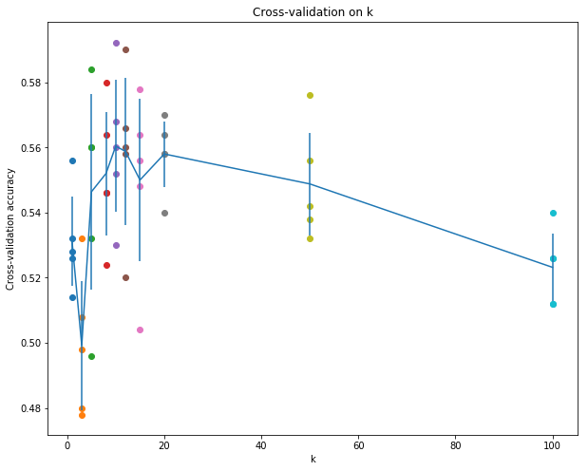

Got 137 / 500 correct => accuracy: 0.274000

精度低，方法不好