**Table 1: Number of Countries in the Analysis**

+------------+---------------------+

| Continents | Number of Countries |

+============+=====================+

| Americas | 15 |

+------------+---------------------+

| Africa | 14 |

+------------+---------------------+

| MENA | 15 |

+------------+---------------------+

| Europe | 41 |

+------------+---------------------+

| Asia | 24 |

+------------+---------------------+

| Total | 109 |

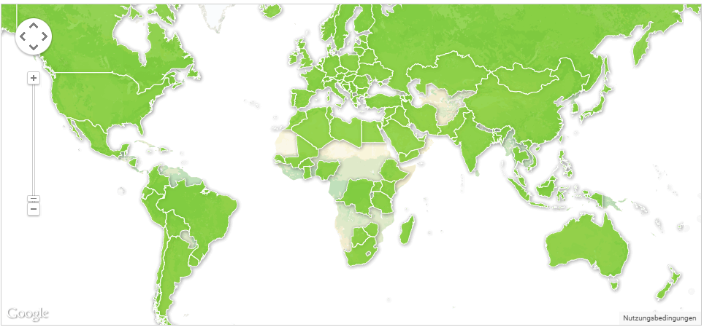+------------+---------------------+

**Fig. 1: Countries in the Renewable Energy Policy Dataset**

<http://www.iea.org/policiesandmeasures/renewableenergy/>

The impact of policies on the RE deployment will be tested by a multiple linear regression that has fixed time (year) and fixed country effects as shown below.

*Yit* =*α*0+*β*\***P** *it* +*δ*\***D***it* + *γ\****C***i + θ\****T***t+ εit*

*Yit* = *Nit* / *Git*

The names and types of the variables used in the dataset are provided in the following table. The dataset covers 25 years and 109 countries (2725 potential observations), and the dependent variable has 2425 observations due to missing values for some years. No special procedure will be applied to missing values, since the number of missing values is quite tolerable for a dataset of this size.

**Table 2: Names and Types of Variables**

<class 'pandas.core.frame.DataFrame'>

Int64Index: 2725 entries, 1 to 109

Data columns (total 33 columns):

Auditing 2725 non-null int64

Codes and Standards 2725 non-null int64

Demonstration Project 2725 non-null int64

Feed-in Tariffs or Premiums 2725 non-null int64

Funds to Sub-National Governments 2725 non-null int64

Grants and Subsidies 2725 non-null int64

Green Certificates 2725 non-null int64

Information and Education 2725 non-null int64

Infrastructure Investments 2725 non-null int64

Institutional Creation 2725 non-null int64

Loans 2725 non-null int64

Monitoring 2725 non-null int64

Obligation Schemes 2725 non-null int64

Other Mandatory Requirements 2725 non-null int64

Procurement Rules 2725 non-null int64

RD&D Funding 2725 non-null int64

Research Programme 2725 non-null int64

Strategic Planning 2725 non-null int64

Tax Relief 2725 non-null int64

Taxes 2725 non-null int64

User Charges 2725 non-null int64

White Certificates 2725 non-null int64

Year 2725 non-null int64

country_index 2725 non-null int64

year 2725 non-null int64

Share of Non-Hydro RE Capacity 2425 non-null float64

Population density (people per sq. km of land area) 2625 non-null float64

GDP per capita, PPP (current international $) 2625 non-null float64

Domestic credit to private sector (% of GDP) 2500 non-null float64

Foreign direct investment, net inflows (% of GDP) 2625 non-null float64

Population, female (% of total) 2625 non-null float64

Energy use (kg of oil equivalent) per $1,000 GDP (2011 PPP) 2500 non-null float64

Adjusted savings: energy depletion (% of GNI) 2625 non-null float64

dtypes: float64(8), int64(25)

memory usage: 723.8 KB

None

The following figure highlights the number of specific policies used by the countries in the dataset: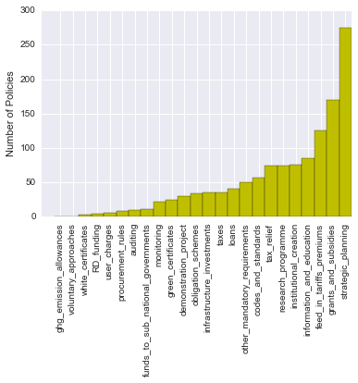

**Fig. 2: Number of Specific Policies**

The heat maps below look at the correlation between RE support policies and development variables in the dataset. The relatively low correlation between RE support policies (the highest is around 0.4) rules out the risk of multicollinearity in the analysis.

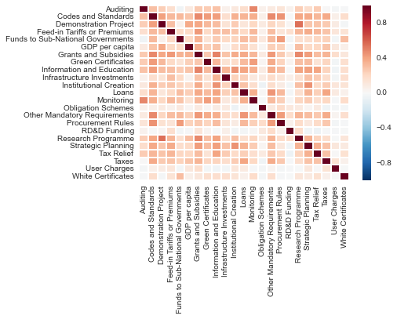

**Fig. 3: Correlations between RE Support Policies**

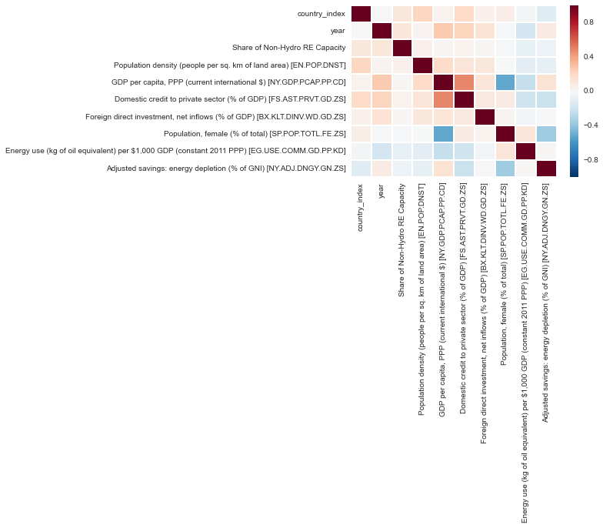**Fig. 4: Correlation Between Development Variables**

The figures below show the relationship between the share of non-hydro RE capacity in total electricity net generation (y-axis) and each variable in the dataset (x-axis).

-------------------------Summary of Regression Analysis-------------------------

Formula: Y ~ <Auditing> + <Codes and Standards> + <Demonstration Project>

+ <Feed-in Tariffs or Premiums> + <Funds to Sub-National Governments>

+ <Grants and Subsidies> + <Green Certificates>

+ <Information and Education> + <Infrastructure Investments> + <Institutional Creation>

+ <Loans> + <Monitoring> + <Obligation Schemes>

+ <Other Mandatory Requirements> + <Procurement Rules> + <RD&D Funding>

+ <Research Programme> + <Strategic Planning> + <Tax Relief> + <Taxes> + <User Charges>

+ <White Certificates> + <country_index> + <year>

+ <Population density (people per sq. km of land area) [EN.POP.DNST]>

+ <GDP per capita, PPP (current international $) [NY.GDP.PCAP.PP.CD]>

+ <Domestic credit to private sector (% of GDP) [FS.AST.PRVT.GD.ZS]>

+ <Foreign direct investment, net inflows (% of GDP) [BX.KLT.DINV.WD.GD.ZS]>

+ <Energy use (kg of oil equivalent) per $1,000 GDP (constant 2011 PPP) [EG.USE.COMM.GD.PP.KD]>

+ <Adjusted savings: energy depletion (% of GNI) [NY.ADJ.DNGY.GN.ZS]>

+ <FE_2> + <FE_3> + <FE_4> + <FE_5>

+ <FE_6> + <FE_7> + <FE_8> + <FE_9> + <FE_10> + <FE_11> + <FE_12>

+ <FE_13> + <FE_14> + <FE_15> + <FE_16> + <FE_17> + <FE_18> + <FE_19>

+ <FE_20> + <FE_21> + <FE_22> + <FE_23> + <FE_24> + <FE_25> + <FE_26>

+ <FE_27> + <FE_28> + <FE_29> + <FE_30> + <FE_31> + <FE_32> + <FE_33>

+ <FE_34> + <FE_35> + <FE_36> + <FE_37> + <FE_38> + <FE_39> + <FE_40>

+ <FE_41> + <FE_42> + <FE_43> + <FE_44> + <FE_45> + <FE_46>

+ <FE_47> + <FE_48> + <FE_49> + <FE_50> + <FE_51> + <FE_52> + <FE_53>

+ <FE_54> + <FE_55> + <FE_56> + <FE_57> + <FE_58> + <FE_59> + <FE_60>

+ <FE_61> + <FE_62> + <FE_63> + <FE_64> + <FE_65> + <FE_66> + <FE_67>

+ <FE_68> + <FE_69> + <FE_70> + <FE_71> + <FE_72> + <FE_73> + <FE_74>

+ <FE_75> + <FE_76> + <FE_77> + <FE_78> + <FE_79> + <FE_80>

+ <FE_81> + <FE_82> + <FE_83> + <FE_84> + <FE_85> + <FE_86> + <FE_87>

+ <FE_88> + <FE_89> + <FE_90> + <FE_91> + <FE_92> + <FE_93> + <FE_94>

+ <FE_95> + <FE_96> + <FE_97> + <FE_98> + <FE_99> + <FE_100> + <FE_101>

+ <FE_102> + <FE_103> + <FE_104> + <FE_105> + <FE_106> + <FE_107>

+ <FE_108> + <FE_109>

Number of Observations: 1801

Number of Degrees of Freedom: 147

R-squared: 0.3138

Adj R-squared: 0.2533

Rmse: 38.2045

F-stat (138, 1654): 5.1817, p-value: 0.0000

Degrees of Freedom: model 146, resid 1654

-----------------------Summary of Estimated Coefficients------------------------------

Variable Coef Std Err t-stat p-value CI 2.5% CI 97.5%

--------------------------------------------------------------------------------------

Auditing -10.4251 10.0820 -1.03 0.3013 -30.1858 9.3357

Codes and Standards 0.2282 5.4212 0.04 0.9664 -10.3974 10.8537

Demonstration Project 10.1486 6.6156 1.53 0.1252 -2.8180 23.1152

Feed-in Tariffs/Premiums 2.0443 4.3645 0.47 0.6396 -6.5101 10.5988

Funds to Sub. Go. -4.5398 7.5722 -0.60 0.5489 -19.3814 10.3017

--------------------------------------------------------------------------------------

Grants and Subsidies -0.3671 4.1356 -0.09 0.9293 -8.4729 7.7388

Green Certificates 5.5159 7.0403 0.78 0.4335 -8.2831 19.3148

Information and Educ. 0.2634 4.8016 0.05 0.9563 -9.1478 9.6746

Infrastr. Investments -2.4466 6.1405 -0.40 0.6904 -14.4819 9.5887

Institutional Creation 0.0380 4.1722 0.01 0.9927 -8.1395 8.2154

--------------------------------------------------------------------------------------

Loans 4.7362 5.1421 0.92 0.3572 -5.3424 14.8147

Monitoring 2.5039 6.9041 0.36 0.7169 -11.0280 16.0359

Obligation Schemes 0.6013 5.1493 0.12 0.9070 -9.4912 10.6939

Other Mandatory Req. -4.1177 5.1001 -0.81 0.4196 -14.1140 5.8786

Procurement Rules -0.3851 8.8975 -0.04 0.9655 -17.8243 17.0541

--------------------------------------------------------------------------------------

RD&D Funding -5.9773 14.2620 -0.42 0.6752 -33.9309 21.9763

Research Programme -4.1507 4.7930 -0.87 0.3866 -13.5450 5.2435

Strategic Planning -0.7952 3.7794 -0.21 0.8334 -8.2028 6.6124

Tax Relief -1.2047 4.4137 -0.27 0.7849 -9.8556 7.4462

Taxes -0.6217 5.7062 -0.11 0.9133 -11.8060 10.5625

--------------------------------------------------------------------------------------

User Charges -7.1401 12.5075 -0.57 0.5682 -31.6549 17.3747

White Certificates -0.4619 18.4812 -0.02 0.9801 -36.6850 35.7612

Population density -0.0681 0.0623 -1.09 0.2746 -0.1903 0.0540

--------------------------------------------------------------------------------------

GDP pc, PPP 0.0003 0.0003 0.78 0.4376 -0.0004 0.0009

Dom. cred. pri. sector 0.1452 0.0529 2.74 0.0061 0.0415 0.2490

FDI -0.0146 0.0920 -0.16 0.8736 -0.1950 0.1657

Energy use 0.0256 0.0284 0.90 0.3672 -0.0301 0.0813

Energy depletion: sav. -0.1442 0.4009 -0.36 0.7191 -0.9300 0.6416

--------------------------------------------------------------------------------------

**Logit Regression Results**

==========================================================================

**Dependent Variable:**

**Feed-in Tariffs or Premiums**

==========================================================================**coef std err z P>|z| [95.0% Conf. Int.]**

---------------------------------------------------------------------------0.9909 0.149 -6.663 0.000 -1.282 -0.699

==========================================================================

**Grants and Subsidies**

==========================================================================

-1.0131 0.149 -6.777 0.000 -1.306 -0.720

==========================================================================

**Obligation Schemes**

==========================================================================

-2.4615 0.246 -10.024 0.000 -2.943 -1.980

==========================================================================

**Tax Relief**

==========================================================================

-1.3808 0.165 -8.372 0.000 -1.704 -1.058

==========================================================================

**Taxes**

==========================================================================

-2.0992 0.212 -9.907 0.000 -2.515 -1.684

==========================================================================

**Strategic Planning**

-0.3440 0.134 -2.565 0.010 -0.607 -0.081

==========================================================================

Auditing Codes and Standards Country Index Demonstration Project \

count 2725.000000 2725.000000 2725.00000 2725.000000

mean 0.035229 0.128440 55.00000 0.085505

std 0.184393 0.334641 31.47004 0.279682

min 0.000000 0.000000 1.00000 0.000000

25% 0.000000 0.000000 28.00000 0.000000

50% 0.000000 0.000000 55.00000 0.000000

75% 0.000000 0.000000 82.00000 0.000000

max 1.000000 1.000000 109.00000 1.000000

Feed-in Tariffs or Premiums Funds to Sub-National Governments \

count 2725.000000 2725.000000

mean 0.190826 0.044771

std 0.393024 0.206838

min 0.000000 0.000000

25% 0.000000 0.000000

50% 0.000000 0.000000

75% 0.000000 0.000000

max 1.000000 1.000000

Grants and Subsidies Green Certificates Information and Education \

count 2725.000000 2725.000000 2725.000000

mean 0.245138 0.052844 0.139817

std 0.430248 0.223763 0.346860

min 0.000000 0.000000 0.000000

25% 0.000000 0.000000 0.000000

50% 0.000000 0.000000 0.000000

75% 0.000000 0.000000 0.000000

max 1.000000 1.000000 1.000000

Infrastructure Investments \

count 2725.000000

mean 0.062018

std 0.241233

min 0.000000

25% 0.000000

50% 0.000000

75% 0.000000

max 1.000000

... \

count ...

mean ...

std ...

min ...

25% ...

50% ...

75% ...

max ...

country_index year Share of Non-Hydro RE Capacity \

count 2725.00000 2725.000000 2252.000000

mean 55.00000 2002.000000 13.354663

std 31.47004 7.212426 96.832864

min 1.00000 1990.000000 0.000000

25% 28.00000 1996.000000 0.000000

50% 55.00000 2002.000000 0.328000

75% 82.00000 2008.000000 6.282500

max 109.00000 2014.000000 2057.613000

Population density (people per sq. km of land area) [EN.POP.DNST] \

count 2593.000000

mean 179.496892

std 607.628321

min 1.405906

25% 30.245686

50% 70.873792

75% 124.817539

max 7713.142857

GDP per capita, PPP (current international $) [NY.GDP.PCAP.PP.CD] \

count 2496.000000

mean 15510.554661

std 17337.230639

min 352.773837

25% 3995.108783

50% 9152.945453

75% 22114.136260

max 136727.253600

Domestic credit to private sector (% of GDP) [FS.AST.PRVT.GD.ZS] \

count 2437.000000

mean 56.464357

std 49.256538

min 0.198286

25% 20.280578

50% 38.545974

75% 82.414525

max 311.063029

Foreign direct investment, net inflows (% of GDP) [BX.KLT.DINV.WD.GD.ZS] \

count 2487.000000

mean 3.816226

std 10.134676

min -57.429697

25% 0.841936

50% 2.237348

75% 4.683984

max 430.640692

Population, female (% of total) [SP.POP.TOTL.FE.ZS] \

count 2616.000000

mean 50.025379

std 2.987058

min 23.470113

25% 49.743983

50% 50.440958

75% 51.067437

max 54.313019

Energy use (kg of oil equivalent) per $1,000 GDP (constant 2011 PPP) [EG.USE.COMM.GD.PP.KD] \

count 2079.000000

mean 160.529530

std 103.721216

min 38.271414

25% 97.471634

50% 126.717686

75% 186.027022

max 736.757295

Adjusted savings: energy depletion (% of GNI) [NY.ADJ.DNGY.GN.ZS]

count 2489.000000

mean 3.364880

std 6.841597

min 0.000000

25% 0.000000

50% 0.184736

75% 2.566317

max 50.097404

[8 rows x 34 columns]