Data Mining – Final Project Report Cantay Caliskan

This project investigates the relationship between different types of renewable energy support policies and non-hydroelectric renewable energy capacities among 109 countries in the 1990-2014 period. The study is motivated by the general belief in the field that some renewable energy (RE) support policies bring about much better RE deployment than other policies and are therefore prioritized by policymakers. The analysis aims to contribute to the field by using a large panel data set for the 109 countries available in the International Renewable Energy Agency (IRENA) Global Renewable Energy Policies and Measures Database and integrating a dependent variable into the regression model that reflects the RE development efforts more accurately than previous research.

This report talks about the structure and the methodology of the project in the first part. In the second part, it introduces the names and the types of the variables in the dataset, along with same illustrative figures that show the relationship between the variables.

The project aims to answer the following questions:

* Main question: Is there a single policy or a set of policies that lead to higher and faster RE deployment everywhere in the world?
* Do particular regions in the world (such as Europe and Americas) use certain types of RE support policies? How similar are the RE support policies of countries in particular regions?
* How did the usage of different RE support policies evolve over time? Which policies were preferred more in the past? Which policies are preferred today?

The panel data for the project was compiled by scraping the policy variables from the IRENA web site and downloading development and RE capacity and generation variables from World Bank and US Energy Information Administration (EIA) web pages respectively. To maintain consistency and accuracy in terms of the policy perspective, the policy variables were collected using a single source, IRENA database. The post-Cold War period (1990-2014) has been selected due to increasing number of innovations in the RE sector that have been realized in the 1990s and the great increase in the number of countries in this period, many of which are post-Soviet nations. The number of countries from each continent in the dataset is provided below.

**Table 1: Number of Countries in the Analysis**

+------------+---------------------+

| Continents | Number of Countries |

+============+=====================+

| Americas | 15 |

+------------+---------------------+

| Africa | 14 |

+------------+---------------------+

| MENA | 15 |

+------------+---------------------+

| Europe | 41 |

+------------+---------------------+

| Asia | 24 |

+------------+---------------------+

| Total | 109 |

+------------+---------------------+

A map of all countries included in the dataset is given below. The countries in the dataset are in green color.

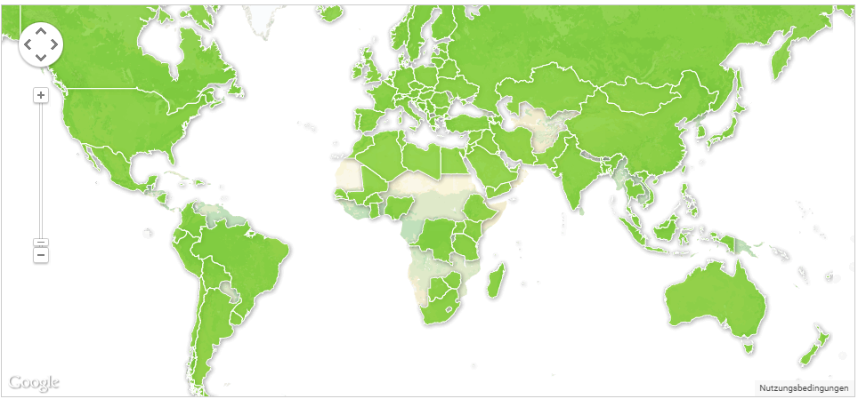**Fig. 1: Countries in the Renewable Energy Policy Dataset**

The project investigates the effectiveness of the following 21 RE support policies: auditing, codes and standards, demonstration project, feed-in tariffs or premiums, funds to sub-national governments, grants and subsidies, green certificates, information and education, infrastructure investments, institutional creation, loans, monitoring, obligation schemes, other mandatory requirements, procurement rules, RD&D funding, research program, strategic planning, tax relief, user charges, and white certificates.

As indicated, these policies have been collected from the web page of IRENA (<http://www.iea.org/policiesandmeasures/renewableenergy/>) The scraper code written in Python language opens the web page for every country in the IRENA dataset, and consequently opens every policy page associated with every country. After this procedure, it stores all of the policy information on these individual pages and categorizes the different policies for the 1990-2014 using a binary categorization. Thus, for the years in which a policy has been in practice, the code assigns a “1” value, and “0” otherwise. This project takes only the national-level policies that focus on multiple types of RE into consideration for the sake of generalization. State-level policies and policies aimed at specific types of RE (like solar energy) can also be analyzed separately. The binary approach is rather simplistic, but necessary; same RE support policies implemented in two different countries can have different impacts due to the amount of financial support they provide, law enforcement, business climate, and previous experiences of investors. Nevertheless, binary option offers a feasible option to do the analysis.

The impact of policies on the RE deployment will be tested by a multiple linear regression that has fixed time (year) and fixed country effects as shown below.

*Yit* =*α*0+*β*\***P** *it* +*δ*\***D***it* + *γ\****C***i + θ\****T***t+ εit*

*Yit* = *Nit* / *Git*

The variable *Yit* is a ratio of total non-hydro electric generation capacity (*Nit*)[1] and total electricity net generation (*Git*) in country *i* at year *t*. P*it* is the RE policy variable, D*it* stands for development variables related to each country[2], T*t* represents year fixed effects and C*i* represents country-fixed effects.

The control variables P*it* and D*it*, and the fixed effects T*t* and C*i* that are used in the regression analysis can be listed as follows:

1. Policy variables: The policy variables used in the regression refer to nation-wide policies. A considerable portion of federal states initiate state-level policies, as well. The impact of state level policies on the results in this study can largely be neglected,[3] since many of these policies have been put into practice in a proportionally small part of the countries in the dataset and a significant portion of them are pilot projects. The characteristics of different policies are explained in the next section.
2. Population density has been selected due to close relationship between energy production and distribution—a variable that is frequently mentioned by REEGLE (2014). It is easier to build more RE in relatively denser places due to lower costs of electricity grids. Similarly, higher electricity consumption in densely populated areas leads to more dependence on electricity. Thus, there would be more inclination towards investing in RE, since the majority of RE is produced in the form of electricity.
3. GDP per capita is used to control for the possibility that higher income countries would have higher RE capacity, since they are able to invest more (Carley, 2009; Dong, 2012).
4. The variable on the domestic credit to the private sector as a proportion of GDP controls for the impacts of the financial sector development on the share of RE in the electricity sector. Since the fixed costs for RE are relatively high, access to finance can be conducive to more development (Brunnschweiler, 2010; Liming, 2009).
5. Foreign direct investment (FDI) measured by FDI net inflows as a proportion of GDP contributes to RE growth via various ways such as alleviating credit constraint, leading to faster technological progress and leading to spillover effects in RE technologies (De Mello, 1999; Del Rio Gonzalez, 2009; Sawhney and Kahn, 2011).
6. The share of females in the population controls for the fact that women have stronger preferences for environmental quality due to their tendency to be caregivers and to be cooperative (Torgler and Garcia-Valinas, 2007; Torgler et al. 2008; Vona et al. 2012).
7. Energy use per 1000 dollars provides information on energy efficiency and energy intensity and controls for differences in energy consumption between countries to have a stronger sense of policy effect on the actual RE deployment.
8. Adjusted savings focusing on energy depletion provides a measure for the availability of conventional energy sources in a country; nations with larger conventional energy endowment would be less inclined to look for alternative sources, as experienced in the MENA region (Dong, 2012).
9. Fixed time and fixed country models have been chosen due to heterogeneity between years and countries that is constant over time and correlated with independent variables. Years and countries may have observable or unobservable differences between each other. In the case of time effects, this may be the impacts of a global crisis (such as the financial crisis of 2007-2008) or the discovery of a new technology (as in the case of 2000% decline in the prices of silicon photovoltaic cells in the last twenty years). In comparison, taking country effects into consideration, a natural catastrophe (like the 2011 earthquake and tsunami in Japan) or the election of more environmentally-conscious politicians (such as the coalition partnership of Green Party in Germany between 1998 and 2005) may have contributed to the RE prospects of that country. In fact, Zhao et al. (2013) found out that the policy effects on RE deployment have been more pronounced before 1996. Additionally, the Hausman test indicated that a fixed effects model would be preferred over a random effects model with the existing dataset.

The similarities between countries in terms of RE support policies will be done using distance measures and clustering. For this purpose, averages of policy variables over 25 years will be taken and Jaccard distances between different countries will be calculated. Following this procedure, dendograms will be provided. For the evolution of policies over the years, plots will be provided.

The hydroelectric component of RE has been neglected because of the environmentally risky nature of hydroelectric investments, some of which—especially considering large dams—cause environmental damage to an extent that it is irreparable. Similarly, primarily in the developing world, many hydroelectric dams are very large state-initiated, domestically or internationally funded projects that were built before the 1990s (some examples are Akosombo Dam in Ghana and Turkwel Dam in Kenya), have been used for satisfying huge portions of energy consumption and have not been constructed following a politically or socially green agenda.

The names and types of the variables used in the dataset are provided in the following table. The dataset covers 25 years and 109 countries (2725 potential observations), and the dependent variable has 2425 observations due to missing values for some years. No special procedure will be applied to missing values, since the number of missing values is quite tolerable for a dataset of this size.

**Table 2: Names and Types of Variables**

<class 'pandas.core.frame.DataFrame'>

Int64Index: 2725 entries, 1 to 109

Data columns (total 33 columns):

Auditing 2725 non-null int64

Codes and Standards 2725 non-null int64

Demonstration Project 2725 non-null int64

Feed-in Tariffs or Premiums 2725 non-null int64

Funds to Sub-National Governments 2725 non-null int64

Grants and Subsidies 2725 non-null int64

Green Certificates 2725 non-null int64

Information and Education 2725 non-null int64

Infrastructure Investments 2725 non-null int64

Institutional Creation 2725 non-null int64

Loans 2725 non-null int64

Monitoring 2725 non-null int64

Obligation Schemes 2725 non-null int64

Other Mandatory Requirements 2725 non-null int64

Procurement Rules 2725 non-null int64

RD&D Funding 2725 non-null int64

Research Programme 2725 non-null int64

Strategic Planning 2725 non-null int64

Tax Relief 2725 non-null int64

Taxes 2725 non-null int64

User Charges 2725 non-null int64

White Certificates 2725 non-null int64

Year 2725 non-null int64

country_index 2725 non-null int64

year 2725 non-null int64

Share of Non-Hydro RE Capacity 2425 non-null float64

Population density (people per sq. km of land area) 2625 non-null float64

GDP per capita, PPP (current international $) 2625 non-null float64

Domestic credit to private sector (% of GDP) 2500 non-null float64

Foreign direct investment, net inflows (% of GDP) 2625 non-null float64

Population, female (% of total) 2625 non-null float64

Energy use (kg of oil equivalent) per $1,000 GDP (2011 PPP) 2500 non-null float64

Adjusted savings: energy depletion (% of GNI) 2625 non-null float64

dtypes: float64(8), int64(25)

memory usage: 723.8 KB

None

The following figure highlights the number of specific policies used by the countries in the dataset:

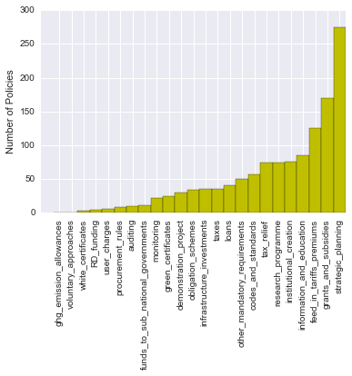

**Fig. 2: Number of Specific Policies**

The heat maps below look at the correlation between RE support policies and development variables in the dataset. The relatively low correlation between RE support policies (the highest is around 0.4) rules out the risk of multicollinearity in the analysis.

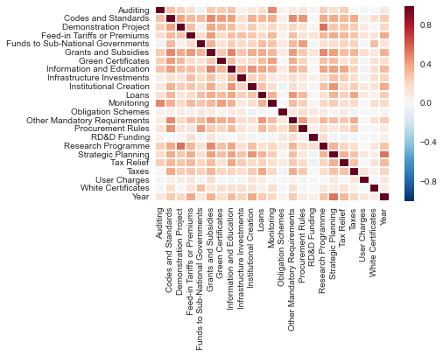**Fig. 3: Correlations between RE Support Policies**

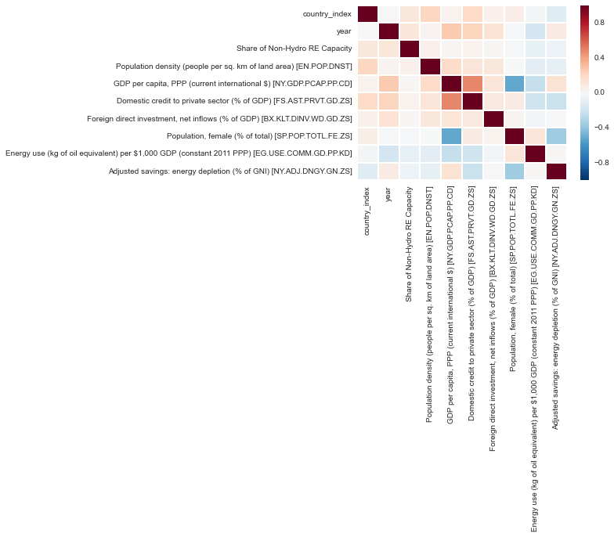**Fig. 4: Correlation Between Development Variables**

The figures below show the relationship between the share of non-hydro RE capacity in total electricity net generation (y-axis) and each variable in the dataset (x-axis).

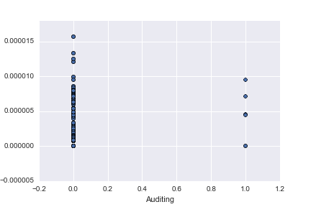

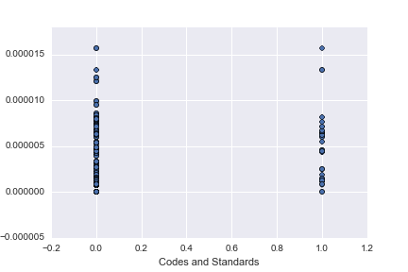

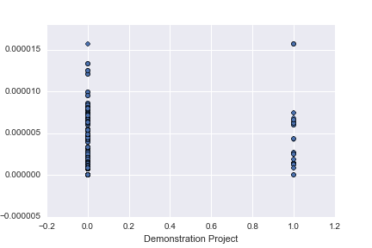

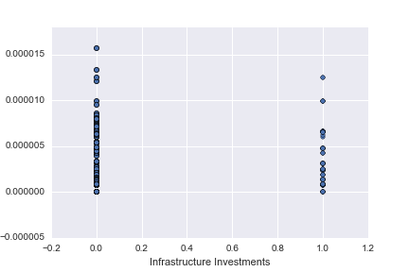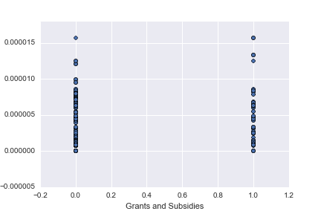

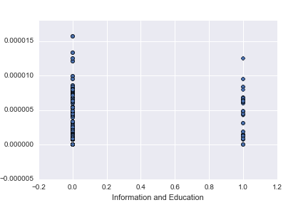

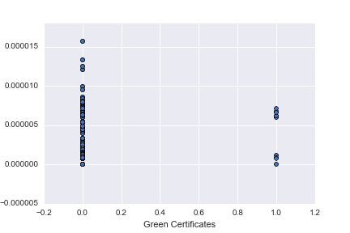

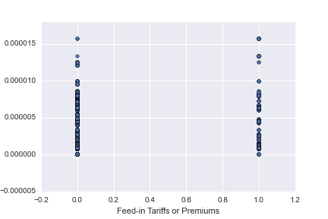

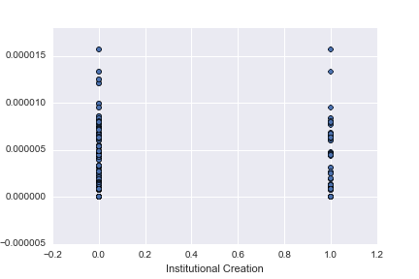

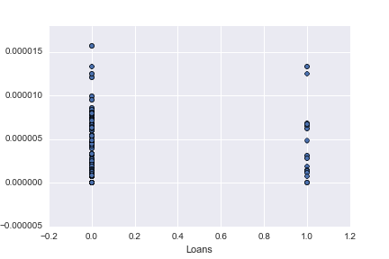

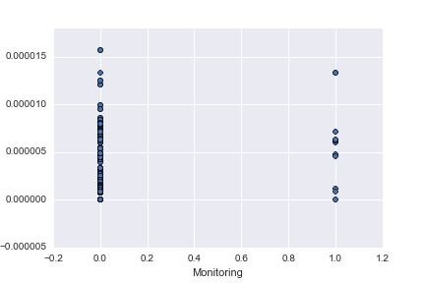

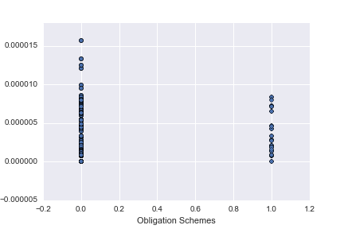

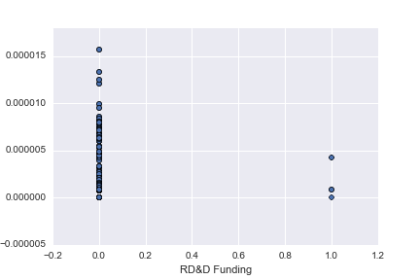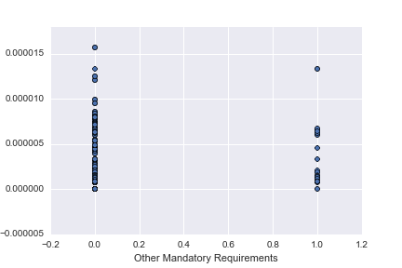

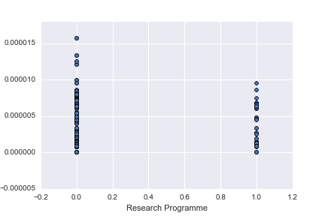

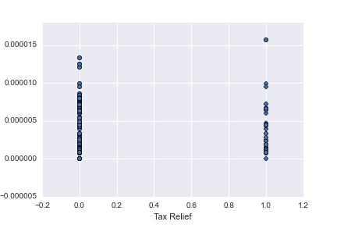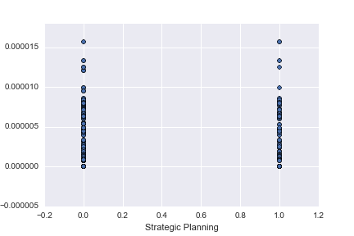

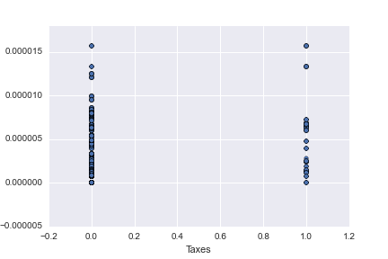

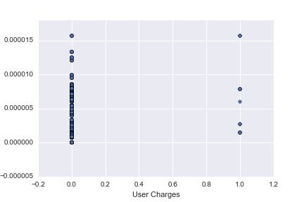

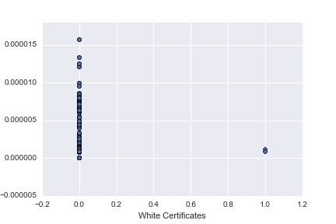

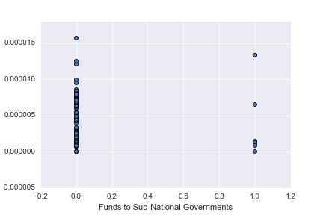

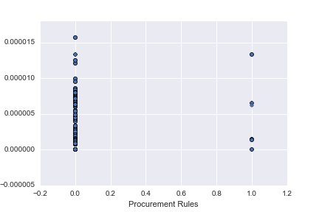

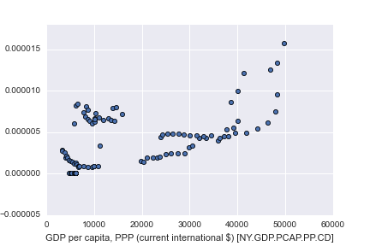

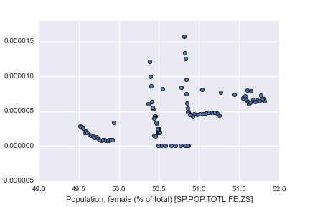

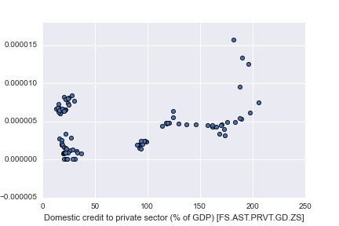

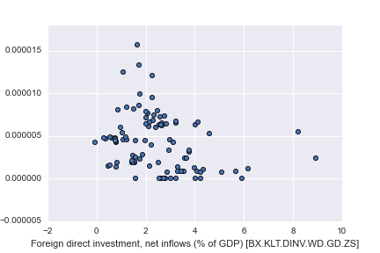

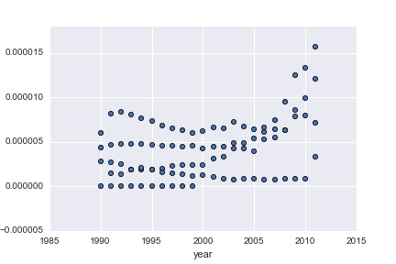

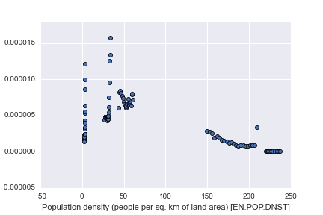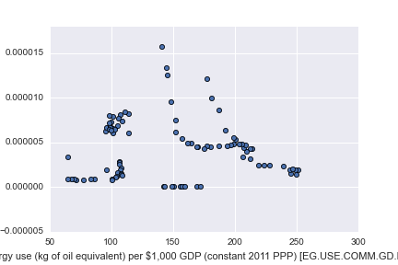

The table below shows statistical information about the development variables.

**Table 3: Statistical Information on Development Variables**

Share of Non-Hydro RE Capacity \

count 2252.000000

mean 0.000013

std 0.000097

min 0.000000

25% 0.000000

50% 0.000000

75% 0.000006

max 0.002058

Population density (people per sq. km of land area) [EN.POP.DNST] \

count 2593.000000

mean 179.496892

std 607.628321

min 1.405906

25% 30.245686

50% 70.873792

75% 124.817539

max 7713.142857

GDP per capita, PPP (current international $) [NY.GDP.PCAP.PP.CD] \

count 2496.000000

mean 15510.554661

std 17337.230639

min 352.773837

25% 3995.108783

50% 9152.945453

75% 22114.136260

max 136727.253600

Domestic credit to private sector (% of GDP) [FS.AST.PRVT.GD.ZS] \

count 2437.000000

mean 56.464357

std 49.256538

min 0.198286

25% 20.280578

50% 38.545974

75% 82.414525

max 311.063029

Foreign direct investment, net inflows (% of GDP) [BX.KLT.DINV.WD.GD.ZS] \

count 2487.000000

mean 3.816226

std 10.134676

min -57.429697

25% 0.841936

50% 2.237348

75% 4.683984

max 430.640692

Population, female (% of total) [SP.POP.TOTL.FE.ZS] \

count 2616.000000

mean 50.025379

std 2.987058

min 23.470113

25% 49.743983

50% 50.440958

75% 51.067437

max 54.313019

Energy use (kg of oil equivalent) per $1,000 GDP (constant 2011 PPP) [EG.USE.COMM.GD.PP.KD] \

count 2079.000000

mean 160.529530

std 103.721216

min 38.271414

25% 97.471634

50% 126.717686

75% 186.027022

max 736.757295

Adjusted savings: energy depletion (% of GNI) [NY.ADJ.DNGY.GN.ZS]

count 2489.000000

mean 3.364880

std 6.841597

min 0.000000

25% 0.000000

50% 0.184736

75% 2.566317

max 50.097404

1. Non-hydro electric energy includes geothermal, solar, tide and wave, wind, biomass and waste types of RE. The unit of energy that has been taken into consideration is kWh.
2. Development variables include population density (people per sq. km of land area), electricity consumption (kWh) per capita, energy use (kg of oil equivalent) per $1,000 GDP (constant 2011 PPP), adjusted savings: energy depletion (% of GNI) (shows the percentage of national income obtained from selling coal, crude oil and natural gas),and GDP per capita (constant 2011 PPP).
3. A limitation of the study in this regard is the US, in which case there are many effective state-wide policies and a decentralized policymaking structure.