|  |  |
| --- | --- |
| Sr No | Program/ Output |
| 1. | /*A storekeeper maintains a file which contains the list of all food items: name, price,  manufacturer – name, quantity available. Write an interactive menu driven C++  program that  will access the file and implement the following tasks. Use reading and writing of  class objects  concepts from the file to implement the program. Use the appropriate file error  handling  functions.  a. Display the food item details when food item name is entered.  b. Display the food items between the price range 100 to 500*/  //22CO16 Joshua B Fernandes 19/11/23  #include <iostream>  #include <fstream>  #include <string>  #include <vector>  #include <sstream>  using namespace std;  class item  {  public:  string name, mname;  double price;  int quantity;  void display()  {  cout << "Product Name : " << name << endl;  cout << "Manufacturer's name : " << mname << endl;  cout << "Price : Rs " << price << "/-" << endl;  cout << "Quantity : " << quantity << " nos" << endl;  }  };  vector<item> shopList;  void saveItems()  {  ofstream file("LIST");  if (!file.is_open()) {  cout << "Failed to open the file.\n";  return;  }  for (const auto& i : shopList) {  file << i.name << "," << i.mname << "," << i.price << "," << i.quantity << "\n";  }  file.close();  }  void enterItem()  {  item i;  cout << "Enter item name: "; cin >> i.name;  cout << "Enter manufacturer name: "; cin >> i.mname;  cout << "Enter price: "; cin >> i.price;  cout << "Enter quantity: "; cin >> i.quantity; shopList.push_back(i); saveItems();  }  void displayItem()  {  string n;  cout << "Enter product name : "; cin.ignore();  getline(cin, n, '\n'); ifstream file("LIST"); if (!file.is_open()) {  cout << "Failed to open the file.\n"; return;  }  string line;  while (getline(file, line)) { stringstream ss(line); item i;  getline(ss, i.name, ',');  getline(ss, i.mname, ','); ss >> i.price; ss.ignore(1, ',');  ss >> i.quantity; if (i.name == n) {  i.display(); return;  }  }  cout << "Item not found.\n";  }  void displayItemsInRange()  {  ifstream file("LIST"); if (!file.is_open()) {  cout << "Failed to open the file.\n"; return;  }  string line;  while (getline(file, line)) { stringstream ss(line); item i;  getline(ss, i.name, ',');  getline(ss, i.mname, ','); ss >> i.price; ss.ignore(1, ',');  ss >> i.quantity;  if (i.price >= 100 && i.price <= 500) { i.display();  }  }  }  int main()  {  int option; do  {  cout << "Enter 0 to stop execution.\n"; cout << "Enter 1 to enter new item.\n"; cout << "Enter 2 to display an item.\n";  cout << "Enter 3 to display items in range 100 - 500.\n"; cout << "Enter your option : ";  cin >> option; if(option == 0)  return 0; else  {  switch(option)  {  case 1:  enterItem(); break;  case 2:  displayItem(); break;  case 3:  displayItemsInRange(); break;  }  }  }  while(option >= 0 && option <= 3);  }  Output:  /*at end of document*/ |
| 2 | /*Write a C++ program to read 10 numbers from users. Insert the even numbers into even. txt and odd numbers into odd.txt respective files. Use file error handling  functions wherever required.*/  //22CO16 Joshua B Fernandes 19/11/23  #include<iostream>  #include<fstream>  #include<string>  using namespace std;  string ord(int a){  string cha;  if(a==1)  cha="st";  else if(a==2)  cha="nd";  else if(a==3)  cha="rd";  else  cha="th";  return cha;  }  int main(){  ofstream even("even.txt");  ofstream odd("odd.txt");  int n[10];  for(int i=1;i<11;i++){  cout<<"Enter "<<i<<ord(i)<<" number :";  cin>>n[i];  if(n[i]%2==0)  even<<n[i]<<" ";  else  odd<<n[i]<<" ";  }  even.close();  odd.close();  }  Output:  /*at end of document*/ |

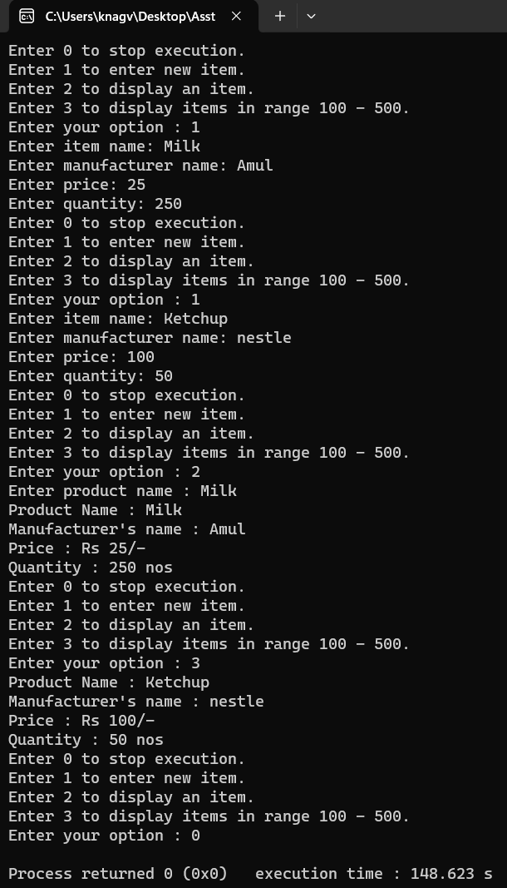

1. 