Creating table and inserting data: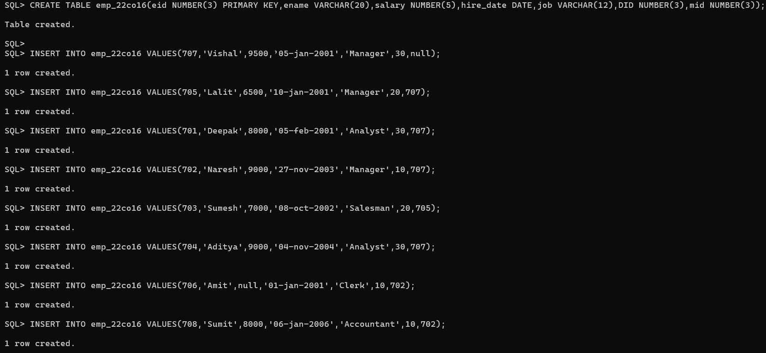

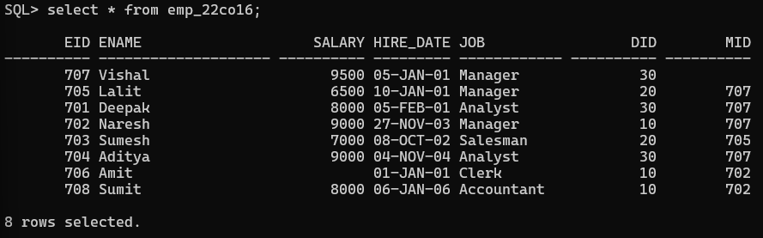

1. Create a trigger for the employee table that would fire for INSERT or UPDATE operations performed on the employee table. This trigger will display the salary difference between the old values and new values.

Output:

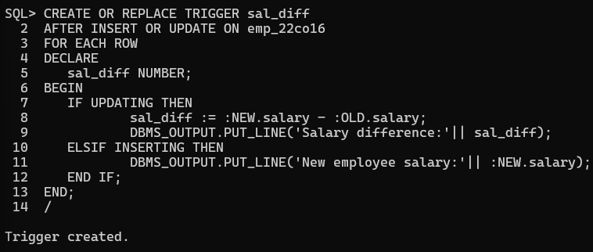

Testing on INSERT and UPDATE operations:

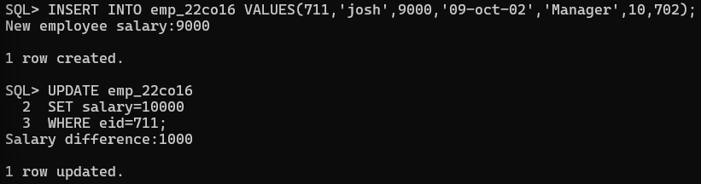

1. Convert employee name into uppercase whenever an employee record is inserted or updated. Trigger to be fired before the insert or update.

Output:

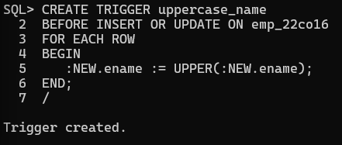

Testing on INSERT and UPDATE operations:

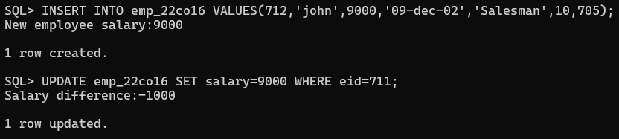

Output after testing the operations:

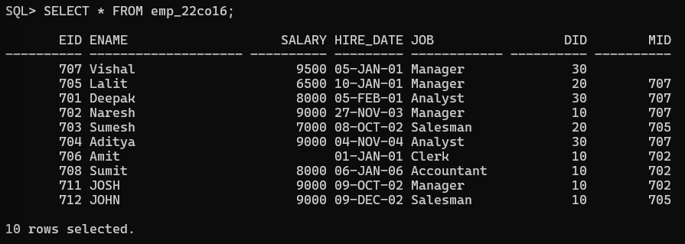

1. Trigger before deleting a record from emp table. Trigger will insert the row to be deleted into another table.

Output:

Creating a new table for deleted records:



Creating the trigger:

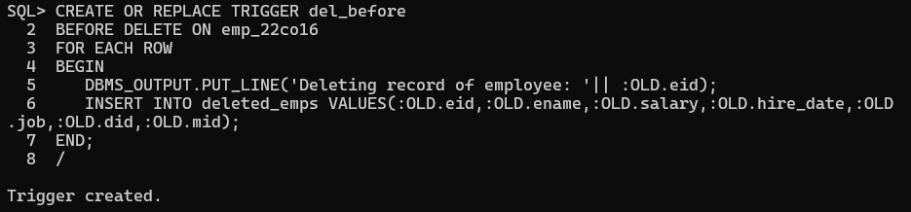

Deleting a record:

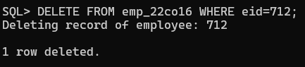

Displaying both tables after DELETE operation:

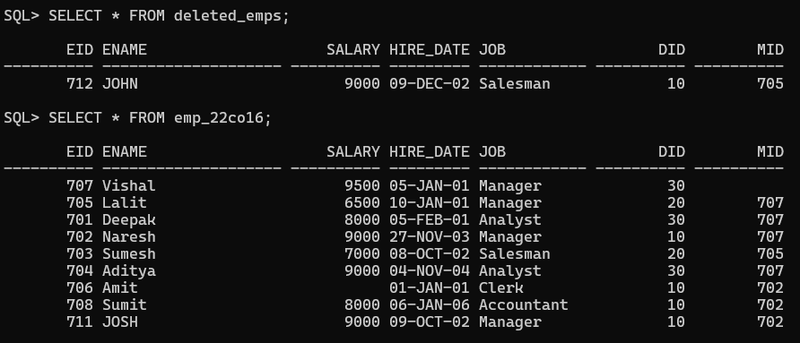

1. Program to indicate invalid salary (if salary is more than 9000) condition using Trigger.

Output: 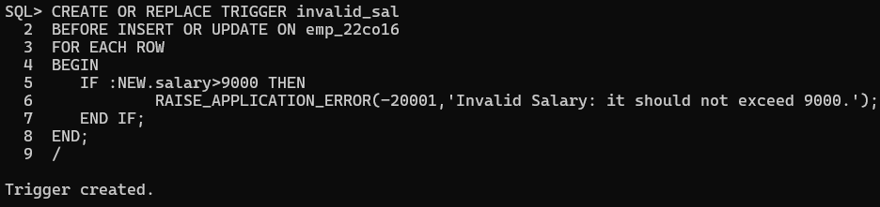

Testing the condition:

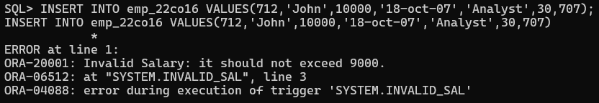

CONCLUSION:

Triggers were successfully studied and implemented.