1. Create a table named SALES_Rollno.

Output:

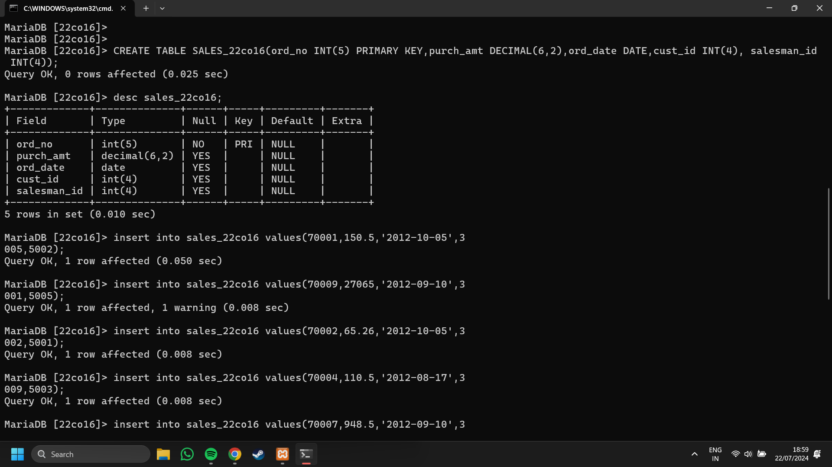



2. Display the contents of the SALES_Rollno.

Output:

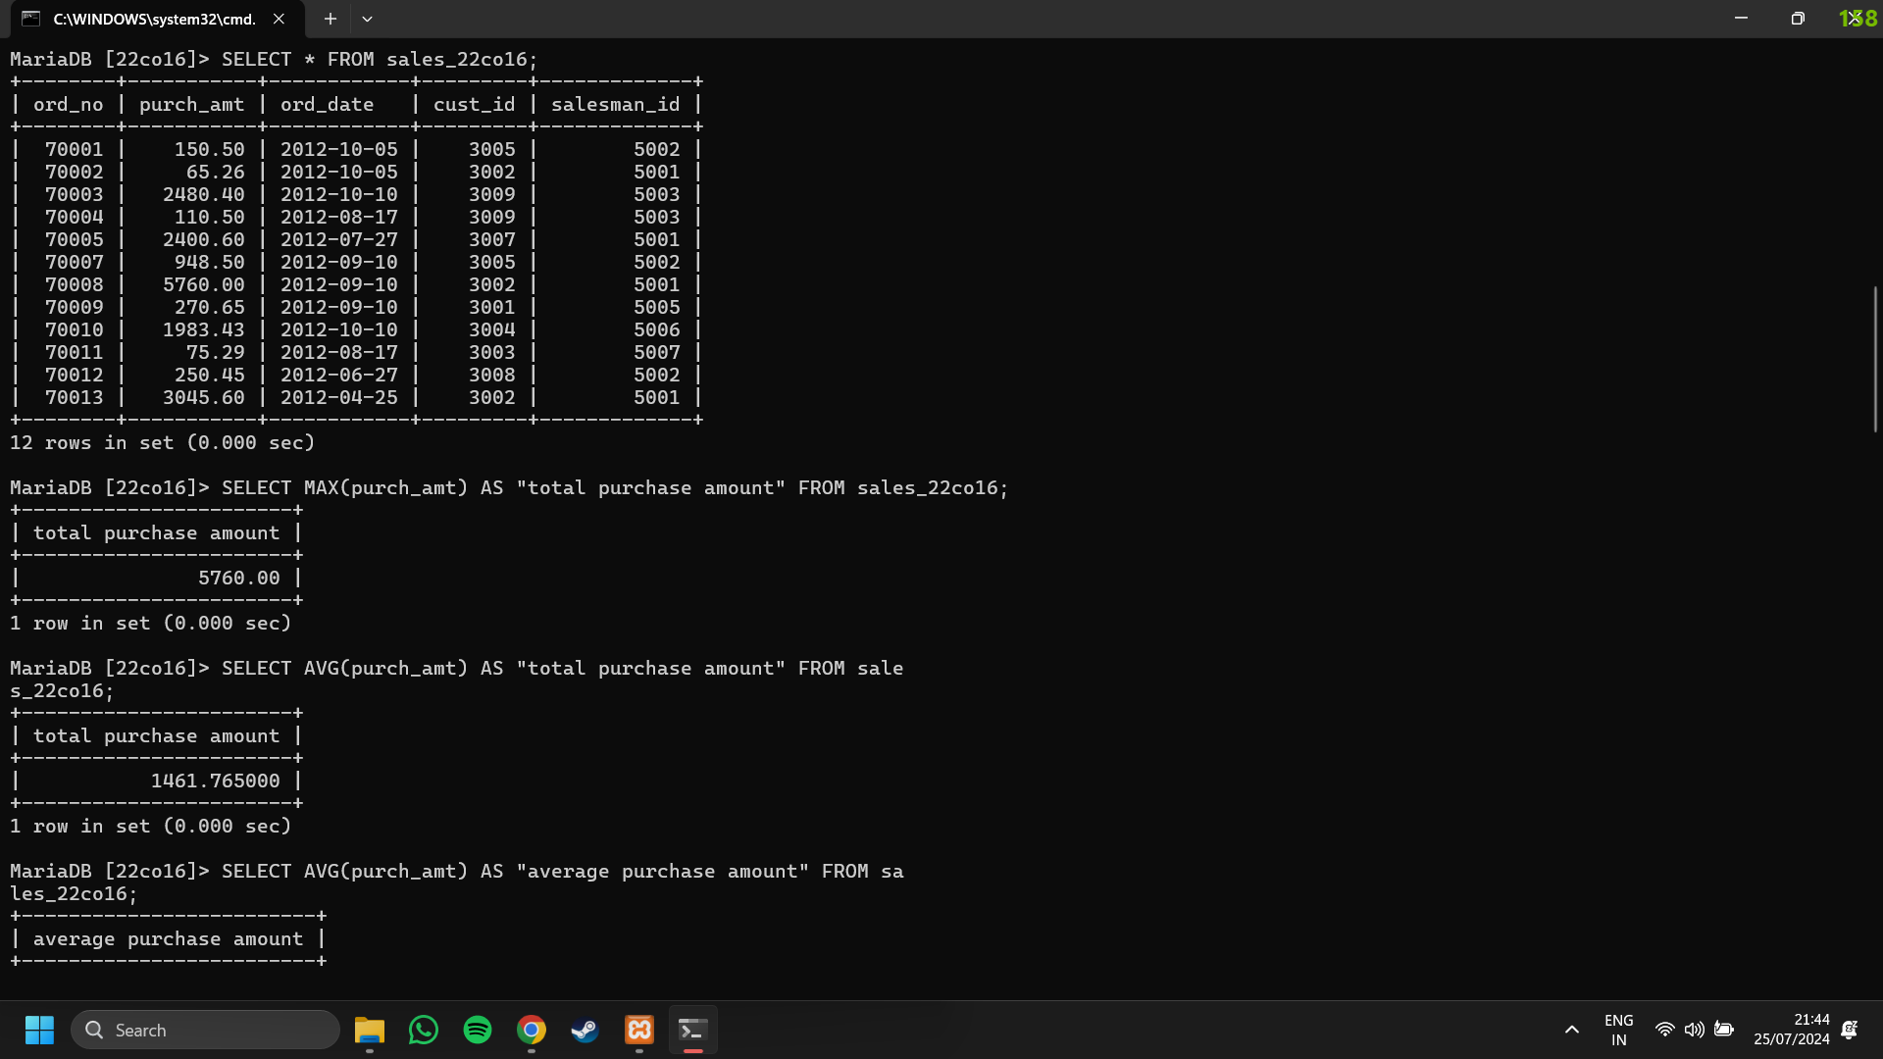

3. Write a SQL statement to find the total purchase amount for all orders.

Output:

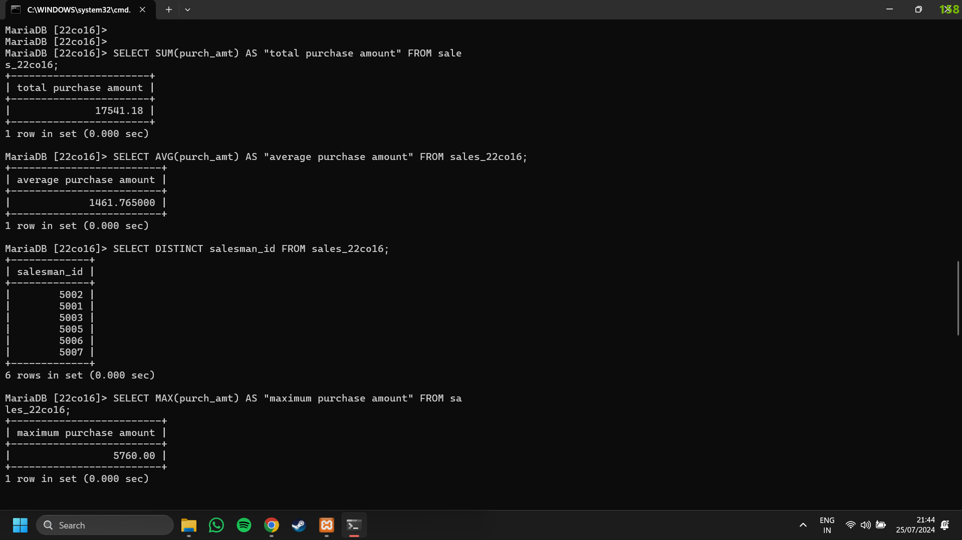

4. Write a SQL statement to find the average purchase amount of all orders.

Output:



5. Write a SQL statement to find the distinct salesman from sales.

Output:



6. Write a SQL statement to get the maximum purchase amount of all the orders.

Output:



7. Write a SQL statement to get the minimum purchase amount of all the orders.

Output:

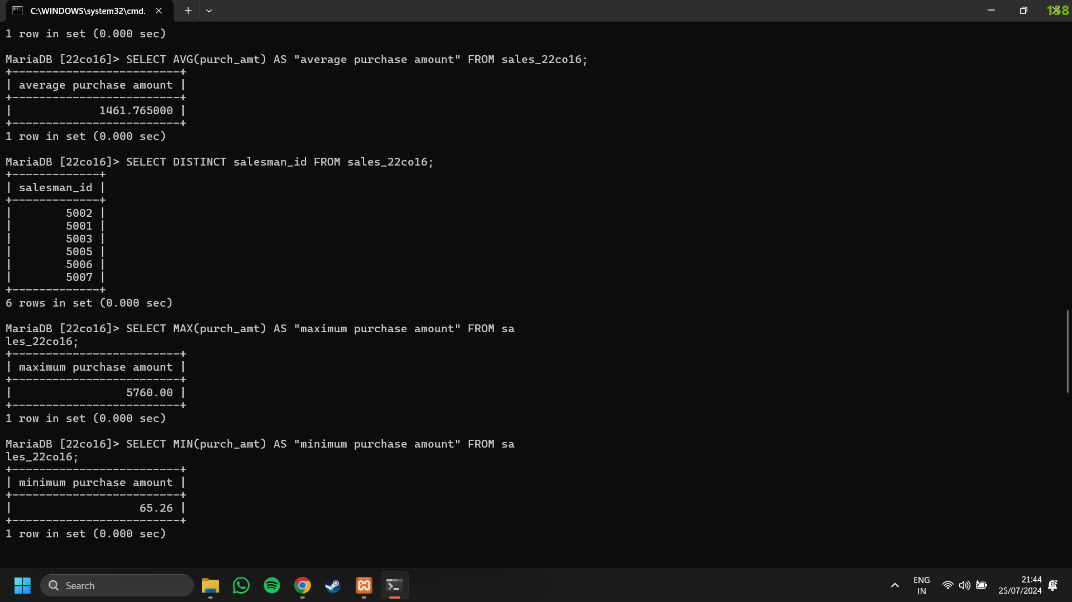

8. Find the highest purchase amount ordered by each customer.

Output:

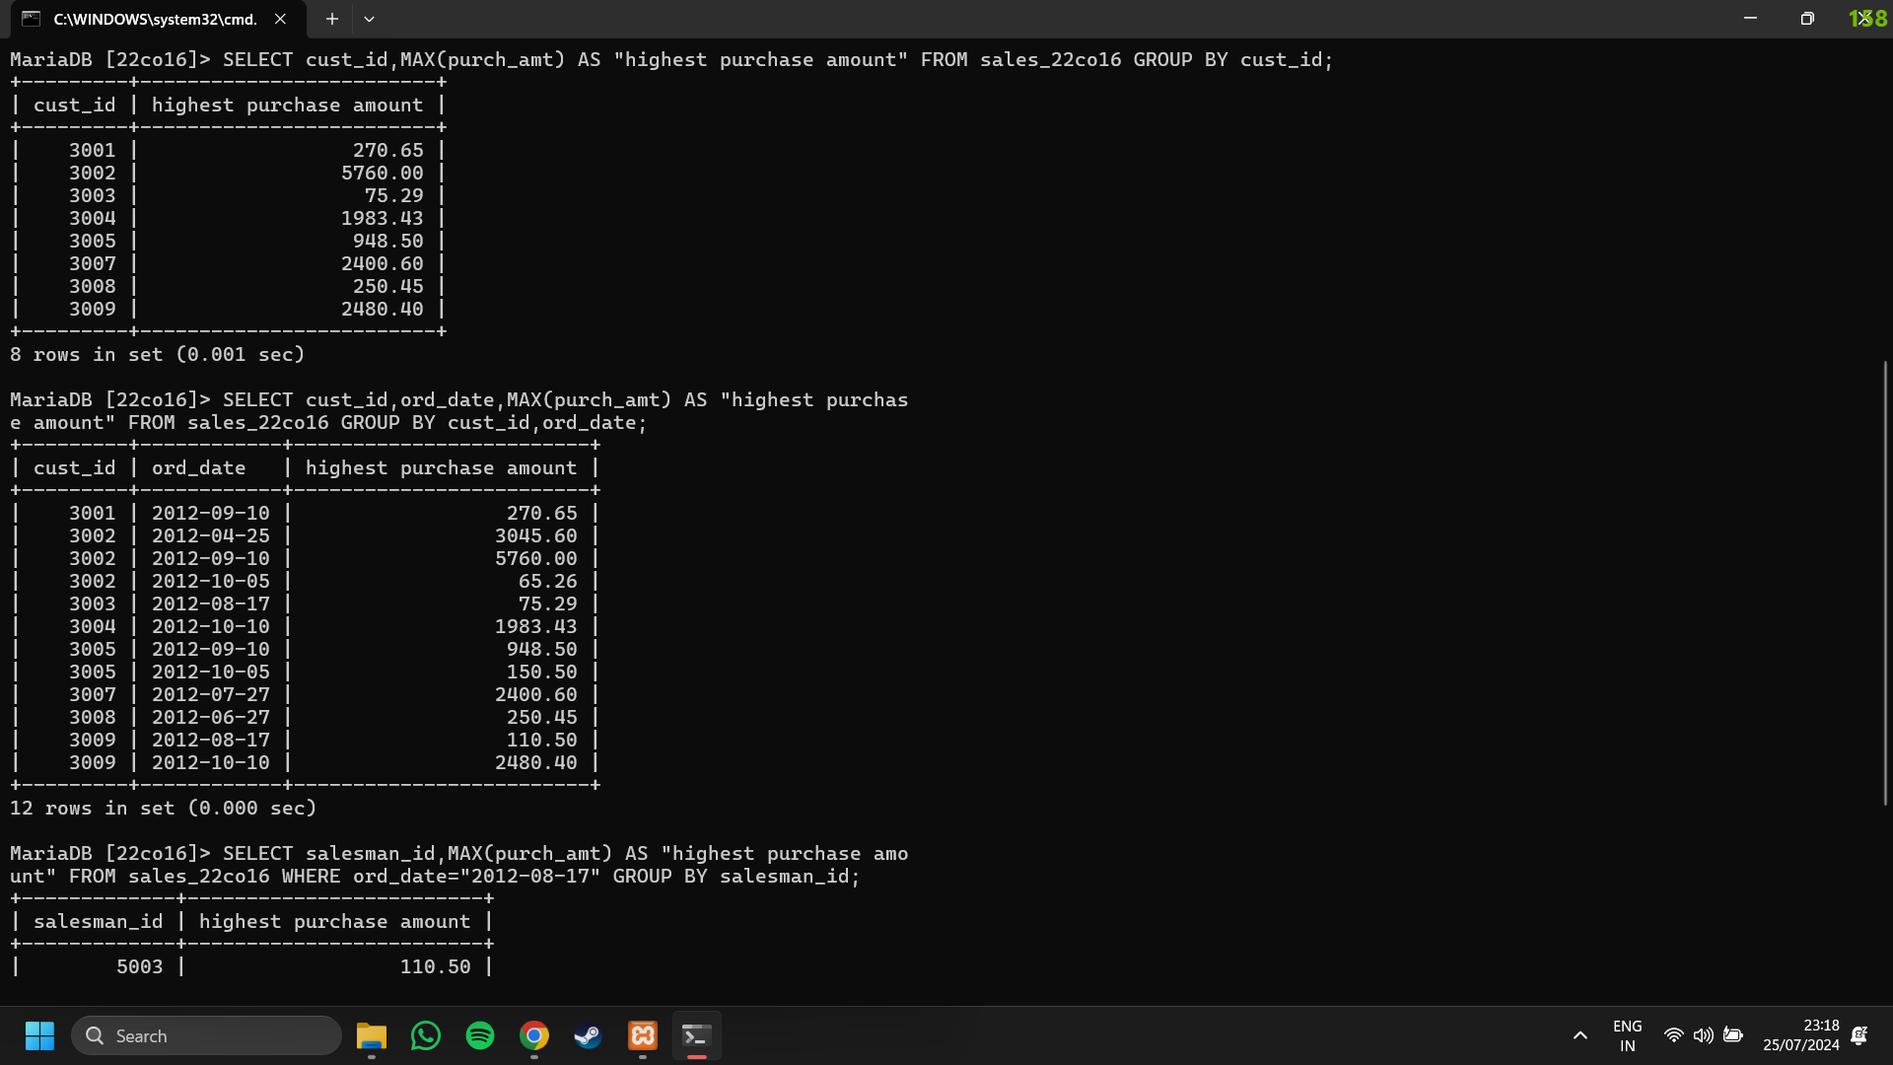

9. Write a SQL statement to find the highest purchase amount ordered by each customer on a particular date with their ID, order date and highest purchase amount.

Output:



10. Write a SQL statement to find the highest purchase amount on a date ‘2012-08-17’ for each salesman with their ID.

Output: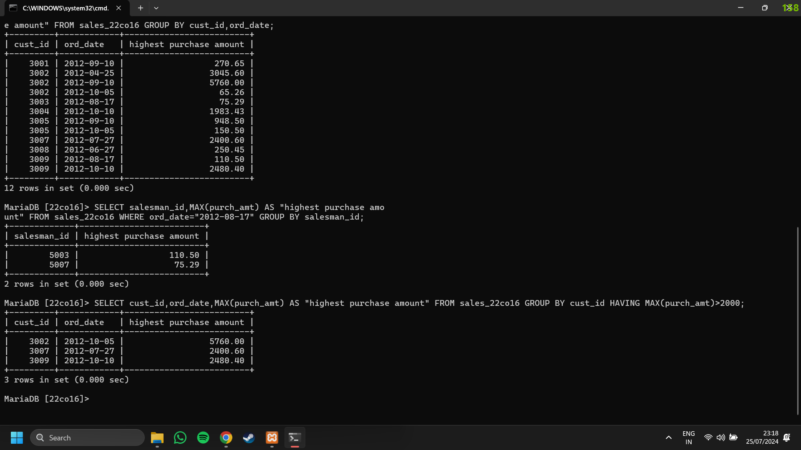

11. Write a SQL statement to find the highest purchase amount with their ID and order date, for only those customers who have highest purchase amount in a day is more than 2000.

Output:

12. Write a SQL statement to find the highest purchase amount with their ID and order date, for those customers who have a higher purchase amount in a day is within the range 2000 and 6000.

Output: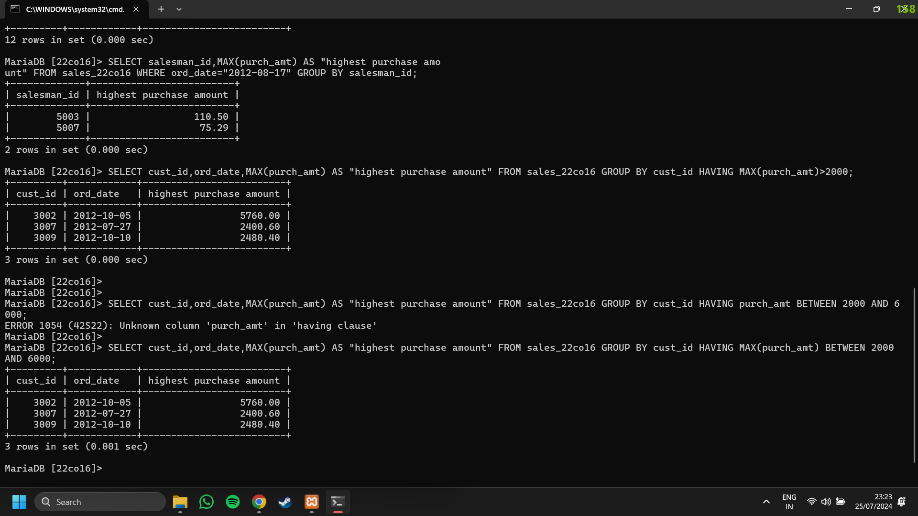

13. Write a SQL statement to find the highest purchase amount with their ID and order date, for only those customers who have a higher purchase amount in a day is within the list 2000, 3000, 5760 and 6000.

Output: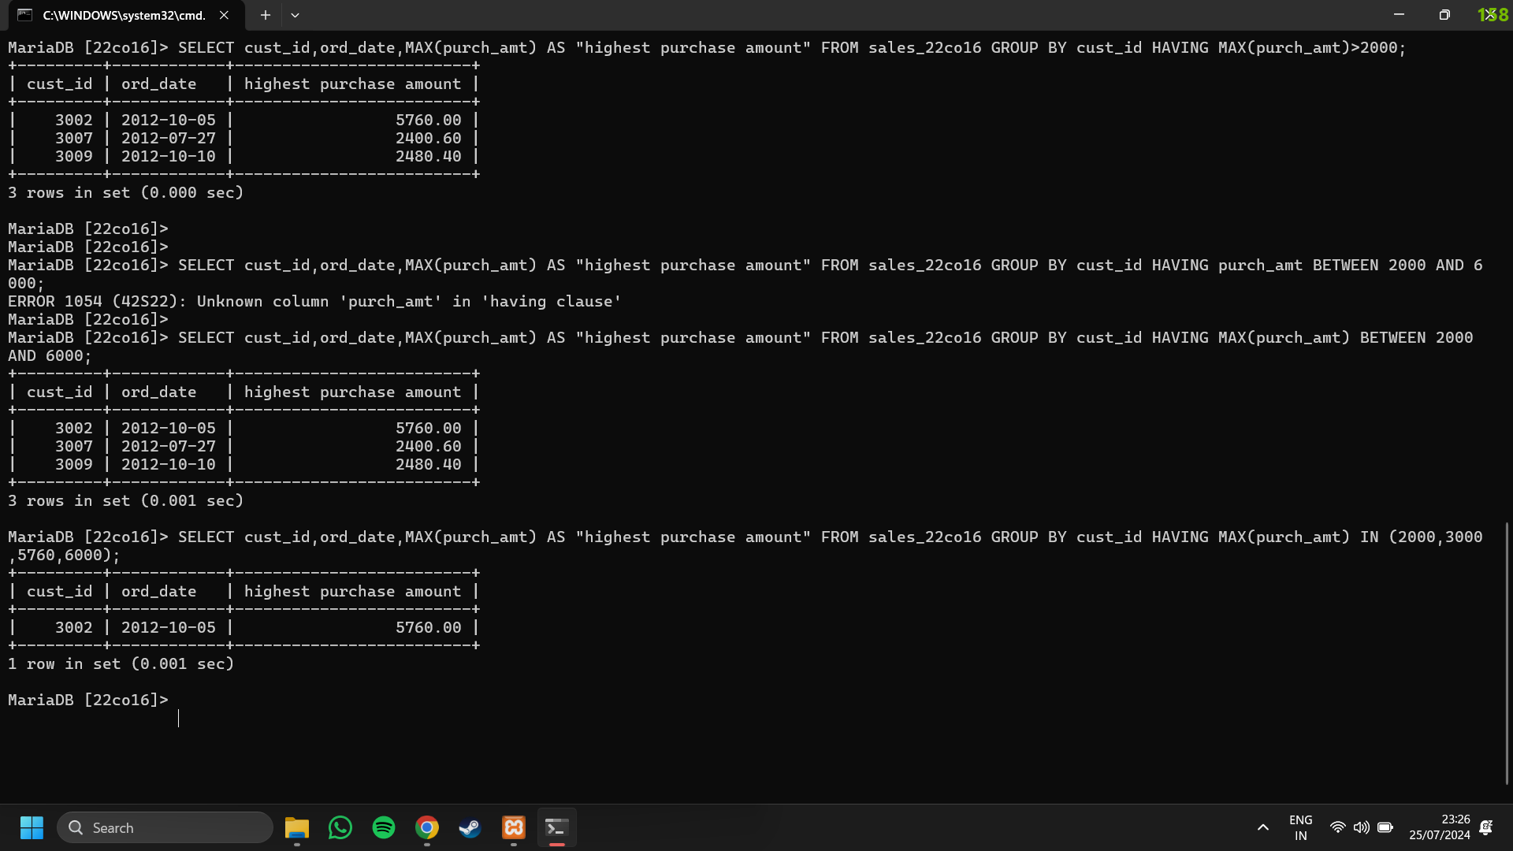

CONCLUSION:

In this experiment, we learnt about SQL aggregate functions ie MIN(),MAX(), SUM(), COUNT(), AVG() and GROUP BY clause along with the HAVING clause. Various examples are implemented using a Database. Thus, in this experiment we successfully demonstrated the use of group functions on the Database.