1. Create a view “Sale(rollno)1” containing all the details from the sale table.

Output:

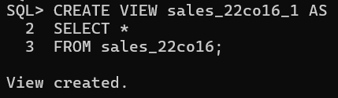

1. Display the contents of “Sale(rollno)1”.

Output:

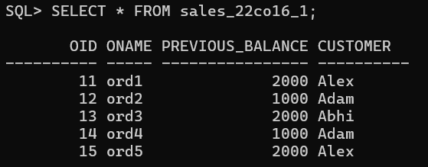

1. Create a view Sale(rollno)2 containing order details and customer name from the sale table.

Output:

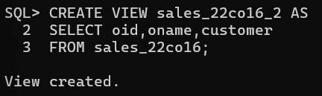

1. Display the contents of “Sale(rollno)02”

Output:

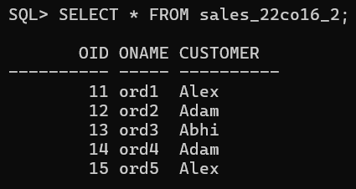

1. Create a view “Sale(rollno)3” containing order and previous balance with the amount increased by 1000 from the sale table.

Output:

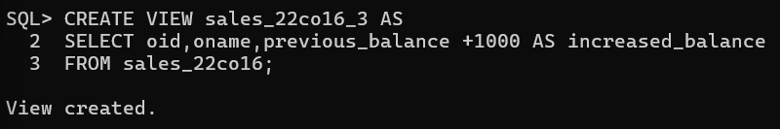

1. Display the contents of Sale(rollno)3

Output:

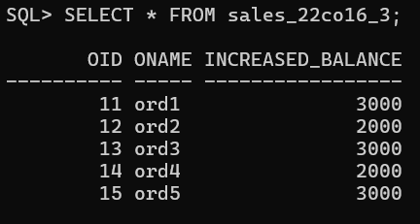

1. Create a view “Sale(rollno)4” for the sale table having order id as 13 and 14. Provide with check option clause. Test the clause by using insert and update statement.

Output:

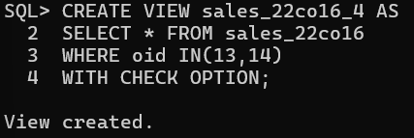

Testing the clause by using insert and update statement:

1. 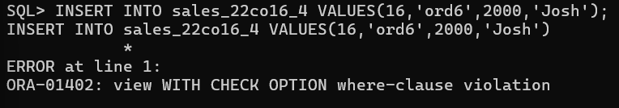
2. 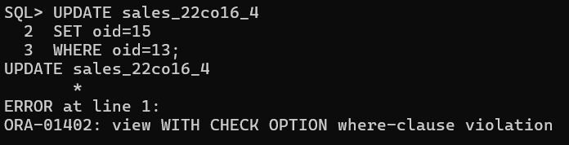
3. Delete a record in Sale(rollno)1 and then display the contents of sale(rollno)1 and Sales tables.

Output:

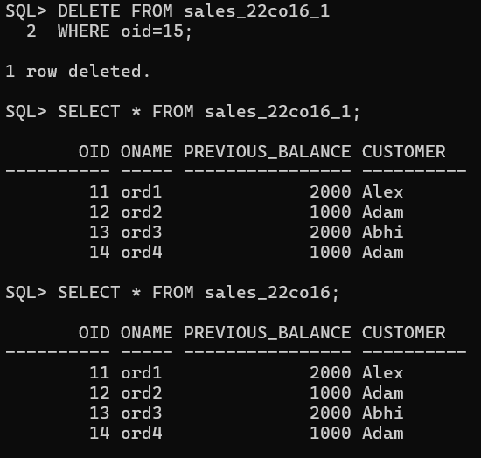

1. Create Sale(rollno)5 view for sale table containing all details of sale table. Use read only clause and test by using update statement.

Output:

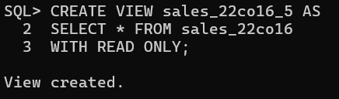

Testing using update statement:

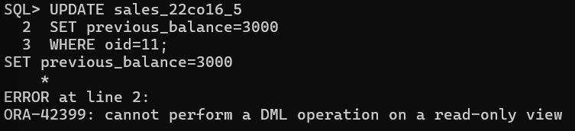

1. Drop view Sale(rollno)5.

Output:

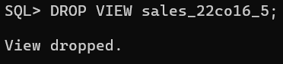

**CONCLUSION:**

In this experiment, SQL commands to perform views was implemented successfully. We learnt about the concept of views, creation of views, updating of views, deletion of views, etc with the help of a database and successfully executed queries on them.