ASSIGNMENT-4

1. WAJS to initialize variables of different data types. Display their values and data types. 06

Input:

<html>

<body>

    <h1>JavaScript Data Types:</h1>

    <script>

        var x = 10;                    // Integer

        var y = 10.5;                  // Float

        var s = "Hello World";         // String

        var bool = true;               // Boolean

        var obj = { name: "John" };    // Object

        var undefinedVar;              // Undefined

        var nullVar = null;            // Null

        document.write("Integer: " + x + " (" + typeof x + ")<br>");

        document.write("Float: " + y + " (" + typeof y + ")<br>");

        document.write("String: " + s + " (" + typeof s + ")<br>");

        document.write("Boolean: " + bool + " (" + typeof bool + ")<br>");

        document.write("Undefined: " + undefinedVar + " (" + typeof undefinedVar + ")<br>");

        document.write("Null: " + nullVar + " (" + typeof nullVar + ")<br>");

        document.write("Object: " + JSON.stringify(obj) + "(" + typeof obj + ")");

    </script>

</body>

</html>

Output:

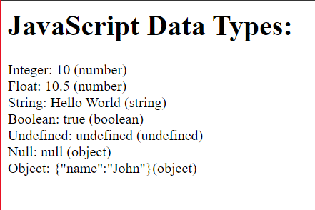

1. Explain 3 different types of pop-up boxes in JavaScript with examples. 06

Input:

<html>

<head>

    <script>

        function f1()

        {

         alert("This is an alert box");

        }

        function f2()

        {

         var x;

         x=prompt("Enter your name:");

         if(x!=null)

         {

            alert("Hello "+x);

         }

        }

        function f3()

        {

         var y=confirm("Click OK");

         if(y)

         {

            alert("You pressed OK");

         }

         else

         {

            alert("You pressed cancel");

         }

        }

     </script>

</head>

<body>

    <h1>Different types of pop-up boxes:</h1>

    <button onclick="f1()">Alert</button>

    <button onclick="f2()">Prompt</button>

    <button onclick="f3()">Confirm</button>

</body>

</html>

Output:

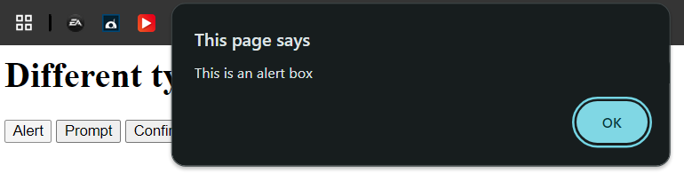 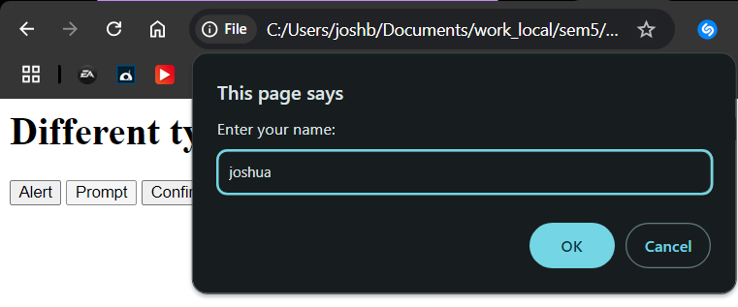

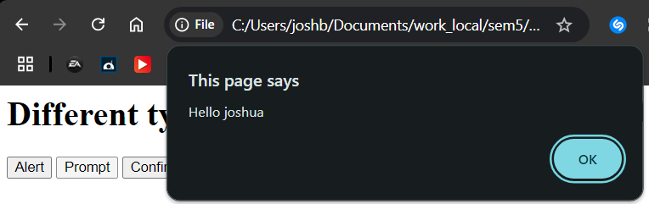 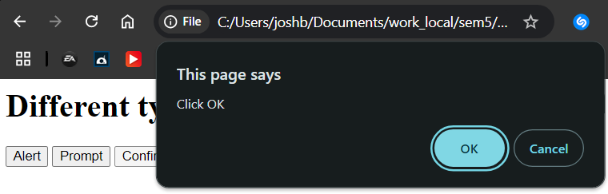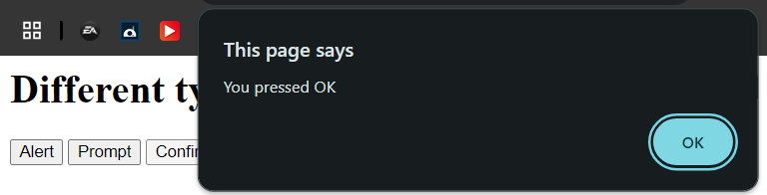

1. WAJS to display sum and average of n numbers. Accept user input. 05

Input:

<html>

<head>

    <script>

        function calculateSumAndAverage()

        {

            var n=parseInt(prompt("Enter the number of elements:"));

            var sum=0;

            for(var i=1;i<=n;i++)

            {

                var num=parseInt(prompt("Enter the "+i+" number:"));

                sum+=num;

            }

            var avg=sum/n;

            document.write("<h1>Output:</h1>")

            document.write("Sum:"+sum+"<br>");

            document.write("Average:"+avg);

        }

     </script>

</head>

<body>

    <button onclick="calculateSumAndAverage()">Calculate the sum and average</button>

</body>

</html>

Output:

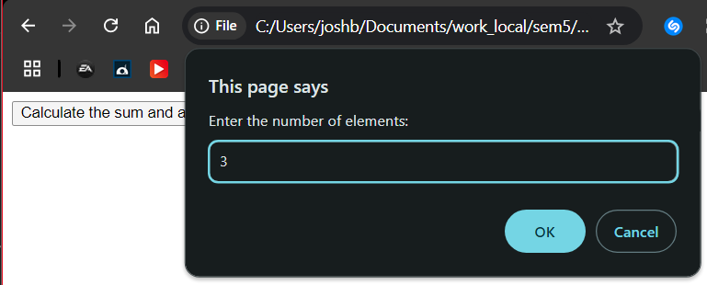

Entering numbers:5,6,7

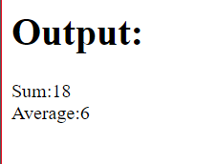

1. WAJS to compute percentage and grade of student. Student will enter marks obtained in 5 subjects. Make use of onclick event and a user defined function. 07

Input:

<html>

<head>

    <script>

        function calculatePercentageAndGrade()

        {

            var s1,s2,s3,s4,s5,totalmarks,percentage;

            s1 = parseFloat(prompt("Enter the subject1 marks:"));

            s2 = parseFloat(prompt("Enter the subject2 marks:"));

            s3 = parseFloat(prompt("Enter the subject3 marks:"));

            s4 = parseFloat(prompt("Enter the subject4 marks:"));

            s5 = parseFloat(prompt("Enter the subject5 marks:"));

            document.write("<h1>Displaying marks of 5 subjects:</h1>");

            document.write("subject1 marks: "+s1);

            document.write("<br>subject2 marks: "+s2);

            document.write("<br>subject3 marks: "+s3);

            document.write("<br>subject4 marks: "+s4);

            document.write("<br>subject5 marks: "+s5);

            totalmarks= s1 + s2 + s3 + s4 + s5;

            document.write("<br><br>Total marks are: "+totalmarks);

            percentage=(totalmarks/500)\*100;

            var grade;

            if (percentage >= 90)

            {

                grade = 'A';

            }

            else if (percentage >= 75)

            {

                grade = 'B';

            }

            else if (percentage >= 60)

            {

                grade = 'C';

            }

            else if (percentage >= 45)

            {

                grade = 'D';

            }

            else

            {

                grade = 'F';

            }

            alert("Percentage: "+percentage.toFixed(2) + "%\nGrade: "+grade);

        }

     </script>

</head>

<body>

    <button onclick="calculatePercentageAndGrade()">Calculate the percentage and grade</button>

</body>

</html>

Output:

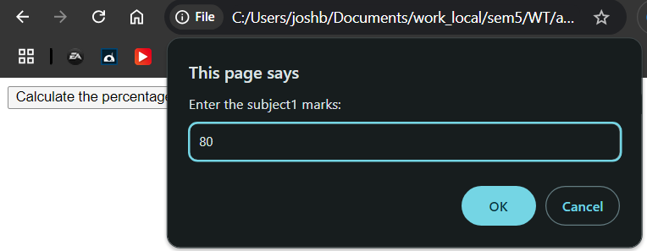 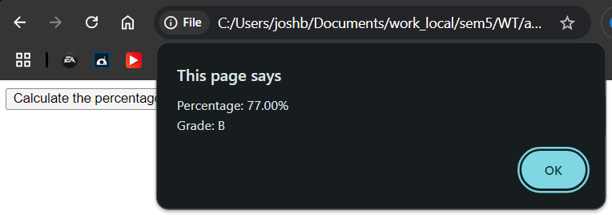

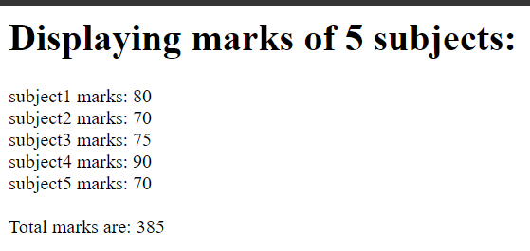

1. Demonstrate following events using JavaScript.
2. Onclick
3. ondblclick
4. onsubmit
5. onreset
6. onload
7. onselect
8. onchange

Input:

<html>

<head>

        <script>

        function f1() {

            alert("Page has loaded!");

        }

        function f2() {

            alert("Button was clicked!");

        }

        function f3() {

            alert("Button was double-clicked!");

        }

        function f4() {

            alert("Form submitted!");

            return false;

        }

        function f5() {

            alert("Form reset!");

        }

        function f6() {

            alert("Text selected!");

        }

        function f7() {

            alert("Dropdown value changed!");

        }

    </script>

</head>

<body onload="f1()">

    <h1>Demonstrating Different Events Using JavaScript</h1>

    <button onclick="f2()">Click Me</button>

    <button ondblclick="f3()">Double Click Me</button><br><br>

    <form onsubmit="return f4()" onreset="f5()">

        <label for="name">Name:</label>

        <input type="text" id="name" name="name"><br><br>

        <label for="comments">Comments:</label><br>

        <textarea id="comments" name="comments" onselect="f6()"></textarea><br><br>

        <label for="options">Choose a City:</label>

        <select id="options" name="options" onchange="f7()">

            <option value="Option 1">Mapusa</option>

            <option value="Option 2">Panjim</option>

            <option value="Option 3">Porvorim</option>

        </select><br><br>

        <input type="submit" value="Submit">

        <input type="reset" value="Reset">

    </form>

</body>

</html>

Output:

* 1. 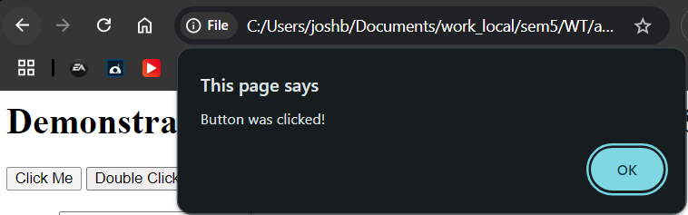
  2. 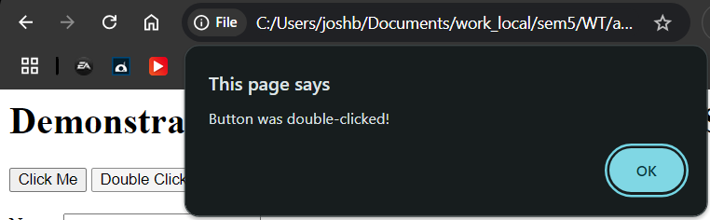
  3. 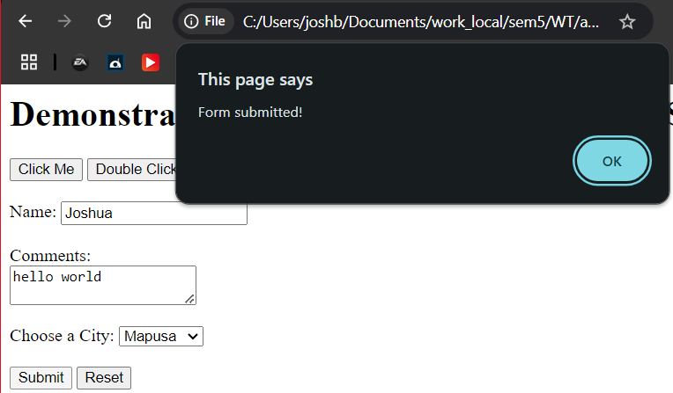
  4. 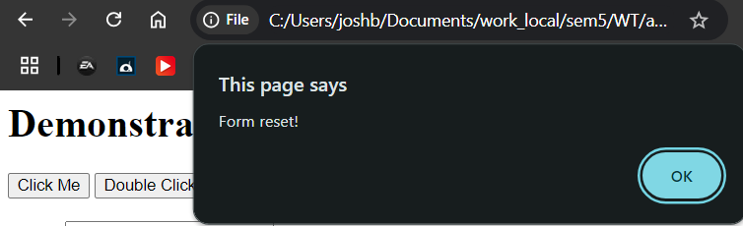
  5. 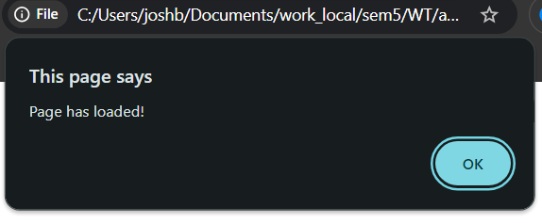
  6. 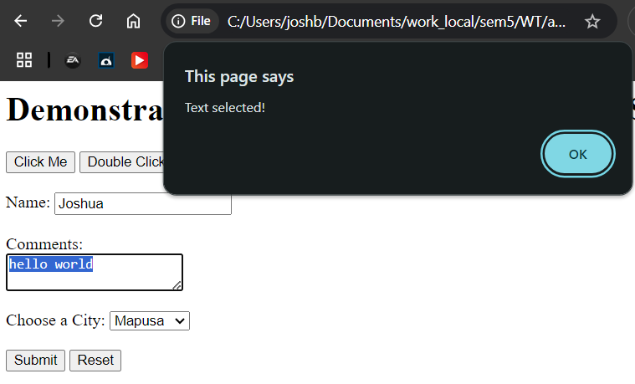
  7. 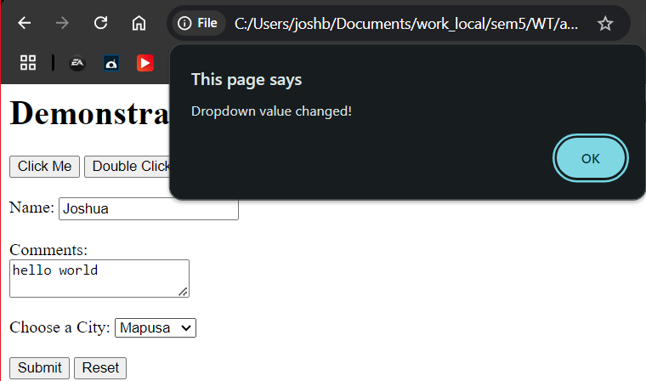

1. Demonstrate following events with JS code.
   1. Onmousedown
   2. Onmouseup
   3. Onmouseover
   4. Onmouseout
   5. onmousemove

Input:

<!DOCTYPE html>

<html>

<head>

    <style>

        div {

          width: 200px;

          height: 100px;

          margin: 20px;

          border: 2px solid black;

          text-align: center

        }

        </style>

</head>

<body>

    <div id="eventBox" onmousemove="handleMouseMove(event)">Interact with Me</div>

    <p id="test"></p>

    <script>

        const eventBox=document.getElementById("eventBox");

        function handleMouseDown() {

            alert("Mouse button pressed down!");

        }

        function handleMouseUp() {

            alert("Mouse button released!");

        }

        function handleMouseOver() {

            alert("Mouse is over the element!");

        }

        function handleMouseOut() {

            alert("Mouse has left the element!");

            document.getElementById("test").innerHTML = "";

        }

        function handleMouseMove(e) {

            let x=e.clientX;

            let y=e.clientY;

            let coor="Coordinates: ("+x+","+y+")";

            document.getElementById("test").innerHTML=coor;

        }

        eventBox.onmousedown = handleMouseDown;

        eventBox.onmouseup = handleMouseUp;

        eventBox.onmouseover = handleMouseOver;

        eventBox.onmouseout = handleMouseOut;

        eventBox.onmousemove = handleMouseMove;

    </script>

</body>

</html>

Output:

1. 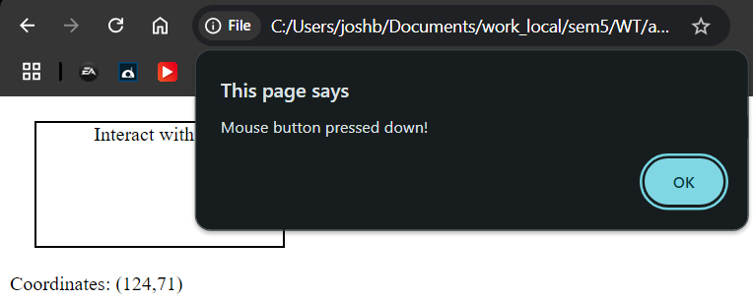
2. 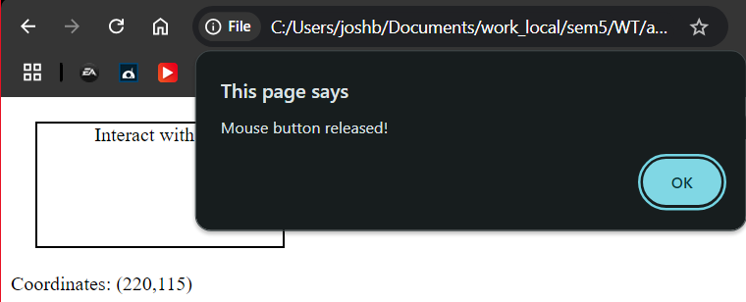
3. 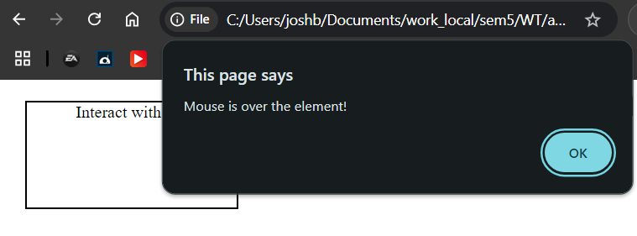
4. 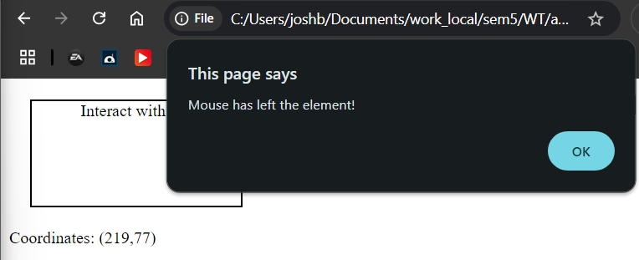
5. 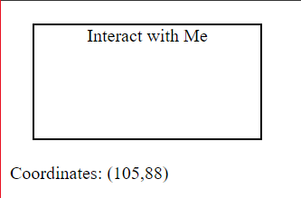
6. Write a JavaScript program to get current day, date and time in the string format using Java's date object.

Input:

<!DOCTYPE html>

<html>

<body>

    <script>

        var d = new Date();

        document.write("Today's date is: " + d + "<br>");

        var d1 = new Date('2022-07-28');

        document.write("Specified date is: " + d1 + "<br>");

        var d2 = new Date('2018');

        document.write("Specified date is: " + d2 + "<br>");

        var d3 = new Date('2018-10');

        document.write("Specified date is: " + d3 + "<br>");

    </script>

</body>

</html>

Output:

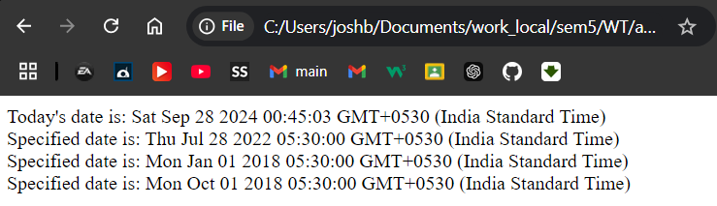

1. Write the JavaScript code to accept name and salary from five employees and display the name of the employee with highest salary and lowest salary. 07

Input:

<!DOCTYPE html>

<html>

<body>

    <script>

        var names = [];

        var salaries = [];

        for (var i = 0; i < 5; i++)

        {

            names[i] = prompt("Enter the name of Employee "+(i+1)+":");

            salaries[i] = parseFloat(prompt("Enter the salary of "+names[i]+":"));

        }

        var max=0;

        var min=0;

        for (var i = 0; i < salaries.length; i++)

        {

            if (salaries[i] > salaries[max])

            {

                max = i;

            }

            if (salaries[i] < salaries[min])

            {

                min = i;

            }

        }

        document.write("Employee with the highest salary: " + names[max] + " with a salary of " + salaries[max] + "<br>");

        document.write("Employee with the lowest salary: " + names[min] + " with a salary of " + salaries[min] + "<br>");

</script>

</body>

</html>

Output after 5 entries:

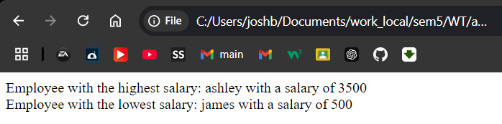

1. Write a JS to implement simple calculator using Switch case. 08

Input:

<!DOCTYPE html>

<html>

<head>

    <script>

        function calculator(){

            var num1 = parseFloat(prompt("Enter the first number:"));

            var operator = prompt("Enter the operator (+, -, \*, /,%):");

            var num2 = parseFloat(prompt("Enter the second number:"));

            var result;

            switch (operator) {

                case '+':

                    result = num1 + num2;

                    break;

                case '-':

                    result = num1 - num2;

                    break;

                case '\*':

                    result = num1 \* num2;

                    break;

                case '/':

                    if (num2 == 0) {

                        alert("Error: Division by zero is not allowed.");

                        return;

                    }

                    result = num1 / num2;

                    break;

                case '%':

                    result = num1 % num2;

                    break;

                default:

                    alert("Invalid operator");

                    return;

            }

            document.write("OUTPUT: " +num1 + " " + operator + " " + num2 + " = " + result);

        }

    </script>

</head>

<body>

    <button onclick="calculator()">Calculate</button>

</body>

</html>

Output:

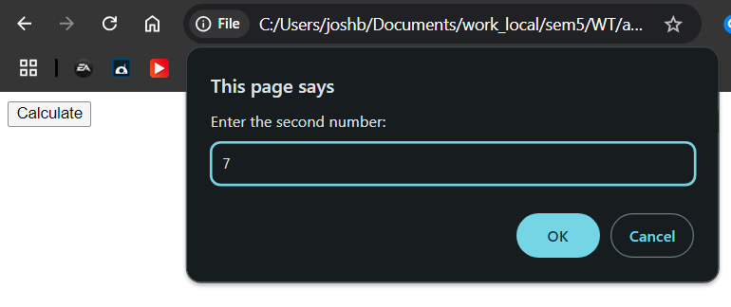 

1. Write a JS demonstrate "for-in" and "for-of" loops. 06

Input:

<!DOCTYPE html>

<html>

<head>

    <script>

        var p={fname:'John',lname:'Dsouza'};

        var fruits=['mango','apple','banana','papaya'];

        document.write("Contents of object:<br>");

        for(i in p) {

            document.write(p[i]+"<br>");

        }

        document.write("<br>Contents of array:<br>");

        for(i of fruits) {

            document.write(i+"<br>");

        }

    </script>

</head>

<body>

</body>

</html>

Output:

