1. Write a php code to display value and datatypes of different types of data

**Input:**

<?php

$integer = 42;

$float = 3.14;

$string = "Hello, PHP!";

$array = array(1, 2, 3);

$boolean = true;

$nullValue = null;

echo "Value: $integer, Data Type: " . gettype($integer) . "<br>";

echo "Value: $float, Data Type: " . gettype($float) . "<br>";

echo "Value: $string, Data Type: " . gettype($string) . "<br>";

echo "Value: " . implode(", ", $array) . ", Data Type: " . gettype($array) . "<br>";

echo "Value: $boolean, Data Type: " . gettype($boolean) . "<br>";

echo "Value: " . var_export($nullValue, true) . ", Data Type: " . gettype($nullValue) . "<br>";

?>

**Output:**

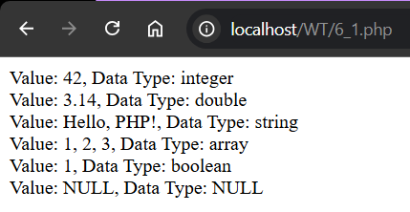

1. Write a php code to demonstrate for each loops on numeric and associative arrays

**Input:**

<?php

// Numeric array

$numericArray = array(1, 2, 3, 4, 5);

// Associative array

$associativeArray = array("first" => "Alice", "second" => "Bob", "third" => "Charlie");

// Using foreach on numeric array

echo "Numeric Array:<br>";

foreach ($numericArray as $value) {

    echo $value . "<br>";

}

// Using foreach on associative array

echo "Associative Array:<br>";

foreach ($associativeArray as $key => $value) {

    echo "$key: $value<br>";

}

?>

**Output:**

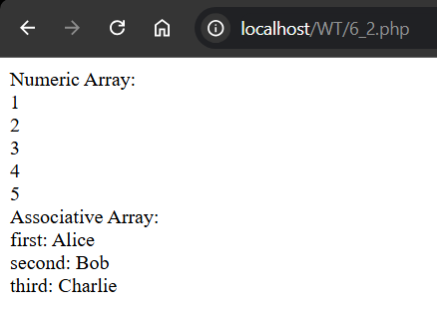

1. To find factorial using recursion

**Input:**

<?php

// Function to calculate factorial

function factorial($n) {

    if ($n <= 1) {

        return 1; // Base case

    }

    return $n * factorial($n - 1); // Recursive call

}

$num = 5;

echo "Factorial of $num is " . factorial($num);

?>

**Output:**



1. To print Fibonacci sequence using recursion

**Input:**

<?php

// Function to print Fibonacci sequence

function fibonacci($n) {

    if ($n <= 0) {

        return 0; // Base case for n = 0

    } elseif ($n == 1) {

        return 1; // Base case for n = 1

    } else {

        return fibonacci($n - 1) + fibonacci($n - 2); // Recursive call

    }

}

$count = 10; // Number of Fibonacci numbers to generate

echo "Fibonacci Sequence:<br>";

for ($i = 0; $i < $count; $i++) {

    echo fibonacci($i) . " ";

}

?>

**Output:**

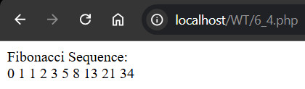

1. To demonstrate variable and call back functions

**Input:**

<?php

// Callback function

function greet($name) {

    return "Hello, $name!";

}

// Variable function

$functionName = 'greet';

echo $functionName("John"); // Calls the greet function

?>

**Output:**

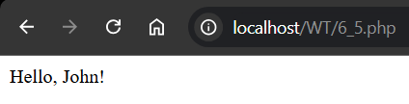

1. To fetch various form controls and insert those values in a table on specified database

**Input:**

**Php code:**

<?php

// Include database connection file

$conn = mysqli_connect('localhost','root','','hospital_mgmt');

if($conn){

    echo "<br>Connected Successfully<br>";

}else{

    echo "<br>Connection Failed<br>";

    exit();

}

if ($_SERVER["REQUEST_METHOD"] == "POST") {

    // Collect and sanitize input data

    $name = mysqli_real_escape_string($conn, $_POST['name']);

    $gender = mysqli_real_escape_string($conn, $_POST['gender']);

    $blood_type = mysqli_real_escape_string($conn, $_POST['blood-type']);

    $contact = mysqli_real_escape_string($conn, $_POST['contact']);

    $age = (int)$_POST['age'];

    $username = mysqli_real_escape_string($conn, $_POST['username']);

    $pwd = mysqli_real_escape_string($conn, $_POST['pwd']);

    // Output the form data to confirm it's being received correctly

    echo "<h3>Form Data Received:</h3>";

    echo "Name: " . $name . "<br>";

    echo "Gender: " . $gender . "<br>";

    echo "Blood Type: " . $blood_type . "<br>";

    echo "Contact: " . $contact . "<br>";

    echo "Age: " . $age . "<br>";

    echo "Username: " . $username . "<br>";

    // Hash the password

    $hashedPwd = password_hash($pwd, PASSWORD_DEFAULT);

    // Prepare SQL query

    $sql = "INSERT INTO users (name, gender, blood_type, contact, age, username, password)

            VALUES ('$name', '$gender', '$blood_type', '$contact', $age, '$username', '$hashedPwd')";

    // Execute query and check for success

    if (mysqli_query($conn, $sql)) {

    // Get the last inserted user ID

    $userId = mysqli_insert_id($conn);

        echo "<br><h4>User signed up successfully!</h4><br>Your User ID is: " . $userId . "<br>";

    mysqli_close($conn);

    // Redirect to the Sign-In page after a 5-second delay

    header("Refresh: 5; url=../client/signin.html");

    exit();  // Ensure no further code executes after redirection

    } else {

        echo "Error: " . $sql . "<br>" . mysqli_error($conn);

    }

mysqli_close($conn);

}

?>

**Output:**

**Html**: **Php**:

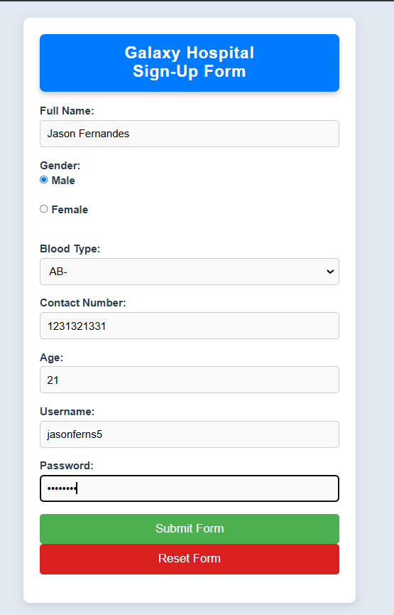 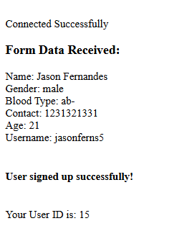

**Php server side:**



1. Demonstrate display operation using php and mysql(displays a join operation)

**Input:**

<?php

// Include database connection file

$conn = mysqli_connect('localhost', 'root', '', 'hospital_mgmt');

// Check connection

if (!$conn) {

    die("Connection Failed: " . mysqli_connect_error());

}

$doctors_wards = []; // Initialize array to hold results

$error_message = "";

// Fetch data when the button is clicked

if (isset($_POST['join_button'])) {

    // SQL query to join the 'doctors' and 'wards' tables

    $sql = "SELECT doctor.DoctorId AS doctor_id, doctor.NAME AS doctor_name, ward.wardid, ward.wardname

            FROM doctor

            INNER JOIN ward

            ON doctor.WardId = ward.wardid";

    $result = mysqli_query($conn, $sql);

    // Check if query was successful and there are results

    if ($result && mysqli_num_rows($result) > 0) {

        $doctors_wards = mysqli_fetch_all($result, MYSQLI_ASSOC); // Fetch all results as an associative array

    } else {

        $error_message = "No results found or error: " . mysqli_error($conn);

    }

}

// Close the connection

mysqli_close($conn);

?>

**Output:**

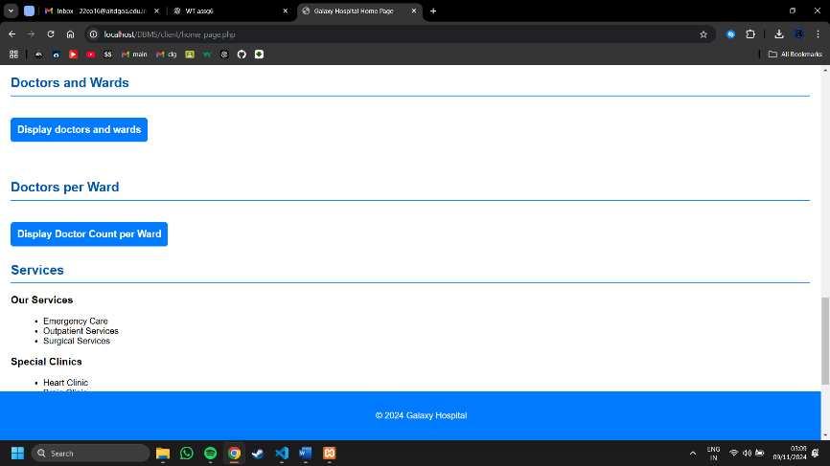

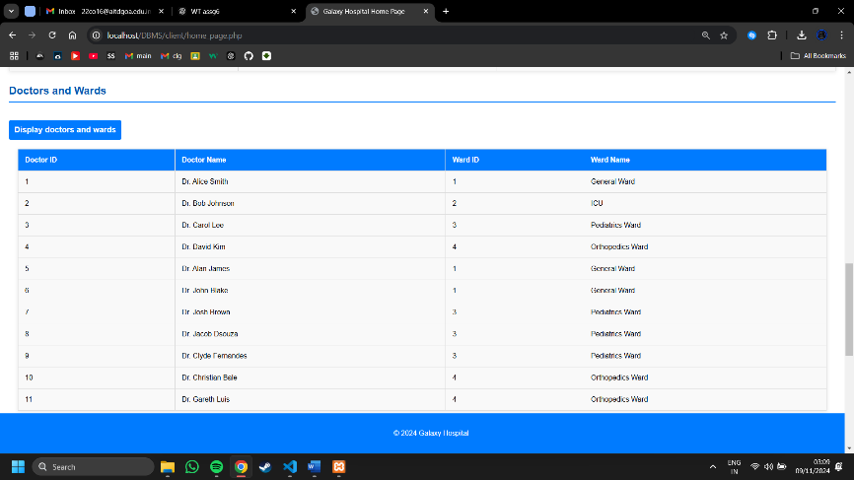

1. Demonstrate update operation in the same manner

**Input:**

<?php

// Include database connection file

// require 'db_connection.php'; // Update the path as needed

$conn = mysqli_connect('localhost', 'root', '', 'hospital_mgmt');

if ($conn) {

    echo "<br>Connected Successfully.<br>";

} else {

    echo "<br>Connection Failed.";

    exit();

}

if ($_SERVER["REQUEST_METHOD"] == "POST") {

    // Collect form data

    $id = $_POST['id']; // For update and delete

    $userId = $_POST['userid'];

    $patientName = mysqli_real_escape_string($conn, $_POST['patient_name']);

    $appointmentDate = mysqli_real_escape_string($conn, $_POST['appointment_date']);

    $appointmentTime = mysqli_real_escape_string($conn, $_POST['appointment_time']);

    $wardNo = $_POST['ward_no'];

    $action = $_POST['action']; // Action can be "add", "update", or "delete"

    $redirectToHome = false; // Flag to check if we should redirect to home

    // Output the received form data

    echo "<h3>Form Data Received:</h3>";

    echo "User ID: " . $userId . "<br>";

    echo "Patient Name: " . $patientName . "<br>";

    echo "Appointment Date: " . $appointmentDate . "<br>";

    echo "Appointment Time: " . $appointmentTime . "<br>";

    echo "Ward Number: " . $wardNo . "<br>";

    if ($action == 'add') {

        // Insert appointment record

        $sql = "INSERT INTO appointment (user_id, patient_name, appointment_date, appointment_time, ward_no)

                VALUES ('$userId', '$patientName', '$appointmentDate', '$appointmentTime', '$wardNo')";

        if (mysqli_query($conn, $sql)) {

            // Get the last inserted appointment ID

            $appointmentId = mysqli_insert_id($conn);

            echo "<br><h4>Appointment booked successfully.<\h4><br>Your Appointment ID is: " . $appointmentId;

            $redirectToHome = true; // Set flag to true for redirection

        } else {

            echo "Error: " . $sql . "<br>" . mysqli_error($conn);

        }

    } elseif ($action == 'update') {

        // Update appointment record

        if (!empty($id)) {

            $sql = "UPDATE appointment

                    SET user_id = '$userId', patient_name = '$patientName', appointment_date = '$appointmentDate',

                        appointment_time = '$appointmentTime', ward_no = '$wardNo'

                    WHERE id = '$id'";

            if (mysqli_query($conn, $sql)) {

                echo "<br><h4>Appointment updated successfully.<\h4><br>Your Appointment ID is: " . $id;

                $redirectToHome = true; // Set flag to true for redirection

            } else {

                echo "Error: " . $sql . "<br>" . mysqli_error($conn);

            }

        } else {

            echo "<br>Appointment ID is required for updating.";

        }

    } elseif ($action == 'delete') {

        // Delete appointment record

        if (!empty($id)) {

            $sql = "DELETE FROM appointment WHERE id = '$id'";

            if (mysqli_query($conn, $sql)) {

                echo "<br>Appointment ID " . $id . " has been deleted successfully.";

                $redirectToHome = true; // Set flag to true for redirection

            } else {

                echo "Error: " . $sql . "<br>" . mysqli_error($conn);

            }

        } else {

            echo "<br>Appointment ID is required for deletion.";

        }

    }

    // Close the database connection

    mysqli_close($conn);

    // Redirect to homepage after a successful operation

    if ($redirectToHome) {

        header("Refresh: 5; url=../client/home_page.php");

        exit();

    }

}

?>

**Output:**

**Html: Php:**

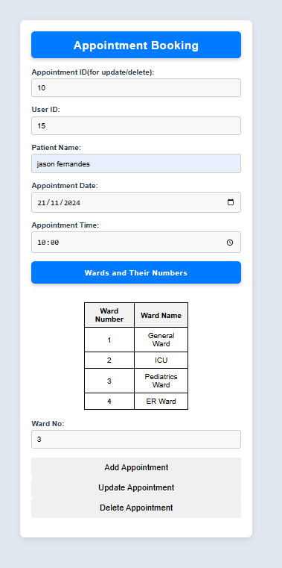 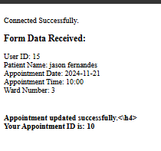

**Php server side:**

**Before update operation:**



**After update operation: **