## Set 1

### Facts:

- Fido is a dog.

- Rover is a dog.

- Henry is a dog.

- Felix is a cat.

- Jane is a cat.

- Anything is an animal if it is a dog.



### Queries:

- Find names of the dog.

- Find names of the cat.

- Who is the animal?



## Set 2

### Facts:

- Fido is a dog.

- Fido is large.

- Rover is a dog.

- Rover is large.

- Tom is a dog.

- Mary is a cat.

- Bill is a cat.

- Bill is large.

- Anything is large animal if it is a dog and large.

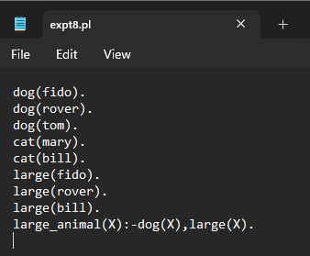

### Queries:

- Who is the large animal.



## Set 3

### Facts:

- Charlie is a parent of James.

- Elizabeth is a parent of James.

- George is a parent of Sophia.

- Catherine is a parent of Sophia.

- Charlie is a parent of Kith.

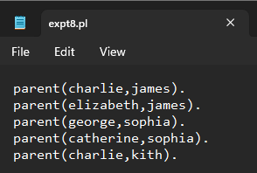

### Queries:

- Was George the parent of Sophia.

- Who are James' parents?

- Who are the children of Charlie?

- Who is a parent of whom?



## Set 4

### Facts:

- John likes Susie.

- Everyone likes Susie.

- John likes everybody.

- John likes everybody and everybody likes John.

- John likes Susie or John likes Mary.

- John does not like pizza.

- John likes Susie if John likes Mary.

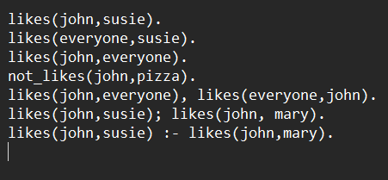

### Queries:

- Does John like Susie?

- Whom does John like?

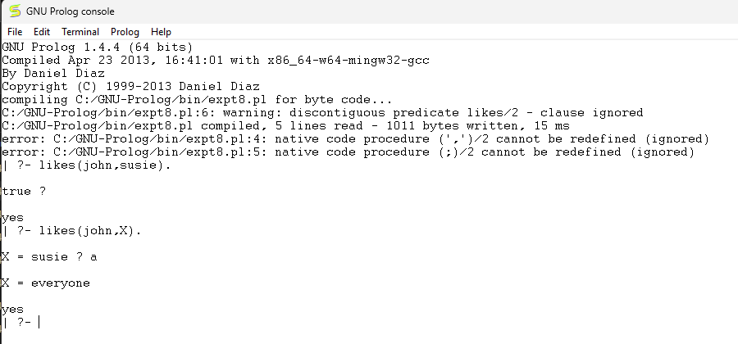

## Set 5

### Facts:

- Tom is a cat.

- Kunal loves to eat Pasta.

- Hair is black.

- Nawaz loves to play games.

- Pratyusha is lazy.

- Lili is happy if she dances.

- Tom is hungry if he is searching for food.

- Jack and Bili are friends if both love to play cricket.

- Will go to play if school is closed, and he is free.

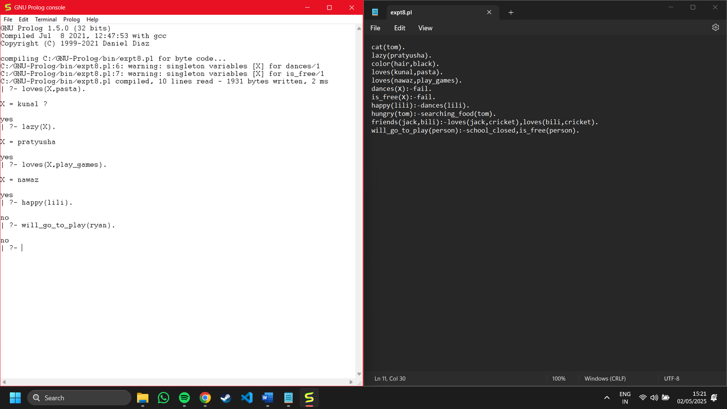

### Queries:

- Who loves to eat pasta?

- Who is lazy?

- Who loves to play games?

- Is Lili happy?

- Will Ryan go to play?



## Set 6

### Facts:

- Pam is a parent of Bob.

- Tom is a parent of Bob.

- Tom is a parent of Liz.

- Bob is a parent of Ann.

- Bob is a parent of Pat.

- Pat is a parent of Jim.

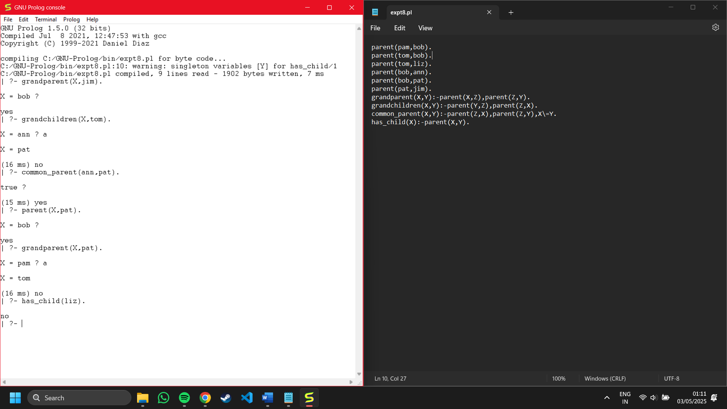

### Queries:

- Who is a grandparent of Jim?

- Who are Tom's grandchildren?

- Do Ann and Pat have a common parent?

- Who is Pat's parent?

- Who is Pat's grandparent?

- Does Liz have a child?



## Set 7

### Facts:

- Jia is a woman.

- John is a man.

- John is healthy.

- Jia is healthy.

- John is wealthy.

- Anyone is a traveller if healthy and wealthy.

- Anyone can travel if they are a traveller.



### Queries:

- Who can travel?

- Who is healthy and wealthy?



## Set 8

### Facts:

- Burger is food.

- Sandwich is food.

- Pizza is food.

- Sandwich is lunch.

- Pizza is dinner.

- Anything is a meal if it is food.

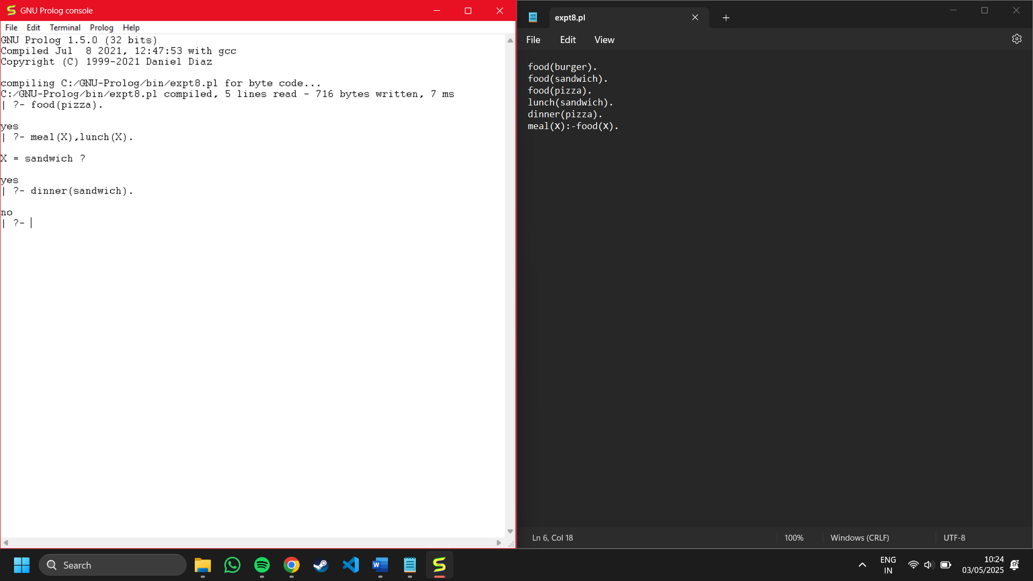

### Queries:

- Is pizza a food?

- Which food is meal and lunch?

- Is sandwich a dinner?



## Set 9

### Facts:

- Charlie studies CSC135.

- Olivia studies CSC135.

- Jack studies CSC131.

- Arthur studies CSC134.

- Kirke teaches CSC135.

- Collins teaches CSC131 and CSC171.

- Juniper teaches CSC134.

- X is a professor of Y if X teaches C and Y studies C.



### Queries:

- What does Charlie study?

- Who are the students of Professor Kirke?



## Set 10

### Facts:

- Charlie is suffering from fever, running nose, and headache.

- Micky is suffering from cough, headache, running nose, and sneezing.

- Branda is suffering from fever and rash.

- Flu symptoms: headache, body ache, fever, running nose, cough, conjunctivitis.

- Measles symptoms: fever, cough, conjunctivitis, running nose, rash.

- Whooping cough symptoms: cough, sneezing, running nose.

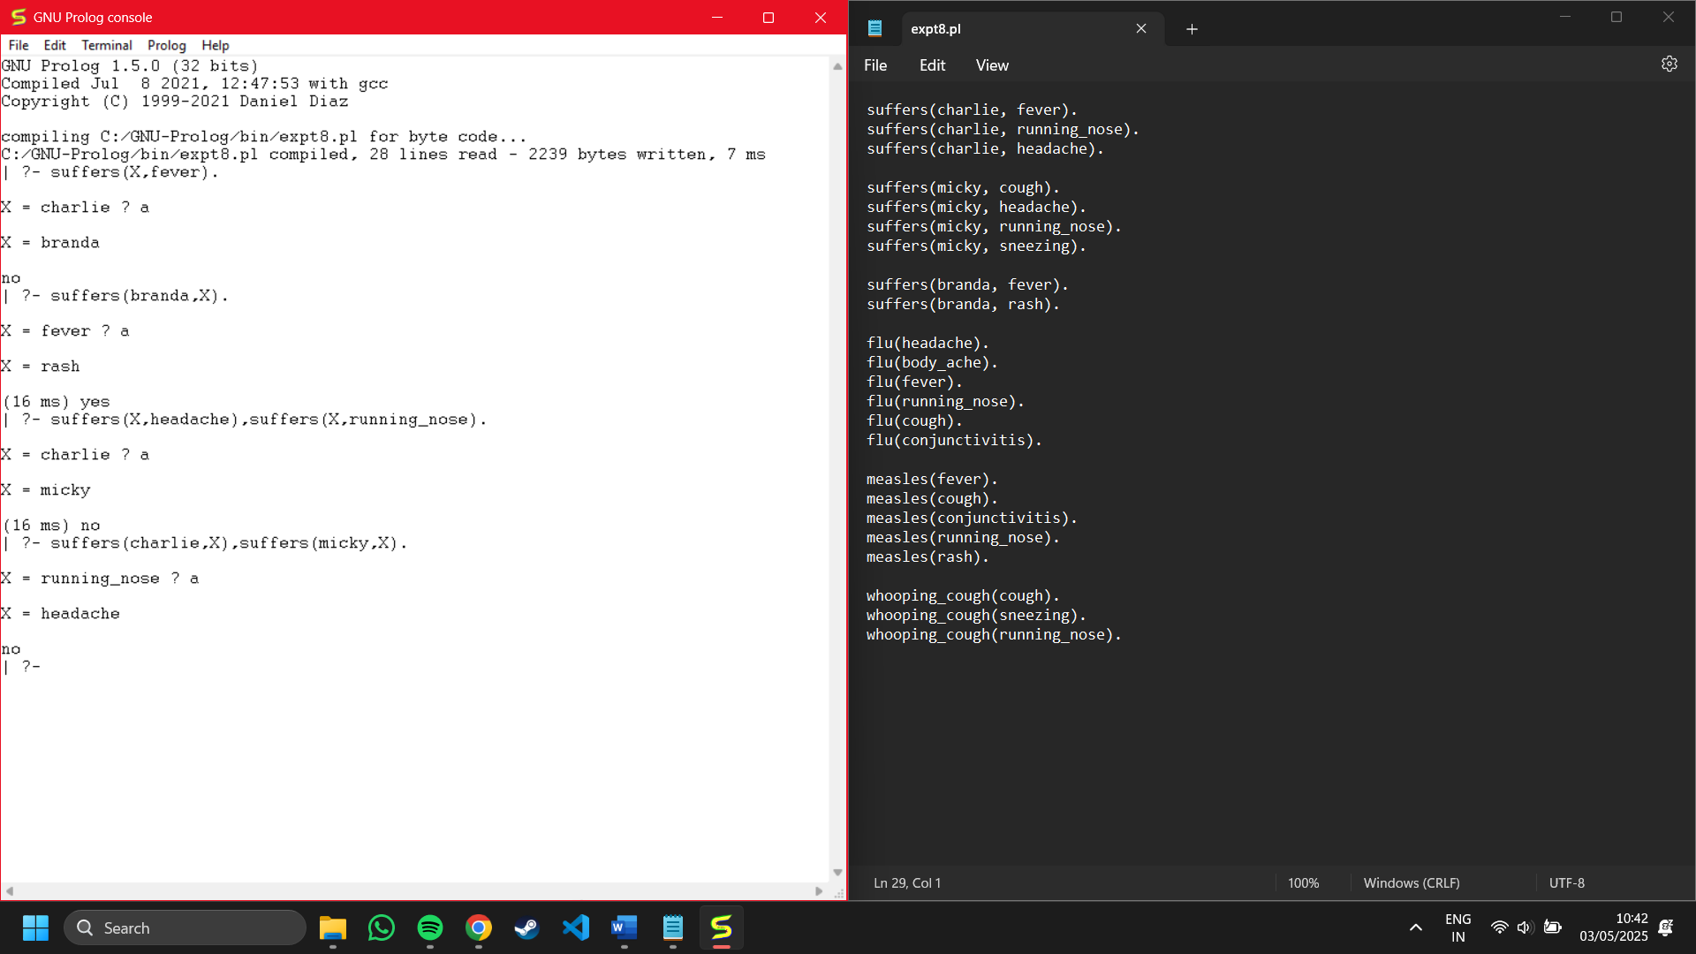

### Queries:

- Who is suffering from fever?

- Which symptoms is Branda suffering from?

- Find common patients with symptoms headache and running nose.

- Find the common symptom of Charlie and Micky.



## Set 11

### Facts:

- Marcus was a man and a Pompeian.

- All Pompeians were Romans.

- Caesar was a ruler.

- All Romans were either loyal to Caesar or hated him.

- People only try to assassinate rulers whom they are not loyal to.

- Marcus tried to assassinate Caesar.

- All men are people.

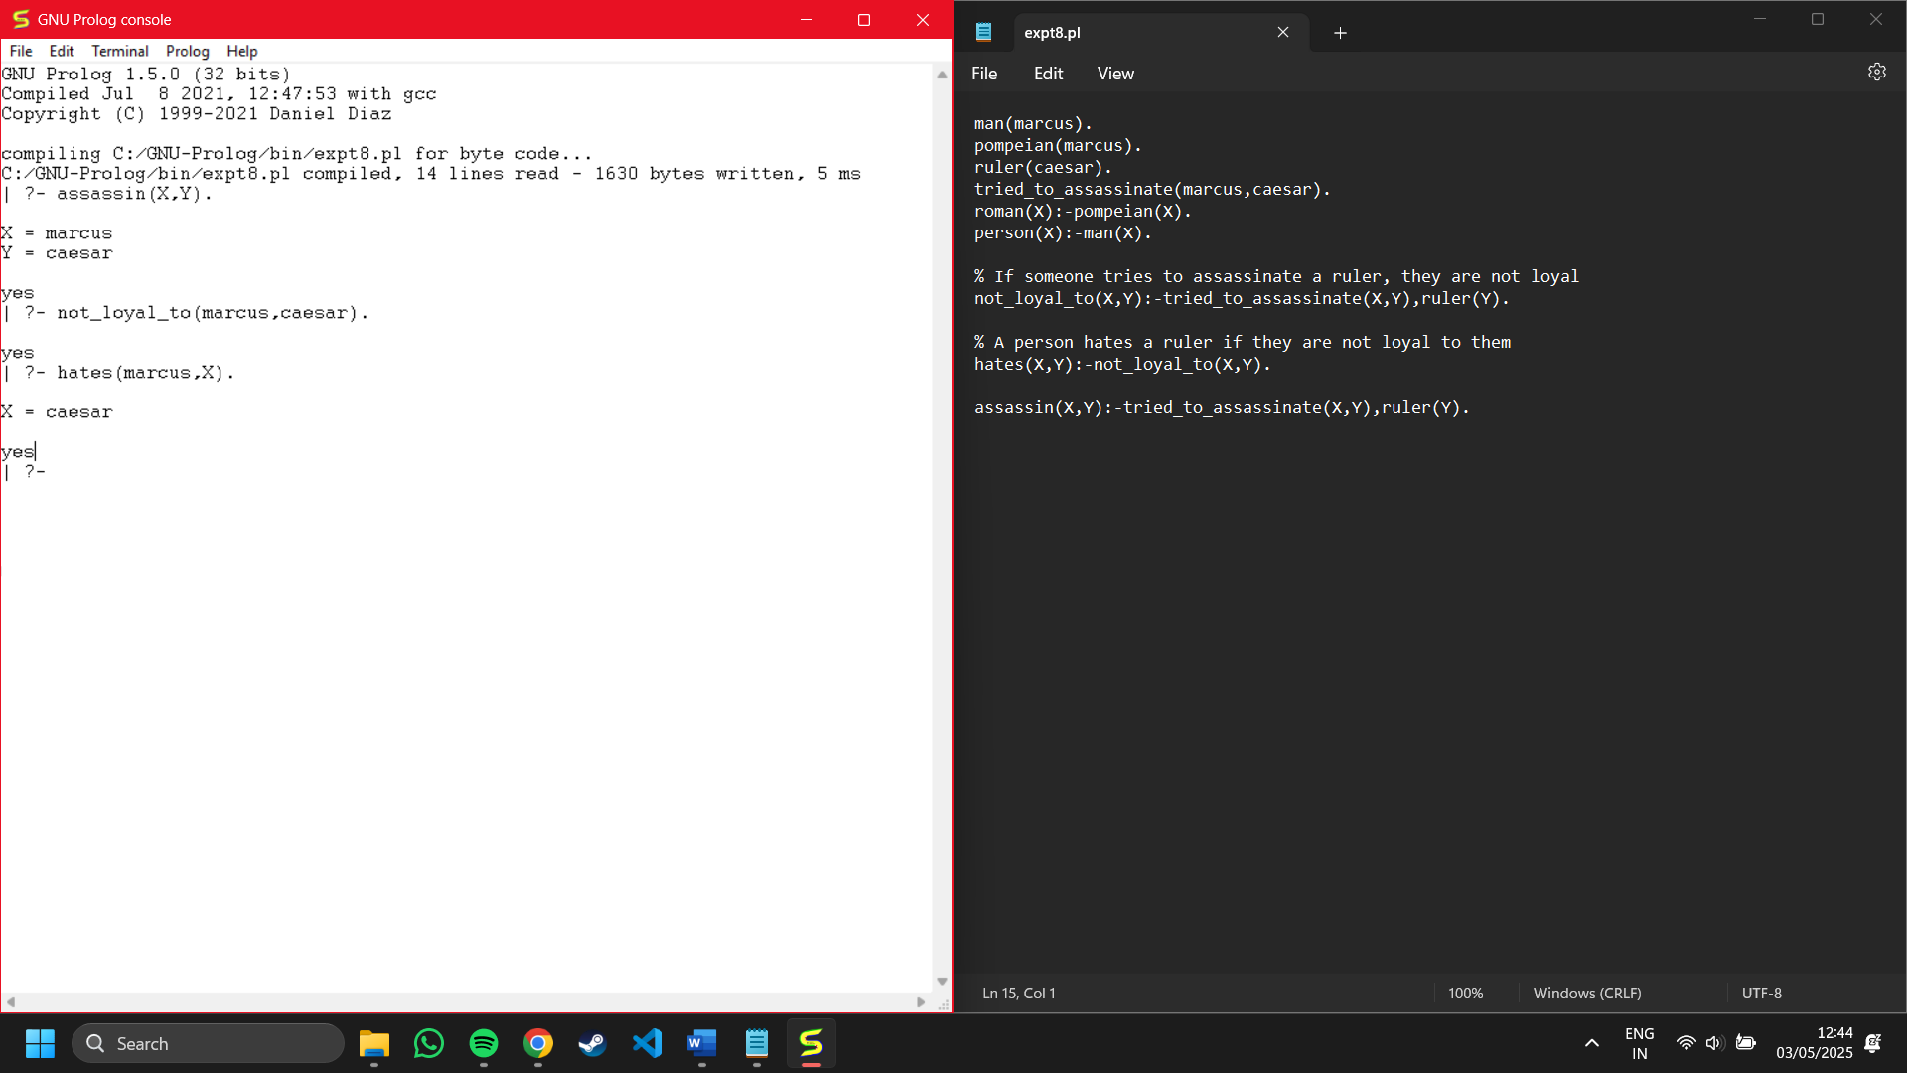

### Queries:

- Who tried to assassinate ruler?

- Was Marcus loyal to Caesar?

- Whom did Marcus hate?



## Set 12

### Facts:

- Moderate cough, chills, severe body ache, and running nose are symptoms of flu.

- Chills and high fever are symptoms of chickenpox.

- Mild body ache, running nose, and chills are symptoms of cold.

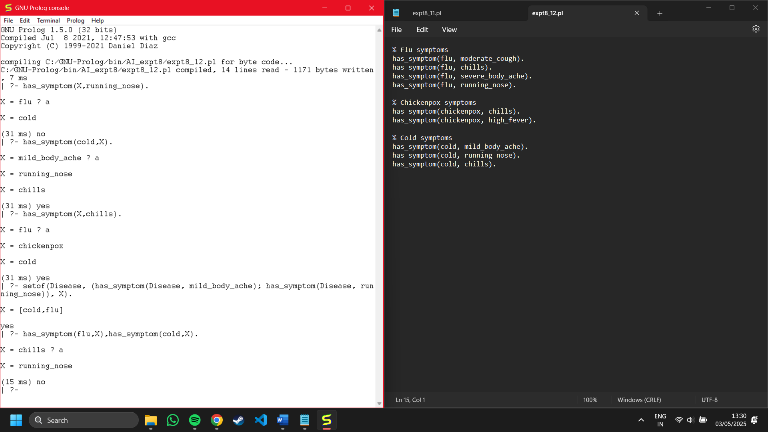

### Queries:

- Get list of all diseases with running nose as a symptom.

- Find all symptoms for disease cold.

- Find diseases with symptom chills.

- Find diseases with symptom mild body ache or runny nose.

- Common symptoms for cold and flu.



## Set 13

### Facts:

- John is the father of Alice.

- Alice is the mother of Tom.

- Mary is the sister of Alice.

- Tom is the son of Alice.

- Paul is the brother of Mary.

- John is the husband of Sarah.

- Sarah is the wife of John.



### Queries:

- Is John the father of Alice?

- Who is the mother of Tom?

- Is Mary the sister of Alice?

- Who is the husband of Sarah?

- Who is the wife of John?



## Set 14

### Facts:

- The capital of France is Paris.

- The capital of England is London.

- The capital of Germany is Berlin.

- The capital of Italy is Rome.

- The capital of Spain is Madrid.

- The capital of Japan is Tokyo.

- The capital of India is New Delhi.



### Queries:

- Is Paris the capital of France?

- What is the capital of Japan?

- Is Berlin the capital of Germany?

- What is the capital of Italy?

- Is Madrid the capital of Portugal?



## Set 15

### Facts:

- A chair is furniture.

- A table is furniture.

- A bed is furniture.

- A spoon is a utensil.

- A fork is a utensil.

- A knife is a utensil.

- A laptop is an electronic device.



### Queries:

- Is a chair considered furniture?

- What category does a spoon belong to?

- Is a laptop an electronic device?

- What category does a knife belong to?

- Is a bed a utensil?

