**For single machine:**

1. **Server code:**

import java.net.*;

import java.io.*;

public class socketserver {

private Socket socket = null;

private ServerSocket server = null;

private DataInputStream in = null;

private DataOutputStream out = null;

private BufferedReader console = null;

public socketserver(int port) {

try {

server = new ServerSocket(port);

System.out.println("Server started");

System.out.println("Waiting for a client...");

socket = server.accept();

System.out.println("Client connected");

in = new DataInputStream(new BufferedInputStream(socket.getInputStream()));

out = new DataOutputStream(socket.getOutputStream());

console = new BufferedReader(new InputStreamReader(System.in));

String received = "", toSend = "";

while (!received.equals("over")) {

received = in.readUTF();

System.out.println("From Client: " + received);

System.out.print("To Client: ");

toSend = console.readLine();

out.writeUTF(toSend);

}

System.out.println("Closing connection");

socket.close();

in.close();

out.close();

console.close();

} catch (IOException i) {

System.out.println(i);

}

}

public static void main(String args[]) {

new socketserver(8052);

}

}

1. **Client code:**

import java.net.*;

import java.io.*;

public class socketclient {

private Socket socket = null;

private BufferedReader input = null;

private DataOutputStream out = null;

private DataInputStream in = null;

public socketclient(String address, int port) {

try {

socket = new Socket(address, port);

System.out.println("Connected to Server");

input = new BufferedReader(new InputStreamReader(System.in));

out = new DataOutputStream(socket.getOutputStream());

in = new DataInputStream(socket.getInputStream());

String toSend = "", received = "";

while (!toSend.equals("over")) {

System.out.print("To Server: ");

toSend = input.readLine(); // Now using BufferedReader

out.writeUTF(toSend);

received = in.readUTF();

System.out.println("From Server: " + received);

}

input.close();

out.close();

in.close();

socket.close();

} catch (IOException i) {

System.out.println(i);

}

}

public static void main(String args[]) {

new socketclient("localhost", 8052);

}

}

**Output:**

1. **Server side:**

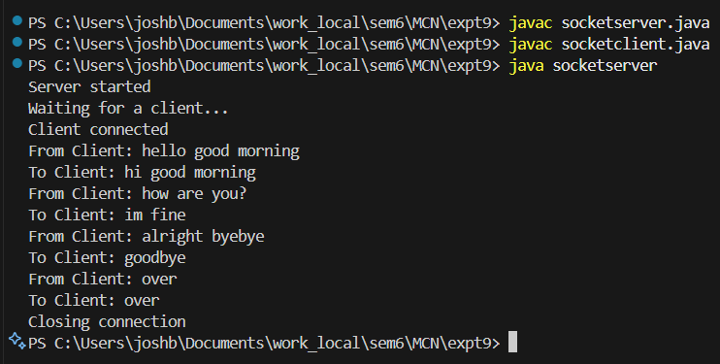

1. **Client side:**

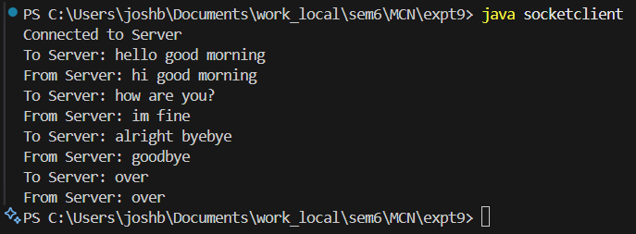

**For 2 machines:**

1. **Server code:**

import java.net.*;

import java.io.*;

public class socketserver {

private Socket socket = null;

private ServerSocket server = null;

private DataInputStream in = null;

private DataOutputStream out = null;

private BufferedReader console = null;

public socketserver(int port) {

try {

server = new ServerSocket(port);

System.out.println("Server started");

System.out.println("Waiting for a client...");

socket = server.accept();

System.out.println("Client connected");

in = new DataInputStream(new BufferedInputStream(socket.getInputStream()));

out = new DataOutputStream(socket.getOutputStream());

console = new BufferedReader(new InputStreamReader(System.in)); // ✅ fixed

String received = "", toSend = "";

while (!received.equals("over")) {

received = in.readUTF();

System.out.println("From Client: " + received);

System.out.print("To Client: ");

toSend = console.readLine();

out.writeUTF(toSend);

}

System.out.println("Closing connection");

socket.close();

in.close();

out.close();

console.close();

} catch (IOException i) {

System.out.println(i);

}

}

public static void main(String args[]) {

new socketserver(8052);

}

}

1. **Client code:**

import java.net.*;

import java.io.*;

public class socketclient {

private Socket socket = null;

private BufferedReader input = null;

private DataOutputStream out = null;

private DataInputStream in = null;

public socketclient(String address, int port) {

try {

socket = new Socket(address, port);

System.out.println("Connected to Server");

input = new BufferedReader(new InputStreamReader(System.in));

out = new DataOutputStream(socket.getOutputStream());

in = new DataInputStream(socket.getInputStream());

String toSend = "", received = "";

while (!toSend.equals("over")) {

System.out.print("To Server: ");

toSend = input.readLine();

out.writeUTF(toSend);

received = in.readUTF();

System.out.println("From Server: " + received);

}

input.close();

out.close();

in.close();

socket.close();

} catch (IOException i) {

System.out.println(i);

}

}

public static void main(String args[]) {

new socketclient("192.168.0.191", 8052);

}

}

**Output:**

1. **Server side:**



1. **Client side:**

