Supplementary Figures: station-level SPI-3, SPEI-3 and VHI time series
Supporting Information for ‘Selecting drought-index accumulation scales for rainfed agriculture in Turkish Thrace: a Landsat Vegetation Health Index and yield evaluation’

S1. Scope and calculation
Figures S1–S7 show station/district-specific annual growing-season series for 1985–2024. SPI-3 and flexibly standardized Thornthwaite SPEI-3 were averaged over June–October for each meteorological station. VHI was calculated independently for the matching district cropland as 0.5 VCI + 0.5 TCI and then averaged over the same months. No temporal smoother was applied. All district-years contained at least three valid VHI months; means use the available valid observations.
Dashed lines at −1 and 40 are descriptive drought/stress references and are not the cross-validated threshold used in the categorical analysis. The shaded final interval identifies 2024. Pearson correlations in Table S1 and the legends compare annual June–October means and are descriptive.
Table S1. Station-level annual associations between June–October drought indices and VHI.
Station/district | Role | Years | r: SPI-3/VHI | r: SPEI-3/VHI | Min. valid months
Edirne | Primary plateau | 40 | 0.537 | 0.544 | 4
Kırklareli | Primary plateau | 40 | 0.544 | 0.584 | 4
Lüleburgaz | Primary plateau | 40 | 0.404 | 0.517 | 3
Çorlu | Primary plateau | 40 | 0.688 | 0.739 | 3
Tekirdağ | Primary plateau | 40 | 0.671 | 0.700 | 3
Uzunköprü | Primary plateau | 40 | 0.600 | 0.688 | 4
İpsala | Contrast valley | 40 | 0.280 | 0.330 | 4

S2. Station figures
The same colours, axes and reference lines are used throughout to support direct comparison among stations.

Figure S1. Edirne
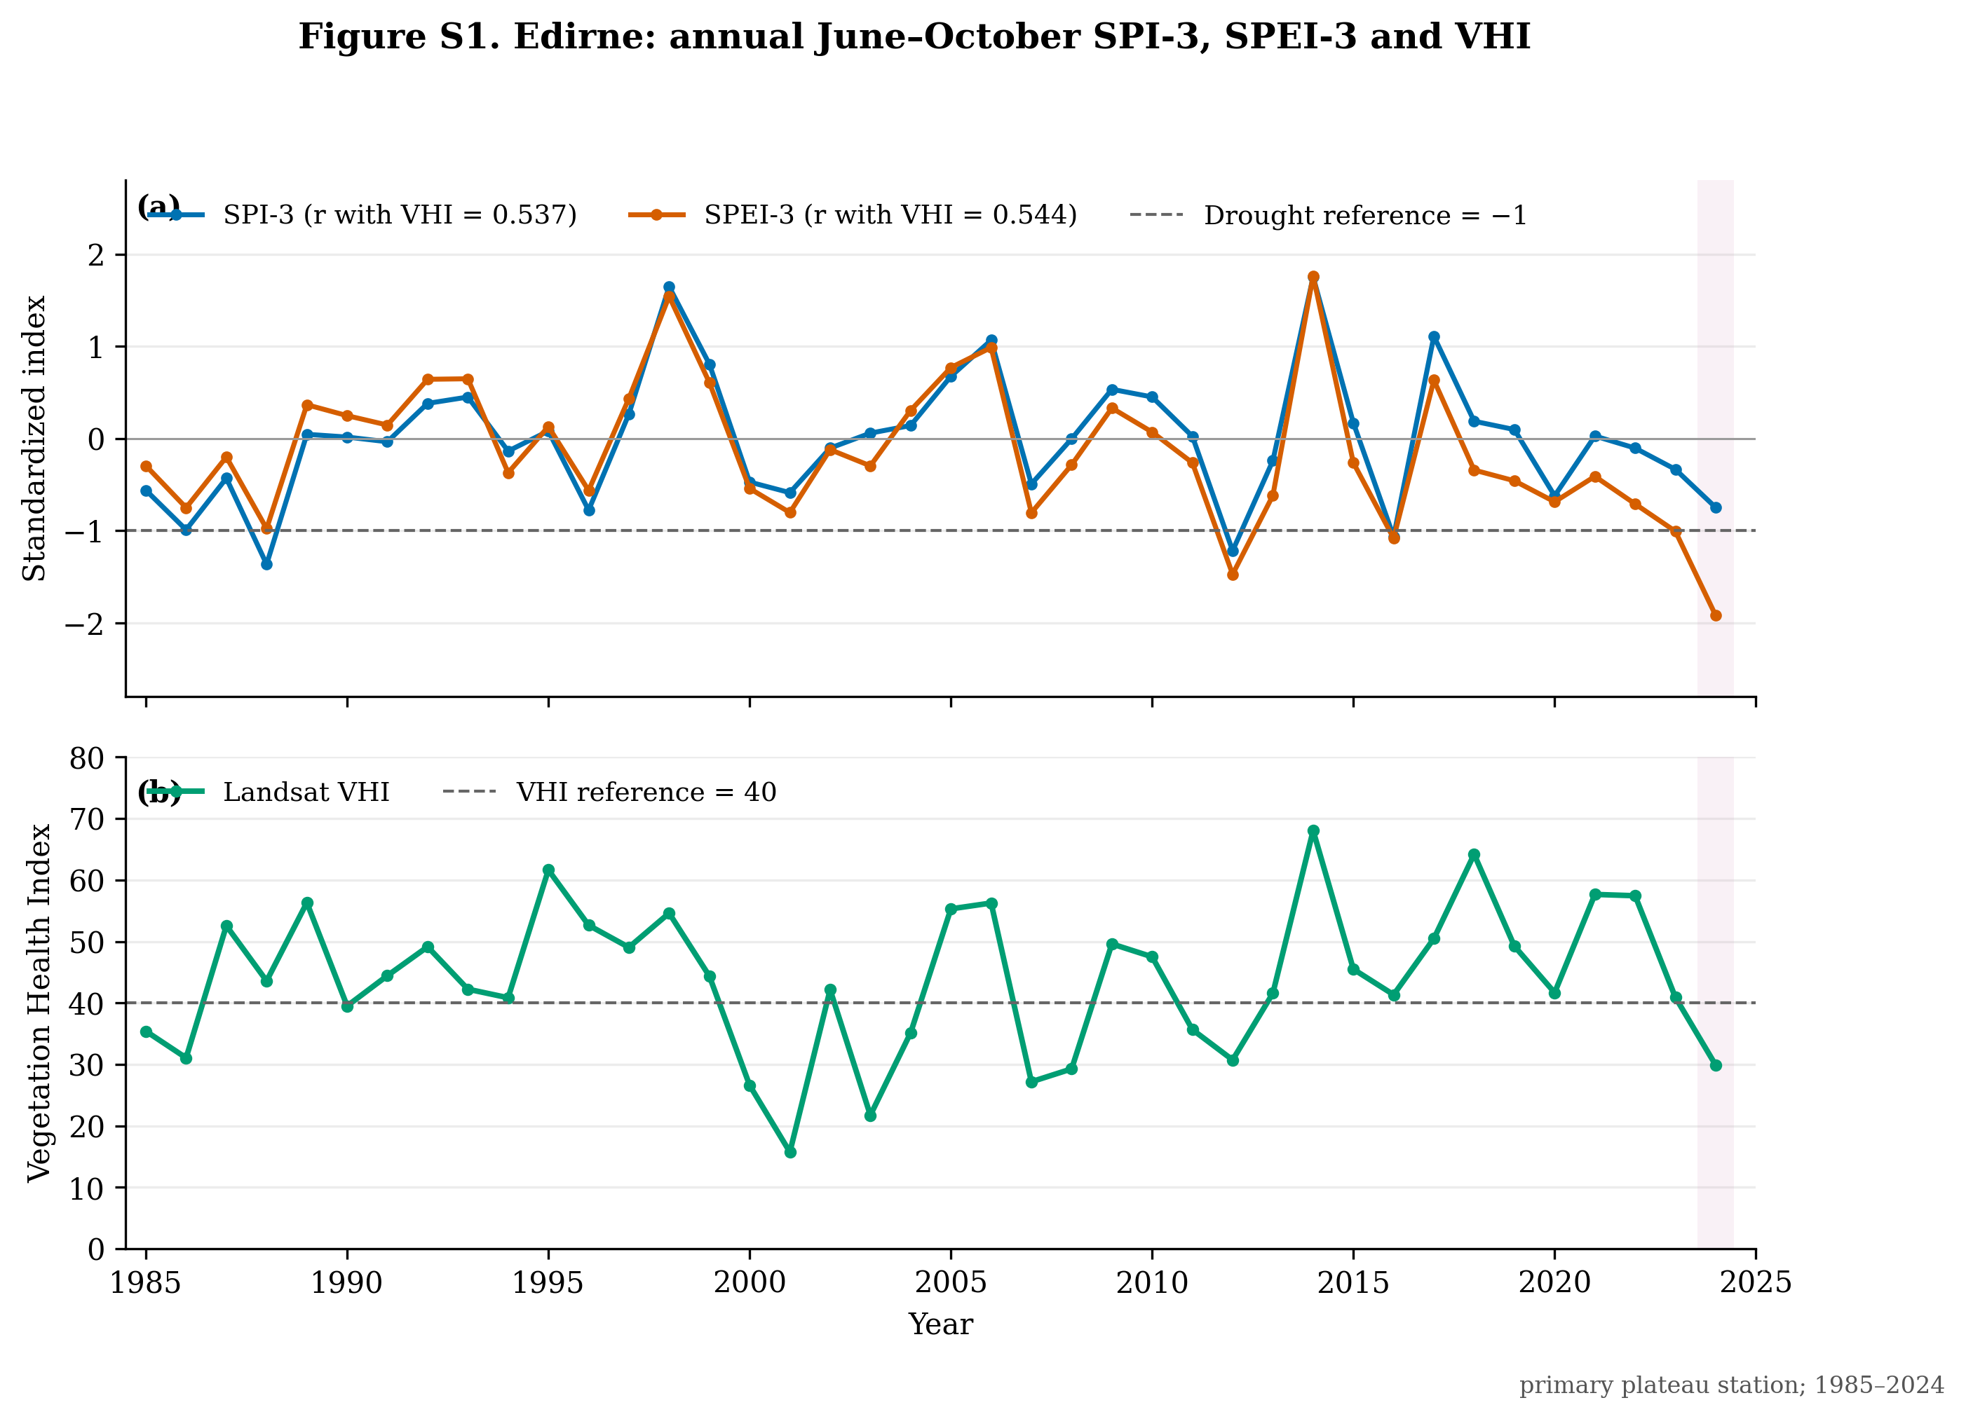
Figure S1. Edirne (primary rainfed plateau domain), 1985–2024. (a) Annual June–October mean SPI-3 and flexibly standardized SPEI-3 from the matched meteorological station. (b) Annual June–October mean equal-weighted Landsat VHI for district cropland. Pearson correlations with VHI are r = 0.537 for SPI-3 and r = 0.544 for SPEI-3 (n = 40 years). The shaded interval identifies 2024.

Figure S2. Kırklareli
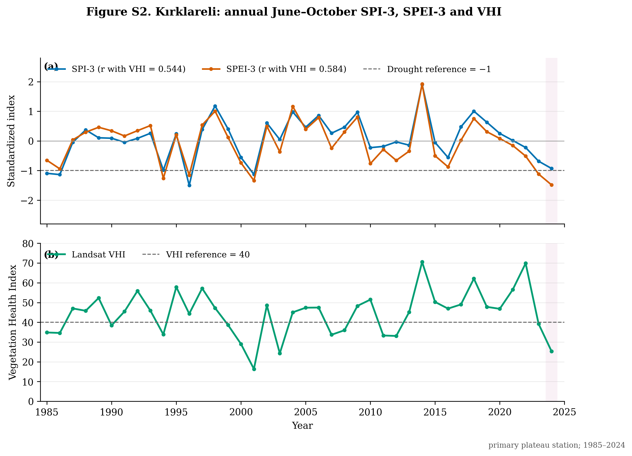
Figure S2. Kırklareli (primary rainfed plateau domain), 1985–2024. (a) Annual June–October mean SPI-3 and flexibly standardized SPEI-3 from the matched meteorological station. (b) Annual June–October mean equal-weighted Landsat VHI for district cropland. Pearson correlations with VHI are r = 0.544 for SPI-3 and r = 0.584 for SPEI-3 (n = 40 years). The shaded interval identifies 2024.

Figure S3. Lüleburgaz
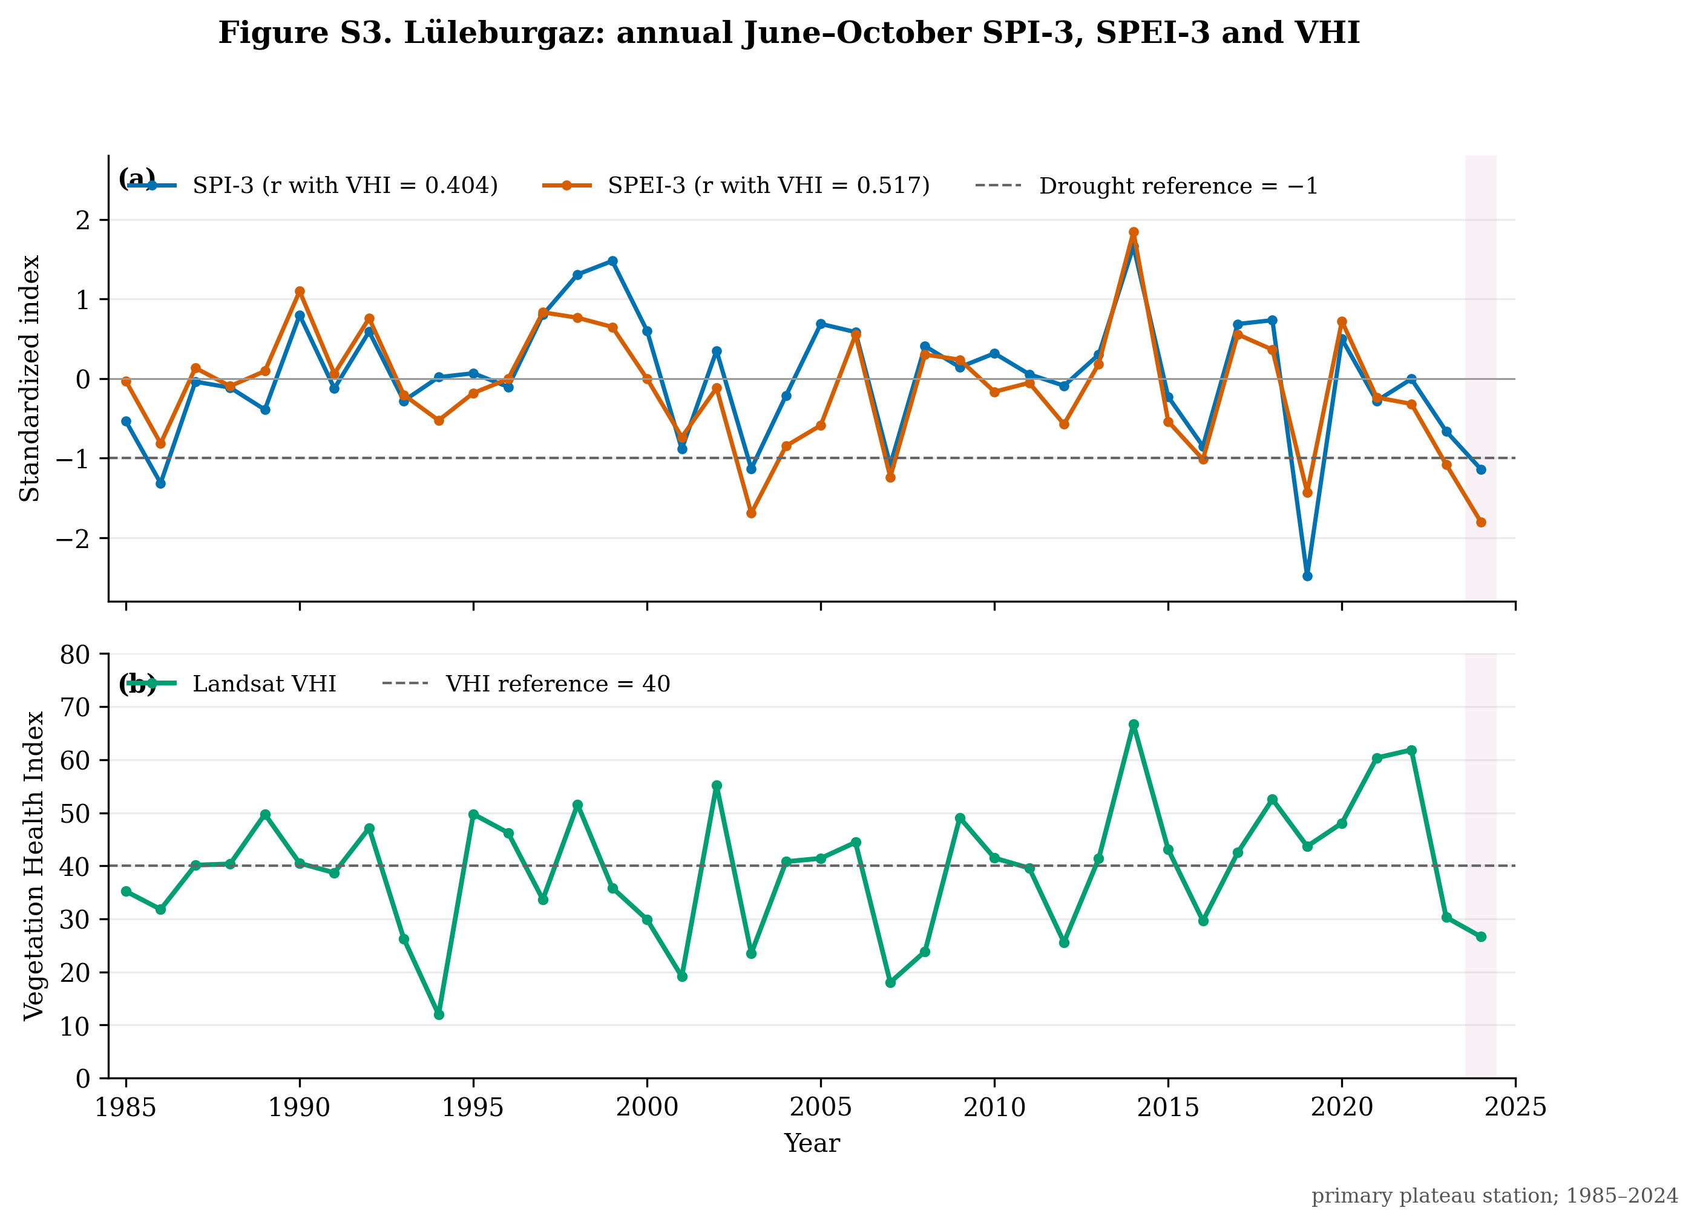
Figure S3. Lüleburgaz (primary rainfed plateau domain), 1985–2024. (a) Annual June–October mean SPI-3 and flexibly standardized SPEI-3 from the matched meteorological station. (b) Annual June–October mean equal-weighted Landsat VHI for district cropland. Pearson correlations with VHI are r = 0.404 for SPI-3 and r = 0.517 for SPEI-3 (n = 40 years). The shaded interval identifies 2024.

Figure S4. Çorlu
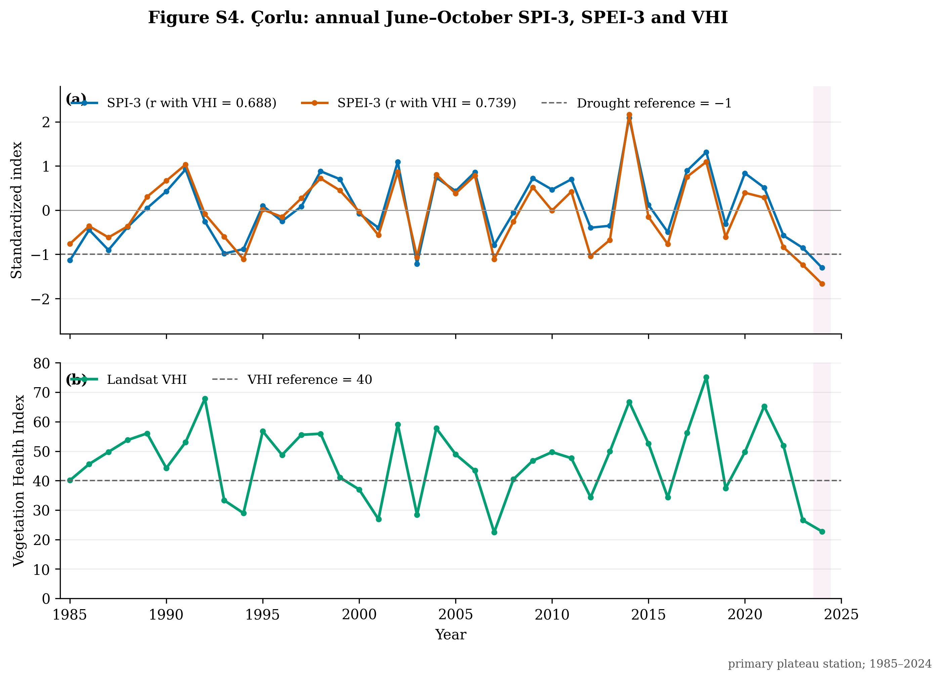
Figure S4. Çorlu (primary rainfed plateau domain), 1985–2024. (a) Annual June–October mean SPI-3 and flexibly standardized SPEI-3 from the matched meteorological station. (b) Annual June–October mean equal-weighted Landsat VHI for district cropland. Pearson correlations with VHI are r = 0.688 for SPI-3 and r = 0.739 for SPEI-3 (n = 40 years). The shaded interval identifies 2024.

Figure S5. Tekirdağ
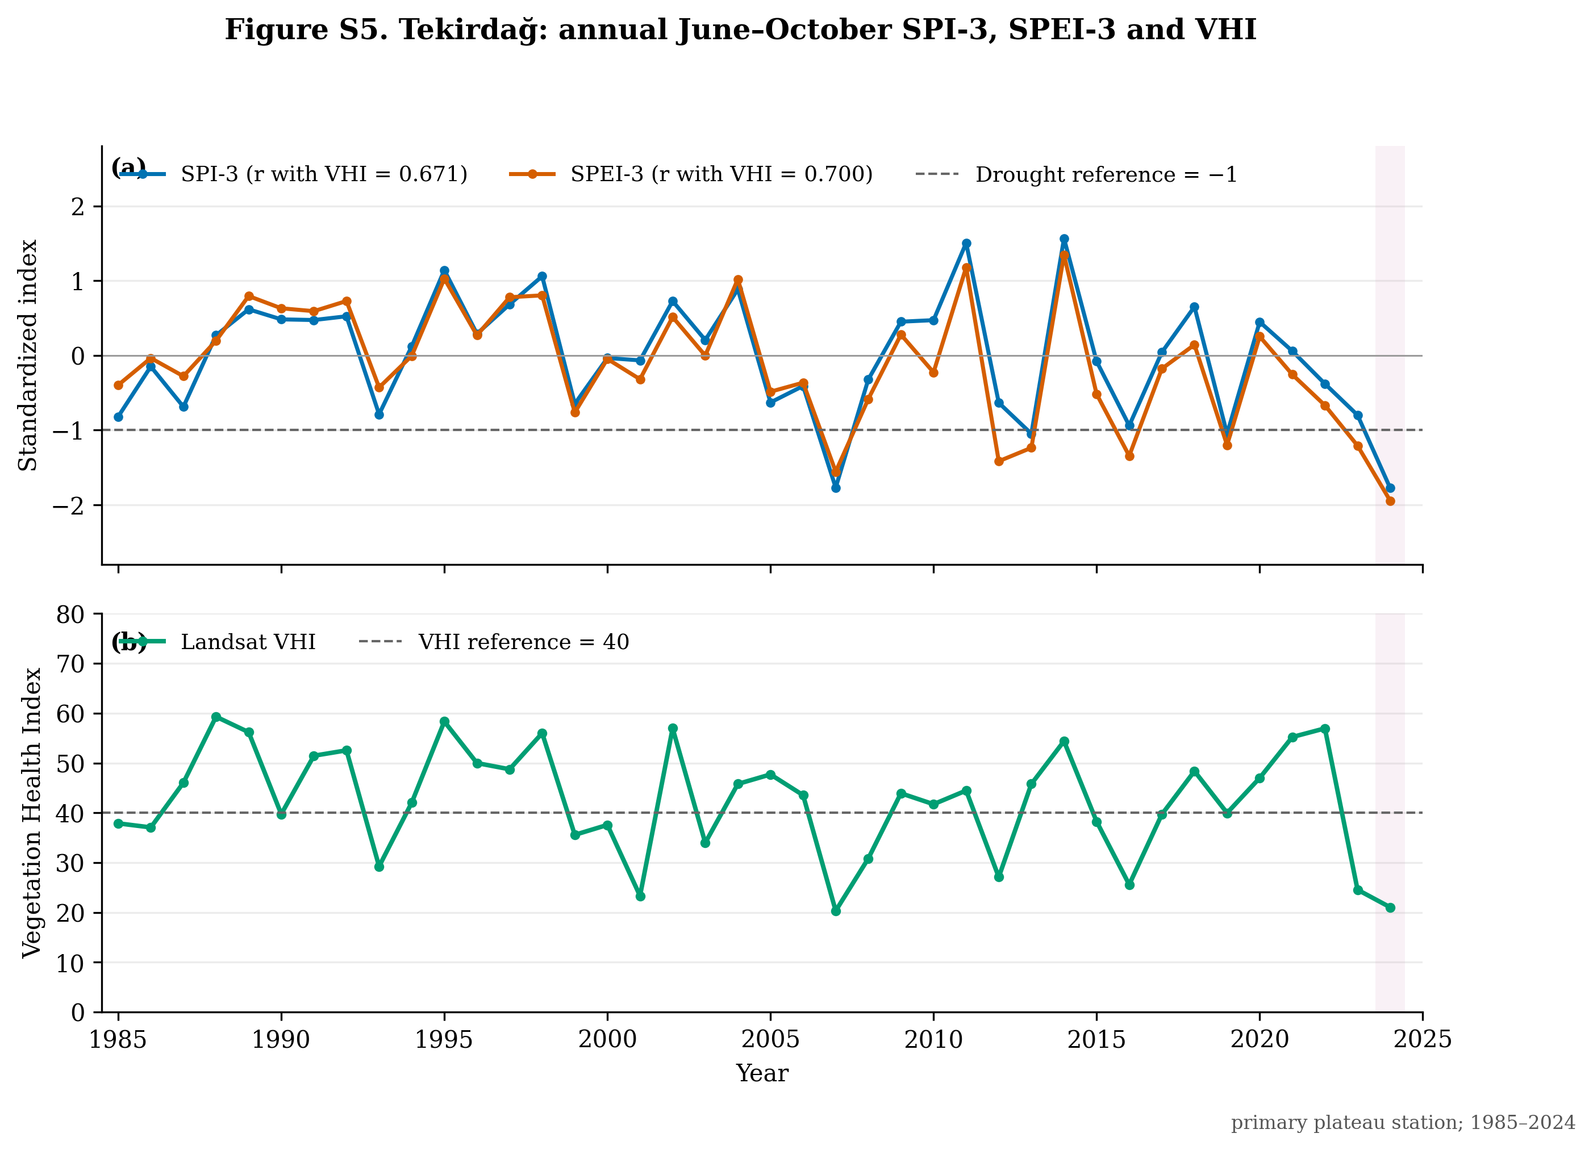
Figure S5. Tekirdağ (primary rainfed plateau domain), 1985–2024. (a) Annual June–October mean SPI-3 and flexibly standardized SPEI-3 from the matched meteorological station. (b) Annual June–October mean equal-weighted Landsat VHI for district cropland. Pearson correlations with VHI are r = 0.671 for SPI-3 and r = 0.700 for SPEI-3 (n = 40 years). The shaded interval identifies 2024.

Figure S6. Uzunköprü
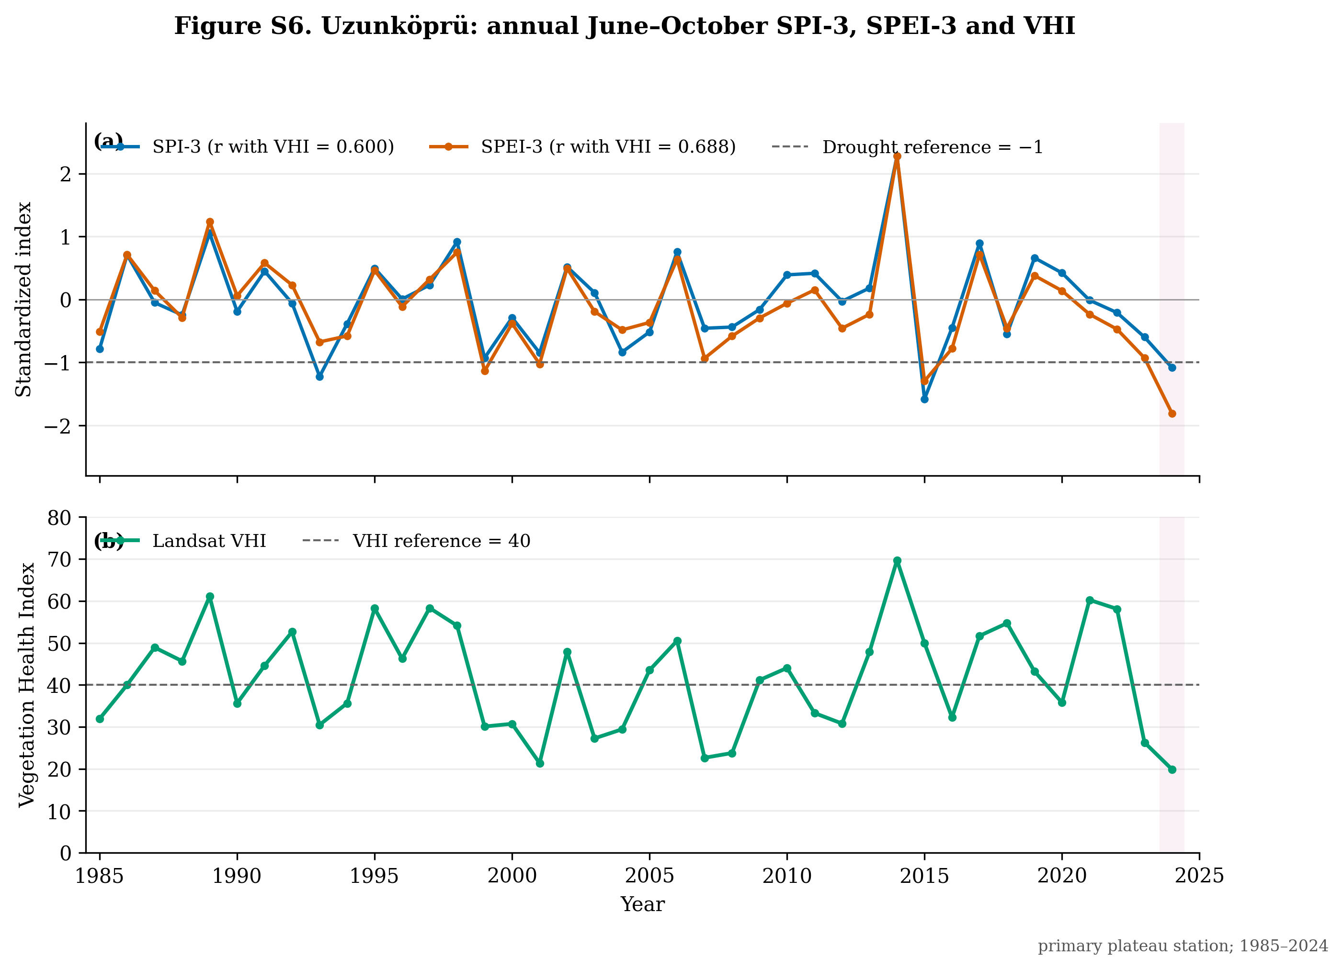
Figure S6. Uzunköprü (primary rainfed plateau domain), 1985–2024. (a) Annual June–October mean SPI-3 and flexibly standardized SPEI-3 from the matched meteorological station. (b) Annual June–October mean equal-weighted Landsat VHI for district cropland. Pearson correlations with VHI are r = 0.600 for SPI-3 and r = 0.688 for SPEI-3 (n = 40 years). The shaded interval identifies 2024.

Figure S7. İpsala
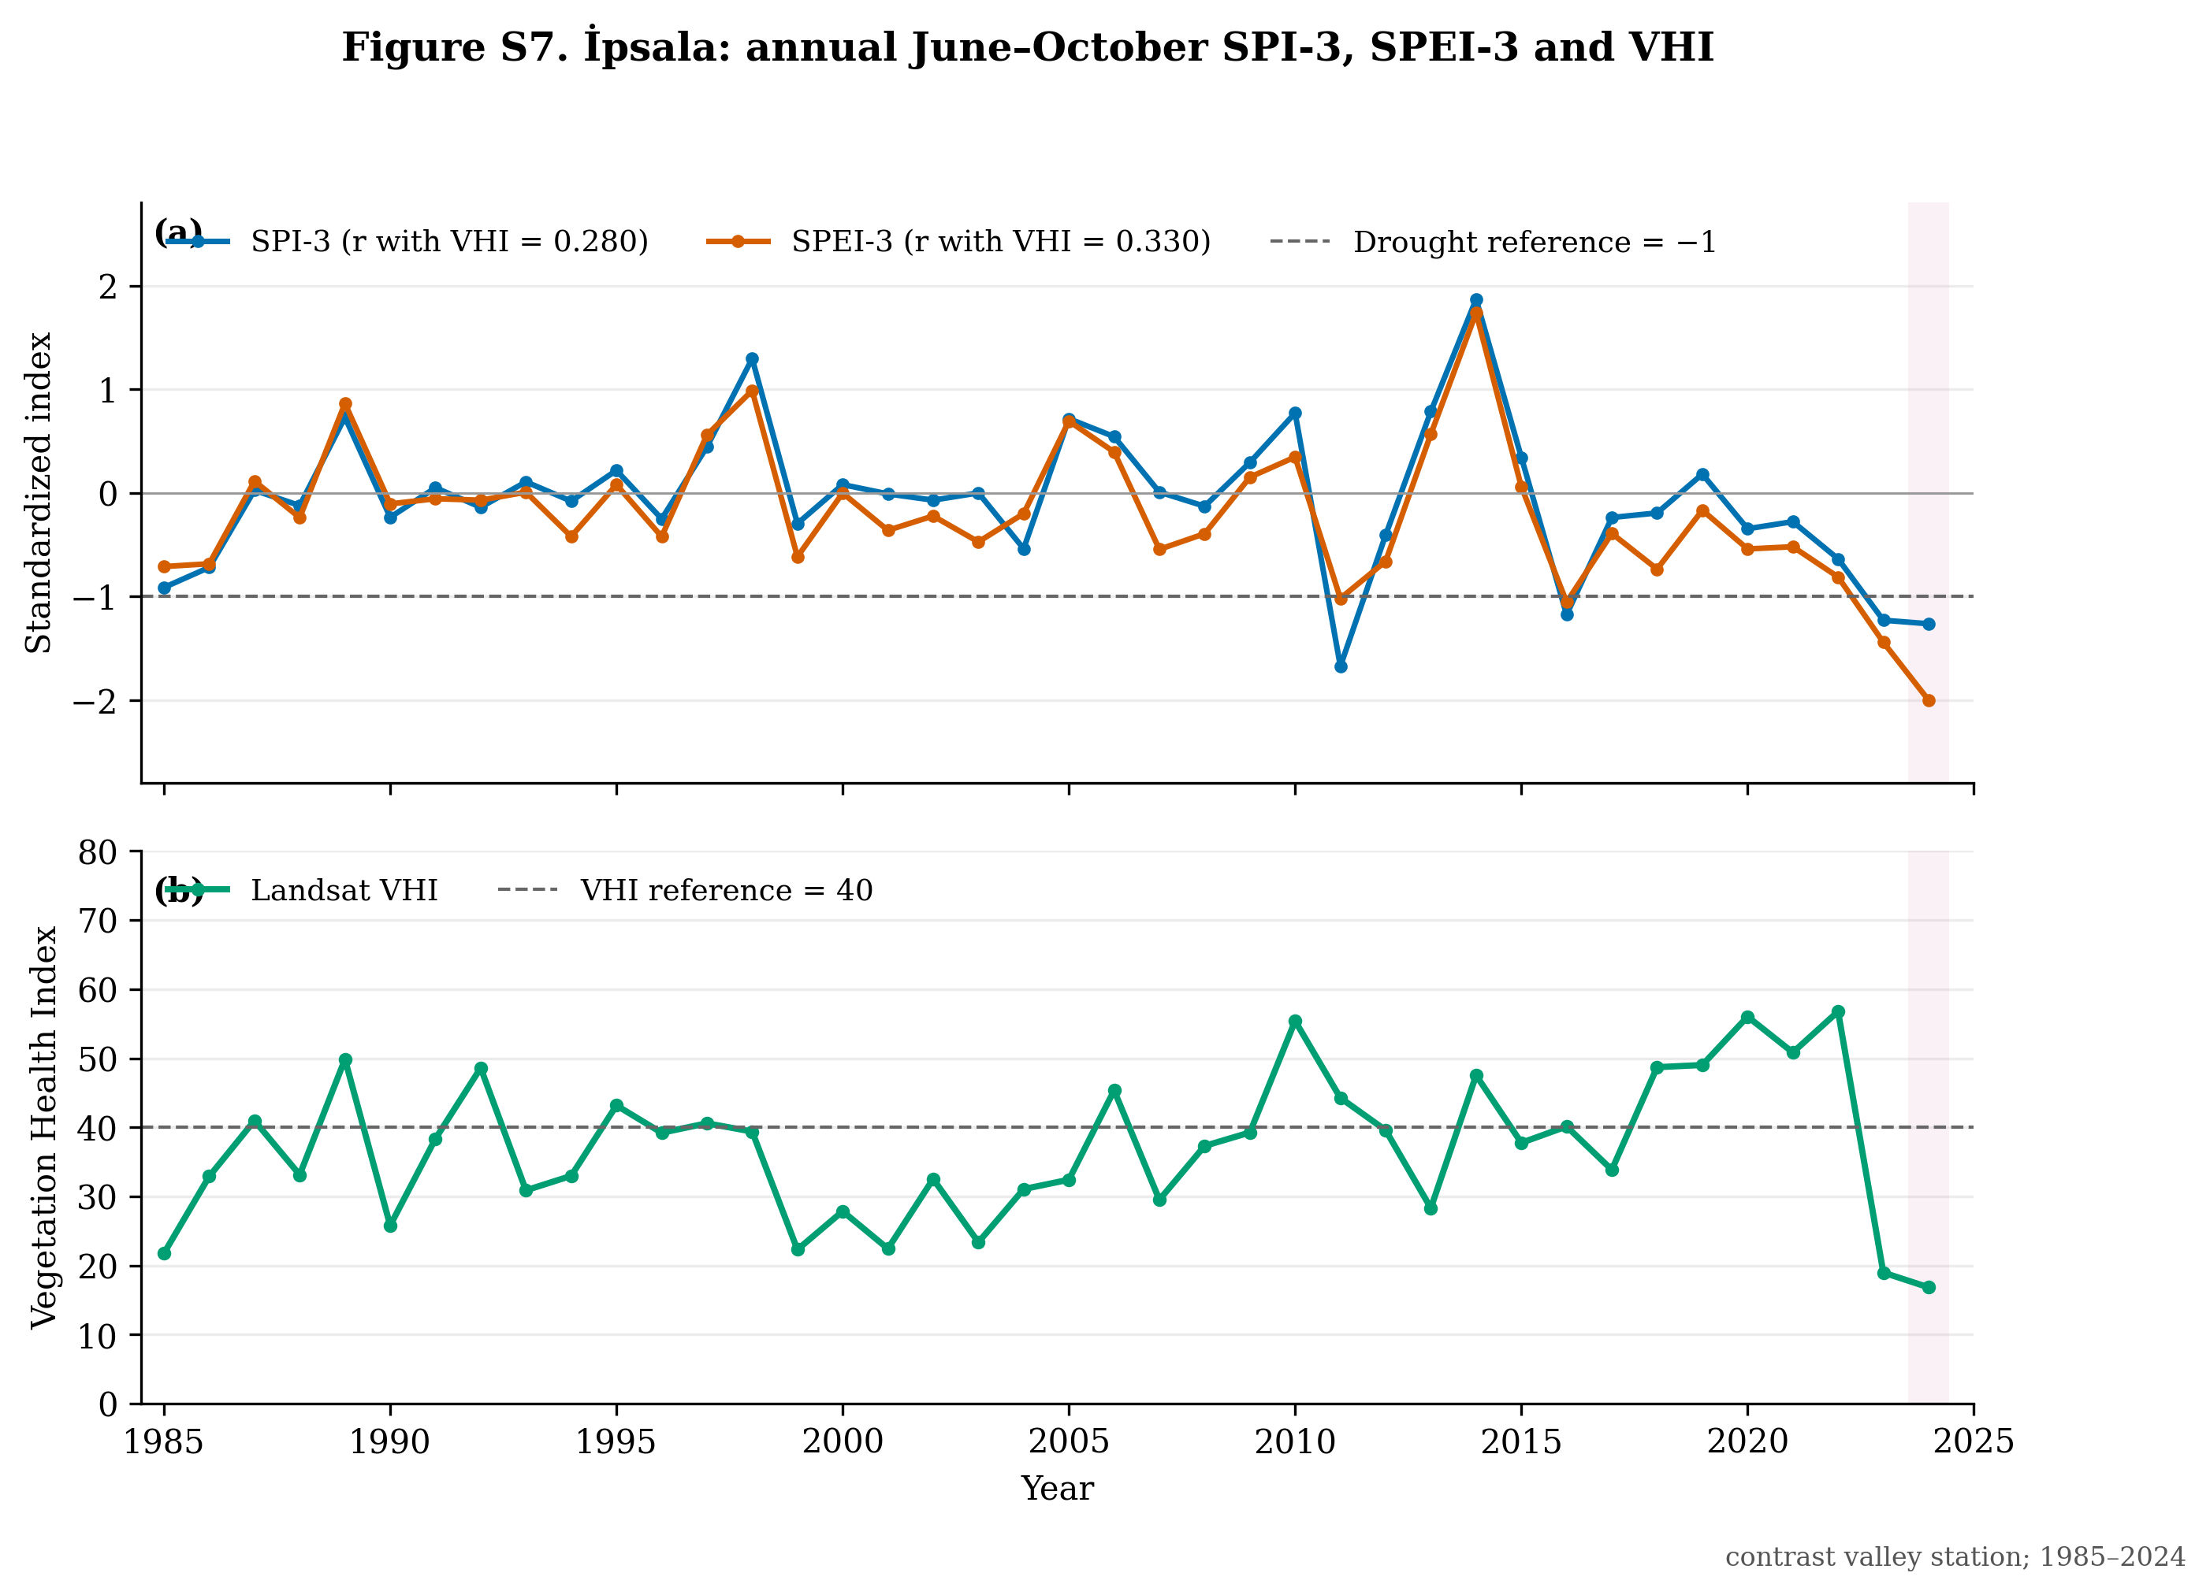
Figure S7. İpsala (contrast valley domain), 1985–2024. (a) Annual June–October mean SPI-3 and flexibly standardized SPEI-3 from the matched meteorological station. (b) Annual June–October mean equal-weighted Landsat VHI for district cropland. Pearson correlations with VHI are r = 0.280 for SPI-3 and r = 0.330 for SPEI-3 (n = 40 years). The shaded interval identifies 2024.

