Facility Scheduling System
Architecture & Design — Curling Sheet Scheduling on Exchange Online
Project: Curling sheet scheduling and availability management on Exchange Online
Status: Design phase — no implementation yet
Date: 2026-07-09
Author: Design iteration between club operator and Claude

1. Executive Summary 2
2. Scope and Requirements 2
2.1 In Scope 2
2.2 Out of Scope (explicitly deferred or rejected) 2
2.3 Constraints and Environment 3
3. System Architecture 3
3.1 Component Overview 3
3.2 What Exchange Provides vs. What the App Owns 4
4. Data Architecture 5
4.1 Anatomy of a Booking (one EXO calendar event) 5
4.2 State Model 5
4.3 Ephemeral Cache 6
5. API Interactions 6
5.1 Graph Operations by Use Case 7
5.2 Booking Creation (write path) 7
5.3 Consolidated Availability (derived read path) 8
5.4 Public View (anonymous read path) 9
6. Identity, Security, and Permissions 9
6.1 Conflict Enforcement — Why the App Owns It (design-review finding) 9
6.2 Identity Model 10
6.3 Scoping the App Identity (mandatory, not optional) 10
6.4 Other Security Requirements 10
7. Tenant Provisioning Checklist (one-time + per-new-sheet) 11
8. Risks, Limitations, and Pre-Build Verification Spikes 11
9. Design Decision Record 12
10. Generalization Note 13

1. Executive Summary
A web-based system for managing the scheduling and availability of curling sheets, built on Microsoft Exchange Online (EXO) resource mailboxes as the system of record. Each sheet is modeled as an EXO resource mailbox; every booking is a calendar event on that mailbox. A custom web application — not Outlook — is the operational interface for staff, providing per-sheet and consolidated availability views, booking management with domain-specific states (e.g., “potential rental hold” vs. “confirmed rental”), and a minimized read-only public view embeddable in the club’s CMS website.
The design deliberately avoids any adjacent authoritative datastore: all booking data, including rich metadata (renter contact, pricing, notes), lives on the calendar event itself. The only additional infrastructure is a short-lived, disposable read cache.
The pattern generalizes to other bookable facilities (bowling lanes, tennis courts, etc.) — nothing in the architecture is curling-specific except the vocabulary.

2. Scope and Requirements

2.1 In Scope
# | Requirement
R1 | Model each curling sheet (5 initially) as an independently bookable resource with its own calendar
R2 | Staff-mediated booking: staff create, modify, and cancel all bookings through a custom web UI
R3 | Booking states beyond free/busy: at minimum potential rental hold (soft, blocks other bookings) and confirmed rental (hard)
R4 | Booking categories: Rental / League / Event / Other, consistently represented across all sheets
R5 | Rich contextual metadata attached to the booking itself: renter name, contact, price, notes
R6 | Multiple views for different purposes: per-sheet grid, all-sheets aligned timeline, and derived/consolidated views (e.g., “times when ≥2 sheets are available for rental”)
R7 | Anonymous public read-only view of summarized availability, embeddable in the club website (Drupal today, possibly WordPress later)
R8 | Outlook/OWA remains available as a read-only fallback for viewing calendars — bookings must look sensible there (subjects, colors, free/busy)
R9 | Recurring bookings (league blocks) supported via native calendar recurrence
R10 | Double-booking prevention — enforced by the application (see §6.1)

2.2 Out of Scope (explicitly deferred or rejected)
- Payments, fees, deposits
- Membership rules, booking caps, priority tiers, waitlists
- Member/public self-service booking (no member identity object)
- Post-season reporting or cancellation audit history — cancelled bookings are hard-deleted, metadata loss on cancellation is accepted
- Automatic expiration of rental holds (revisit later; manual for now)
- ICS calendar publishing (evaluated and rejected based on prior operational experience)
- Companion/adjacent authoritative database (explicit constraint: all data of record stays on the calendar event)

2.3 Constraints and Environment
Constraint | Detail
Tenant | Existing Microsoft 365 tenant, lower licensing tier (not E3/E5). Resource mailboxes require no license below the size threshold — verify against the specific SKU before build.
Concurrency | Effectively 1 staff user at a time; 2 by rare coincidence.
Source of truth | Exchange Online. The web app holds no authoritative data.
Cache | Ephemeral only: short-TTL, non-authoritative, fully rebuildable from EXO at any moment.
Public surface | Must never expose booking metadata (PII, pricing); server-side minimization is mandatory.
CMS | Public view integrates as a thin embed calling the app’s public endpoint — no Graph logic inside the CMS, keeping it portable across the Drupal-vs-WordPress decision.

3. System Architecture

3.1 Component Overview
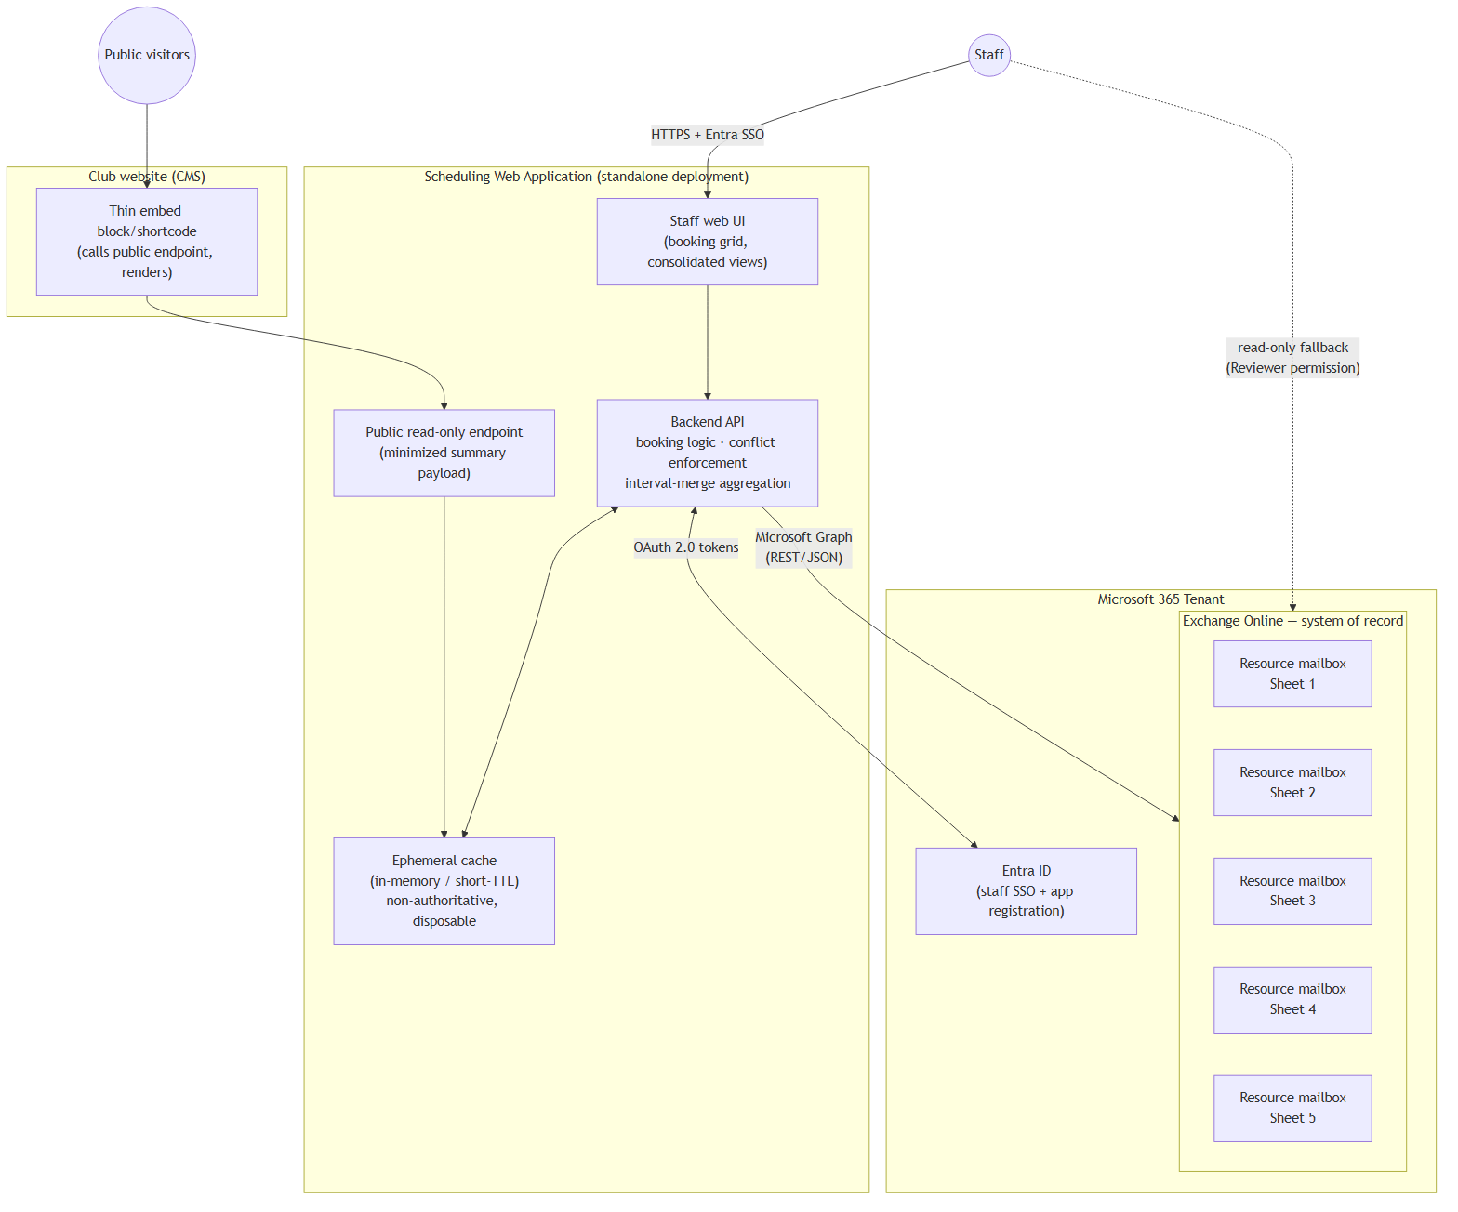
Figure 1 — System components and trust boundaries
Key structural decisions visible above:
- The staff app is a standalone deployment, isolated from the CMS’s failure domain (core updates, plugin conflicts, theme changes on the website cannot take down booking).
- The CMS integration is one thin block that renders JSON from the public endpoint. It contains no credentials and no Graph logic, so it survives a Drupal upgrade or a WordPress migration with trivial rework.
- The public endpoint reads only from cache, never triggering Graph calls per anonymous request — unpredictable public/bot traffic cannot exhaust Graph quota.
- Outlook is a read path only. Staff hold Reviewer (read-only) calendar permission on the resource mailboxes, which structurally prevents out-of-band edits — the one class of change the app couldn’t see (having no webhook infrastructure).

3.2 What Exchange Provides vs. What the App Owns
An honest division of labor (this was sharpened during design review — see §6.1):
Concern | Owner
Durable storage of bookings + metadata | Exchange Online
Recurrence semantics (league series, occurrences, exceptions) | Exchange Online
Free/busy computation (getSchedule) | Exchange Online
Fallback human-readable calendar UI | Exchange Online (Outlook/OWA)
Mailbox permissions, audit logging | Exchange Online
Conflict / double-booking enforcement | Application (direct writes bypass the Resource Booking Attendant)
Slot granularity & business validation (e.g., start-on-the-hour) | Application
State vocabulary and category schema integrity | Application (sole-writer discipline; Exchange validates nothing)
Consolidated/derived views (interval merge) | Application
Public data minimization | Application

4. Data Architecture

4.1 Anatomy of a Booking (one EXO calendar event)
Every piece of booking data lives on the event object. Fields are allocated to native properties by access pattern:
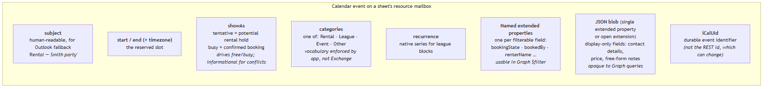
Figure 2 — Property allocation on a booking event
Design rule: any field that could ever appear in a “show me all bookings where X” query gets its own named single-value extended property (server-side filterable to a useful degree). Everything display-only goes in the JSON blob. Both mechanisms are for small payloads — notes stay a single text field, never an append-only log.
Integrity note: Exchange validates none of this — not category strings, not extended-property shape. Schema integrity comes entirely from the application being the sole writer with a fixed vocabulary. This is a load-bearing invariant, reinforced structurally by staff having read-only Outlook access.

4.2 State Model
Business state | showAs | Category | Blocks other bookings?
Open / available | (no event) | — | No
Potential rental hold | tentative | Rental | Yes (app-enforced)
Confirmed rental | busy | Rental | Yes
League block | busy (or tentative if provisional) | League | Yes
Event / Other | busy | Event / Other | Yes

- showAs does double duty: it keeps getSchedule free/busy and the Outlook fallback view semantically honest, and it encodes the hold-vs-confirmed distinction. Conflict enforcement, however, is the app’s job regardless of showAs (§6.1).
- Confirming a rental = update showAs from tentative → busy on the existing event (plus metadata updates). The event’s identity and slot are unchanged.
- Cancellation = hard delete of the event. Accepted consequence: metadata is unrecoverable beyond EXO’s recoverable-items window (~weeks). Re-entry cost of a lost booking is low at this scale.
- Additional states/categories are expected later; the mechanism (category taxonomy + extended properties) absorbs them without structural change. Auto-expiring holds are a possible future addition (deferred).

4.3 Ephemeral Cache
Property | Value
Contents | Recently fetched availability data and event detail, keyed by sheet + time window; precomputed consolidated views
TTL | Short (order of 30–60 s) — near-real-time without webhook infrastructure
Invalidation | On every write the app itself performs (it is the sole writer, so this is complete)
Authority | None. Holds no data of record; empty/stale cache simply rebuilds from Graph on next read
Technology | In-memory in the app process; Redis only if deployment topology later demands it

Explicitly rejected: Graph change-notification webhooks. Subscriptions expire (~3 days max) and require renewal jobs and missed-notification reconciliation — infrastructure that exists to catch out-of-band edits, of which there are none by construction (sole-writer app + read-only staff access in Outlook). Revisit only if out-of-band edits ever become possible.

5. API Interactions

5.1 Graph Operations by Use Case
Operation | Graph call | Notes
Coarse availability, all sheets | POST /users/{any}/calendar/getSchedule | One batched call for all 5 mailboxes; returns free/tentative/busy intervals. ~62-day window cap per call — chunk season-long views.
Rich per-sheet detail (grid with categories/states) | GET /users/{sheet}/calendarView?startDateTime=…&endDateTime=… + property selection | calendarView (not /events) so recurrences expand into occurrences. Request extended properties explicitly.
Create booking | POST /users/{sheet}/calendar/events | Direct write; preceded by app-side conflict check under per-sheet lock (§6.1).
Confirm hold / edit booking | PATCH /users/{sheet}/events/{id} | Update showAs, metadata properties. Resolve current REST id via iCalUId if needed.
Cancel booking | DELETE /users/{sheet}/events/{id} | Hard delete per §4.2.
Category palette setup (one-time) | GET/POST /users/{sheet}/outlook/masterCategories | Provision identical name+color sets on every sheet mailbox; repeat when adding sheet #6.

Timezone rule for every read: pass Prefer: outlook.timezone explicitly. The season spans two DST transitions; never assume a fixed UTC offset.

5.2 Booking Creation (write path)
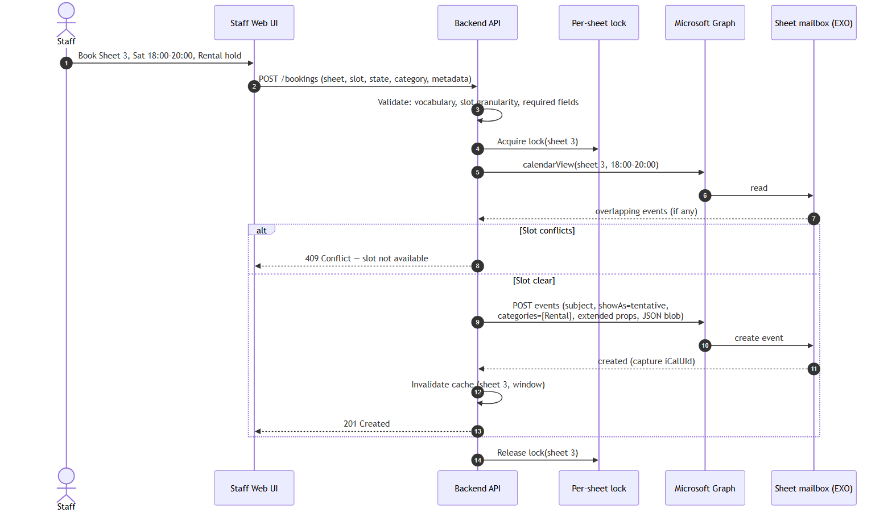
Figure 3 — Booking write path with per-sheet lock and conflict check
The check-then-write under a per-sheet lock closes the race window between two simultaneous staff bookings. At 1–2 concurrent users this is comfortably sufficient; it is correct at any scale where this app remains the sole writer.

5.3 Consolidated Availability (derived read path)
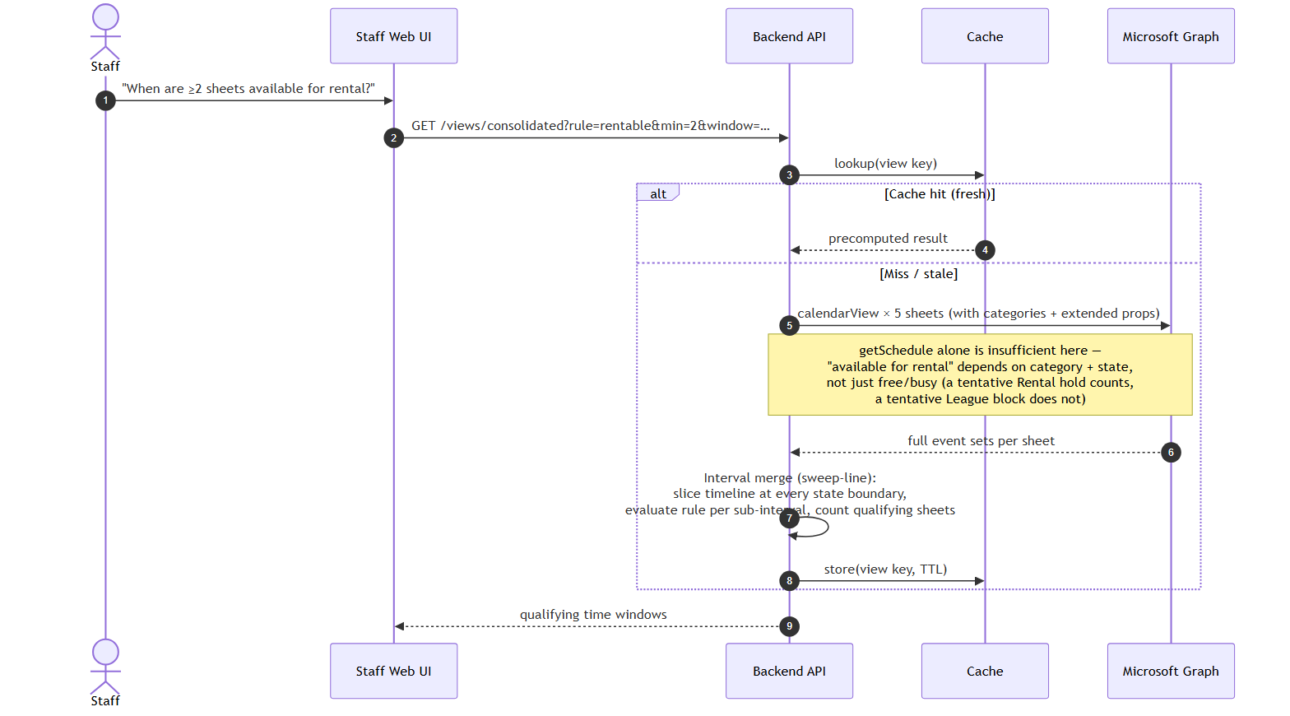
Figure 4 — Consolidated availability via interval merge
Bookings across sheets don’t align to a common grid, so aggregation is an interval-overlay computation owned by the app. Each named view (per-sheet grid, consolidated rental availability, future views) is a rule over the same fetched data — the cache absorbs the fan-out so five differently-shaped views don’t mean five independent Graph storms.

5.4 Public View (anonymous read path)
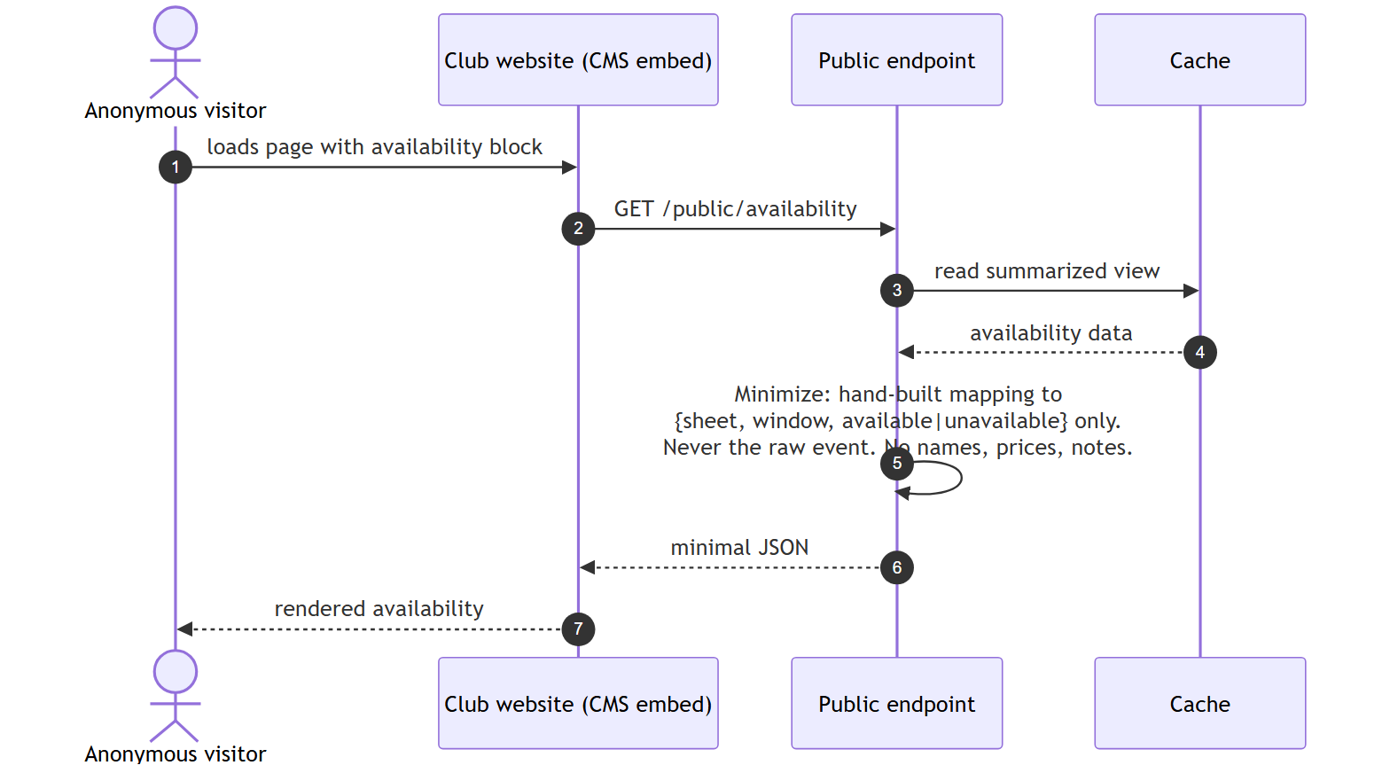
Figure 5 — Anonymous public read path with minimization
The minimization step is a deliberate, separately-maintained mapping — not a reuse of the internal API with anonymous access allowed. This prevents the failure mode where a field added to the internal payload silently leaks to the public page. If the cache is cold, the endpoint may serve slightly stale data or trigger one guarded refresh — but anonymous traffic volume never translates 1:1 into Graph calls.

6. Identity, Security, and Permissions

6.1 Conflict Enforcement — Why the App Owns It (design-review finding)
Exchange’s native double-booking prevention (Set-CalendarProcessing … AllowConflicts $false) is enforced by the Resource Booking Attendant, which only processes meeting requests sent to the resource. This app creates events directly on the resource calendar via Graph — no meeting request exists, the attendant never runs, and Exchange will accept overlapping events. This is confirmed, documented behavior, not an edge case.
Booking via meeting invites would restore Exchange arbitration but is asynchronous (accept/decline arrives as a response message) and drags organizer-mailbox semantics into a staff UI that wants instant feedback. Decision: direct writes + application-owned conflict enforcement (validate → lock per sheet → check → write), which the concurrency profile (1–2 users) makes trivially safe. Consequence: showAs is informational (free/busy honesty, hold-vs-confirmed encoding), not an enforcement mechanism.

6.2 Identity Model
Principal | Mechanism | Used for
Staff (interactive) | Entra ID SSO → delegated Graph permissions | Booking create/edit/delete from the UI. Exchange natively records the acting staff member — attribution for free. Requires per-staff Editor permission on each sheet’s calendar folder (onboarding/offboarding step).
App service identity | Client credentials → application permissions | Background work not tied to a session: cache refresh, scheduled fetches, the public endpoint’s data source.
Staff (fallback viewing) | Reviewer (read-only) calendar permission | Opening sheet calendars in Outlook/OWA. Read-only by design — prevents out-of-band edits.
Anonymous public | None — never touches Graph | Receives only the minimized payload from the public endpoint.

If operational simplicity later wins out and all writes move to the app identity, “booked by” attribution must be written into the event’s extended properties (the bookedBy field exists for exactly this), and mailbox audit logging becomes more important.

6.3 Scoping the App Identity (mandatory, not optional)
An unscoped application permission for calendars can touch every mailbox in the tenant. Before the app identity is granted anything:
- Place all sheet resource mailboxes in a dedicated mail-enabled security group.
- Constrain the app registration to that group via Application Access Policy (New-ApplicationAccessPolicy) or its successor, RBAC for Applications in Exchange Online — evaluate both at build time and prefer the RBAC mechanism if the tenant supports it.
- Test the scoping negatively: verify the app identity is denied access to a non-resource mailbox.

6.4 Other Security Requirements
- No secrets in code or plaintext config — environment injection locally, a managed secret store (e.g., Azure Key Vault) in production; client secrets/certificates for the app registration handled the same way.
- The public endpoint is the only internet-anonymous surface: keep it read-only, minimal, rate-limited, and architecturally isolated so what it can expose is easy to reason about.
- Enable mailbox audit logging on the resource mailboxes.
- Standard OWASP hygiene on the web app (it is small, but it is still a web app with an authenticated write path).

7. Tenant Provisioning Checklist (one-time + per-new-sheet)
- Create resource mailboxes (room or equipment type), one per sheet — no license required below the size threshold (verify against the tenant’s SKU).
- Create the mail-enabled security group for sheet mailboxes; add all sheets.
- Set-CalendarProcessing per mailbox: primarily calendar hygiene at this point (e.g., retain subjects/organizer detail rather than blanking them) since booking-policy enforcement is app-owned. Settings verified during the build spike (§8).
- Provision the identical master category list (Rental / League / Event / Other, name + color) on every sheet mailbox.
- Entra ID app registration: delegated calendar scopes for staff sign-in; application calendar scopes for the service identity; admin consent.
- Scope the application permissions to the security group (Application Access Policy or RBAC for Applications) and negatively test it.
- Grant staff: Editor on each sheet calendar folder (delegated write path) and/or Reviewer for read-only Outlook fallback, per §6.2.
- Enable mailbox audit logging on the resource mailboxes.
- Repeat steps 1, 2 (membership), 4, 7 for every sheet added later — script this from day one.

8. Risks, Limitations, and Pre-Build Verification Spikes
Item | Nature | Mitigation / action
Category filter behavior in calendarView | Uncertainty — server-side $filter on categories has rough edges | Spike: verify empirically; fall back to pull-broad-filter-in-app (cheap at this scale)
Extended property / open extension size limits | Documented limits exist; exact current numbers unverified | Spike: confirm limits; design keeps payloads small regardless
Category color consistency in Outlook shared-calendar views | Client-dependent resolution of master lists | Low stakes (fallback view only); verify empirically across OWA/desktop
Recurring-series metadata on exceptions | Editing one occurrence’s properties creates exceptions with independent values | Design the league-booking edit flows explicitly around occurrence vs. series semantics
Accidental deletion of active bookings | Recoverable-items window (~weeks) is the only net; no point-in-time restore in EXO | Accepted at this scale — re-entry from a phone call is cheap
Resource mailbox licensing on this SKU | Assumed free below size threshold | Confirm against the tenant’s actual licensing docs before build
getSchedule ~62-day window cap | Hard API limit | Chunk long-range queries; already in design
Graph throttling | Non-issue at 5 sheets / handful of staff | Cache absorbs bursts; none expected
Schema drift (categories, property names) | Exchange validates nothing | Single fixed vocabulary module in app code; sole-writer invariant; read-only staff access in Outlook

9. Design Decision Record
# | Decision | Rationale
D1 | EXO resource mailboxes as system of record | Zero-infrastructure hosted store in a tenant already paid for; native recurrence, free/busy, permissions/audit; Outlook as emergency fallback UI. A pragmatic fit rather than a perfect one — accepted with eyes open (Exchange is the datastore and calendar engine, not the referee).
D2 | Custom web UI; Outlook read-only fallback | Custom views + contextual metadata are core requirements Outlook can’t serve; read-only staff access also protects the sole-writer invariant.
D3 | Direct event writes; app-owned conflict enforcement | Resource Booking Attendant doesn’t run on direct writes; invite-based flow is asynchronous and clunky for a staff UI. Per-sheet lock + check-then-write is trivially safe at 1–2 users.
D4 | showAs tentative/busy encodes hold vs. confirmed | Keeps free/busy and Outlook fallback semantically honest; native enum is not extensible, so business taxonomy lives elsewhere.
D5 | categories for booking type (Rental/League/Event/Other) | Free-form strings validated by app discipline; master-list provisioning gives consistent Outlook colors; web UI owns its own color mapping independently.
D6 | Metadata on the event itself: named extended properties (filterable fields) + one JSON blob (display-only) | Explicit constraint against adjacent datastores; split by access pattern works within Graph’s filtering limitations.
D7 | No companion database | User constraint: avoid fragility/complexity of a second authoritative store. Consequence accepted: cross-event queries are fetch-then-filter in app code.
D8 | Ephemeral short-TTL cache; no webhooks | Sole-writer + read-only Outlook access means nothing to catch out-of-band; 30–60 s TTL gives near-real-time views without subscription renewal/reconciliation infrastructure.
D9 | Hard delete on cancellation | Cancellation audit/reporting explicitly out of scope; simplifies views; recoverable-items window accepted as the only net.
D10 | Standalone app deployment + thin CMS embed | Decouples booking operations from website failure domain; makes the Drupal/WordPress decision irrelevant to this project.
D11 | Hand-built minimized public payload | Prevents accidental PII/price leakage; public endpoint reads cache only, insulating Graph quota from anonymous traffic.
D12 | Microsoft Bookings and Power Apps rejected | Bookings targets customer self-service, not staff-mediated management with custom states/metadata/consolidated views; Power Apps trades away the custom-view flexibility that motivated the project.

10. Generalization Note
To reuse this for bowling lanes, tennis courts, or other facilities: the resource-mailbox-per-unit model, state/category mechanism, conflict enforcement, interval-merge views, and public endpoint are all facility-agnostic. What changes is vocabulary (categories, states), slot-granularity rules, and view definitions — all of which live in the application’s configuration/vocabulary layer, not the architecture.

