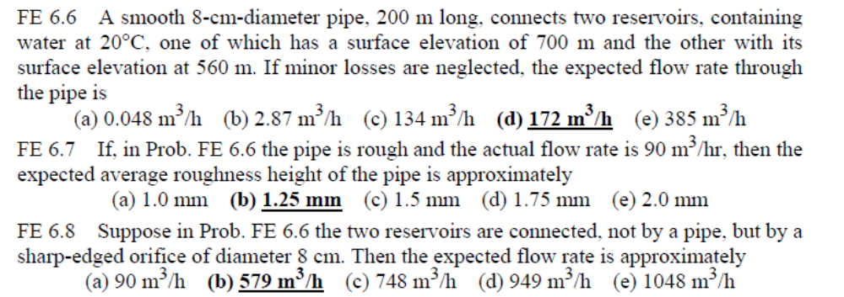
FE6.6:
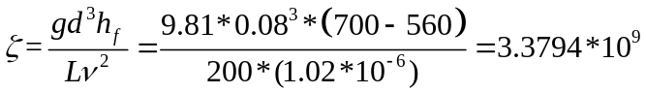
For smooth pipe, 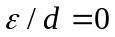 with equation (6.51)
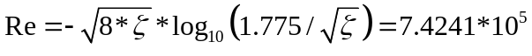
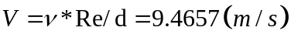
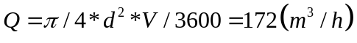
FE6.7:
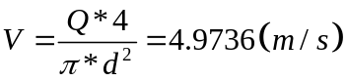
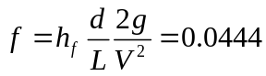
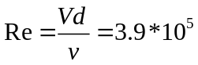
By Moody chart：
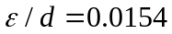
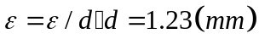
FE6.8:
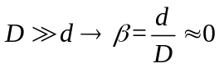
According to equation (6.112):
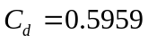
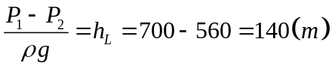
Then:
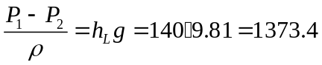
Using equation (6.104):
