Global Tech Layoffs (2020–2023)
A SQL-Driven Exploratory Data Analysis
Technical Documentation
Prepared by: Tobi Nwannukwu
Date: July 2026
Tools: MySQL (data cleaning and querying), Power BI (visualisation)

1. Introduction
Between 2020 and 2023, the technology sector went through two very different shocks: the sudden, short-lived disruption of the COVID-19 pandemic, followed roughly two years later by a much larger and more sustained wave of layoffs driven by slowing growth, rising interest rates, and a market correction after a period of aggressive hiring. This project uses SQL to clean and explore a public dataset of layoff announcements from this period, with the goal of identifying which industries, companies, countries, and funding stages were affected most, how layoffs trended over time, and whether the amount of funding a company had raised had any relationship with the size or severity of its layoffs.
The project was built as a hands-on SQL practice exercise, covering the full workflow of a data project: cleaning raw data, writing exploratory queries with aggregation, window functions and CTEs, and interpreting the results. The full SQL script is available in the accompanying GitHub repository.

2. Data Description

2.1 Source
The dataset originates from Layoffs.fyi, a tech layoff tracker created by Roger Lee, and was accessed as a curated CSV export (“Layoffs Dataset”, published on Kaggle by user swaptr). It records publicly reported layoff events at mostly venture-backed and larger technology-adjacent companies, and is therefore a sample of high-visibility layoffs rather than a complete census of job losses across the economy.

2.2 Format
The raw file, layoffs.csv, contains 2,361 rows and 9 columns: company, location, industry, total_laid_off, percentage_laid_off, date, stage, country, and funds_raised_millions. Each row represents one layoff announcement for a given company on a given date.

2.3 Cleaning Steps
The following steps were applied in SQL before analysis (see layoffs_project.sql for the full script):
- Removed 5 exact duplicate rows using ROW_NUMBER() partitioned across every column.
- Dropped 361 rows where both total_laid_off and percentage_laid_off were missing, since these rows carried no usable layoff signal.
- Converted blank industry values to NULL, then backfilled missing industry values using other rows for the same company where available.
- Standardised inconsistent industry labels (e.g. “Crypto Currency” variants consolidated to “Crypto”).
- Standardised country names by removing a trailing period found on some “United States.” entries.
- Trimmed leading and trailing whitespace from company names.
- Converted the date column from text to a proper DATE type using STR_TO_DATE.
After cleaning, the working dataset contains 1,995 layoff events, spanning 11 March 2020 to 6 March 2023, across 1,633 unique companies, 30 industry labels, and 51 countries.

3. Analysis Method

3.1 Tools
- MySQL: staging tables, data cleaning, and all exploratory queries (aggregation, CTEs, ROW_NUMBER, DENSE_RANK, and running-total window functions).
- Power BI: used to load the cleaned query output and build the charts presented in this document, using the same underlying logic as the SQL script.

3.2 Methods
- Descriptive aggregation (SUM, AVG, MAX, COUNT) grouped by company, industry, country, year, and funding stage.
- Ranking with DENSE_RANK() to identify the top companies and top industries by layoffs within each year.
- A running (cumulative) monthly total calculated with a window function to show how layoffs accumulated over the full period.
- Pearson correlation coefficient (r) to test the linear relationship between funds raised and both total layoffs and percentage of workforce laid off.

3.3 Assumptions
- Rows missing both layoff-count fields were treated as not usable and excluded, which removed about 15% of the raw rows.
- Each row is treated as one distinct layoff event; a company that laid off staff more than once appears more than once.
- percentage_laid_off reflects the share of the workforce cut in that specific announcement, not a cumulative reduction across multiple events.
- 2023 figures cover only January through early March, so they are a partial year and are not directly comparable to full calendar years such as 2022.
- The dataset reflects publicly reported layoffs and is likely skewed towards larger, US-based, and venture-backed companies, rather than the full economy.

4. Results
This section presents the descriptive statistics and correlation analysis. In total, 1,995 recorded layoff events add up to 383,659 employees laid off between March 2020 and March 2023.

4.1 Layoffs by Industry
Recommended visual: horizontal bar chart, since it ranks a moderate number of categories by a single value and keeps long industry labels readable.
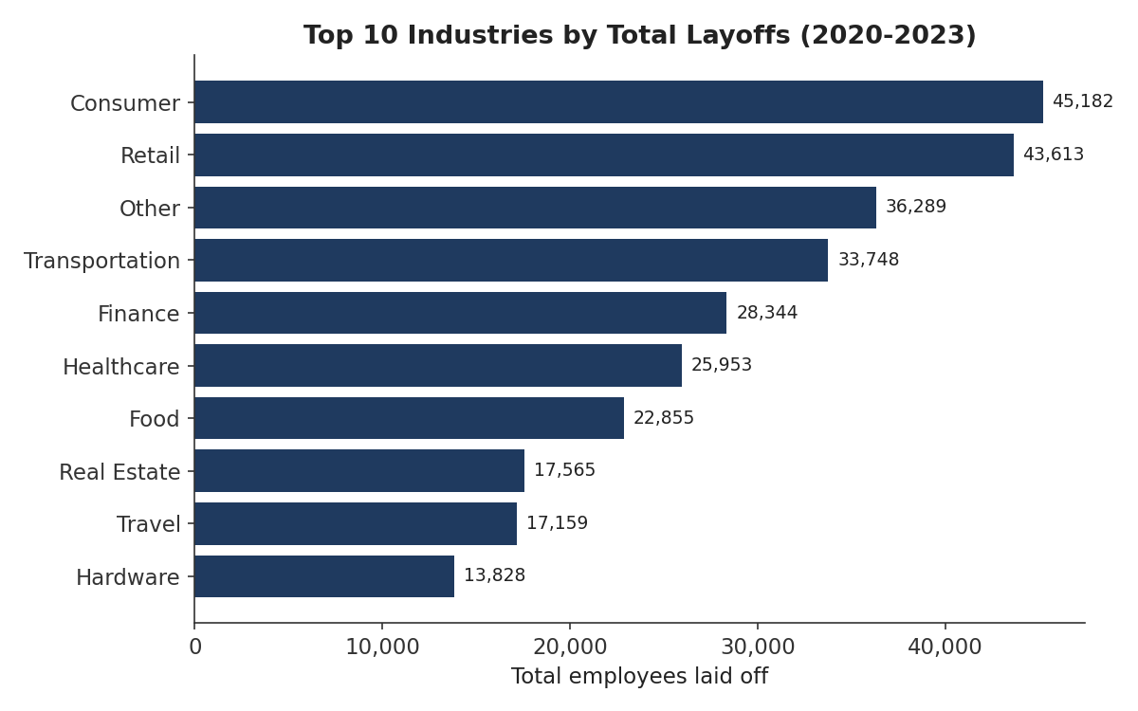
Figure 1. Total layoffs by industry, top 10 (2020–2023).
Consumer, Retail, and the catch-all “Other” category top the list, followed by Transportation and Finance. Notably, no narrowly-labelled “Software” or “Technology” category leads the ranking, which suggests the downturn spread well beyond core software companies into the consumer-facing, logistics, and e-commerce businesses that scaled up around the same hiring boom.

4.2 Layoffs Over Time
Recommended visual: combination bar and line chart, to show the monthly volume alongside the cumulative running total on a shared timeline.
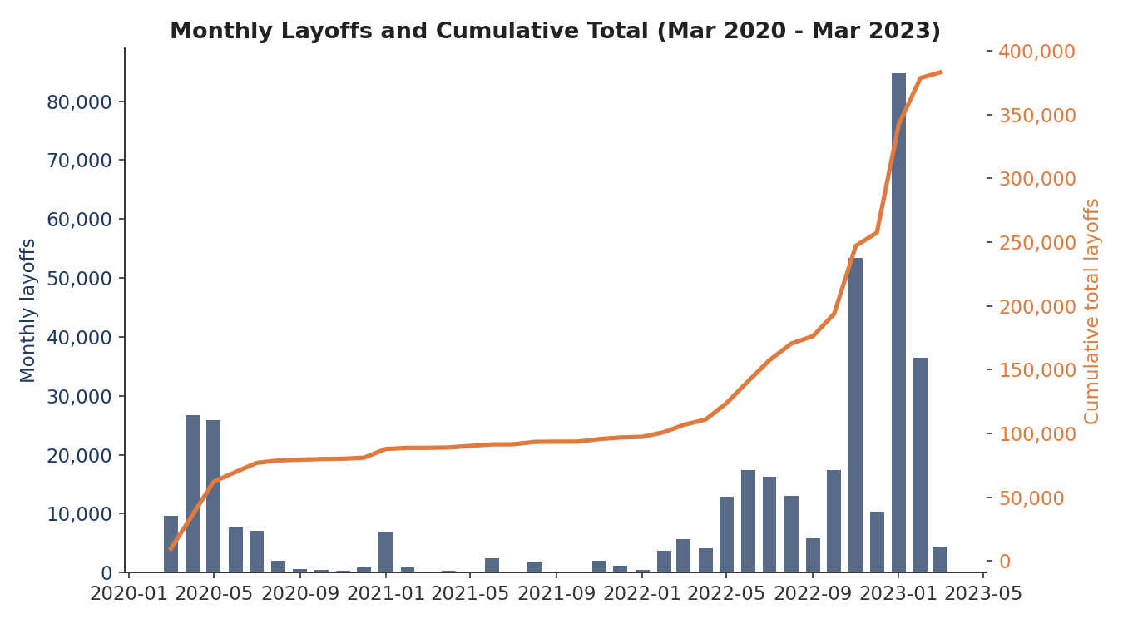
Figure 2. Monthly layoffs (bars) and cumulative total (line), March 2020 to March 2023.
The data shows two distinct waves. The first is the initial pandemic shock in April and May 2020 (roughly 26,700 and 25,800 people respectively), which faded quickly through the rest of 2020 and stayed low through most of 2021. The second wave began building in mid-2022, accelerated through the final months of the year, and peaked in January 2023 at 84,714, the single largest month in the dataset and close to three times the worst month of the 2020 wave. This second wave was both larger and more sustained than the first.

4.3 Layoffs by Company
Recommended visual: horizontal bar chart, consistent with the industry chart, for easy side-by-side comparison.
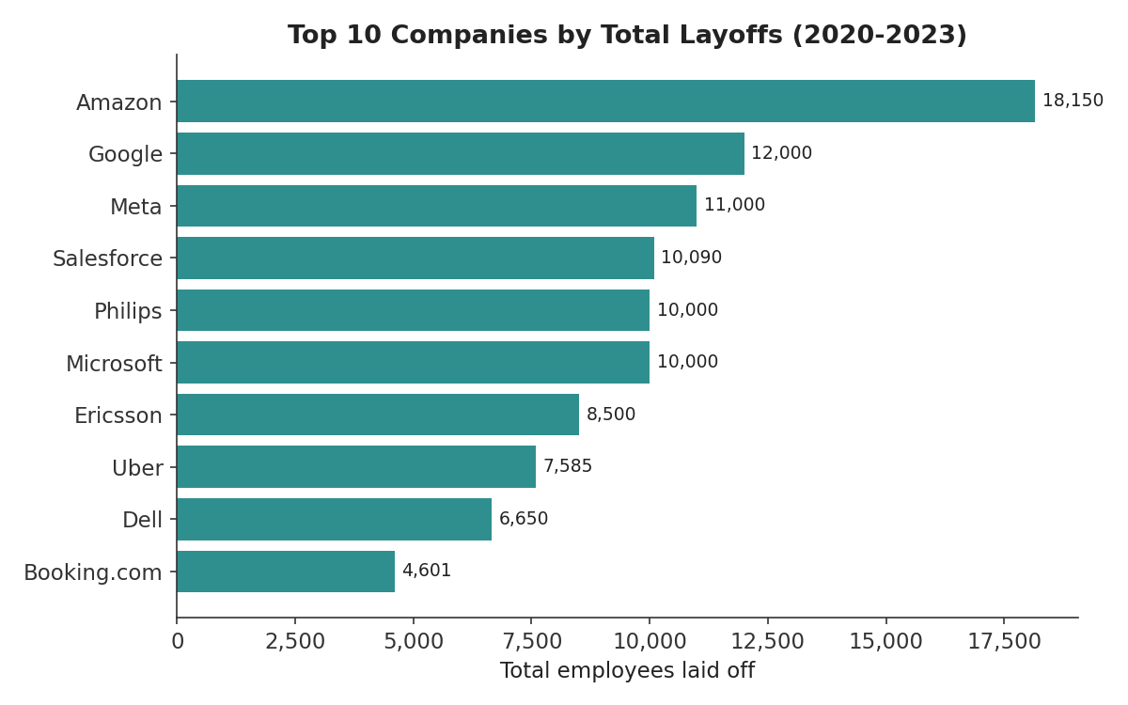
Figure 3. Top 10 companies by total layoffs (2020–2023).
Amazon, Google, Meta, Salesforce, and Microsoft account for the largest absolute headcount reductions. This is partly a reflection of company size rather than crisis severity: these are some of the largest employers in the dataset, so even a modest percentage cut translates into a large absolute number.

4.4 Layoffs by Country
Country | Total Laid Off
United States | 256,559
India | 35,993
Netherlands | 17,220
Sweden | 11,264
Brazil | 10,391
Table 1. Top 5 countries by total layoffs.
The United States accounts for about two-thirds of all recorded layoffs, consistent with the dataset's US-heavy sourcing. India is a distant second, with the Netherlands, Sweden, and Brazil rounding out the top five, largely driven by a small number of large single-company events (e.g. Philips in the Netherlands, Ericsson in Sweden).

4.5 Layoffs by Funding Stage
Recommended visual: vertical bar chart, since funding stage is a small, naturally ordered set of categories.
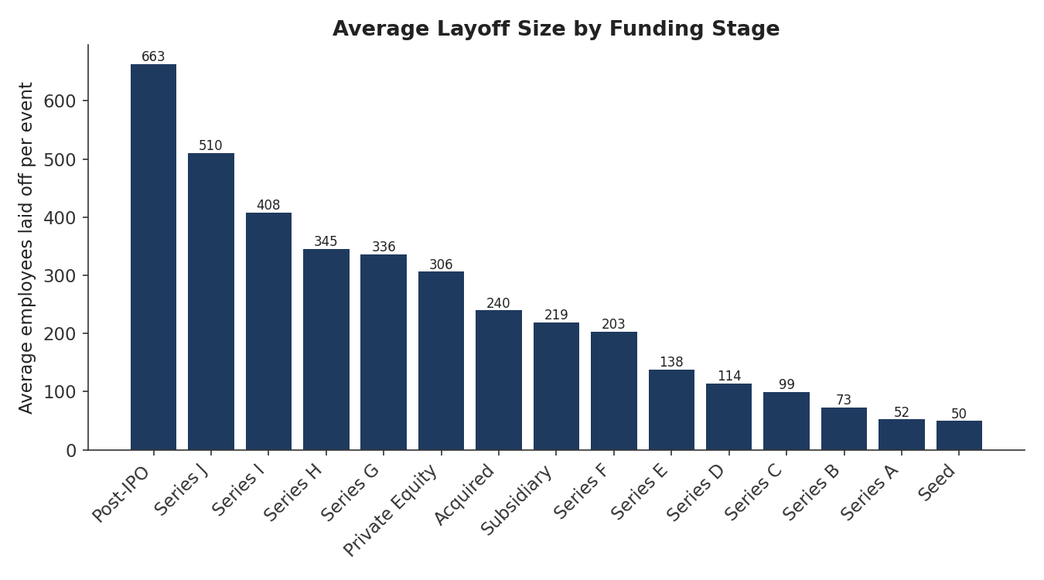
Figure 4. Average employees laid off per event, by funding stage.
Post-IPO companies show the highest average layoff size per event (about 663 people), which lines up with them typically having the largest workforces to cut from. Average layoff size decreases fairly steadily moving towards earlier funding stages, with Seed and Series A companies averaging the smallest cuts. Categories such as Series I and Series J have very few underlying events (7 each) and should be read cautiously, as a single large layoff can swing the average considerably.

4.6 Companies With a Complete Workforce Layoff
116 companies in the cleaned dataset recorded percentage_laid_off = 1, meaning they laid off their entire workforce. Some of these had raised substantial funding beforehand:
Company | Funds Raised ($M)
Britishvolt | 2,400
Quibi | 1,800
Deliveroo Australia | 1,700
Katerra | 1,600
BlockFi | 1,000
Table 2. Companies with 100% workforce layoffs and over $100M raised, top 5 by funding.

4.7 Correlation: Funding vs. Layoffs
Recommended visual: scatter plot with a logarithmic funding axis, since funds raised spans several orders of magnitude across companies.
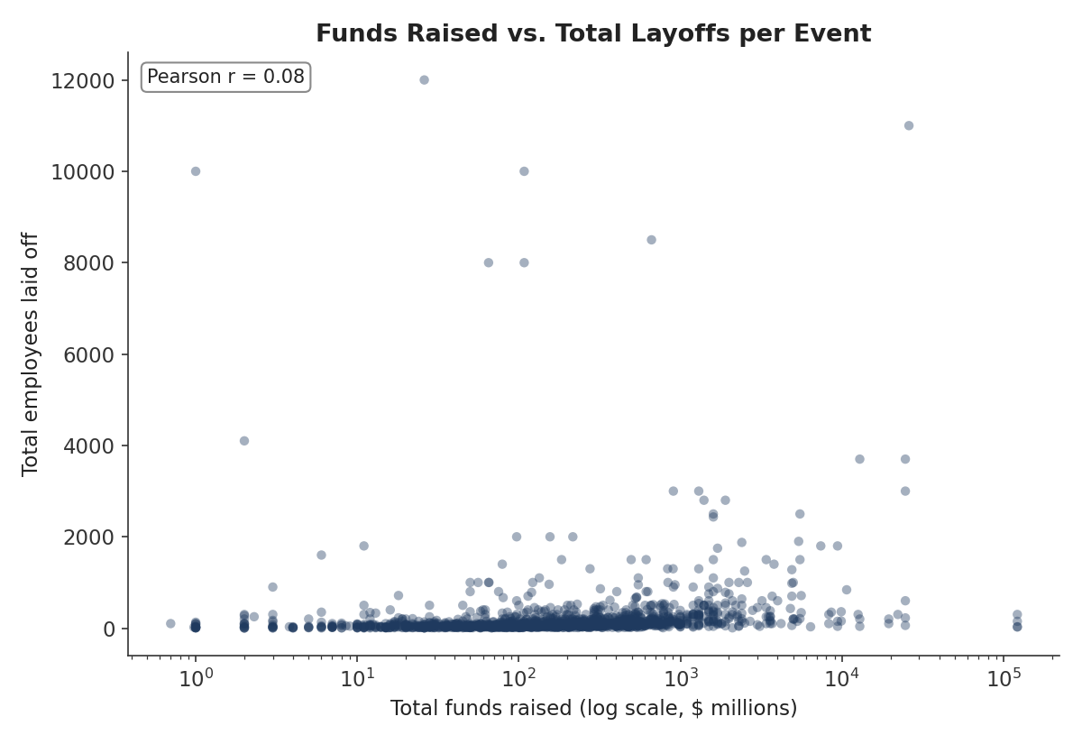
Figure 5. Funds raised (log scale) vs. total employees laid off per event.
The Pearson correlation between funds_raised_millions and total_laid_off is approximately r = 0.08, and between funds_raised_millions and percentage_laid_off is approximately r = -0.07. Both are close to zero, indicating essentially no linear relationship.

4.8 Key Descriptive Patterns
- A clear two-wave shape over time: a sharp but short pandemic-driven spike in 2020, and a larger, longer downturn-driven wave from mid-2022 into early 2023 that peaked at nearly three times the worst month of the first wave.
- The industries hit hardest by volume, Consumer, Retail, and Transportation, sit adjacent to core tech rather than being narrowly defined software companies, suggesting the effect radiated outward from the sector rather than staying contained to it.
- A small number of very large employers (Amazon, Google, Meta, Microsoft, Salesforce) make up a disproportionate share of the headline layoff totals, largely a function of their scale rather than proportionally deeper cuts.
- 116 companies recorded a complete workforce layoff, and several of them, including Britishvolt, Quibi, Deliveroo Australia, and Katerra, had raised well over $1 billion beforehand, showing that a large funding history did not guarantee survival.
- The United States accounts for roughly two-thirds of all recorded layoffs, reflecting both real concentration of the tech industry there and the dataset's US-heavy sourcing.

4.9 Key Correlation Findings
- Funds raised has essentially no linear relationship with either the absolute number of people laid off (r ≈ 0.08) or the percentage of the workforce laid off (r ≈ -0.07).
- The small positive correlation with absolute layoffs is best read as a size effect: companies that raise more money also tend to be larger, so their layoffs are larger in absolute terms, not necessarily proportionally deeper.
- The near-zero (and slightly negative) correlation with percentage_laid_off suggests that better-funded companies were not meaningfully protected from cutting a large share of their staff, nor were they more likely to do so. Funding level, on its own, is not a useful predictor of layoff severity in this dataset.

5. Discussion
The results suggest that layoffs in this period tracked broad macroeconomic cycles more closely than any single company-level financial variable. The 2020 wave aligns with the sudden uncertainty at the start of the pandemic, while the larger and more sustained 2022 to 2023 wave aligns with the period of rising interest rates and a market correction following two years of rapid hiring across the tech sector. Funding raised, which might intuitively seem like a cushion against layoffs, showed no meaningful relationship with either the size or the severity of a company's layoffs, implying that decisions to cut staff were driven more by factors this dataset does not capture directly, such as burn rate, revenue trajectory, and investor pressure, than by how much capital a company had previously raised.

5.1 Limitations
- The dataset only captures publicly reported layoffs, skewed towards venture-backed and larger companies, mostly in the US, so findings should not be generalised to the wider labour market.
- Industry and stage labels are coarse and tracker-assigned; “Other” is the third-largest industry category by volume, which hides meaningful detail.
- Roughly 15% of raw rows were dropped for missing layoff figures, and several funding-stage groups (e.g. Series I, Series J) have very small sample sizes, making their averages unstable.
- Pearson's r only captures a linear relationship; a non-linear or threshold-based relationship between funding and layoffs cannot be ruled out by this analysis alone.
- 2023 figures represent a partial year (January to early March), limiting direct comparison with full years such as 2022.

5.2 Suggested Improvements
- Normalise total_laid_off against each company's pre-layoff headcount where available, rather than relying on percentage_laid_off alone, for a more consistent measure of event severity.
- Cross-reference layoff timing with macroeconomic indicators, such as interest rates or sector stock indices, to test whether the two waves line up with broader market signals.
- Bin funds_raised_millions into quartiles and compare average percentage_laid_off across bins, to check for a non-linear relationship that a single correlation coefficient could miss.
- Supplement the dataset with a second source to reduce reporting bias and fill in missing industry or stage values more reliably.

6. Conclusion
This project cleaned and explored 1,995 layoff events from 2020 to 2023 using SQL, uncovering two distinct waves of layoffs, a short pandemic-driven spike in 2020 and a larger, sustained downturn-driven wave from mid-2022 into early 2023 that peaked at almost three times the size of the first. Layoffs were concentrated in the United States and in industries adjacent to core technology, such as Consumer and Retail, and a handful of large, well-known companies accounted for a disproportionate share of the headline numbers, mostly a reflection of their size. Most notably, the amount of funding a company had raised showed no meaningful relationship with how many people, or what share of its workforce, it laid off.
For anyone using this kind of data to gauge job security, funding history alone is not a reliable signal. For future analysis, incorporating headcount-normalised severity measures and macroeconomic context, as outlined in the Discussion section, would give a fuller picture of what actually drove these decisions.

