# Twitcher



**Streaming website**

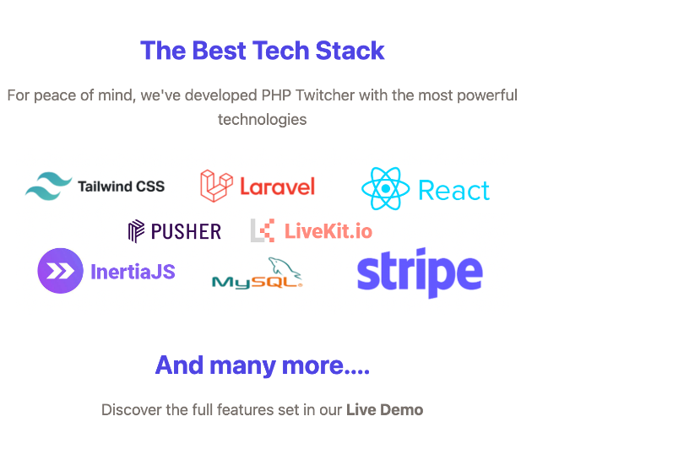 Note:- Use of technology this website bellow mention

Table of Contents

Twitcher 1

Introduction 3

Website working :- 3

1. Home :- 4

2. Channels:- 4

1. Videos:- 5

2. Galleries :- gallery is a same work to videos 6

3. Tokens :- 6

4. Login :- 7

5. SignUp:- 7

6. White / dark ui : - 8

Streamer panel:- 8

3. Users :- 12

Admin panels :- 14

# Introduction

## Website working :-

Hit this URLs:- <https://love248.com/> open the website interface

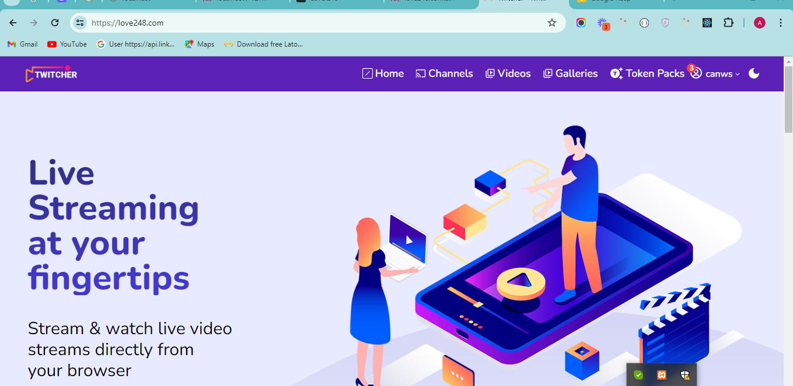

This website is a streaming website for use of users and streamers

There is open website 7 menus

1. Home
2. Channels
3. Videos
4. Gallery
5. Token package
6. Login
7. Signup
8. Dark / white color

### Home :-

Home is open show all users and streamers

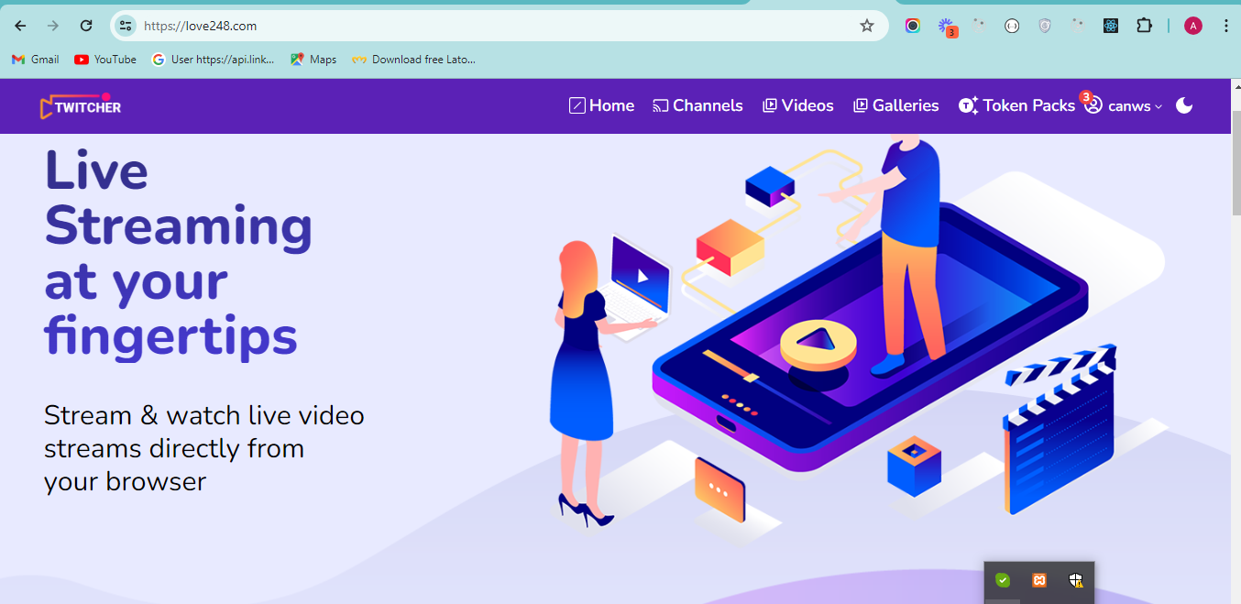

### Channels:-

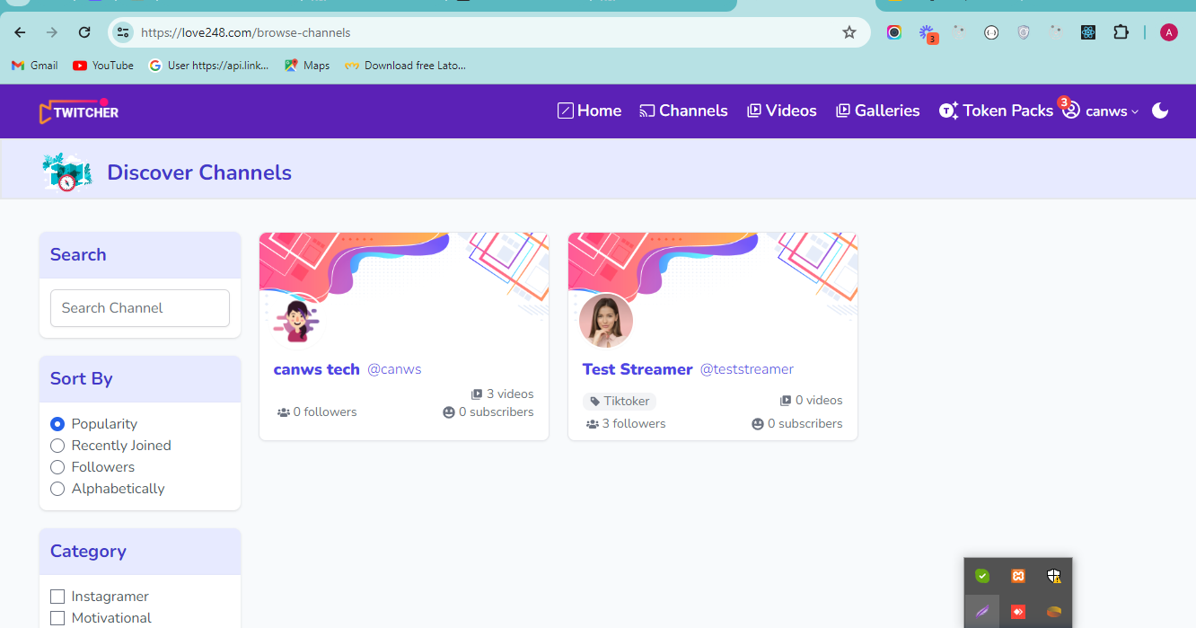There is show all channels of all streamers live or off line both

Users of streamer fillers multiple types and click any channels page click after open this page

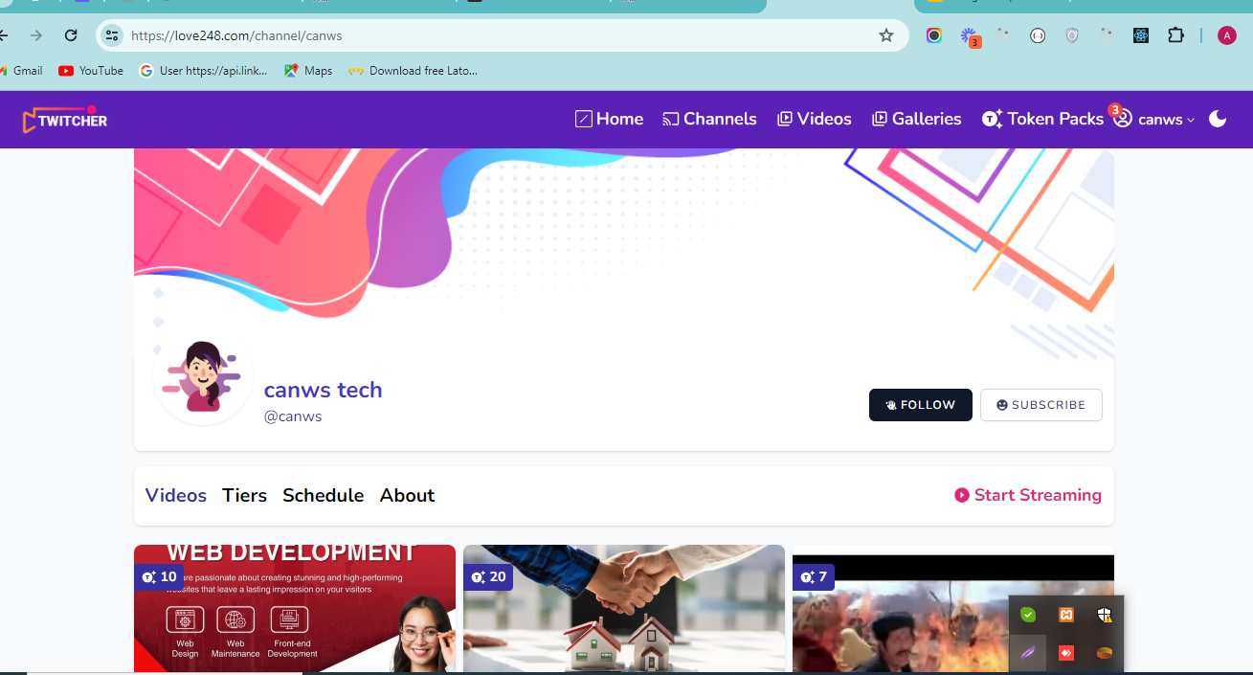

If streamer login show button start streaming other wise users login show watch streaming

Note:- this is show that’s time when streamer live other wise users login watching not show

### Videos:-

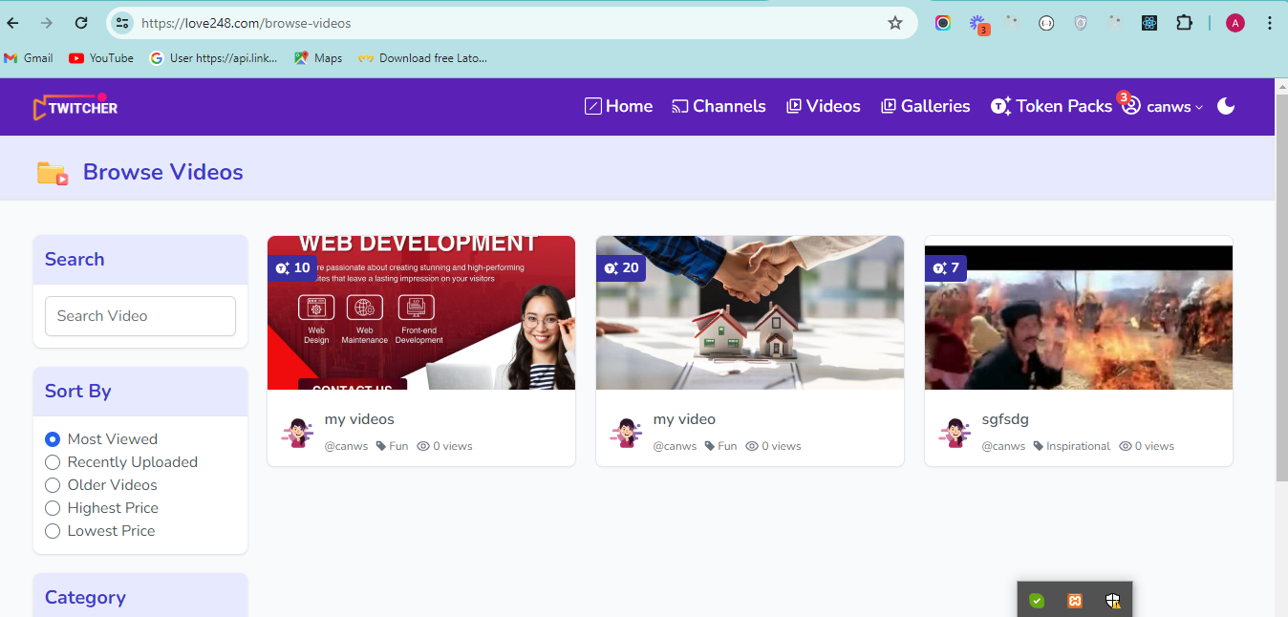 There is show all streamer uploaded video and access the users buy tokens

### Galleries :- gallery is a same work to videos

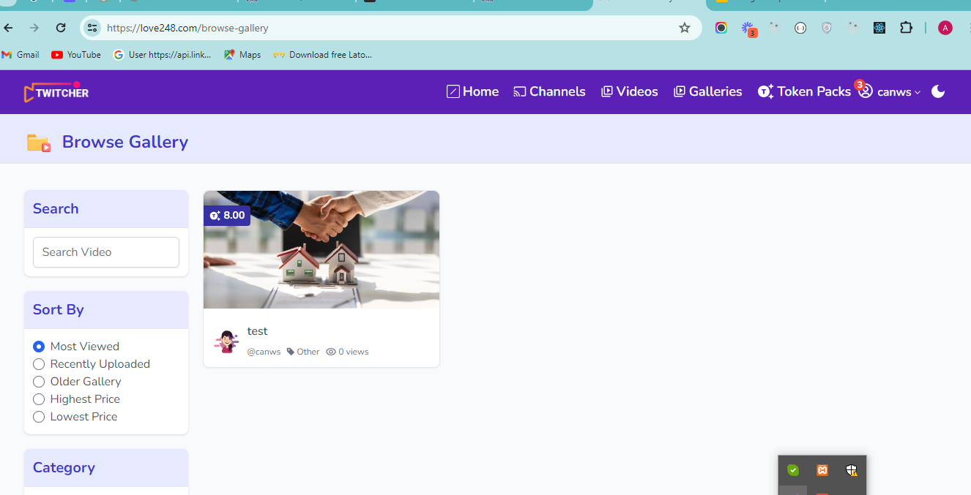

### Tokens :-

Token page is a take for subscriptions without subscription not not any thinks access the website

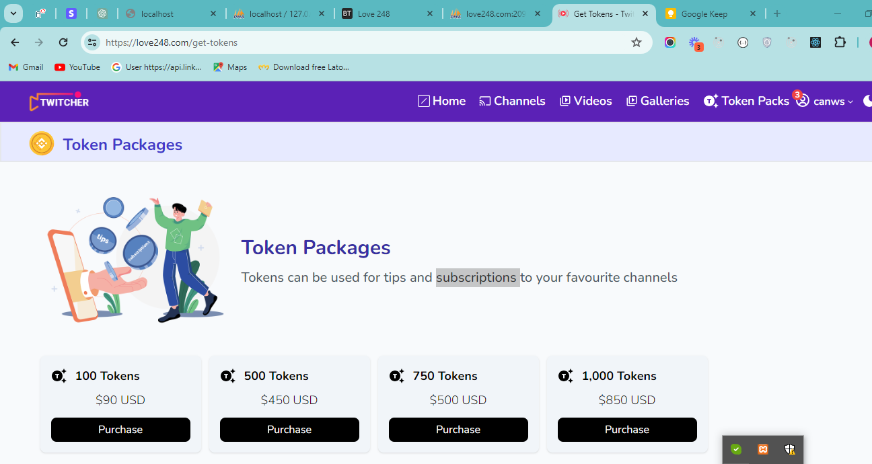Same as plan page

### Login :-

Login is users and streamer both login click on login button open this interface

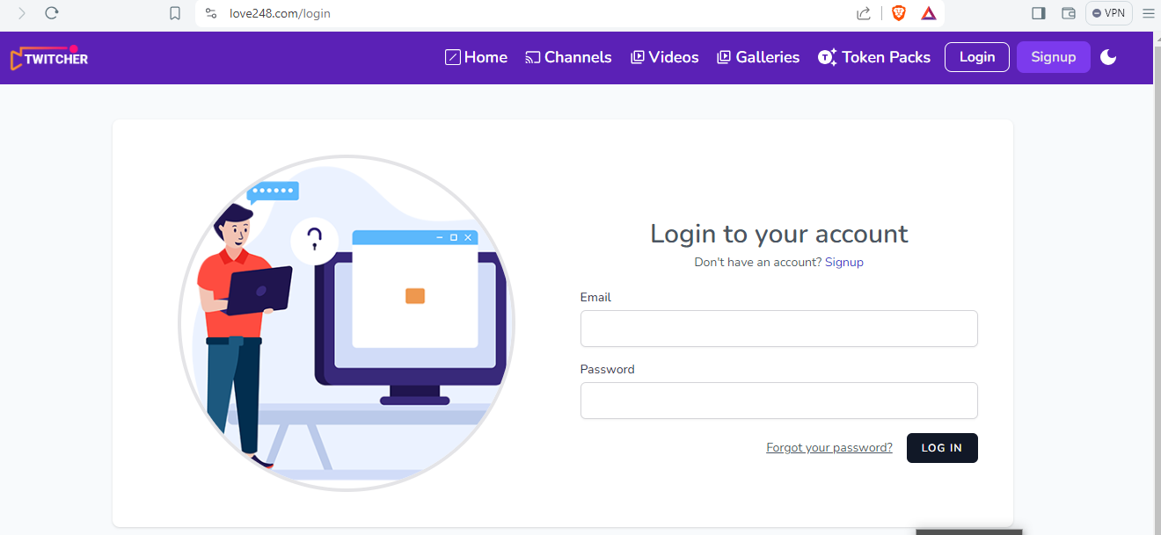

Testing Login details :-

|  |  |
| --- | --- |
| Streamer | Users |
| Email :- [canwstech@gmail.com](mailto:canwstech@gmail.com)  Password :- :- General123.. | Email :- [navjot.canws@gmail.com](mailto:navjot.canws@gmail.com)  Password :- :- General123.. |

### SignUp:-

This is registering page two type of users register streamer and users

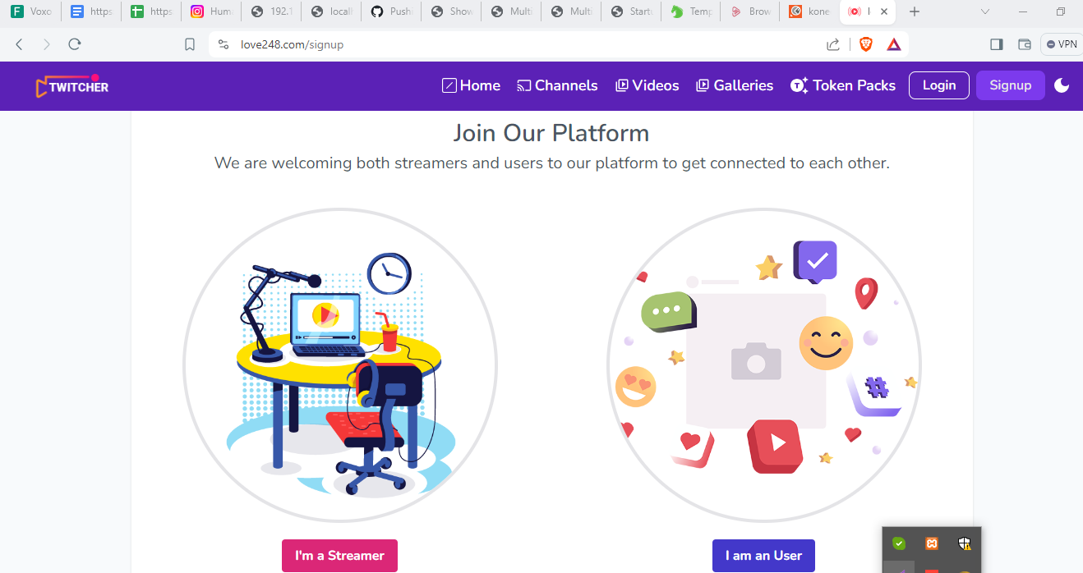

### White / dark ui : -

This button is change ui color

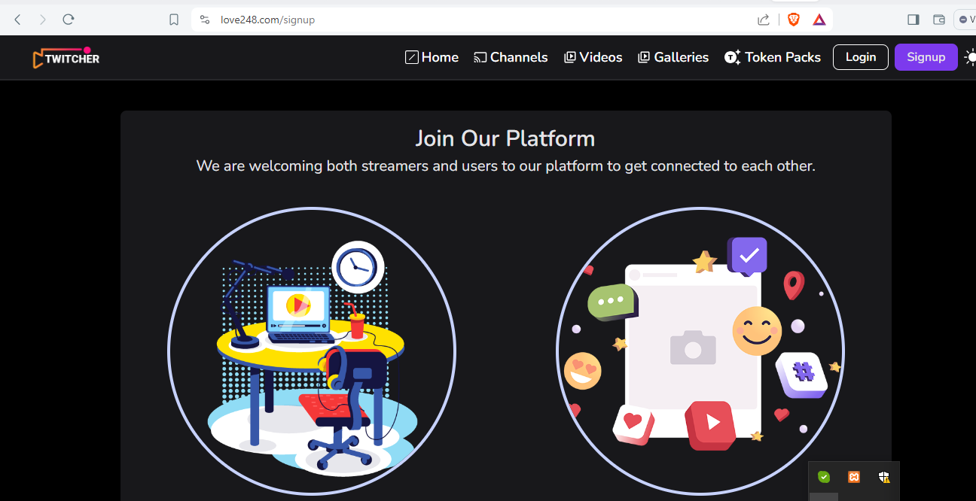

### 

There four main part this website

1. Streamer panel
2. Users panel
3. Admin panel
4. Super admin panel

## Streamer panel:-

Streamer is login after click the channel menu bar and open all channels and self page click open this page and click streaming is start after open new page

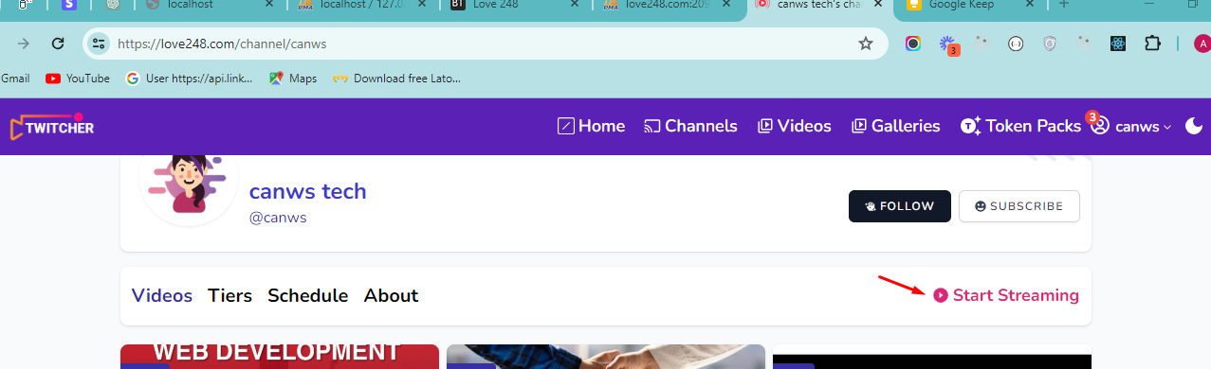

Start streaming click after check two validation

1. Age of 18 years
2. Subscription buy

Both are check after open next streamer page

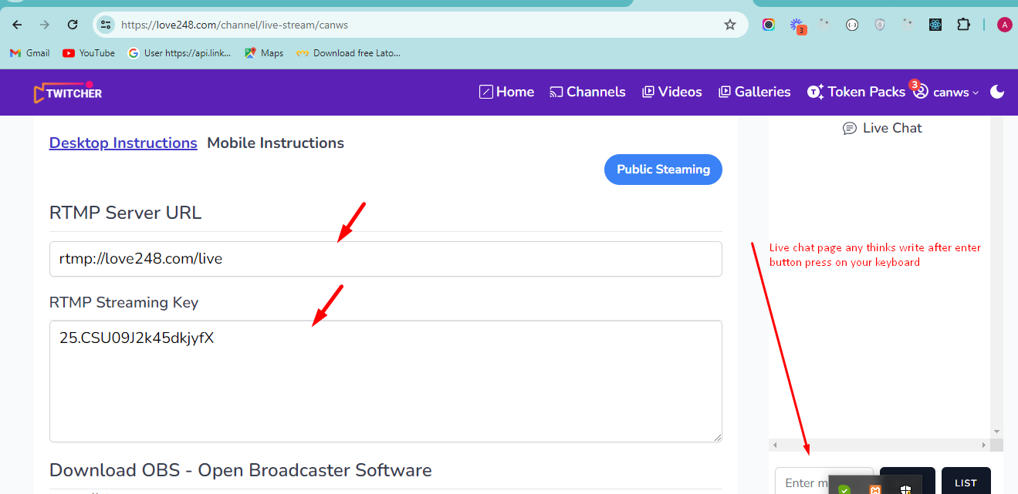

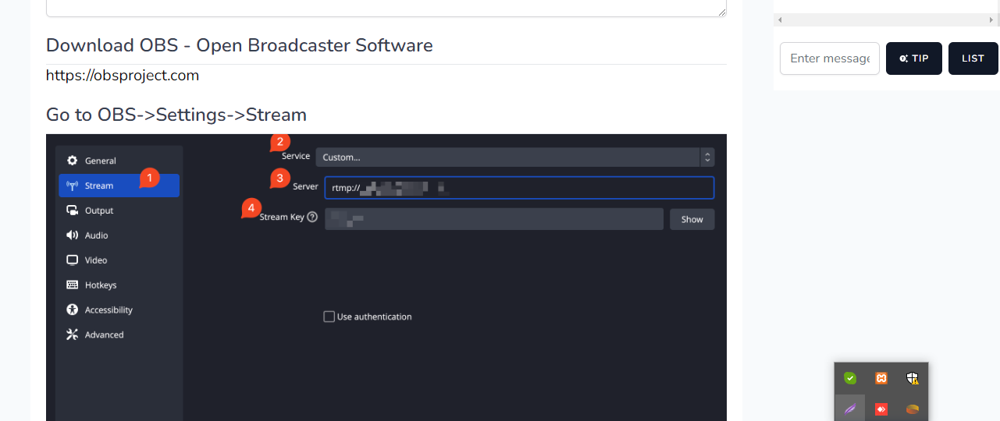

Start streaming download OBS Software using links and install your system after open and click setting button and set upper image as and enter urls passwords and start streaming and multiple settings

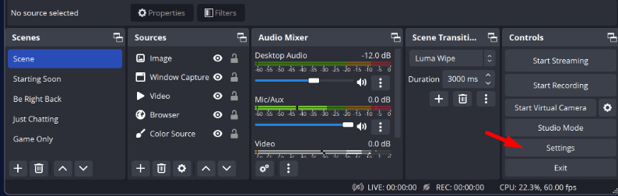

Streaming is two part

1. Public
2. Private

#### Public streaming :-

All users access public streaming and no earning streamer but any users give tips then streamer account add streamer is not send self tips only send message

##### Private :-

Private streaming is start to only see requested users and streamer .private start click list button 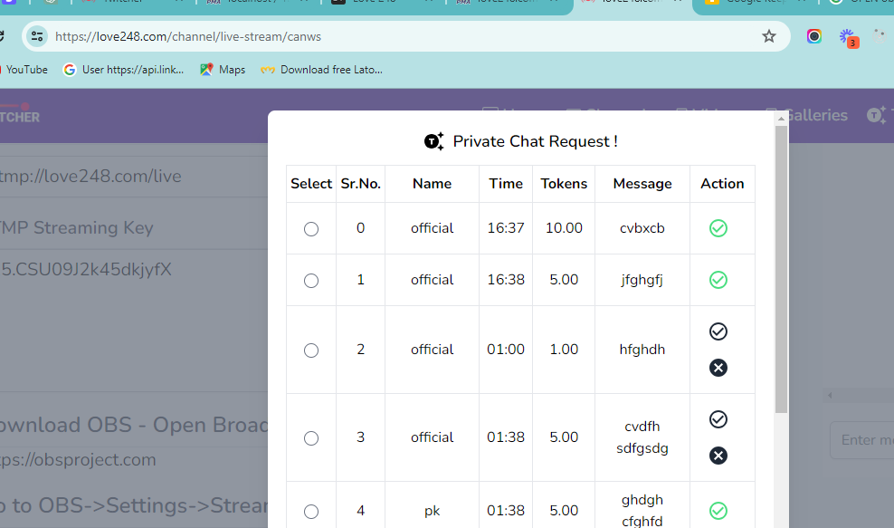

First accept user then check and request send button click after start steaming private and public streaming is off

Private streaming start timer user and streamer both side and time after stop and streaming restart

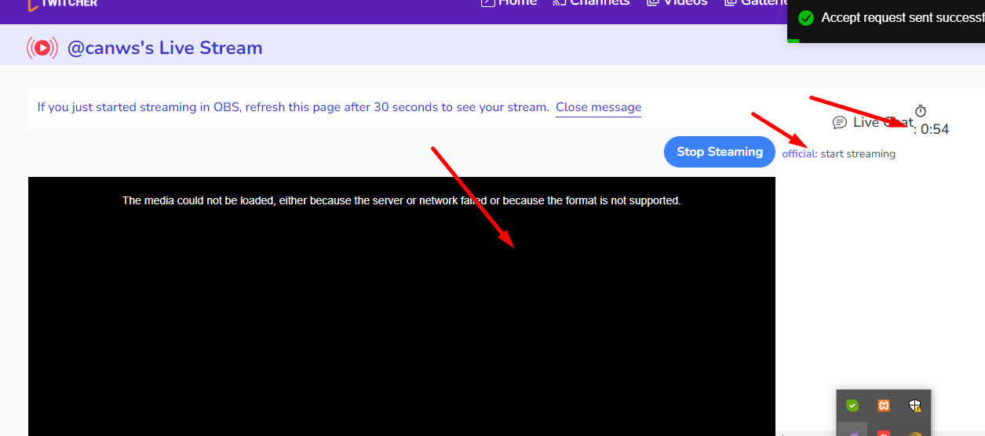

This is private steaming

##### Streamer account :-

Click your account and open my account page and manage your detail and update info ,

See listing of videos and gallery listing

##### 

## Users :-

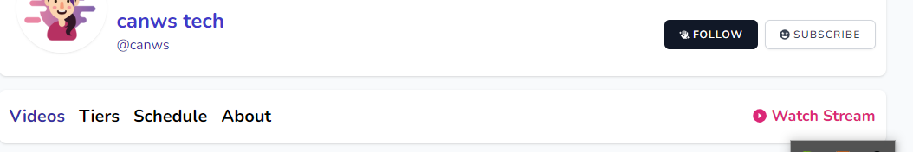Users login after click channels and live streamer page click after watching click then open same page and send message and tips or request private streaming

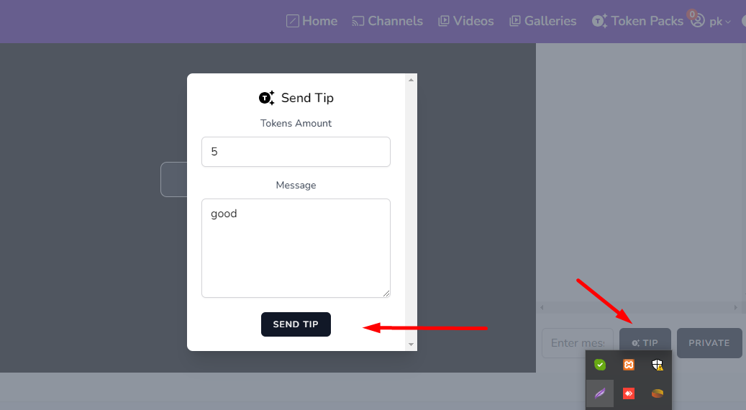

Send streamers tipe click tips open this modals and send tips

###### Request Private streaming :-

Click one private button and open this

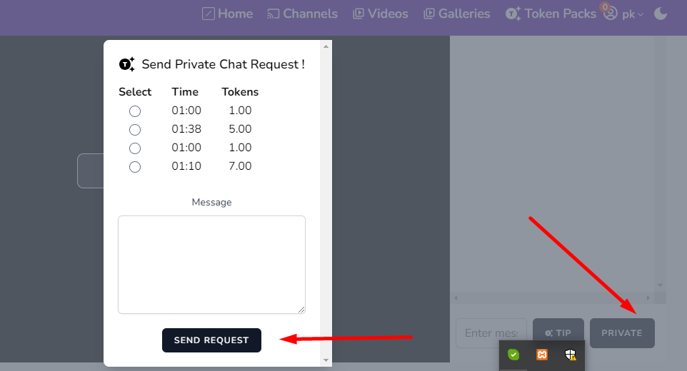

Send and accept after private is started

##### Users account :-

Click your account and open my account page and manage your detail and update info ,

See listing of videos and gallery listing

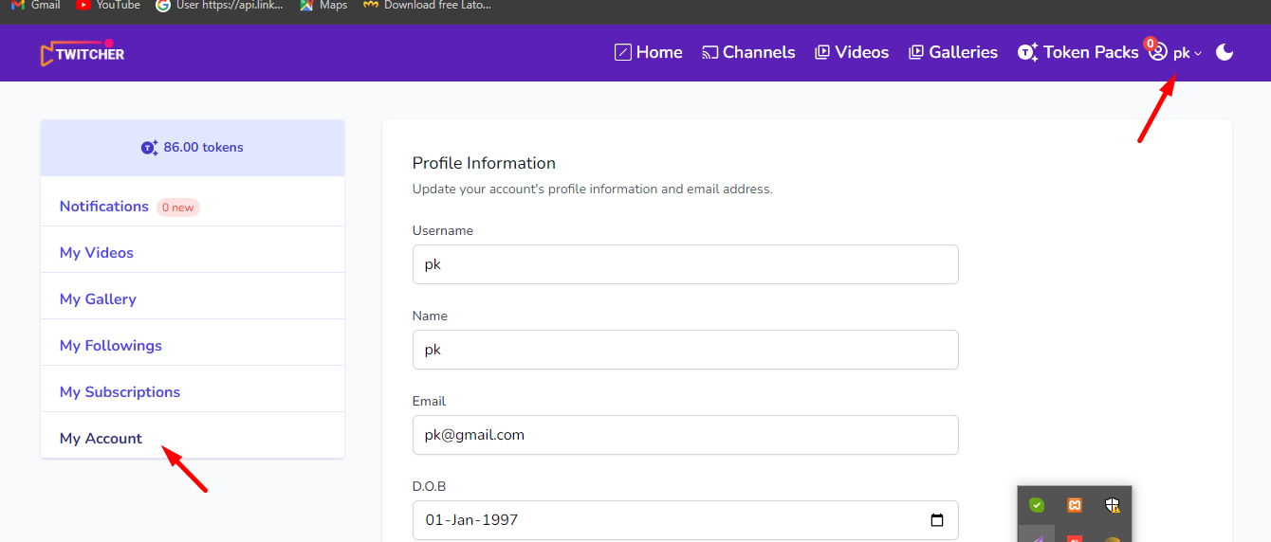

## Admin panels :-

Admin logins URLs:- <https://love248.com/admin/login>

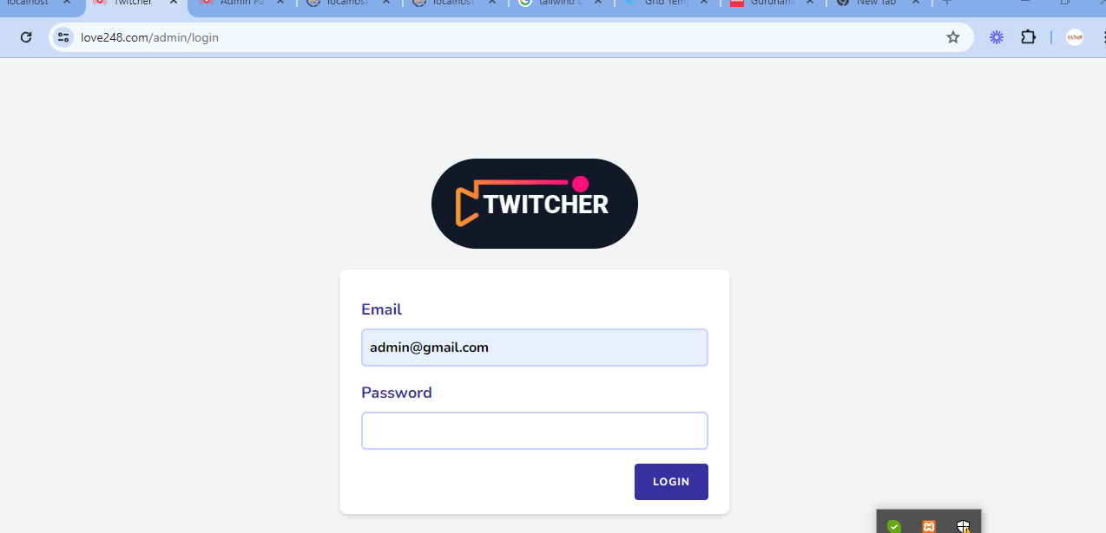

Email:- [admin@gamil.com](mailto:admin@gamil.com)

Password:- General123..

Login after open this page

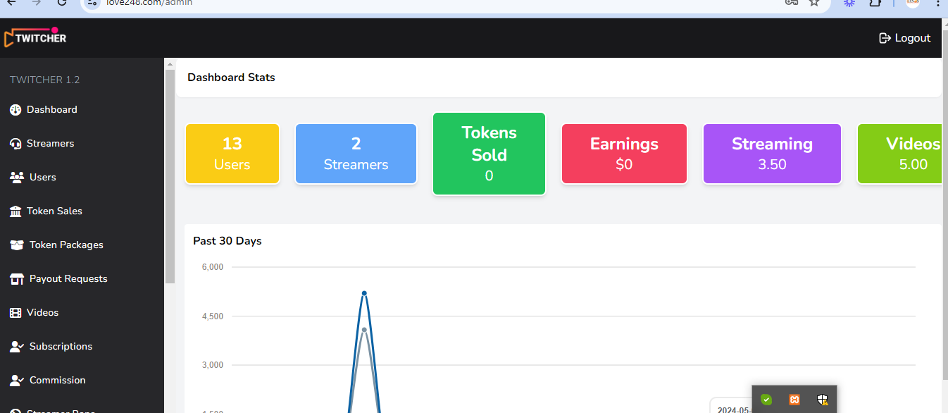

Admin manage all details for uses and multiple admins