Echarts is a tool of visualizing data in multiple charts, and an icon library of JavaScript. Echarts can provide intuitional, lively, interactive, personalized-customization-able data visualized tables to front-end development.

1. High table diversification and visualized expression

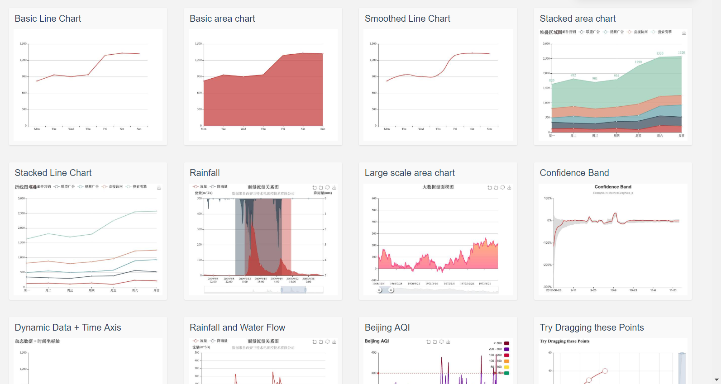

1. Quoting code directly to be efficient

