# AIM Django Demo Project Report

Baohua Cao

SECTION I: SETUP DEV AND DATABASE, DEMO SQL

SECTION II: DEV CODING AND BUILD WEB / ADMIN

FINAL OUTPUT:

<http://ec2-54-186-83-10.us-west-2.compute.amazonaws.com:8000/>

<http://ec2-54-186-83-10.us-west-2.compute.amazonaws.com:8000/admin/>

Username: admin Password: smiletolife

**SECTION I: SETUP DEV AND DATABASE, DEMO SQL**

1. Create an AWS EC2 instance.
2. Install software packages and updates.
3. Setup virtualenv with python3

source myenv/bin/activate

1. Git clone:

git clone <https://github.com/michaelb87/aim-recruiting-django.git>

1. Install requirements.txt

pip install -r requirements.txt

Fixed software bundles installation issues.

1. Make migrations

(myenv) [root@ip-172-31-31-17 aim-recruiting-django]# python manage.py makemigrations

Migrations for 'demo_app':

demo_app/migrations/0001_initial.py

- Create model Publisher

- Create model Source

- Create model RevenueRecord

(myenv) [root@ip-172-31-31-17 aim-recruiting-django]# python manage.py migrate

Operations to perform:

Apply all migrations: admin, auth, contenttypes, demo_app, sessions

Running migrations:

Applying contenttypes.0001_initial... OK

Applying auth.0001_initial... OK

Applying admin.0001_initial... OK

Applying admin.0002_logentry_remove_auto_add... OK

Applying admin.0003_logentry_add_action_flag_choices... OK

Applying contenttypes.0002_remove_content_type_name... OK

Applying auth.0002_alter_permission_name_max_length... OK

Applying auth.0003_alter_user_email_max_length... OK

Applying auth.0004_alter_user_username_opts... OK

Applying auth.0005_alter_user_last_login_null... OK

Applying auth.0006_require_contenttypes_0002... OK

Applying auth.0007_alter_validators_add_error_messages... OK

Applying auth.0008_alter_user_username_max_length... OK

Applying auth.0009_alter_user_last_name_max_length... OK

Applying auth.0010_alter_group_name_max_length... OK

Applying auth.0011_update_proxy_permissions... OK

Applying demo_app.0001_initial... OK

Applying sessions.0001_initial... OK

1) Write a custom django admin command to ingest demo data eg. `python manage.py ingest demo_data.csv`

(myenv) [ec2-user@ip-172-31-31-17 aim-recruiting-django]$vim demo_app/management/commands/ingest.py

from django.core.management.base import BaseCommand, CommandError

import os

import csv

from demo_app.models import Publisher, Source, RevenueRecord

import datetime

class Command(BaseCommand):

def add_arguments(self, parser):

parser.add_argument('file', type=str)

def handle(self, *args, **options):

file = options['file']

if not os.path.exists(file):

raise CommandError("%s doesnt exist." % file)

self.stdout.write(self.style.SUCCESS('Successfully read file "%s"' % file))

with open(file, 'r') as csv_file:

reader = csv.reader(csv_file, delimiter=',')

fields_name = list(next(reader))

self.stdout.write(" ".join(fields_name))

objects_counter = [0] * 3

for row in reader:

date, pub_name, source, clicks, revenue = tuple(row)

self.stdout.write(" ".join([date, pub_name, source, clicks, revenue]))

try:

Publisher_Obj = Publisher.objects.get(name=pub_name)

except Publisher.DoesNotExist:

Publisher_Obj = Publisher(name=pub_name)

Publisher_Obj.save()

objects_counter[0] += 1

self.stdout.write('Created a new publisher record.')

try:

Source_Obj = Source.objects.get(name=source)

except Source.DoesNotExist:

Source_Obj = Source(name=source)

Source_Obj.save()

objects_counter[1] += 1

self.stdout.write('Created a new source record.')

Publisher_Obj = Publisher.objects.get(name=pub_name)

Source_Obj = Source.objects.get(name=source)

clicks, revenue = int(clicks), float(revenue)

year, month, day = tuple([int(i) for i in date.split("-")])

date = datetime.date(year, month, day)

revenue_record = RevenueRecord(date=date, publisher=Publisher_Obj, source=Source_Obj, clicks=clicks, revenue=revenue)

revenue_record.save()

objects_counter[2] += 1

self.stdout.write('Created a new revenue record.')

self.stdout.write("Created %s publisher records, %s source records, and %s revenue records" % tuple(objects_counter))

(myenv) [ec2-user@ip-172-31-31-17 aim-recruiting-django]$ python manage.py ingest "demo_data.csv"

Successfully read file "demo_data.csv"

date pub_name source clicks revenue

2019-10-01 micha google 138 49.68

Created a new publisher record.

Created a new source record.

Created a new revenue record.

2019-10-01 mark yahoo 263 231.44

Created a new publisher record.

Created a new source record.

Created a new revenue record.

2019-10-01 melanie google 374 179.52

Created a new publisher record.

Created a new revenue record.

2019-10-01 logan yahoo 492 403.44

Created a new publisher record.

Created a new revenue record.

2019-10-02 micha yahoo 134 127.75

Created a new revenue record.

2019-10-02 mark google 278 239.08

Created a new revenue record.

2019-10-02 melanie yahoo 478 22.31

Created a new revenue record.

2019-10-02 logan google 285 134.90

Created a new revenue record.

2019-10-03 micha google 325 244.83

Created a new revenue record.

2019-10-03 mark google 73 13.14

Created a new revenue record.

2019-10-03 melanie google 100 94.67

Created a new revenue record.

2019-10-03 logan google 424 330.72

Created a new revenue record.

2019-10-04 micha google 489 65.20

Created a new revenue record.

2019-10-04 mark google 244 92.72

Created a new revenue record.

2019-10-04 melanie google 213 210.16

Created a new revenue record.

2019-10-04 logan yahoo 84 6.16

Created a new revenue record.

2019-10-05 micha yahoo 420 282.80

Created a new revenue record.

2019-10-05 mark yahoo 421 140.33

Created a new revenue record.

2019-10-05 melanie yahoo 239 184.83

Created a new revenue record.

2019-10-05 logan yahoo 181 20.51

Created a new revenue record.

2019-10-06 micha yahoo 103 4.81

Created a new revenue record.

2019-10-06 mark google 494 55.99

Created a new revenue record.

2019-10-06 melanie google 331 88.27

Created a new revenue record.

2019-10-06 logan google 368 318.93

Created a new revenue record.

2019-10-07 micha google 210 65.80

Created a new revenue record.

2019-10-07 mark yahoo 147 128.38

Created a new revenue record.

2019-10-07 melanie yahoo 108 59.76

Created a new revenue record.

2019-10-07 logan yahoo 31 20.25

Created a new revenue record.

2019-10-08 micha google 353 298.87

Created a new revenue record.

2019-10-08 mark yahoo 44 26.69

Created a new revenue record.

2019-10-08 melanie google 117 67.08

Created a new revenue record.

2019-10-08 logan google 271 231.25

Created a new revenue record.

2019-10-09 micha yahoo 111 90.28

Created a new revenue record.

2019-10-09 mark google 364 283.92

Created a new revenue record.

2019-10-09 melanie google 475 85.50

Created a new revenue record.

2019-10-09 logan yahoo 49 26.79

Created a new revenue record.

2019-10-10 micha google 231 107.80

Created a new revenue record.

2019-10-10 mark google 158 122.19

Created a new revenue record.

2019-10-10 melanie google 69 40.48

Created a new revenue record.

2019-10-10 logan google 201 61.64

Created a new revenue record.

2019-10-11 micha yahoo 188 159.17

Created a new revenue record.

2019-10-11 mark yahoo 48 9.28

Created a new revenue record.

2019-10-11 melanie google 206 145.57

Created a new revenue record.

2019-10-11 logan google 129 100.62

Created a new revenue record.

2019-10-12 micha yahoo 109 86.47

Created a new revenue record.

2019-10-12 mark yahoo 161 156.71

Created a new revenue record.

2019-10-12 melanie yahoo 375 27.50

Created a new revenue record.

2019-10-12 logan yahoo 467 62.27

Created a new revenue record.

2019-10-13 micha google 37 22.94

Created a new revenue record.

2019-10-13 mark google 371 262.17

Created a new revenue record.

2019-10-13 melanie google 38 1.27

Created a new revenue record.

2019-10-13 logan yahoo 307 151.45

Created a new revenue record.

2019-10-14 micha google 86 36.12

Created a new revenue record.

2019-10-14 mark google 147 23.52

Created a new revenue record.

2019-10-14 melanie yahoo 114 23.56

Created a new revenue record.

2019-10-14 logan google 376 300.80

Created a new revenue record.

2019-10-15 micha google 378 221.76

Created a new revenue record.

2019-10-15 mark yahoo 261 212.28

Created a new revenue record.

2019-10-15 melanie google 295 116.03

Created a new revenue record.

2019-10-15 logan yahoo 221 184.17

Created a new revenue record.

2019-10-16 micha yahoo 316 107.44

Created a new revenue record.

2019-10-16 mark yahoo 164 106.05

Created a new revenue record.

2019-10-16 melanie yahoo 241 17.67

Created a new revenue record.

2019-10-16 logan yahoo 432 118.08

Created a new revenue record.

2019-10-17 micha google 418 415.21

Created a new revenue record.

2019-10-17 mark google 300 176.00

Created a new revenue record.

2019-10-17 melanie yahoo 103 6.87

Created a new revenue record.

2019-10-17 logan yahoo 138 29.44

Created a new revenue record.

2019-10-18 micha yahoo 413 19.27

Created a new revenue record.

2019-10-18 mark yahoo 307 36.84

Created a new revenue record.

2019-10-18 melanie google 217 47.74

Created a new revenue record.

2019-10-18 logan yahoo 275 157.67

Created a new revenue record.

2019-10-19 micha google 465 365.80

Created a new revenue record.

2019-10-19 mark yahoo 270 61.20

Created a new revenue record.

2019-10-19 melanie yahoo 255 212.50

Created a new revenue record.

2019-10-19 logan yahoo 45 16.80

Created a new revenue record.

2019-10-20 micha google 138 129.72

Created a new revenue record.

2019-10-20 mark google 498 169.32

Created a new revenue record.

2019-10-20 melanie google 340 156.40

Created a new revenue record.

2019-10-20 logan google 207 38.64

Created a new revenue record.

2019-10-21 micha google 483 460.46

Created a new revenue record.

2019-10-21 mark google 169 140.83

Created a new revenue record.

2019-10-21 melanie google 217 65.10

Created a new revenue record.

2019-10-21 logan google 490 392.00

Created a new revenue record.

2019-10-22 micha yahoo 51 31.62

Created a new revenue record.

2019-10-22 mark yahoo 434 2.89

Created a new revenue record.

2019-10-22 melanie yahoo 209 30.65

Created a new revenue record.

2019-10-22 logan yahoo 144 128.64

Created a new revenue record.

2019-10-23 micha google 109 88.65

Created a new revenue record.

2019-10-23 mark yahoo 499 182.97

Created a new revenue record.

2019-10-23 melanie google 384 17.92

Created a new revenue record.

2019-10-23 logan google 186 100.44

Created a new revenue record.

2019-10-24 micha yahoo 162 114.48

Created a new revenue record.

2019-10-24 mark yahoo 142 107.92

Created a new revenue record.

2019-10-24 melanie google 106 46.64

Created a new revenue record.

2019-10-24 logan google 105 87.50

Created a new revenue record.

2019-10-25 micha google 245 238.47

Created a new revenue record.

2019-10-25 mark google 293 220.73

Created a new revenue record.

2019-10-25 melanie yahoo 366 43.92

Created a new revenue record.

2019-10-25 logan google 112 11.20

Created a new revenue record.

2019-10-26 micha yahoo 214 179.76

Created a new revenue record.

2019-10-26 mark google 323 94.75

Created a new revenue record.

2019-10-26 melanie google 66 36.08

Created a new revenue record.

2019-10-26 logan google 437 142.75

Created a new revenue record.

2019-10-27 micha google 260 195.87

Created a new revenue record.

2019-10-27 mark google 138 47.84

Created a new revenue record.

2019-10-27 melanie yahoo 365 46.23

Created a new revenue record.

2019-10-27 logan yahoo 124 83.49

Created a new revenue record.

2019-10-28 micha google 298 282.11

Created a new revenue record.

2019-10-28 mark google 350 39.67

Created a new revenue record.

2019-10-28 melanie yahoo 318 154.76

Created a new revenue record.

2019-10-28 logan yahoo 247 189.37

Created a new revenue record.

2019-10-29 micha google 44 13.79

Created a new revenue record.

2019-10-29 mark yahoo 310 155.00

Created a new revenue record.

2019-10-29 melanie yahoo 146 127.51

Created a new revenue record.

2019-10-29 logan yahoo 492 357.52

Created a new revenue record.

2019-10-30 micha yahoo 41 24.60

Created a new revenue record.

2019-10-30 mark google 329 149.15

Created a new revenue record.

2019-10-30 melanie google 46 38.33

Created a new revenue record.

2019-10-30 logan yahoo 457 237.64

Created a new revenue record.

2019-10-31 micha yahoo 463 450.65

Created a new revenue record.

2019-10-31 mark google 376 82.72

Created a new revenue record.

2019-10-31 melanie yahoo 97 73.07

Created a new revenue record.

2019-10-31 logan yahoo 312 255.84

Created a new revenue record.

Created 4 publisher records, 2 source records, and 124 revenue records

mysql> show databases;

+--------------------+

| Database |

+--------------------+

| django_demo |

| information_schema |

| mysql |

| performance_schema |

| sys |

+--------------------+

5 rows in set (0.00 sec)

mysql> use django_demo;

Reading table information for completion of table and column names

You can turn off this feature to get a quicker startup with -A

Database changed

mysql> show tables;

+----------------------------+

| Tables_in_django_demo |

+----------------------------+

| auth_group |

| auth_group_permissions |

| auth_permission |

| auth_user |

| auth_user_groups |

| auth_user_user_permissions |

| demo_app_publisher |

| demo_app_revenuerecord |

| demo_app_source |

| django_admin_log |

| django_content_type |

| django_migrations |

| django_session |

+----------------------------+

13 rows in set (0.01 sec)

mysql> select * from demo_app_publisher;

+----+---------+

| id | name |

+----+---------+

| 5 | micha |

| 6 | mark |

| 7 | melanie |

| 8 | logan |

+----+---------+

4 rows in set (0.00 sec)

mysql> select * from demo_app_source;

+----+--------+

| id | name |

+----+--------+

| 1 | google |

| 2 | yahoo |

+----+--------+

2 rows in set (0.00 sec)

mysql> select * from demo_app_revenuerecord

-> ;

+-----+------------+--------+---------+--------------+-----------+

| id | date | clicks | revenue | publisher_id | source_id |

+-----+------------+--------+---------+--------------+-----------+

| 1 | 2019-10-01 | 138 | 49.68 | 5 | 1 |

| 2 | 2019-10-01 | 263 | 231.44 | 6 | 2 |

| 3 | 2019-10-01 | 374 | 179.52 | 7 | 1 |

| 4 | 2019-10-01 | 492 | 403.44 | 8 | 2 |

| 5 | 2019-10-02 | 134 | 127.75 | 5 | 2 |

| 6 | 2019-10-02 | 278 | 239.08 | 6 | 1 |

| 7 | 2019-10-02 | 478 | 22.31 | 7 | 2 |

| 8 | 2019-10-02 | 285 | 134.9 | 8 | 1 |

| 9 | 2019-10-03 | 325 | 244.83 | 5 | 1 |

| 10 | 2019-10-03 | 73 | 13.14 | 6 | 1 |

| 11 | 2019-10-03 | 100 | 94.67 | 7 | 1 |

| 12 | 2019-10-03 | 424 | 330.72 | 8 | 1 |

| 13 | 2019-10-04 | 489 | 65.2 | 5 | 1 |

| 14 | 2019-10-04 | 244 | 92.72 | 6 | 1 |

| 15 | 2019-10-04 | 213 | 210.16 | 7 | 1 |

| 16 | 2019-10-04 | 84 | 6.16 | 8 | 2 |

| 17 | 2019-10-05 | 420 | 282.8 | 5 | 2 |

| 18 | 2019-10-05 | 421 | 140.33 | 6 | 2 |

| 19 | 2019-10-05 | 239 | 184.83 | 7 | 2 |

| 20 | 2019-10-05 | 181 | 20.51 | 8 | 2 |

| 21 | 2019-10-06 | 103 | 4.81 | 5 | 2 |

| 22 | 2019-10-06 | 494 | 55.99 | 6 | 1 |

| 23 | 2019-10-06 | 331 | 88.27 | 7 | 1 |

| 24 | 2019-10-06 | 368 | 318.93 | 8 | 1 |

| 25 | 2019-10-07 | 210 | 65.8 | 5 | 1 |

| 26 | 2019-10-07 | 147 | 128.38 | 6 | 2 |

| 27 | 2019-10-07 | 108 | 59.76 | 7 | 2 |

| 28 | 2019-10-07 | 31 | 20.25 | 8 | 2 |

| 29 | 2019-10-08 | 353 | 298.87 | 5 | 1 |

| 30 | 2019-10-08 | 44 | 26.69 | 6 | 2 |

| 31 | 2019-10-08 | 117 | 67.08 | 7 | 1 |

| 32 | 2019-10-08 | 271 | 231.25 | 8 | 1 |

| 33 | 2019-10-09 | 111 | 90.28 | 5 | 2 |

| 34 | 2019-10-09 | 364 | 283.92 | 6 | 1 |

| 35 | 2019-10-09 | 475 | 85.5 | 7 | 1 |

| 36 | 2019-10-09 | 49 | 26.79 | 8 | 2 |

| 37 | 2019-10-10 | 231 | 107.8 | 5 | 1 |

| 38 | 2019-10-10 | 158 | 122.19 | 6 | 1 |

| 39 | 2019-10-10 | 69 | 40.48 | 7 | 1 |

| 40 | 2019-10-10 | 201 | 61.64 | 8 | 1 |

| 41 | 2019-10-11 | 188 | 159.17 | 5 | 2 |

| 42 | 2019-10-11 | 48 | 9.28 | 6 | 2 |

| 43 | 2019-10-11 | 206 | 145.57 | 7 | 1 |

| 44 | 2019-10-11 | 129 | 100.62 | 8 | 1 |

| 45 | 2019-10-12 | 109 | 86.47 | 5 | 2 |

| 46 | 2019-10-12 | 161 | 156.71 | 6 | 2 |

| 47 | 2019-10-12 | 375 | 27.5 | 7 | 2 |

| 48 | 2019-10-12 | 467 | 62.27 | 8 | 2 |

| 49 | 2019-10-13 | 37 | 22.94 | 5 | 1 |

| 50 | 2019-10-13 | 371 | 262.17 | 6 | 1 |

| 51 | 2019-10-13 | 38 | 1.27 | 7 | 1 |

| 52 | 2019-10-13 | 307 | 151.45 | 8 | 2 |

| 53 | 2019-10-14 | 86 | 36.12 | 5 | 1 |

| 54 | 2019-10-14 | 147 | 23.52 | 6 | 1 |

| 55 | 2019-10-14 | 114 | 23.56 | 7 | 2 |

| 56 | 2019-10-14 | 376 | 300.8 | 8 | 1 |

| 57 | 2019-10-15 | 378 | 221.76 | 5 | 1 |

| 58 | 2019-10-15 | 261 | 212.28 | 6 | 2 |

| 59 | 2019-10-15 | 295 | 116.03 | 7 | 1 |

| 60 | 2019-10-15 | 221 | 184.17 | 8 | 2 |

| 61 | 2019-10-16 | 316 | 107.44 | 5 | 2 |

| 62 | 2019-10-16 | 164 | 106.05 | 6 | 2 |

| 63 | 2019-10-16 | 241 | 17.67 | 7 | 2 |

| 64 | 2019-10-16 | 432 | 118.08 | 8 | 2 |

| 65 | 2019-10-17 | 418 | 415.21 | 5 | 1 |

| 66 | 2019-10-17 | 300 | 176 | 6 | 1 |

| 67 | 2019-10-17 | 103 | 6.87 | 7 | 2 |

| 68 | 2019-10-17 | 138 | 29.44 | 8 | 2 |

| 69 | 2019-10-18 | 413 | 19.27 | 5 | 2 |

| 70 | 2019-10-18 | 307 | 36.84 | 6 | 2 |

| 71 | 2019-10-18 | 217 | 47.74 | 7 | 1 |

| 72 | 2019-10-18 | 275 | 157.67 | 8 | 2 |

| 73 | 2019-10-19 | 465 | 365.8 | 5 | 1 |

| 74 | 2019-10-19 | 270 | 61.2 | 6 | 2 |

| 75 | 2019-10-19 | 255 | 212.5 | 7 | 2 |

| 76 | 2019-10-19 | 45 | 16.8 | 8 | 2 |

| 77 | 2019-10-20 | 138 | 129.72 | 5 | 1 |

| 78 | 2019-10-20 | 498 | 169.32 | 6 | 1 |

| 79 | 2019-10-20 | 340 | 156.4 | 7 | 1 |

| 80 | 2019-10-20 | 207 | 38.64 | 8 | 1 |

| 81 | 2019-10-21 | 483 | 460.46 | 5 | 1 |

| 82 | 2019-10-21 | 169 | 140.83 | 6 | 1 |

| 83 | 2019-10-21 | 217 | 65.1 | 7 | 1 |

| 84 | 2019-10-21 | 490 | 392 | 8 | 1 |

| 85 | 2019-10-22 | 51 | 31.62 | 5 | 2 |

| 86 | 2019-10-22 | 434 | 2.89 | 6 | 2 |

| 87 | 2019-10-22 | 209 | 30.65 | 7 | 2 |

| 88 | 2019-10-22 | 144 | 128.64 | 8 | 2 |

| 89 | 2019-10-23 | 109 | 88.65 | 5 | 1 |

| 90 | 2019-10-23 | 499 | 182.97 | 6 | 2 |

| 91 | 2019-10-23 | 384 | 17.92 | 7 | 1 |

| 92 | 2019-10-23 | 186 | 100.44 | 8 | 1 |

| 93 | 2019-10-24 | 162 | 114.48 | 5 | 2 |

| 94 | 2019-10-24 | 142 | 107.92 | 6 | 2 |

| 95 | 2019-10-24 | 106 | 46.64 | 7 | 1 |

| 96 | 2019-10-24 | 105 | 87.5 | 8 | 1 |

| 97 | 2019-10-25 | 245 | 238.47 | 5 | 1 |

| 98 | 2019-10-25 | 293 | 220.73 | 6 | 1 |

| 99 | 2019-10-25 | 366 | 43.92 | 7 | 2 |

| 100 | 2019-10-25 | 112 | 11.2 | 8 | 1 |

| 101 | 2019-10-26 | 214 | 179.76 | 5 | 2 |

| 102 | 2019-10-26 | 323 | 94.75 | 6 | 1 |

| 103 | 2019-10-26 | 66 | 36.08 | 7 | 1 |

| 104 | 2019-10-26 | 437 | 142.75 | 8 | 1 |

| 105 | 2019-10-27 | 260 | 195.87 | 5 | 1 |

| 106 | 2019-10-27 | 138 | 47.84 | 6 | 1 |

| 107 | 2019-10-27 | 365 | 46.23 | 7 | 2 |

| 108 | 2019-10-27 | 124 | 83.49 | 8 | 2 |

| 109 | 2019-10-28 | 298 | 282.11 | 5 | 1 |

| 110 | 2019-10-28 | 350 | 39.67 | 6 | 1 |

| 111 | 2019-10-28 | 318 | 154.76 | 7 | 2 |

| 112 | 2019-10-28 | 247 | 189.37 | 8 | 2 |

| 113 | 2019-10-29 | 44 | 13.79 | 5 | 1 |

| 114 | 2019-10-29 | 310 | 155 | 6 | 2 |

| 115 | 2019-10-29 | 146 | 127.51 | 7 | 2 |

| 116 | 2019-10-29 | 492 | 357.52 | 8 | 2 |

| 117 | 2019-10-30 | 41 | 24.6 | 5 | 2 |

| 118 | 2019-10-30 | 329 | 149.15 | 6 | 1 |

| 119 | 2019-10-30 | 46 | 38.33 | 7 | 1 |

| 120 | 2019-10-30 | 457 | 237.64 | 8 | 2 |

| 121 | 2019-10-31 | 463 | 450.65 | 5 | 2 |

| 122 | 2019-10-31 | 376 | 82.72 | 6 | 1 |

| 123 | 2019-10-31 | 97 | 73.07 | 7 | 2 |

| 124 | 2019-10-31 | 312 | 255.84 | 8 | 2 |

+-----+------------+--------+---------+--------------+-----------+

124 rows in set (0.00 sec)

2)

show a table with the following columns:

- date

- sum(revenue)

- sum(clicks)

| date | total_revenue | total_clicks |

| 2019-10-01 | 864.08 | 1267 |

| 2019-10-02 | 524.04 | 1175 |

| 2019-10-03 | 683.36 | 922 |

| 2019-10-04 | 374.24 | 1030 |

| 2019-10-05 | 628.47 | 1261 |

| 2019-10-06 | 468.00 | 1296 |

| 2019-10-07 | 274.19 | 496 |

| 2019-10-08 | 623.89 | 785 |

| 2019-10-09 | 486.49 | 999 |

| 2019-10-10 | 332.11 | 659 |

| 2019-10-11 | 414.64 | 571 |

| 2019-10-12 | 332.95 | 1112 |

| 2019-10-13 | 437.83 | 753 |

| 2019-10-14 | 384.00 | 723 |

| 2019-10-15 | 734.24 | 1155 |

| 2019-10-16 | 349.24 | 1153 |

| 2019-10-17 | 627.52 | 959 |

| 2019-10-18 | 261.52 | 1212 |

| 2019-10-19 | 656.30 | 1035 |

| 2019-10-20 | 494.08 | 1183 |

| 2019-10-21 | 1058.39 | 1359 |

| 2019-10-22 | 193.80 | 838 |

| 2019-10-23 | 389.98 | 1178 |

| 2019-10-24 | 356.54 | 515 |

| 2019-10-25 | 514.32 | 1016 |

| 2019-10-26 | 453.34 | 1040 |

| 2019-10-27 | 373.43 | 887 |

| 2019-10-28 | 665.91 | 1213 |

| 2019-10-29 | 653.82 | 992 |

| 2019-10-30 | 449.72 | 873 |

| 2019-10-31 | 862.28 | 1248 |

3)

show another table with the following columns:

- publisher name

- sum(revenue)

- sum(clicks)

| publisher | total_revenue | total_clicks |

| micha | 4982.18 | 7432 |

| mark | 3771.72 | 8376 |

| melanie | 2467.90 | 7008 |

| logan | 4700.92 | 8089 |

show another table with the following columns:

- publisher name

- date

- sum(revenue) by date

- sum(clicks) by date

| publisher | date | total_revenue | total_clicks |

| micha | 2019-10-01 | 49.68 | 138 |

| micha | 2019-10-02 | 127.75 | 134 |

| micha | 2019-10-03 | 244.83 | 325 |

| micha | 2019-10-04 | 65.20 | 489 |

| micha | 2019-10-05 | 282.80 | 420 |

| micha | 2019-10-06 | 4.81 | 103 |

| micha | 2019-10-07 | 65.80 | 210 |

| micha | 2019-10-08 | 298.87 | 353 |

| micha | 2019-10-09 | 90.28 | 111 |

| micha | 2019-10-10 | 107.80 | 231 |

| micha | 2019-10-11 | 159.17 | 188 |

| micha | 2019-10-12 | 86.47 | 109 |

| micha | 2019-10-13 | 22.94 | 37 |

| micha | 2019-10-14 | 36.12 | 86 |

| micha | 2019-10-15 | 221.76 | 378 |

| micha | 2019-10-16 | 107.44 | 316 |

| micha | 2019-10-17 | 415.21 | 418 |

| micha | 2019-10-18 | 19.27 | 413 |

| micha | 2019-10-19 | 365.80 | 465 |

| micha | 2019-10-20 | 129.72 | 138 |

| micha | 2019-10-21 | 460.46 | 483 |

| micha | 2019-10-22 | 31.62 | 51 |

| micha | 2019-10-23 | 88.65 | 109 |

| micha | 2019-10-24 | 114.48 | 162 |

| micha | 2019-10-25 | 238.47 | 245 |

| micha | 2019-10-26 | 179.76 | 214 |

| micha | 2019-10-27 | 195.87 | 260 |

| micha | 2019-10-28 | 282.11 | 298 |

| micha | 2019-10-29 | 13.79 | 44 |

| micha | 2019-10-30 | 24.60 | 41 |

| micha | 2019-10-31 | 450.65 | 463 |

| mark | 2019-10-01 | 231.44 | 263 |

| mark | 2019-10-02 | 239.08 | 278 |

| mark | 2019-10-03 | 13.14 | 73 |

| mark | 2019-10-04 | 92.72 | 244 |

| mark | 2019-10-05 | 140.33 | 421 |

| mark | 2019-10-06 | 55.99 | 494 |

| mark | 2019-10-07 | 128.38 | 147 |

| mark | 2019-10-08 | 26.69 | 44 |

| mark | 2019-10-09 | 283.92 | 364 |

| mark | 2019-10-10 | 122.19 | 158 |

| mark | 2019-10-11 | 9.28 | 48 |

| mark | 2019-10-12 | 156.71 | 161 |

| mark | 2019-10-13 | 262.17 | 371 |

| mark | 2019-10-14 | 23.52 | 147 |

| mark | 2019-10-15 | 212.28 | 261 |

| mark | 2019-10-16 | 106.05 | 164 |

| mark | 2019-10-17 | 176.00 | 300 |

| mark | 2019-10-18 | 36.84 | 307 |

| mark | 2019-10-19 | 61.20 | 270 |

| mark | 2019-10-20 | 169.32 | 498 |

| mark | 2019-10-21 | 140.83 | 169 |

| mark | 2019-10-22 | 2.89 | 434 |

| mark | 2019-10-23 | 182.97 | 499 |

| mark | 2019-10-24 | 107.92 | 142 |

| mark | 2019-10-25 | 220.73 | 293 |

| mark | 2019-10-26 | 94.75 | 323 |

| mark | 2019-10-27 | 47.84 | 138 |

| mark | 2019-10-28 | 39.67 | 350 |

| mark | 2019-10-29 | 155.00 | 310 |

| mark | 2019-10-30 | 149.15 | 329 |

| mark | 2019-10-31 | 82.72 | 376 |

| melanie | 2019-10-01 | 179.52 | 374 |

| melanie | 2019-10-02 | 22.31 | 478 |

| melanie | 2019-10-03 | 94.67 | 100 |

| melanie | 2019-10-04 | 210.16 | 213 |

| melanie | 2019-10-05 | 184.83 | 239 |

| melanie | 2019-10-06 | 88.27 | 331 |

| melanie | 2019-10-07 | 59.76 | 108 |

| melanie | 2019-10-08 | 67.08 | 117 |

| melanie | 2019-10-09 | 85.50 | 475 |

| melanie | 2019-10-10 | 40.48 | 69 |

| melanie | 2019-10-11 | 145.57 | 206 |

| melanie | 2019-10-12 | 27.50 | 375 |

| melanie | 2019-10-13 | 1.27 | 38 |

| melanie | 2019-10-14 | 23.56 | 114 |

| melanie | 2019-10-15 | 116.03 | 295 |

| melanie | 2019-10-16 | 17.67 | 241 |

| melanie | 2019-10-17 | 6.87 | 103 |

| melanie | 2019-10-18 | 47.74 | 217 |

| melanie | 2019-10-19 | 212.50 | 255 |

| melanie | 2019-10-20 | 156.40 | 340 |

| melanie | 2019-10-21 | 65.10 | 217 |

| melanie | 2019-10-22 | 30.65 | 209 |

| melanie | 2019-10-23 | 17.92 | 384 |

| melanie | 2019-10-24 | 46.64 | 106 |

| melanie | 2019-10-25 | 43.92 | 366 |

| melanie | 2019-10-26 | 36.08 | 66 |

| melanie | 2019-10-27 | 46.23 | 365 |

| melanie | 2019-10-28 | 154.76 | 318 |

| melanie | 2019-10-29 | 127.51 | 146 |

| melanie | 2019-10-30 | 38.33 | 46 |

| melanie | 2019-10-31 | 73.07 | 97 |

| logan | 2019-10-01 | 403.44 | 492 |

| logan | 2019-10-02 | 134.90 | 285 |

| logan | 2019-10-03 | 330.72 | 424 |

| logan | 2019-10-04 | 6.16 | 84 |

| logan | 2019-10-05 | 20.51 | 181 |

| logan | 2019-10-06 | 318.93 | 368 |

| logan | 2019-10-07 | 20.25 | 31 |

| logan | 2019-10-08 | 231.25 | 271 |

| logan | 2019-10-09 | 26.79 | 49 |

| logan | 2019-10-10 | 61.64 | 201 |

| logan | 2019-10-11 | 100.62 | 129 |

| logan | 2019-10-12 | 62.27 | 467 |

| logan | 2019-10-13 | 151.45 | 307 |

| logan | 2019-10-14 | 300.80 | 376 |

| logan | 2019-10-15 | 184.17 | 221 |

| logan | 2019-10-16 | 118.08 | 432 |

| logan | 2019-10-17 | 29.44 | 138 |

| logan | 2019-10-18 | 157.67 | 275 |

| logan | 2019-10-19 | 16.80 | 45 |

| logan | 2019-10-20 | 38.64 | 207 |

| logan | 2019-10-21 | 392.00 | 490 |

| logan | 2019-10-22 | 128.64 | 144 |

| logan | 2019-10-23 | 100.44 | 186 |

| logan | 2019-10-24 | 87.50 | 105 |

| logan | 2019-10-25 | 11.20 | 112 |

| logan | 2019-10-26 | 142.75 | 437 |

| logan | 2019-10-27 | 83.49 | 124 |

| logan | 2019-10-28 | 189.37 | 247 |

| logan | 2019-10-29 | 357.52 | 492 |

| logan | 2019-10-30 | 237.64 | 457 |

| logan | 2019-10-31 | 255.84 | 312 |

4)

show a table with the following columns:

- source

- sum(revenue)

- sum(clicks)

| source | total_revenue | total_clicks |

| google | 9204.97 | 16797 |

| yahoo | 6717.75 | 14108 |

show a table with the following columns:

- publisher

- source

- sum(revenue)

- sum(clicks)

| publisher | source | total_revenue | total_clicks |

| micha | yahoo | 1679.10 | 2725 |

| micha | google | 3303.08 | 4707 |

| mark | yahoo | 1557.98 | 3471 |

| mark | google | 2213.74 | 4905 |

| melanie | yahoo | 1031.14 | 3414 |

| melanie | google | 1436.76 | 3594 |

| logan | yahoo | 2449.53 | 4498 |

| logan | google | 2251.39 | 3591 |

**Setting up development environment issues and fixes:**

......

File "/Library/Frameworks/Python.framework/Versions/3.7/lib/python3.7/importlib/__init__.py", line 127, in import_module

return _bootstrap._gcd_import(name[level:], package, level)

File "/Library/Frameworks/Python.framework/Versions/3.7/lib/python3.7/site-packages/django/db/backends/mysql/base.py", line 36, in <module>

raise ImproperlyConfigured('mysqlclient 1.3.13 or newer is required; you have %s.' % Database.__version__)

django.core.exceptions.ImproperlyConfigured: mysqlclient 1.3.13 or newer is required; you have 0.9.3.

Update the mysqlclient version to fix this and update the __init__.py under the project:

import pymysql

pymysql.install_as_MySQLdb()

Commented out the version check from the base.py file:

Fixed:

Vim python3.7/site-packages/django/db/backends/mysql/base.py

34 version = Database.version_info

35 #if version < (1, 3, 13):

36 # raise ImproperlyConfigured('mysqlclient 1.3.13 or newer is required; you have %s.' % Database.__version__)

37

File "/Library/Frameworks/Python.framework/Versions/3.7/lib/python3.7/site-packages/django/db/backends/mysql/operations.py", line 146, in last_executed_query

query = query.decode(errors='replace')

AttributeError: 'str' object has no attribute 'decode'

Fixed:

140 def last_executed_query(self, cursor, sql, params):

141 # With MySQLdb, cursor objects have an (undocumented) "_executed"

142 # attribute where the exact query sent to the database is saved.

143 # See MySQLdb/cursors.py in the source distribution.

144 query = getattr(cursor, '_executed', None)

145 if query is not None:

146 query = query.encode(errors='replace')

# decode modified to encode

147 return query

Reset mysql root password by using mysql safe mode to access the mysql database.

**SECTION II: DEV CODING AND BUILD WEB / ADMIN**

1. Create Admin

(myenv) [ec2-user@ip-172-31-31-17 aim-recruiting-django]$ python manage.py createsuperuser

Username (leave blank to use 'ec2-user'): admin

Email address: caobaohua@gmail.com

Password:

Password (again):

Superuser created successfully.

1. Enable AWS EC2 Security Group for Remote Access

Open 8000 for TCP in ec2 instance’s security group

Custom TCP Rule TCP 8000 0.0.0.0/0

1. Run Django Server:

(myenv) [ec2-user@ip-172-31-31-17 aim-recruiting-django]$ python manage.py runserver 0.0.0.0:8000

Watching for file changes with StatReloader

Performing system checks...

System check identified no issues (0 silenced).

November 27, 2019 - 01:38:05

Django version 2.2.7, using settings 'demo.settings'

Starting development server at http://0.0.0.0:8000/

Quit the server with CONTROL-C.

[27/Nov/2019 01:38:08] "GET / HTTP/1.1" 200 126

[27/Nov/2019 01:41:48] "GET / HTTP/1.1" 200 167

1. Remotely Access Main Home-Page from Browsers:

<http://ec2-54-186-83-10.us-west-2.compute.amazonaws.com:8000/>

Or

<http://54.186.83.10:8000/>

1. Remotely Access Admin System from Browsers:

<http://ec2-54-186-83-10.us-west-2.compute.amazonaws.com:8000/>admin/

<http://54.186.83.10:8000/>admin/

User: admin

Password: smiletolife

1. Collect Static Files of JS, HTML, CSS, IMAGES

(myenv) [ec2-user@ip-172-31-31-17 aim-recruiting-django]$ python manage.py collectstatic

You have requested to collect static files at the destination

location as specified in your settings:

/home/ec2-user/aim-recruiting-django/static

This will overwrite existing files!

Are you sure you want to do this?

Type 'yes' to continue, or 'no' to cancel: yes

1. Restart Django Server

(myenv) [ec2-user@ip-172-31-31-17 aim-recruiting-django]$ python manage.py runserver 0.0.0.0:8000

Watching for file changes with StatReloader

Performing system checks...

System check identified no issues (0 silenced).

November 27, 2019 - 11:27:14

Django version 2.2.7, using settings 'demo.settings'

Starting development server at http://0.0.0.0:8000/

Quit the server with CONTROL-C.

1. Add Routings

Update urls.py to add routings as follows:

urlpatterns = [

path('', views.IndexView.as_view(), name='index'),

path('date_view/<str:date>/', views.date_view, name='date_view'),

path('publisher_view/<int:publisher>/<str:date>/',views.publisher_view, name='publisher_view'),

]

1. Add Views

Update views.py to add new data processing logic as follows:

from django.shortcuts import render

from django.views import View

from .models import Publisher, Source, RevenueRecord

from django.db.models import Sum

from .tables import *

from django_tables2 import RequestConfig

#from django.http import HttpResponse

class IndexView(View):

def get(self, request):

table = RevenueRecordTable(RevenueRecord.objects.values('date')\

.annotate(Sum('revenue')).annotate(Sum('clicks')))

RequestConfig(request).configure(table)

return render(request, 'index_template.html', {'table': table})

def date_view(request, date):

DateRevenueObjects = RevenueRecord.objects.filter(date=date).values('publisher')\

.annotate(Sum('revenue')).annotate(Sum('clicks'))

for obj in DateRevenueObjects:

obj['date'] = date

obj['name'] = Publisher.objects.get(pk=obj['publisher']).name

#return HttpResponse(str(obj))

table = DateRevenueTable(DateRevenueObjects)

RequestConfig(request).configure(table)

return render(request, 'date_template.html', {'table': table})

def publisher_view(request, publisher, date):

PublisherRevenueObjects = RevenueRecord.objects.filter(date=date,publisher=publisher).values('source')\

.annotate(Sum('revenue')).annotate(Sum('clicks'))

for obj in PublisherRevenueObjects:

obj['source_name'] = Source.objects.get(pk=obj['source']).name

table = PublisherRevenueTable(PublisherRevenueObjects)

return render(request, 'publisher_template.html', {'table': table})

#return HttpResponse('<html><head></head><body>publisher: %s, date: %s</body></html>' % (publisher, date))

1. Add Django tables2

Add django tables2 to use the new djang’s tables2 template for table rendering, ordering and pagination as follows:

# add your table herei

import django_tables2 as tables

from .models import RevenueRecord

import datetime

class RevenueRecordTable(tables.Table):

class Meta:

model = RevenueRecord

#template_name = "django_tables2/bootstrap.html"

fields = ("date", "revenue__sum", "clicks__sum")

#date = tables.LinkColumn('date_view', args=[tables.A('date')])

date = tables.Column(linkify=('date_view',{'date':tables.A('date')}))

revenue__sum = tables.Column()

def render_revenue__sum(self, value):

return '{:0.2f}'.format(value)

class DateRevenueTable(tables.Table):

revenue__sum = tables.Column()

class Meta:

model = RevenueRecord

fields = ("name", "revenue__sum", "clicks__sum")

name = tables.Column(linkify=('publisher_view', {'publisher': tables.A('publisher'), 'date': tables.A('date')}))

def render_revenue__sum(self, value):

return '{:0.2f}'.format(value)

class PublisherRevenueTable(tables.Table):

class Meta:

model = RevenueRecord

fields = ("source_name", "revenue__sum", "clicks__sum")

revenue__sum = tables.Column()

def render_revenue__sum(self, value):

return '{:0.2f}'.format(value)

1. Add Templates

Add html templates to render the front-end html pages and tables as follows:

{% load render_table from django_tables2 %}

<!doctype html>

<html>

<head>

<title>Demo Page</title>

</head>

<body>

{% render_table table %}

</body>

</html>

{% load render_table from django_tables2 %}

<!doctype html>

<html>

<head>

<title>Daily Revenue Page</title>

</head>

<body>

{% render_table table %}

</body>

</html>

{% load render_table from django_tables2 %}

<!doctype html>

<html>

<head>

<title>Publisher Daily Revenue Page</title>

</head>

<body>

{% render_table table %}

</body>

</html>

1. Collect Static Files and Run Django Server to update the web system

(myenv) [ec2-user@ip-172-31-31-17 aim-recruiting-django]$ python manage.py collectstatic

(myenv) [ec2-user@ip-172-31-31-17 aim-recruiting-django]$ python manage.py runserver 0.0.0.0:8000

Watching for file changes with StatReloader

Performing system checks...

System check identified no issues (0 silenced).

November 27, 2019 - 13:19:34

Django version 2.2.7, using settings 'demo.settings'

Starting development server at http://0.0.0.0:8000/

Quit the server with CONTROL-C.

1. Open browsers and test

<http://ec2-54-186-83-10.us-west-2.compute.amazonaws.com:8000/>

<http://ec2-54-186-83-10.us-west-2.compute.amazonaws.com:8000/admin/>

<http://54.186.83.10:8000/>

<http://54.186.83.10:8000/admin/login/?next=/admin/>

Screen shots:

2) On the main page show a table with the following columns:

- date

- sum(revenue)

- sum(clicks)

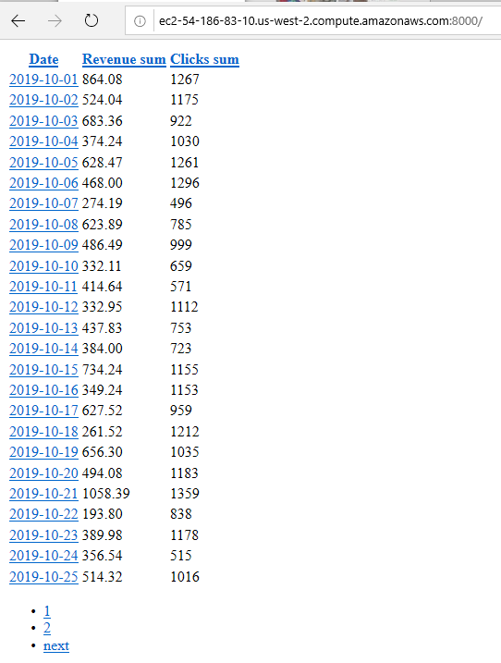

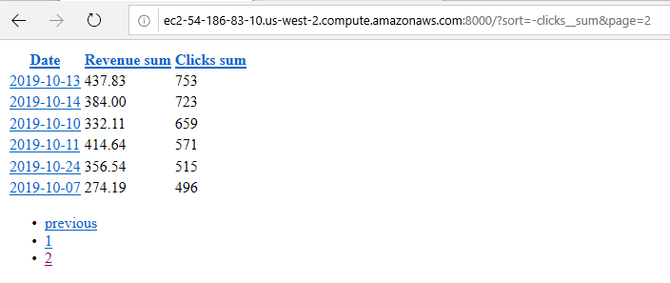

Pagination

Ordering

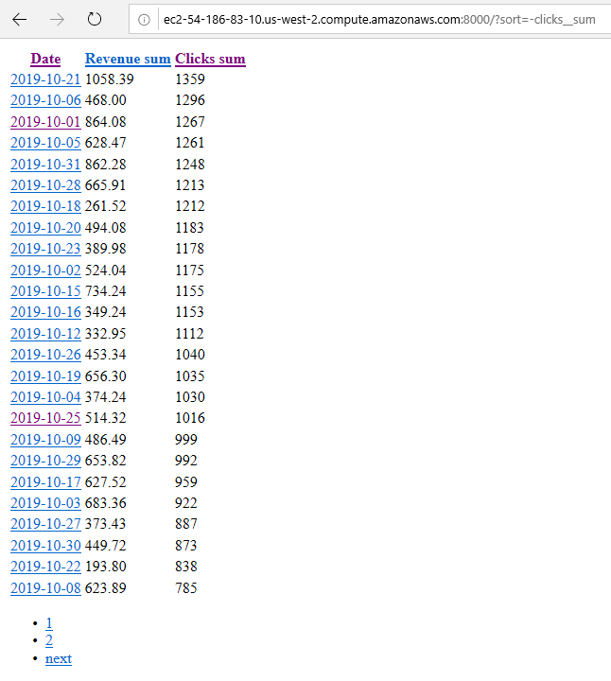

3) When clicked on the date show another table with the following columns:

- publisher name

- sum(revenue)

- sum(clicks)

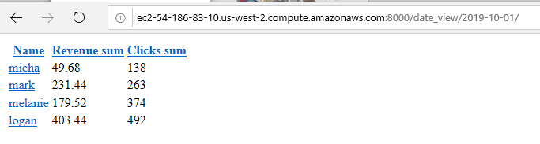

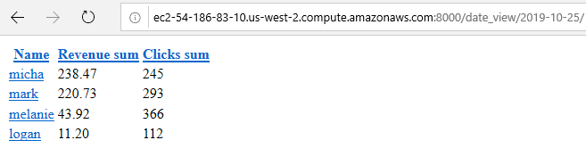

4) When clicked on the publisher name show a table with the following columns:

- source

- sum(revenue)

- sum(clicks)

(only show data for selected publisher and day)

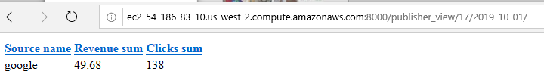

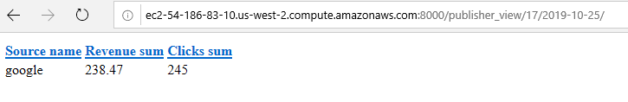

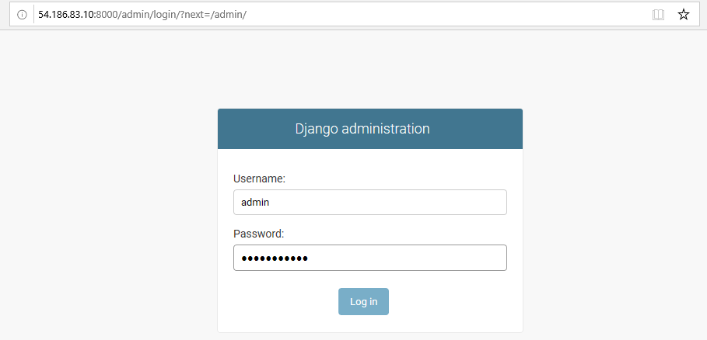

Django Admin System

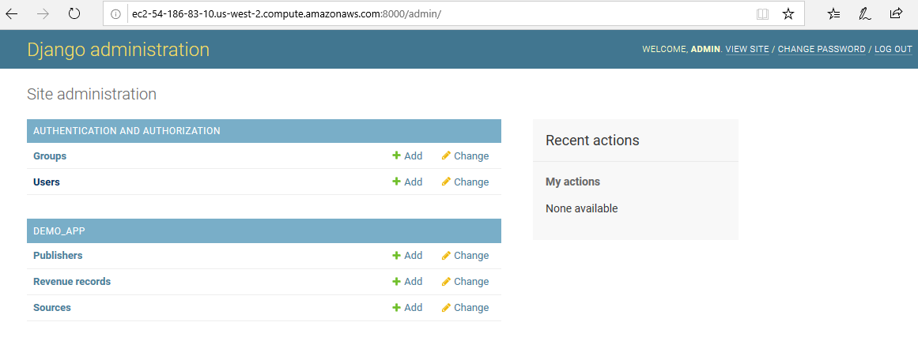

Django Admin Home

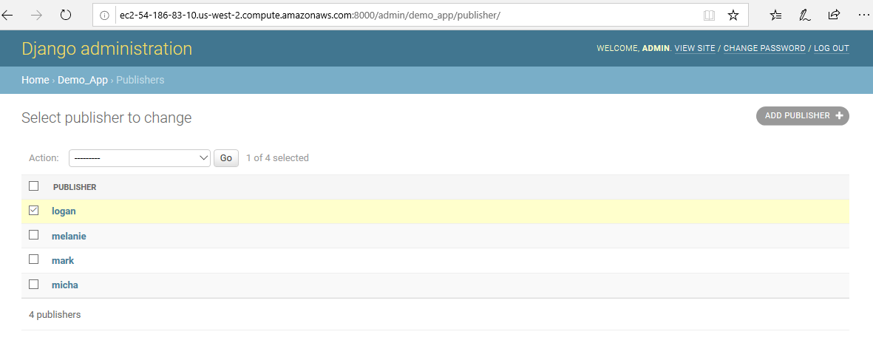

Publishers Listing

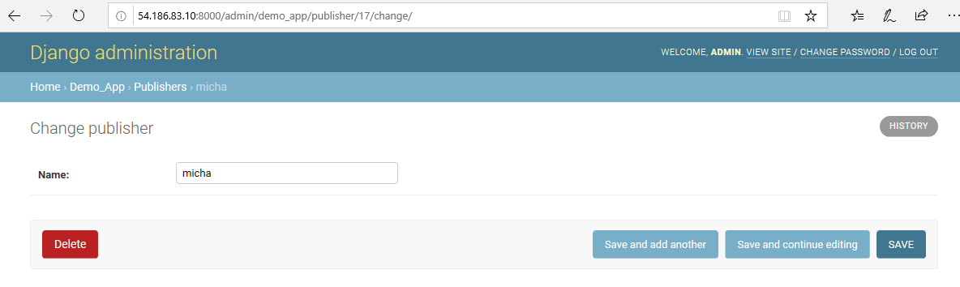

Publisher Editing

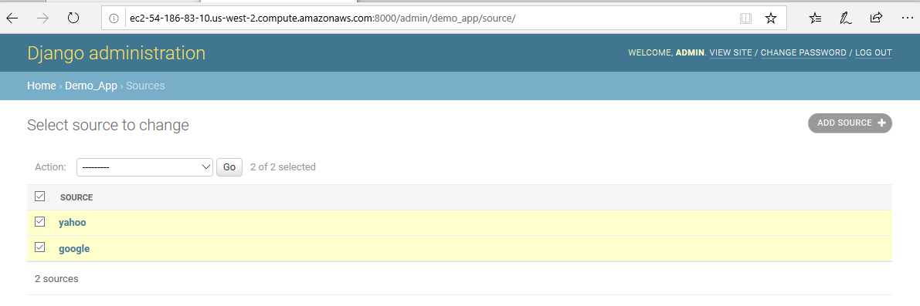

Source Listing

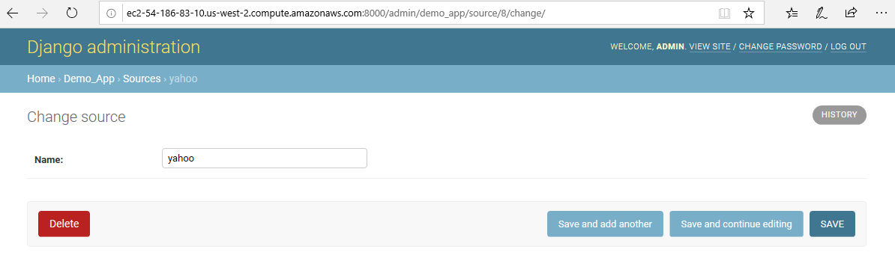

Source Editing

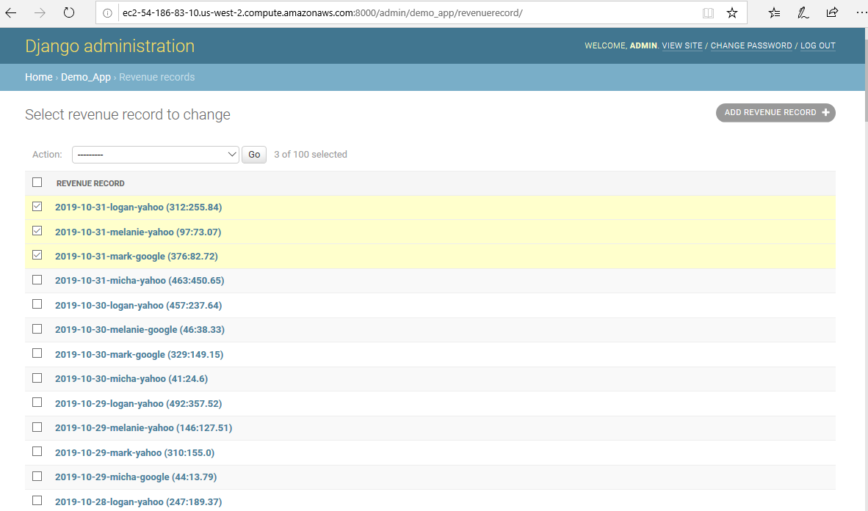

Revenue Report Listing

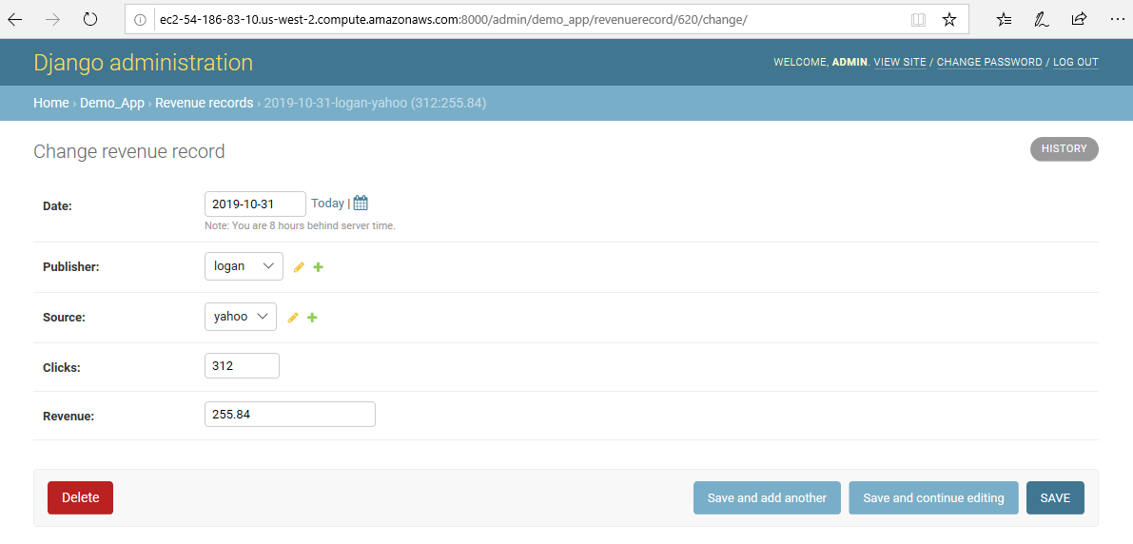

Revenue Report Editing

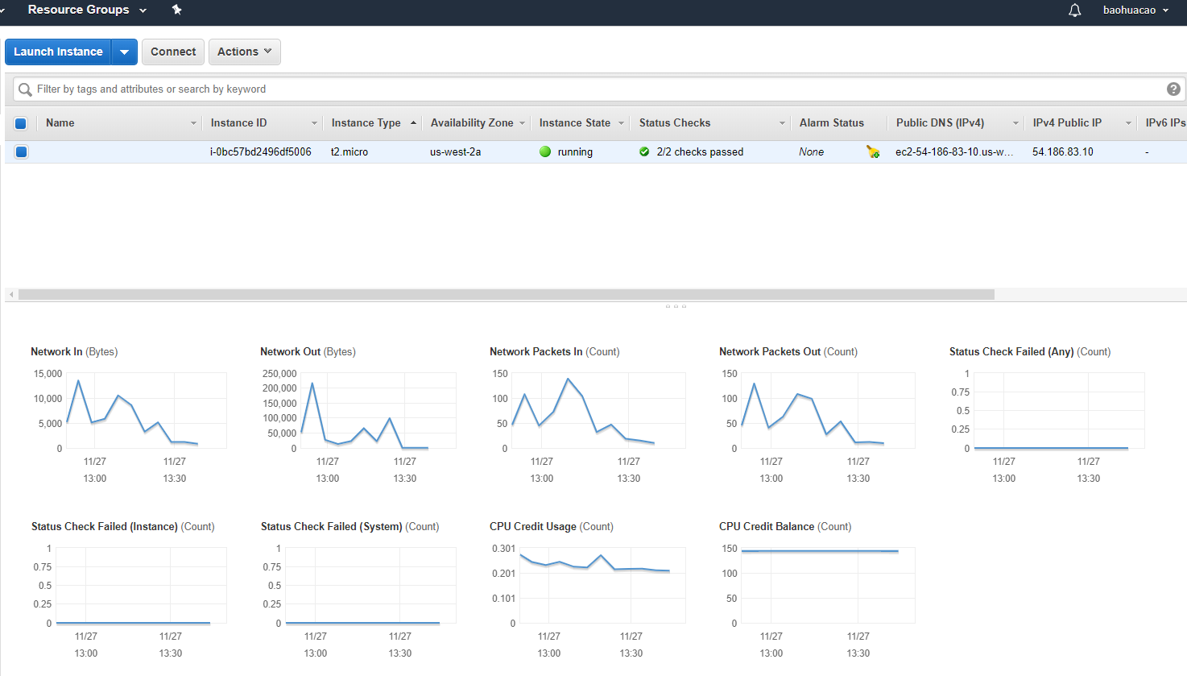

AWS CLOUD MONITOR

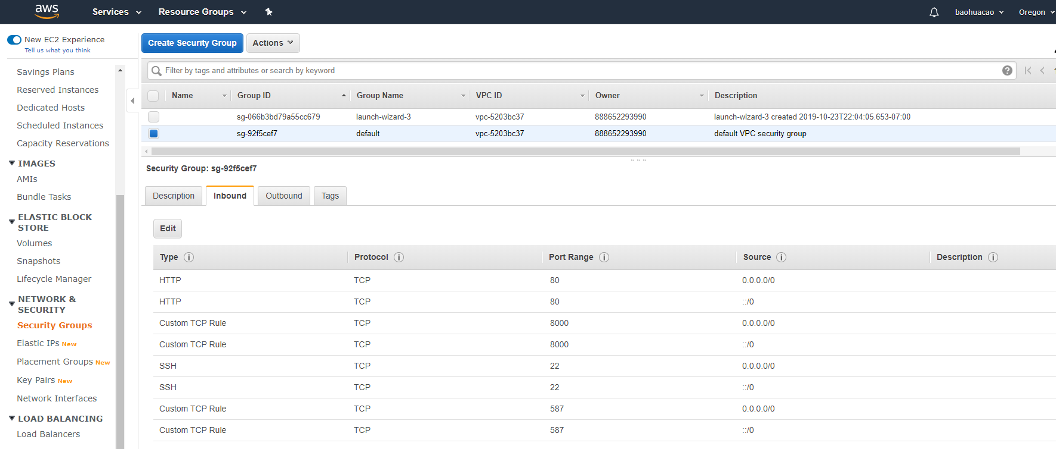

AWS SECURITY GROUP | AWS EC2 IP: 54.186.83.10

ec2-54-186-83-10.us-west-2.compute.amazonaws.com

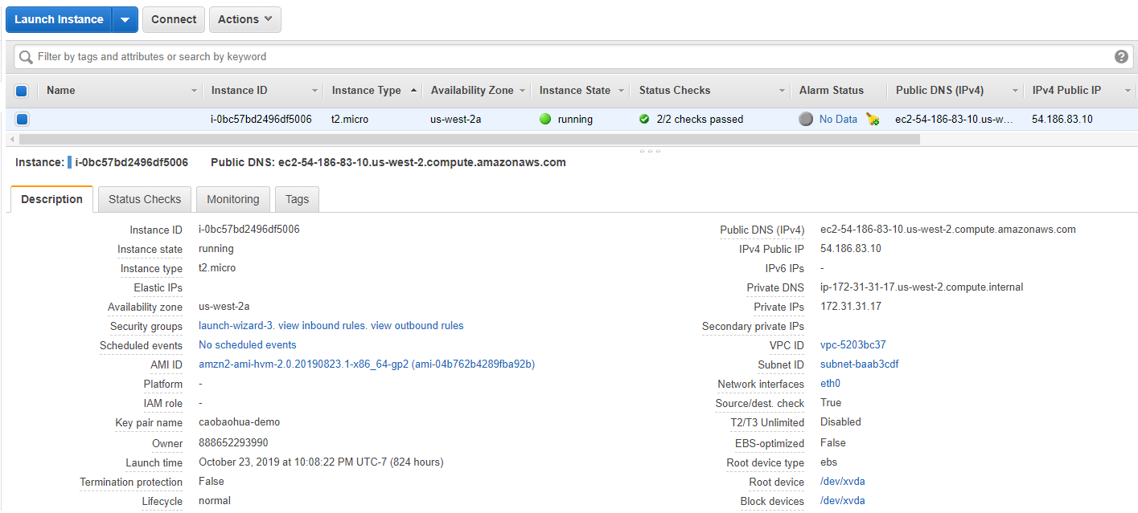

TREE CODE

