

**Tick4Tock**

* Trade your own time for other’s time
* Store time you had completed to be used in future transaction

# 

# 

# Contents

Contents

Project Statement

Objective

Technical Approach

External Scan

Use Case Scenarios

Feature Listing

Design Mockups

Fact Sheet

Measuring Success

# 

# 

# Project Statement

In our modern age, people are becoming increasingly busier. Take an average Raffles Institution student for instance. He needs to arrive at school before 7.30 a.m. and only gets to leave school around 7 p.m. on CCA days. That leaves approximately 4 hours to do anything else if we assume he sleeps for 8 hours. This does not take into account travelling time, time to do homework, or even time for other activities. As seen from above, people are running short on time.

Not only is that a problem in of itself, it also can cause people to not be able to do things they want to do in their free time. Instead of going to the park, meeting up with friends, or any other activities the person might enjoy, they are forced to use their free time to do menial tasks such as cleaning their house, doing the laundry etc. What we realised is there are two core issues to resolve: how do we get people to do what they want and how do we get tasks they do not want to be done.

Objective

# 

The solution to the issues mentioned is simply to get people to do things they do not want to do in exchange for other people, or the same person, doing something in return. Abstractly, this can be seen as time trading, as one party is trading his or her free time to do an activity for a person in exchange for another person doing the same for them. Thus, this is the basis for the idea of our webapp, Tick4Tock.

Technical Approach

# 

We will build a webapp using Django that will allow people to partake in time trading. This will be done by having users detailing an activity they want others to do for them, including details such as location, people involved, necessary items, duration etc. They can also state things they are willing to do in return on their page or together with their request.

If another user finds that they are willing to do what the first user requested, then those two users can get in contact and arrange the details, including duration of work. Then, both users will carry out their actions and the each user can verify if the other user has done their part of the contract. Both users need to agree on the time that will recorded in the system prior to doing the actual activity.

An alternative to directly trading time is to store time. For instance, instead of getting a direct reward from the other user, the user will get “Time Points”, which they can trade in later to pay another user to do a work for them. This can also help with cases where both users require different amount of time to do their time. For instance, in a case where one user is doing work for 3 hours but the user he is doing it for is only doing 2 hours for him, he can get a net gain of 1 hour worth of time points as he gain 3 hours for what he did and only has to pay 2 hours. This balances out the worth of events using a common currency as basis for comparison. in order to incentivise fairness, users with negative time points will not be allowed to ask for help, only able to help others instead.

As for the issue of security, we understand there is a limit to what we can do to ensure users do not harm one another. Other than minimum age requirements, we can implement a system where users have to link their social network sites and we do a background search based on that. The problem with this is that there is so much information we can extract from social media. Additionally, we also have a technical limit because we as student coders do not know comprehensively how to do this. Another method to do this is to implement a system where a user is given ratings based on how well they done previously. This will work similarly to Reddit’s karma system, based on the concept of karma. The better the work a user do, the better the rating they will receive. Although this can give users a rough impression of how reliable another user is, it will not solve the issue of security definitively. Ultimately, the responsibility of trusting another user rests on the users themselves, although we will try our best to help our users in this regard.

External Scan

# 

Generally, the idea of time banking is already explored. However, there are not a lot of big apps that cater to such an idea. We will discuss two in this proposal, Time Trader and hOurworld. Time Trader work similar to our idea, using the concept of a currency to measure how much work a user has done. However, we find that the app is outdated, as shown by the fact that the facebook login feature does not work anymore, and not very popular, with only 174 members as of 1st September 2015.

As for hOurworld, it is a much more popular app, with 34299 members as of 1st September 2015. Looking through the video, we find that it is much more focused on building communities than simply trading time. Their services revolve around users creating communities of hour exchange in their community.

Across the board, we find that most of these time exchanges app have similar functionalities. Firstly, they only cater to small communities. For instance, Time Trader only covers an area of approximately 80 km2. Secondly, they rely on the usage of time currency, which our app also proposes. Lastly, they are mostly set on helping people set up time banks of their own, whereas our app seeks to make an easy system for people to get things done quickly.

# 

# 

# 

Use Case Scenarios

# 

Scenario 1

User A likes baking and User B would rather transfer plants when the pot is too small for the plant. User A has some plants at home which grew from seeds and need to be transferred to continue growing healthily, and User B wants to get some cookie for the party that he/she will attend in a few days’ time. User A will then help User B to bake cookies while User B help User A transfer plants, which would take approximately 2 hours each.

Scenario 2

2 new users, C and D, are both Secondary 3 students. However, C is strong in Mathematics but weak in Geography, while D is simply the opposite of C. Therefore, C and D can exchange hours of tutoring as C teaches D Mathematics and D teaches C Geography, helping each other and also helping themselves to revise at the same time.

Scenario 3

As for Scenario 3 we have 3 new users, E, F and G. Over the next 3 weeks, E is free only during week 1, F is free only during week 2 and G is free only during week 3. In the first week, G needs help with housework, E can then help out with that, earning himself a few “Time Points” while G “pays” him by deducting the “Time Points” away from his own account, which he then saves up. In the second week, E need someone to paint the old cupboard and he spends his “Time Points” while F comes to the rescue and earn the “Time Points” spent by E. And in the last week, G helps F with some work done usually by electricians and earns “Time Points”, allowing his “Time Points” to go back to where he started.

Scenario 4

The app does not necessary need to be used for physical requests; it can also be used for help across the internet for instance. Let us say user H needs to design a poster but he does not know how to do so. User G who is a poster designing has free time, so he decides to take up this job and help user H design the poster on photoshop, which he then submits to user H over the internet.

# 

Feature Listing

# 

Each user has an account of “Time Points”, which is the only currency in our app, when they help others, the amount of time they spent is converted into “Time Points” and added to their accounts, but when they ask for help, they amount of time the helper spent is converted to “Time Points” and removed from their accounts.

Users can list down the things they would like to do and the system will scan through all available works and find those related to the user’s preference, the system can also sort the works according to distance to find the nearest user that needs help.

Most important, users can request things they want others to do. This will include details such as the activity itself, necessary skills or items required, duration, time period, location, and any other necessary detail depending on the nature of the activity.

A Karma system might also be implemented. Users who felt that another user has done good work for them in the past can give that user an upvote on their page, thus increasing their Karma. This works similarly in the case of decreasing Karma, with the exception of the user doing bad work instead of good work. It will award users who performed well in their services with better reputation and thus users are more inclined to trust these users. However, because it is a minor function, it might not be implemented, depending on circumstances.

# 

Design Mockups

# 

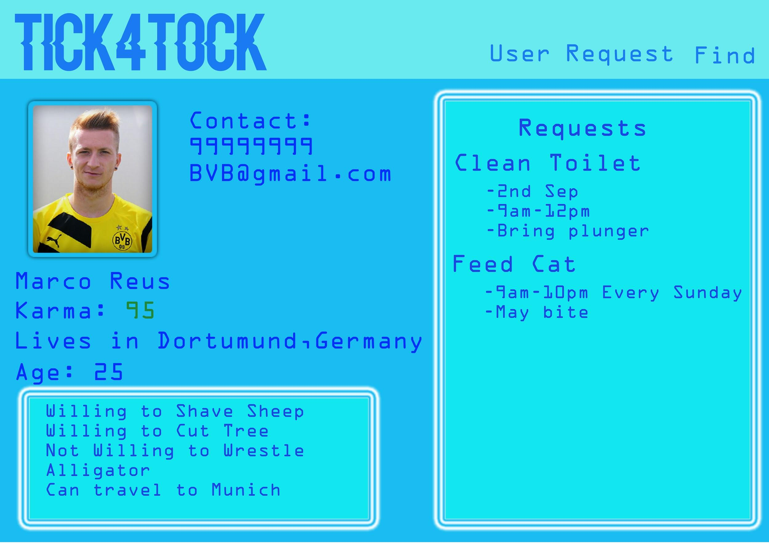

*Diagram 1: Mockup of User Page from Another User’s Perspective*

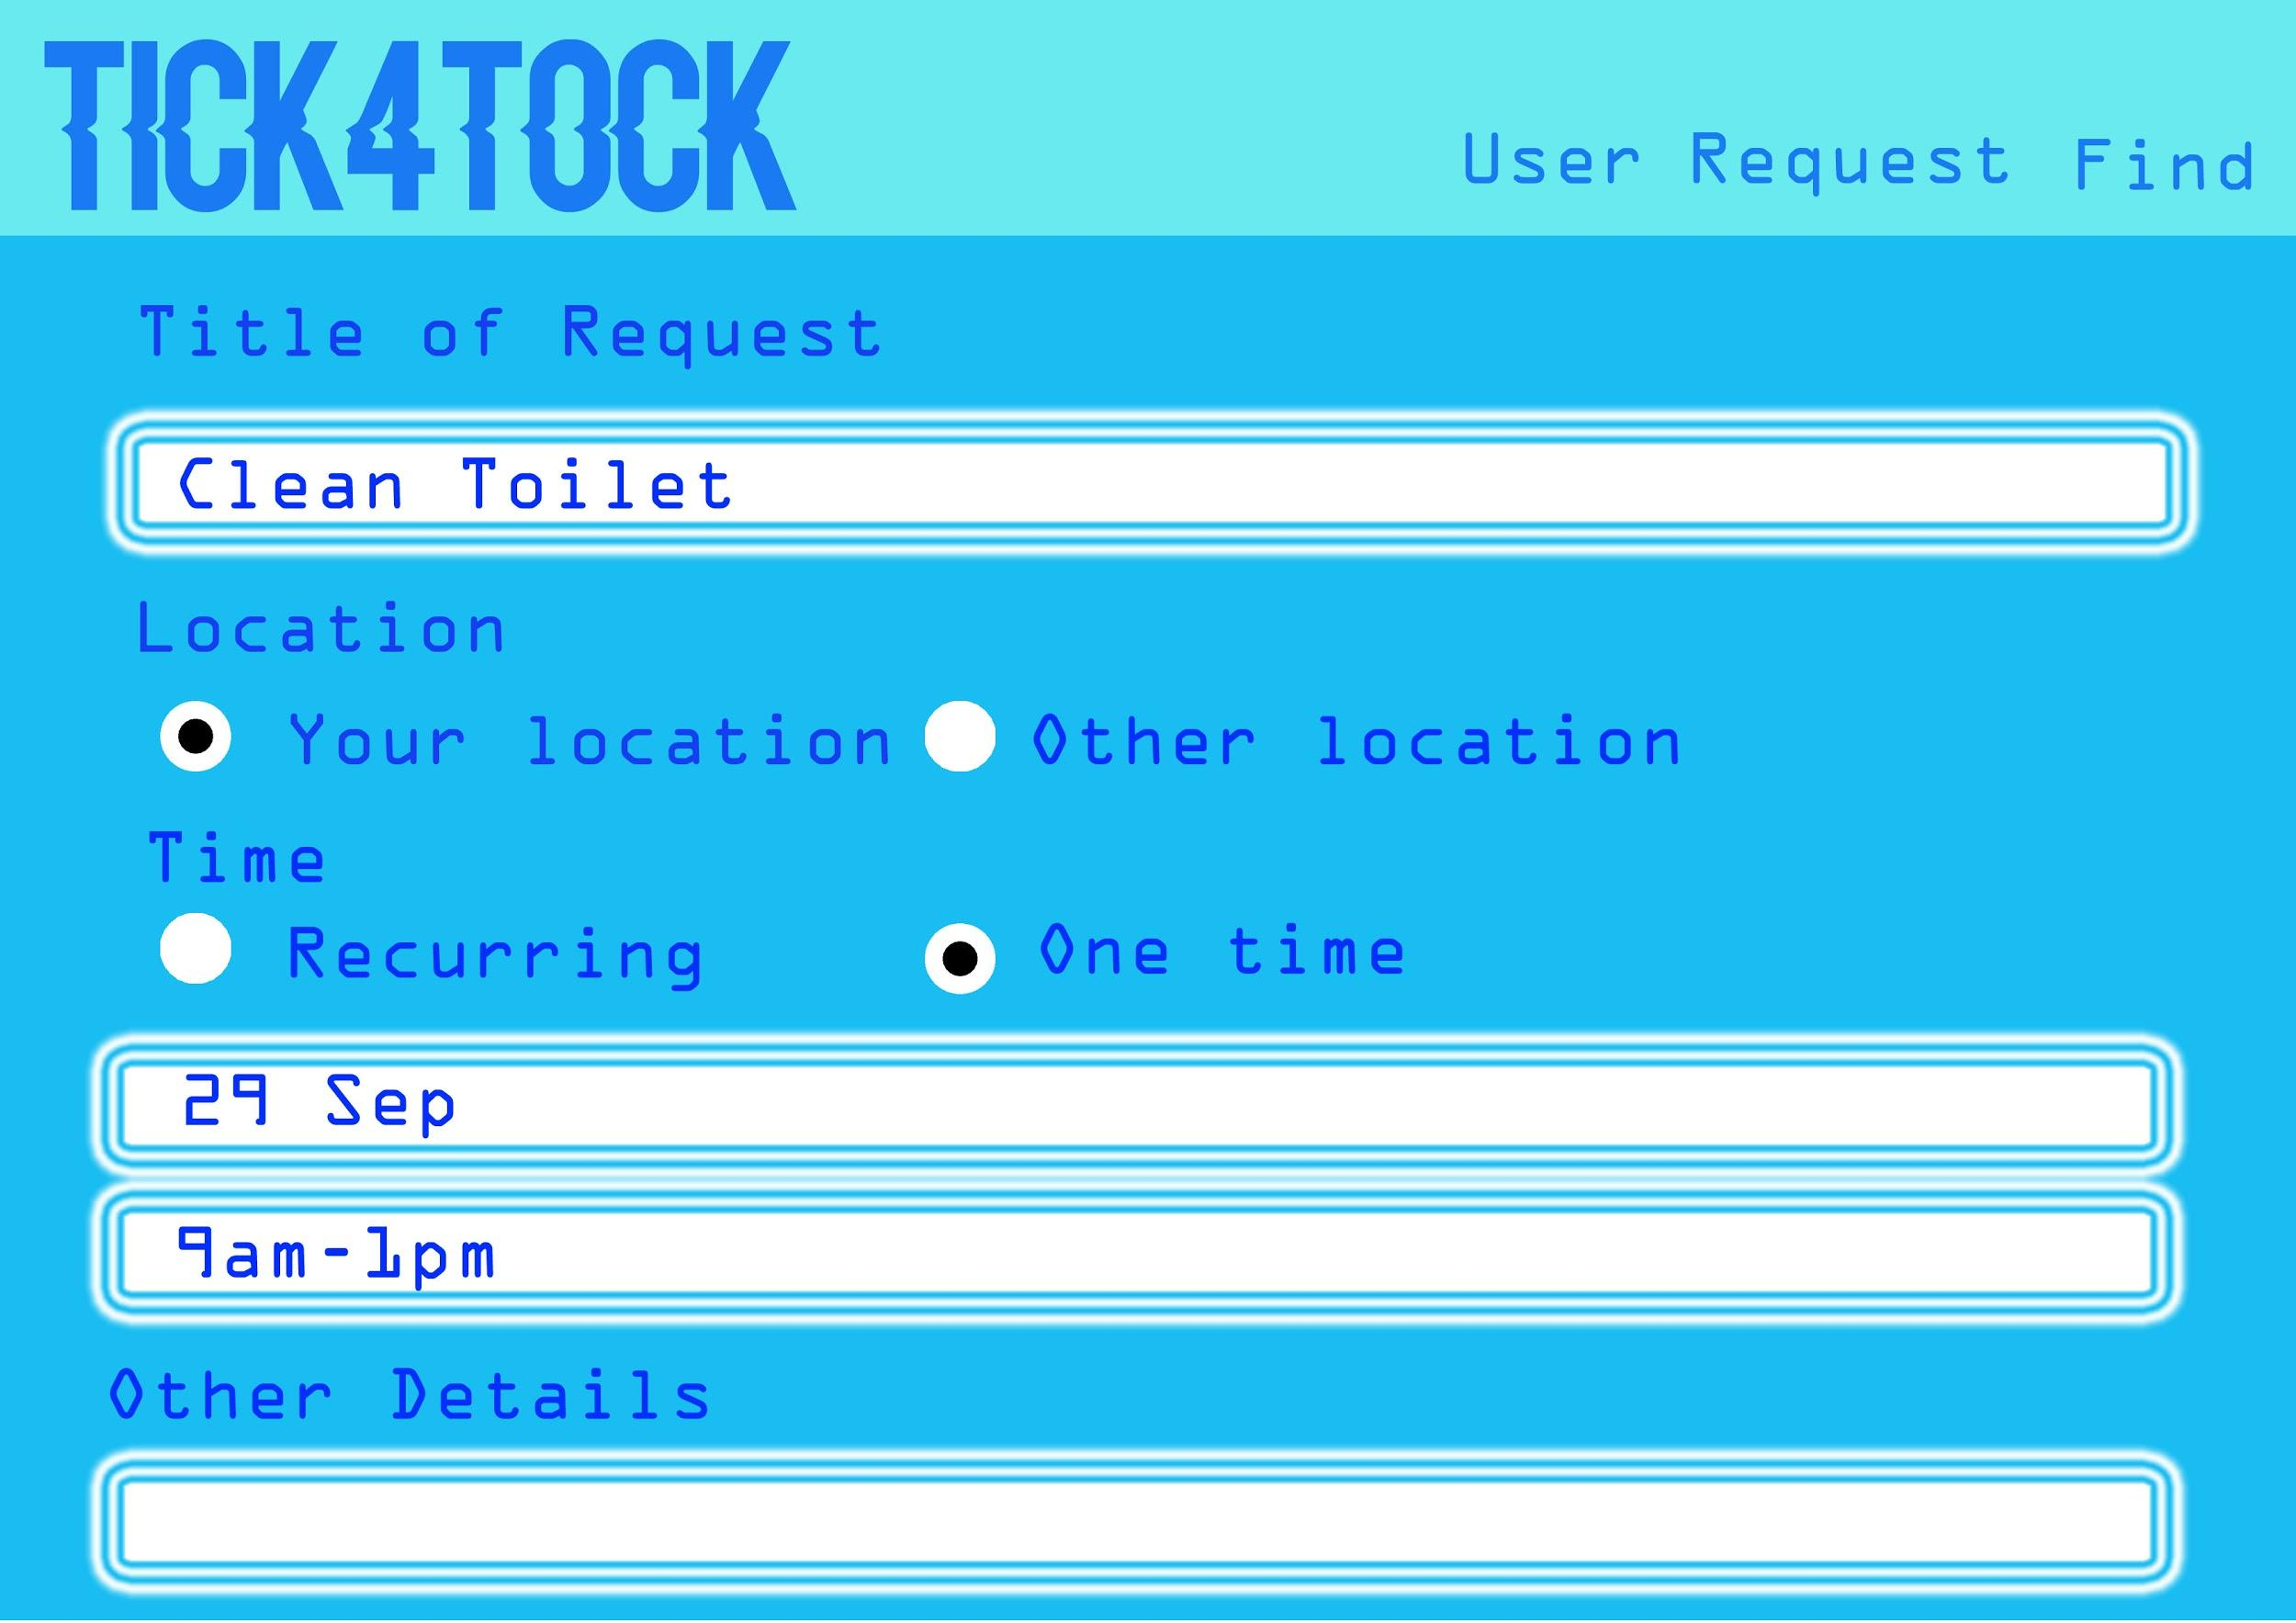

*Diagram 2: Mockup of Request Form*

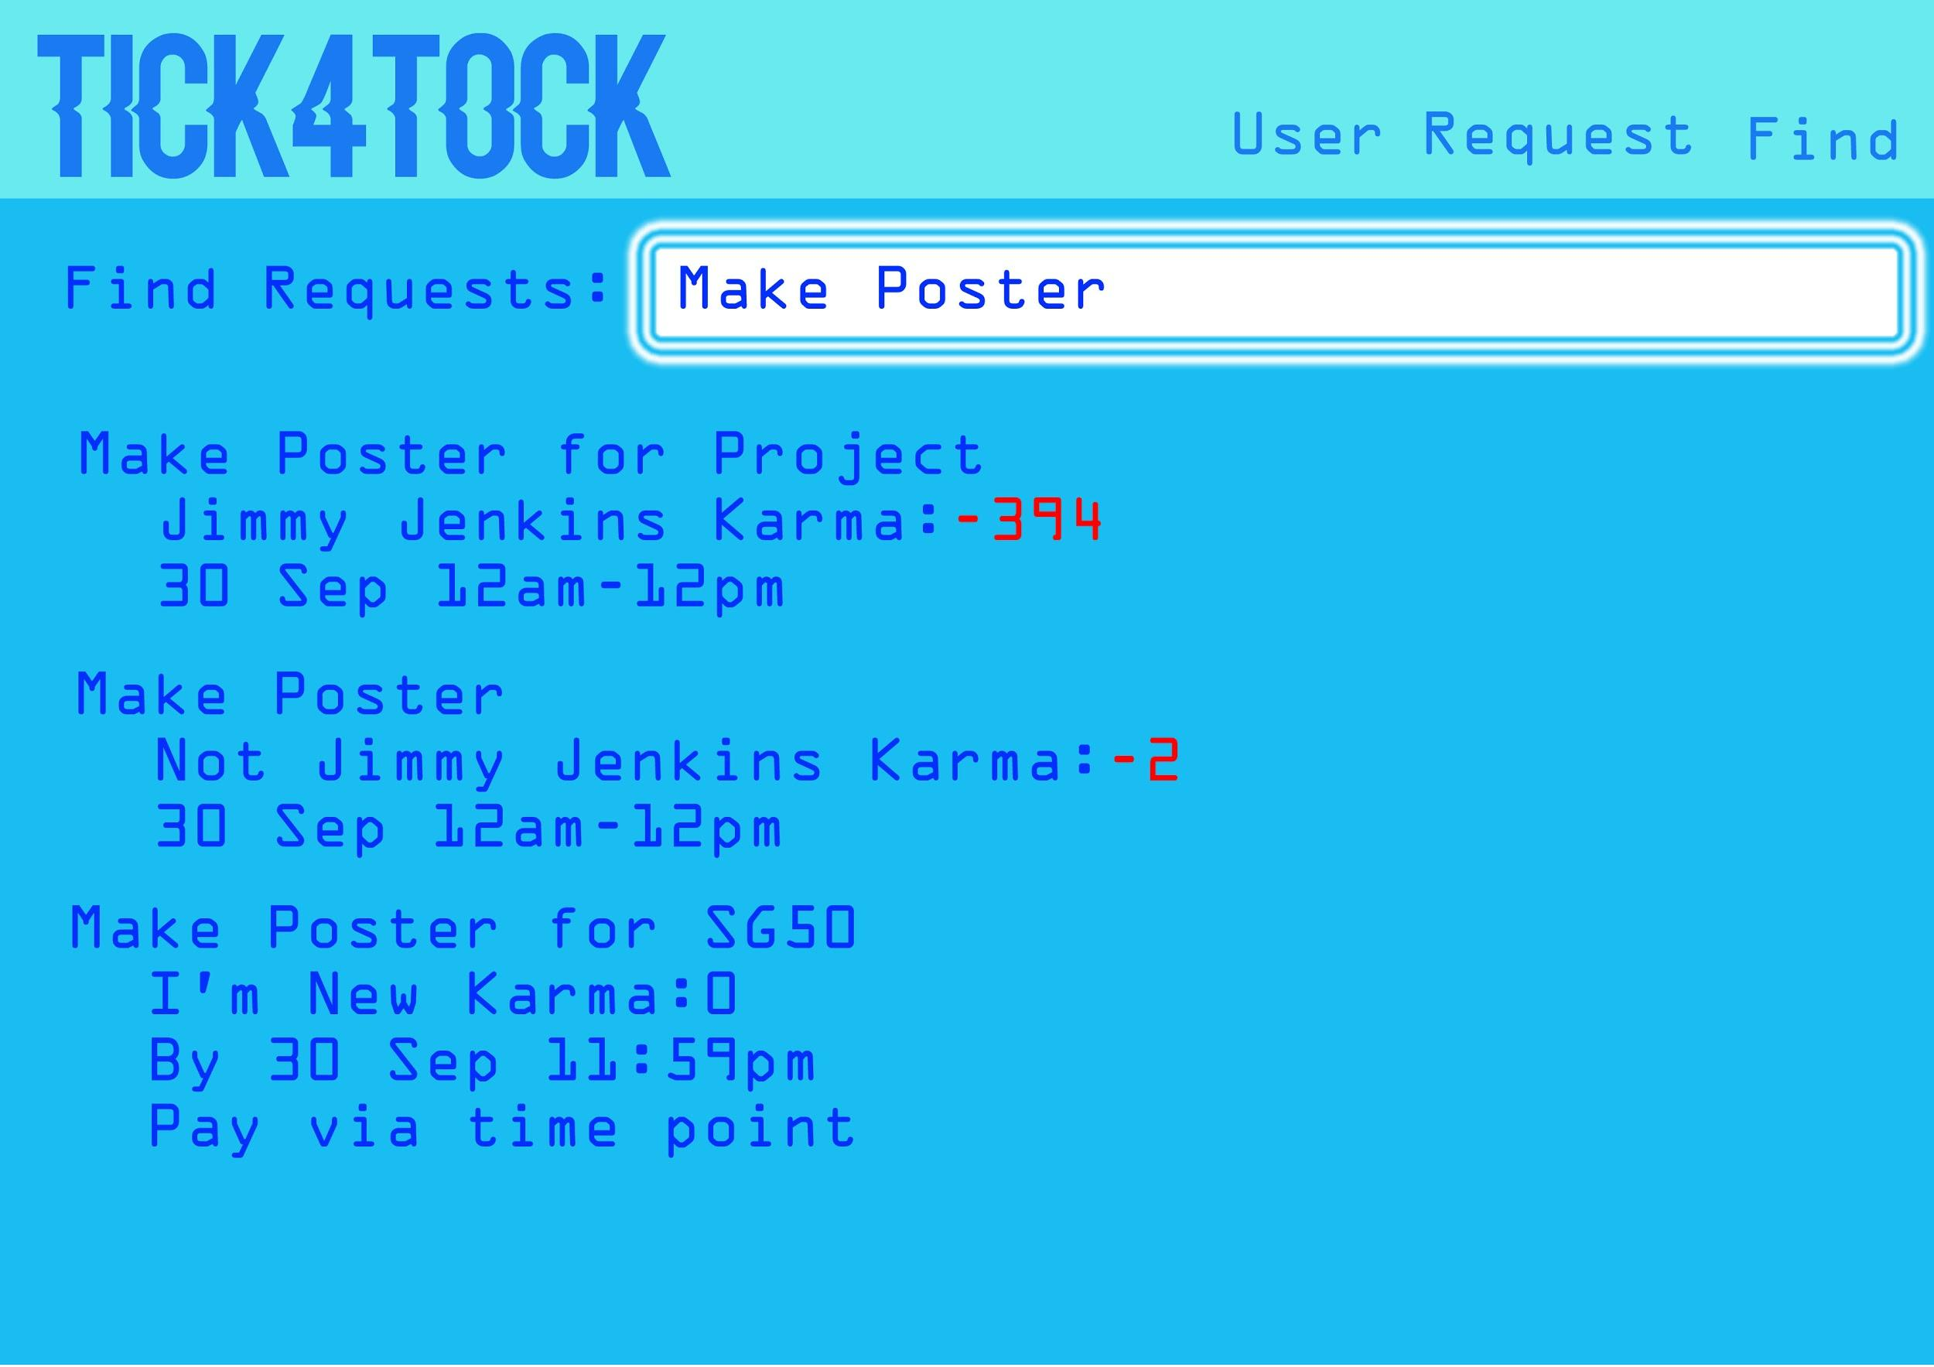

*Diagram 3: Mockup of Page for Searching Other User’s Request*

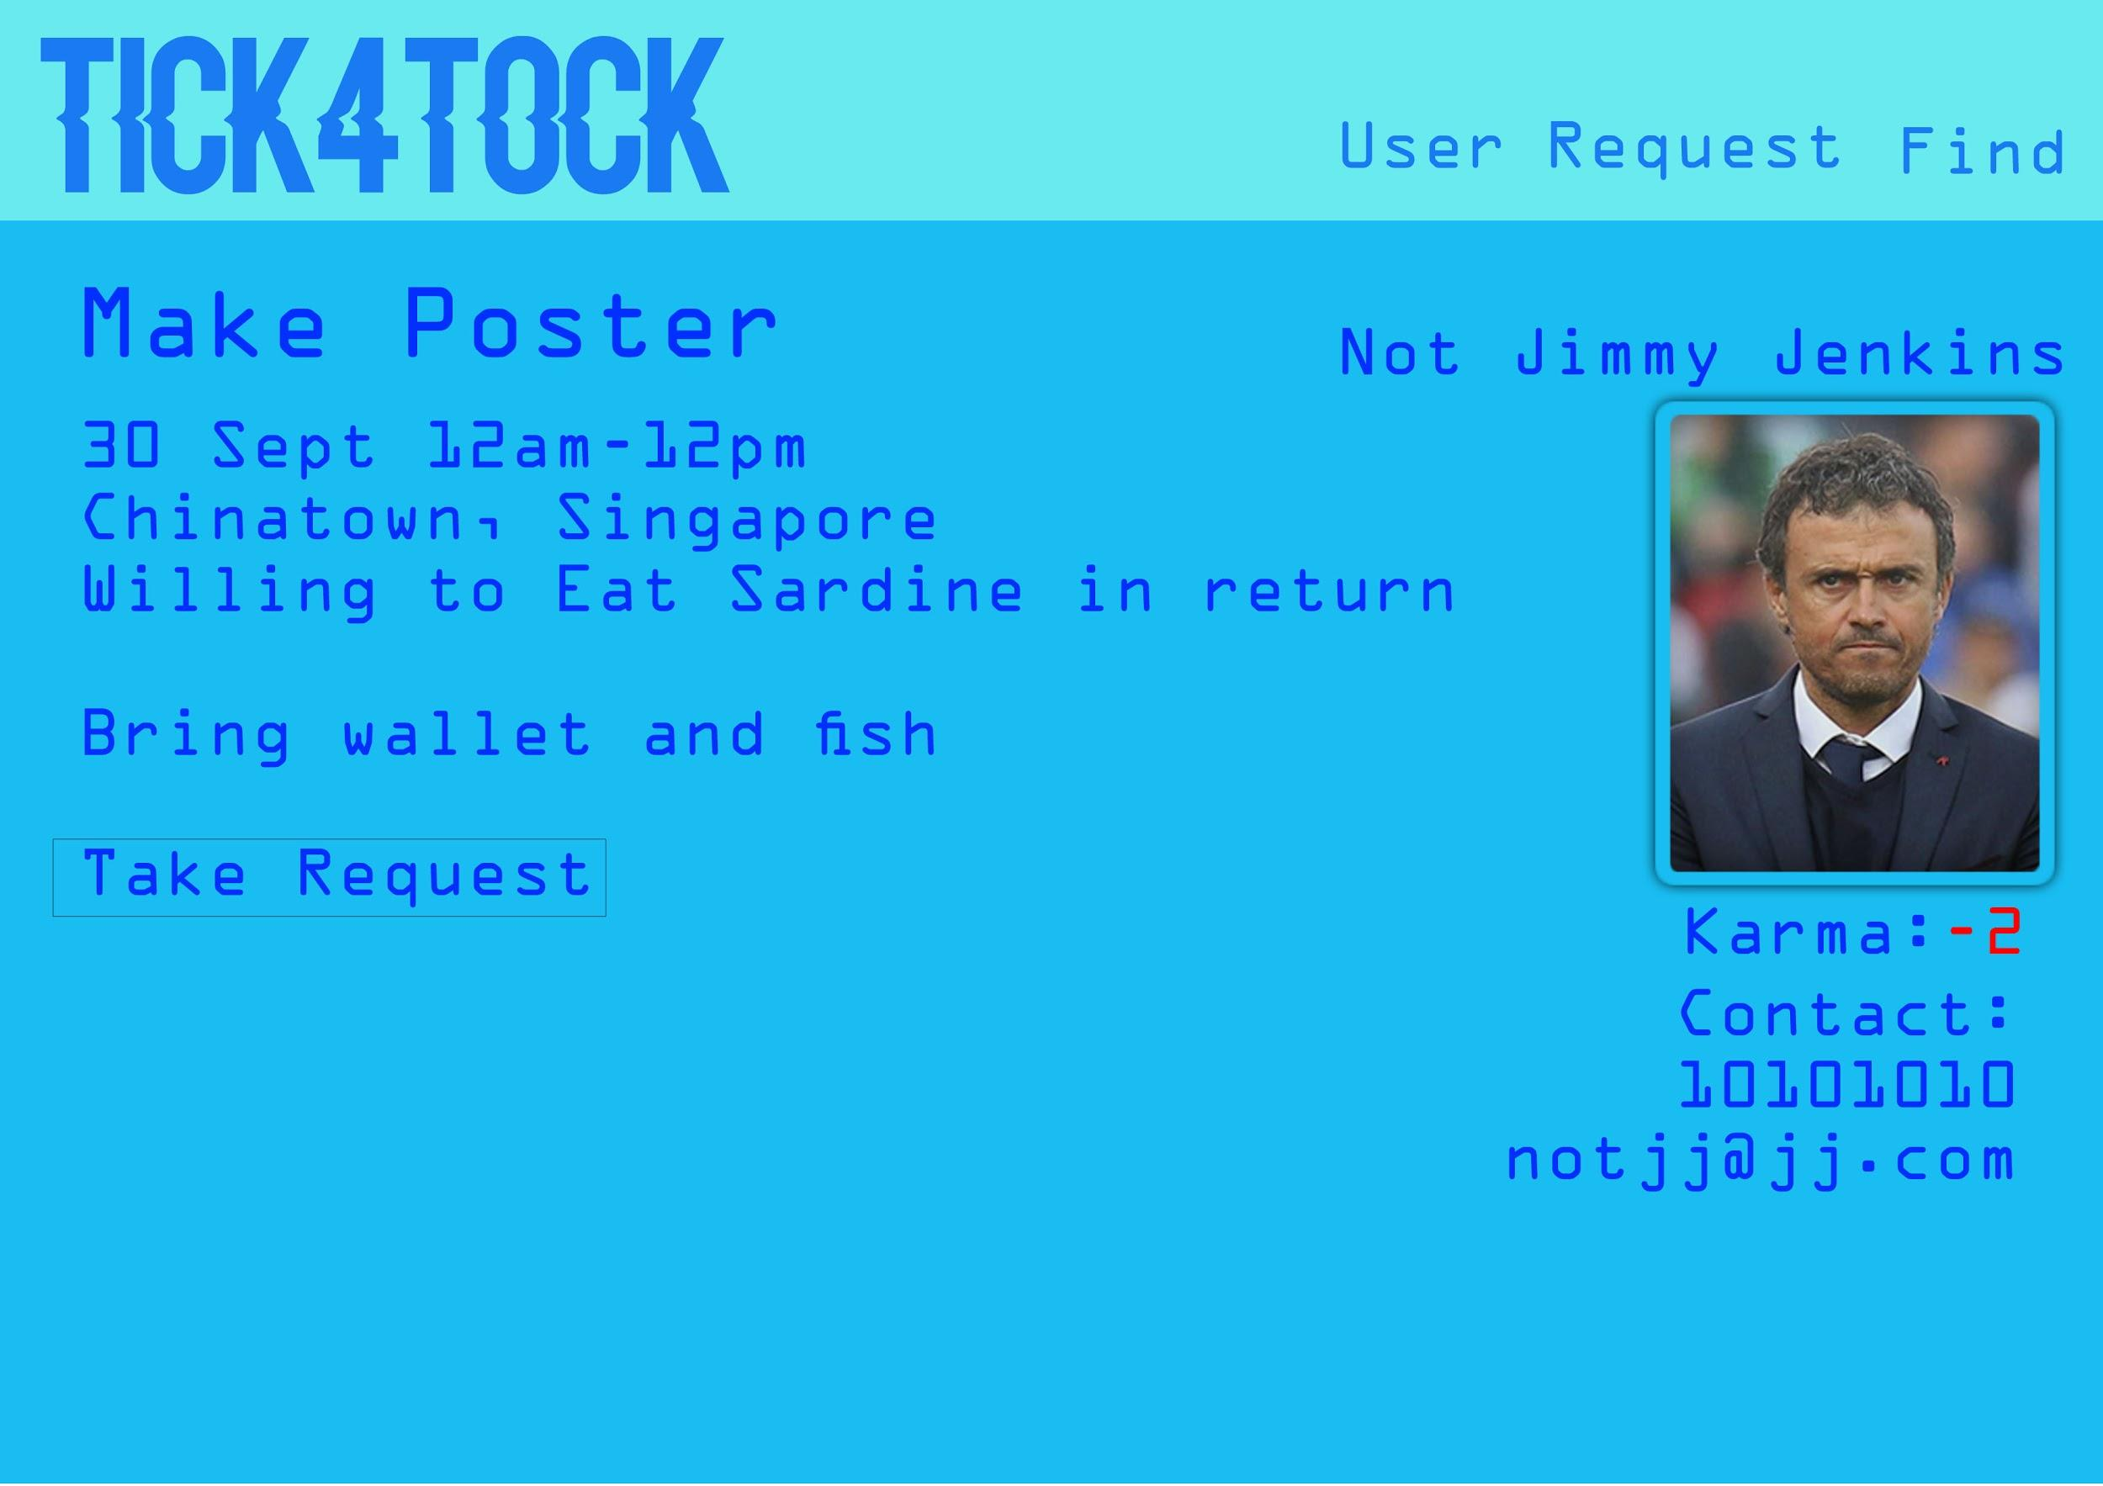

*Diagram 4: Mockup of Request Page*

Fact Sheet

# 

*Diagram 5: Task Sheet*

Measuring Success

# 

To define our app as successful, we will need to look at the next few points. Firstly, it has to have an appealing user interface, with a simple yet elegant design being the best. Secondly, it must be able to find the work available that suit the user’s preference quickly and accurately. Lastly, it should appeal to our target audience, which we can gauge by conducting a survey post-project.