Rather than calculating the output pixels directly, the network produces a set of kernels at(?) each pixel.

Those kernels used to calculate weighted average of the pixels’ neighborhood inversed(?)

In detail:

1. One frame from the burst selected as reference frame.
2. Extract 5x5 patch around the output pixel from all of the burst images.

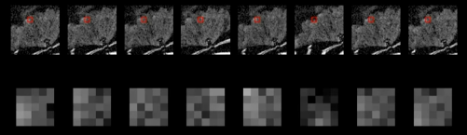

1. The network predicts a corresponding kernel for each patch:

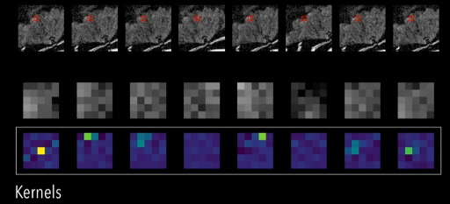

1. Final pixel value is calculated by:

