Eileen Feng & Stephanie Cao

CMSC 372

Professor Deepak Kumar

Assignment 1

1. Answers to the following questions:

a. Describe the behavior of RandomAgent from Step 7

The RandomAgent keeps going to random positions, but never gets stuck and will eventually get to the food. Time needed for the RandomAgent to get food varies. The agent pauses quite often because the STOP action is still included.

Scores recorded for RandomAgent in tinyMaze: 354, 488, 402; average: 414.67

Scores recorded for RandomAgent in openSearch: 631, -660, -230; average: -86.3

b. A screen shot of your myLayout environment from Step 8

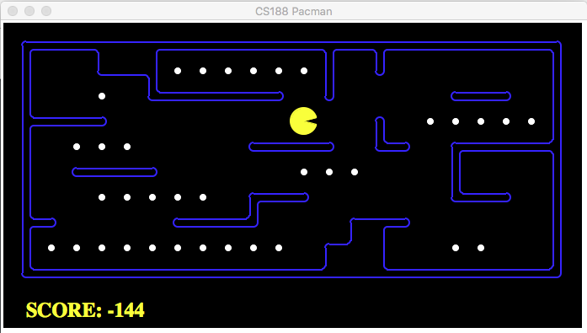

c. Describe the behavior of BetterRandomAgent from Step 9

The BetterRandomAgent behaves similarly to the RandomAgent, except the BetterRandomAgent does not pause at all.

It took less time for the BetterRandomAgent to get to the food.

Scores recorded for BetterRandomAgent in tinyMaze: 454, 414, 484; average: 450.67

Scores recorded for BetterRandomAgent in openSearch: 652, 743, -262; average: 377.67

d. Describe the behavior of ReflexAgent from Step 10

Whenever placed in a block of food, the ReflexAgent tries to finish all the food nearby before it chooses random actions from the legal action list to act on. The ReflexAgent tends to finish the food in one section of the environment first before it moves on to another section.

Scores recorded for ReflexAgent in openSearch: 904, 1234, 906; average: 1014.67

e. For each of the percepts listed in Step 10: Show what command/code enables you to access it. For example: His postion: gameState.getPacmanPosition()

• His position: state.getPacmanPosition()

• The position of all of the ghosts: state.getGhostPositions()

• The locations of the walls: state.getWalls()

• The positions of the capsules: state.getCapsules()

• The positions of each food pellet: state.getFood()

• The total number of food pellets still available: state.getNumFood()

• Whether he has won or lost the game: state.isLose(), state.isWin()

• His current score in the game: state.getScore()

2. Short reflection

This lab provides a great opportunity to better understand how different agents interact with and change the environment differently. Based on the same environment, our RandomAgent and ReflexAgent choose significantly different actions depends on whether it constantly reflects on how it should interact with its surroundings or not. Based on the data recorded, it seems that agent with the “intention” to eat food does finish eating all the food faster than agent without this “intention” (we use quotation marks here since “intention” involves the action of human thinking).