**Opportunities to become key member, Salary up to $1500**

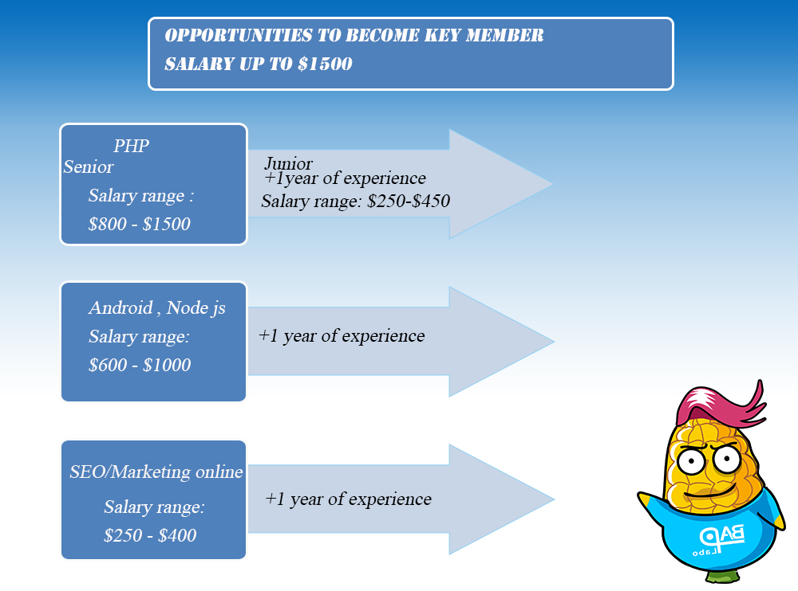

1. **PHP Developer**

**Junior (> 1year of experience)**

**Salary range: $250-$450**

**Essential criteria:**

* Being able to work with PHP frameworks (having experience working with Laravel is a plus)
* Being good at self-learning, willing to learn about new techs
* Being rigorous, cooperative and responsible while working in group
* Being hard-working and able to handle things well under pressure

**Senior**

**Salary range: $800 - $1500**

**Job description:**

* Work with Laravel and develop APIs for the back-end of a large scale system
* Understand and analyze project requirements, design database, research and select appropriate techs for those requirements.
* Take high responsibility of coding for the project
* Construct a secure, scalable project with great performance which is easy to maintain and extend with new features in later phases
* Support other junior developers in the company

**Essential criteria:**

* +2 years of experience of working with PHP frameworks (having experience working with Laravel 5.x is a plus)
* Being well-equipped with years working with MySQL (familiar with indexing technique, database sharding, optimizing SQL queries, etc.)
* Mastering Git skills
* Being rigorous, cooperative, always aim for perfection and work with high responsibility
* Having experience or being willing to learn about ffmpeg (video and image processing), elastic search (full-text search), redis (cache), etc.

1. **Android Developer**

**Salary range: $600-$1000**

**Essential criteria:**

* Being proficient in Java OOP
* Being familiar with SQLite, SQL Server, Eclipse, Android SDK, MVC
* Being rigorous, cooperative and responsible while working in group
* Being good at designing UI

1. **NodeJS Developer**

**Salary range: $600-$1000**

**Essential criteria:**

* +1 year of experience, senior is priority
* Being proficient in NodeJS, Socket.io, WebSocket
* Being familiar with NoSQL (MongoDB) and jQuery (having experience with ES6 is a plus)
* Having experience of Redis and other JS frameworks (AngularJS, VueJS, ReactJS).

1. **SEO/Marketing online/Ads**

**Salary range: $250 - $400**

**Essential criteria:**

* Doing marketing plans on online channel (social networks, forum, website, blog, SEO, Google Adward, community forum/fanpage, Digitial Marketing…) and email marketing.
* Coordinating with another team to complete category in websites of the company.Keep updating news, images, clip on website and social network.
* Making plans, strategies and doing marketing strategies effectively.
* For those who can do both SEO and Marketing online and have years of experience is priority.

**Benefits:**

* 13th-month salary
* Project performance-based bonus
* Weekly soccer activities
* Free snacks in the office
* Monthly birthday for employees
* Weekly seminar to share and exchange tech and non-tech knowledge
* Monthly allowance for team-building activities
* Annual company trip
* Medical insurance, social insurance, accident insurance will be covered based on Labor Laws
* 12 paid leaves/year
* Bonus and gifts in special occasions such as Independence Day the 2nd September, Mid-Autumn Festival, Christmas
* Young and dynamic environment

**Contact:**

* Please kindly send your CV to [recruit@bap.jp](mailto:recruit@bap.jp) or call us via telephone number: 01265347326 (Miss Hanh) or chat via skype: nhuhanh45.

**Thank you!**