Black Box Testing

**BLACK BOX TESTING**, also known as Behavioral Testing, is a [software testing method](http://softwaretestingfundamentals.com/software-testing-methods/) in which the internal structure/design/implementation of the item being tested is not known to the tester. These tests can be functional or non-functional, though usually functional.

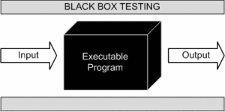

This method is named so because the software program, in the eyes of the tester, is like a black box; inside which one cannot see. This method attempts to find errors in the following categories:

• Incorrect or missing functions

• Interface errors

• Errors in data structures or external database access

• Behavior or performance errors

• Initialization and termination errors

Definition by ISTQB

**• black box testing:** Testing, either functional or non-functional, without reference to the internal structure of the component or system.

**• black box test design technique:** Procedure to derive and/or select test cases based on an analysis of the specification, either functional or non-functional, of a component or system without reference to its internal structure.