Taskly: Web-Based Task Management System
Members:
Psalm Joyce P. Caoitan
Julie Ann P. Acob
Maribel P. Unana

Introduction
In today’s fast-paced world, many people including students and professionals struggle to manage their daily responsibilities, deadlines, and personal goals. Relying on scattered reminders, sticky notes, or different apps often leads to disorganization, lower productivity, and added stress.

To address this problem, we developed Taskly, a web-based task management system designed to centralize and simplify task tracking. Taskly provides users with an intuitive and accessible platform where they can easily record, organize, and monitor their tasks. By bringing everything into one place, the system helps users stay productive, organized, and in control of their day-to-day activities.

Purpose and Description
Target Clients
Taskly is designed for a broad user base, including:
- Students: To manage assignments, project deadlines, and study schedules.
- Professionals & Freelancers: To organize work projects, meetings, and daily to-dos.
- General Public/Individuals: For managing personal errands, household chores, and personal goal tracking.
Problems and Issues
- Disorganization: Tasks are often scattered across different platforms (notebooks, phone notes, email), making it hard to get a unified view.
- Missed Deadlines: Without a clear system for tracking due dates, important deadlines can be easily forgotten.
- Lack of Prioritization: Difficulty in distinguishing between urgent, important, and low-priority tasks leads to inefficient use of time.
- No Sense of Progress: Without a way to visualize completed work, users can feel unproductive and demotivated.
Solutions
- Centralized Hub: Taskly provides a single, secure platform for all task management needs.
- Structured Organization: Features like priority levels, due dates, and statuses (Pending, In Progress, Completed) allow for systematic task organization.
- Visual Tracking: Dedicated views for "Today," "Upcoming," and "Completed" tasks help users focus on immediate actions and visualize their productivity.
- Accessibility: Being a responsive web application, Taskly is accessible from any device with a browser, ensuring tasks are always at the user's fingertips.

Users, Roles and Privileges
The Taskly prototype features a single, unified user role:
User Role | Description | Privileges
Authenticated User | Any individual who has registered for and logged into the system. | • Create, read, update, and delete their own tasks.  • View tasks in different categories (Dashboard, Today, Upcoming, Completed).  • View and edit their own profile information.  • View personal statistics and activity history.
Unauthenticated Guest | A visitor who has not logged in. | • Access only to the Login and Registration pages.

System Features

Login & Registration
This module manages access to the application by allowing new users to register with a unique username, email, and password, and enabling registered users to securely log in to their personal dashboard through PHP session–based user state handling.
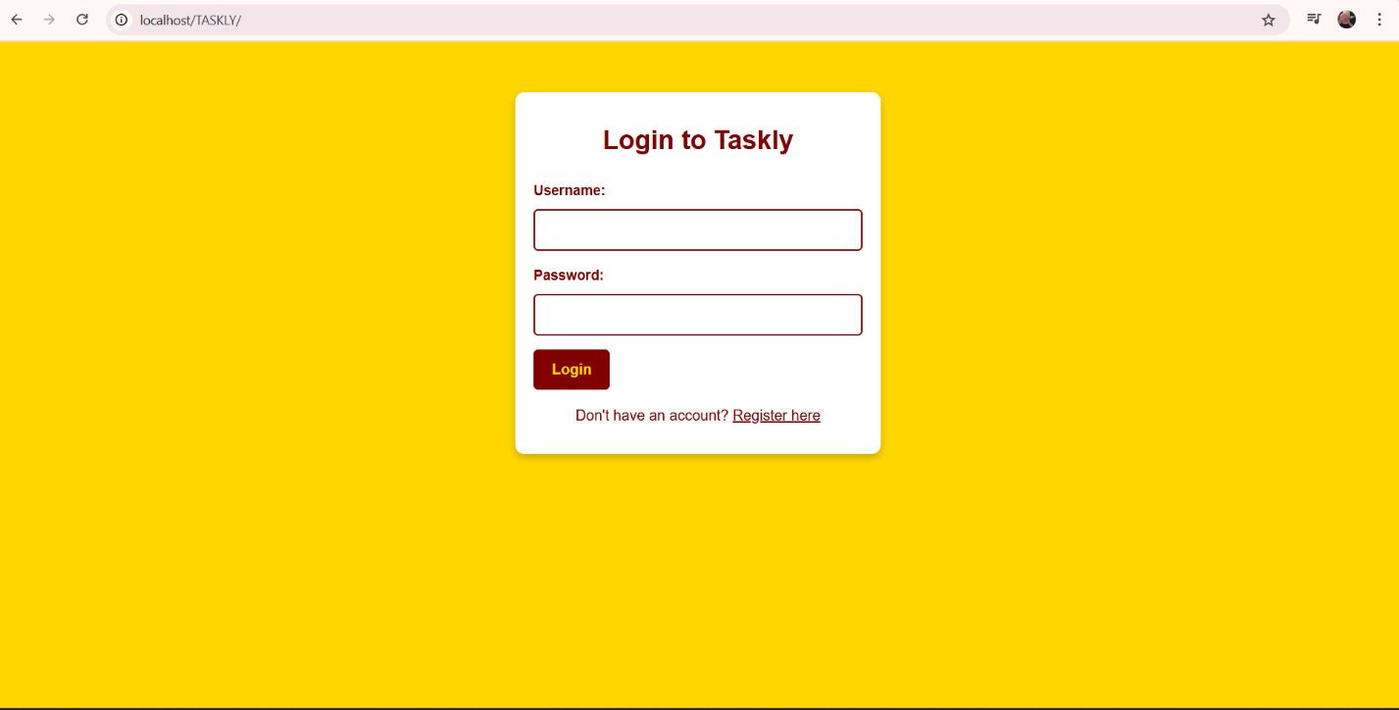

Main Dashboard
The dashboard serves as the central hub after login, providing at-a-glance statistics through key metric cards, a quick task creation form for adding tasks with details like title, description, priority, and due date, and a comprehensive, sortable task list where users can mark tasks as complete, edit them, or delete them.
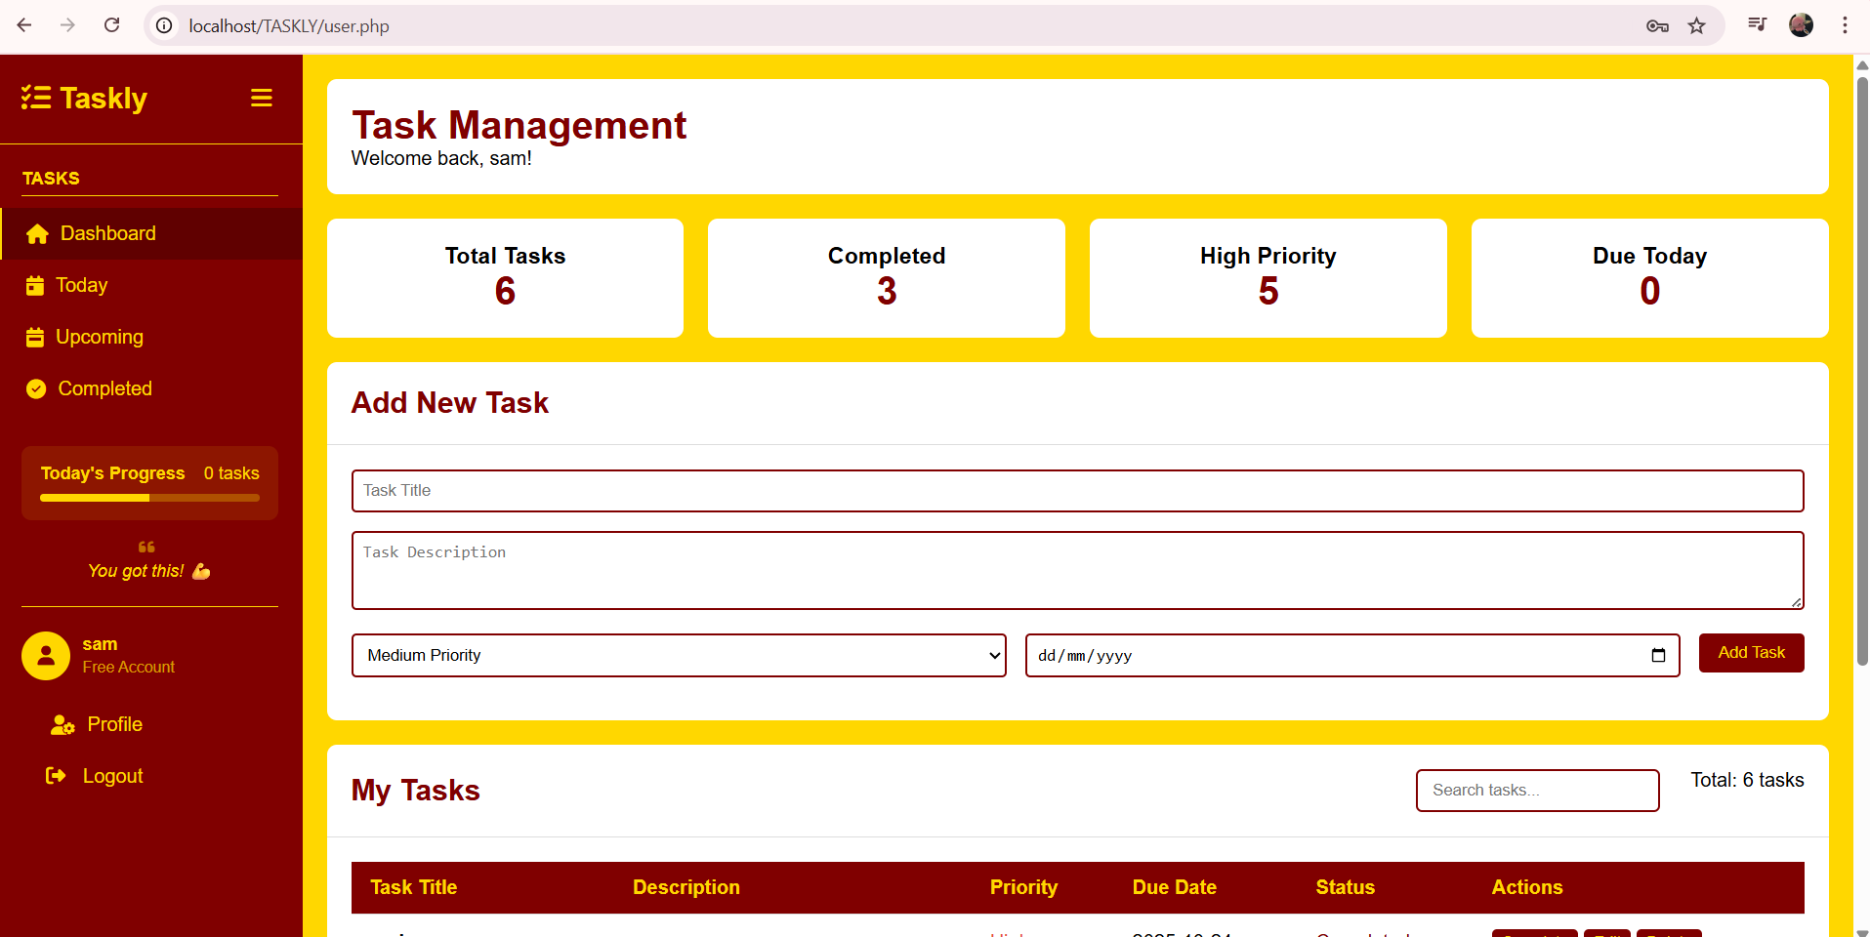
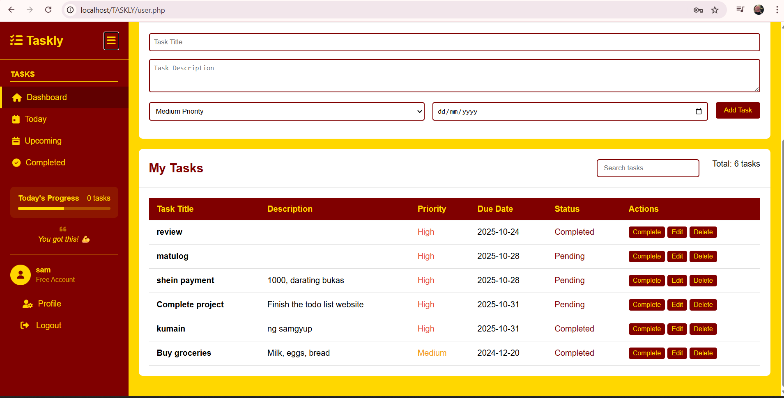

Task Management & Filtered Views
This module lets users view their tasks in focused contexts by showing all tasks due today for immediate priorities, listing upcoming tasks sorted by due date for better planning, and providing a dedicated completed tasks section that highlights finished work and past accomplishments.
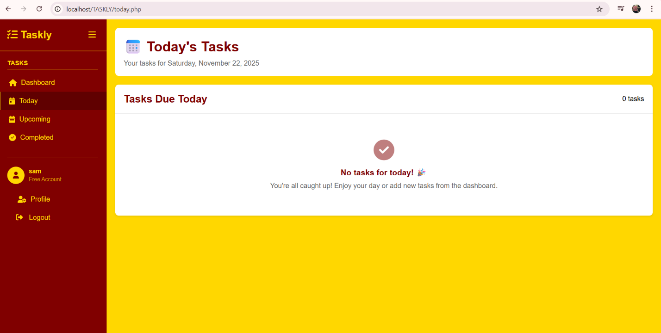

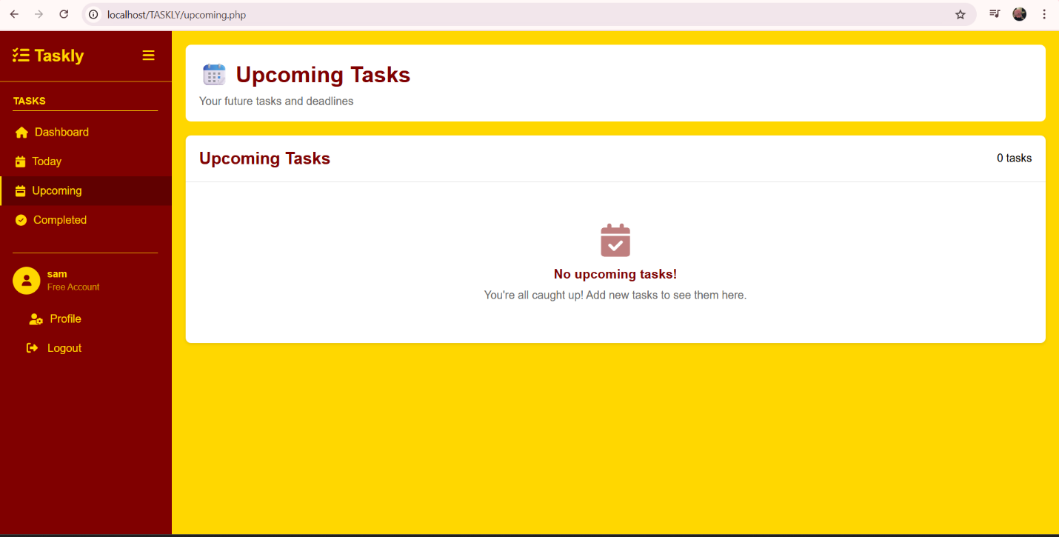

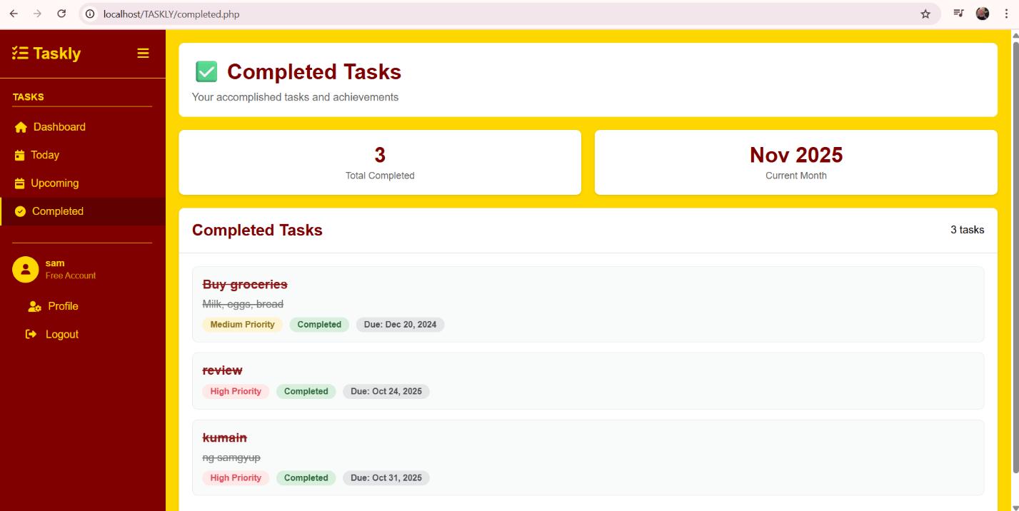

User Profile
This allows users to manage their account and track their productivity by letting them update their profile information, view analytics such as tasks completed, pending tasks, and overall productivity rate, and access a recent activity feed that logs task creations and completions.
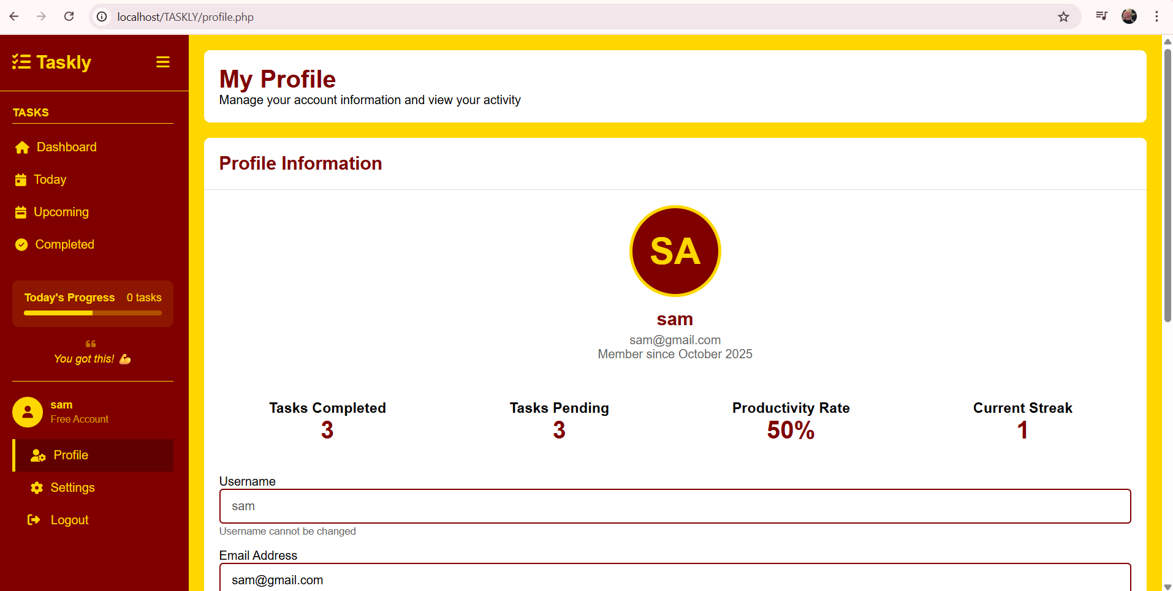
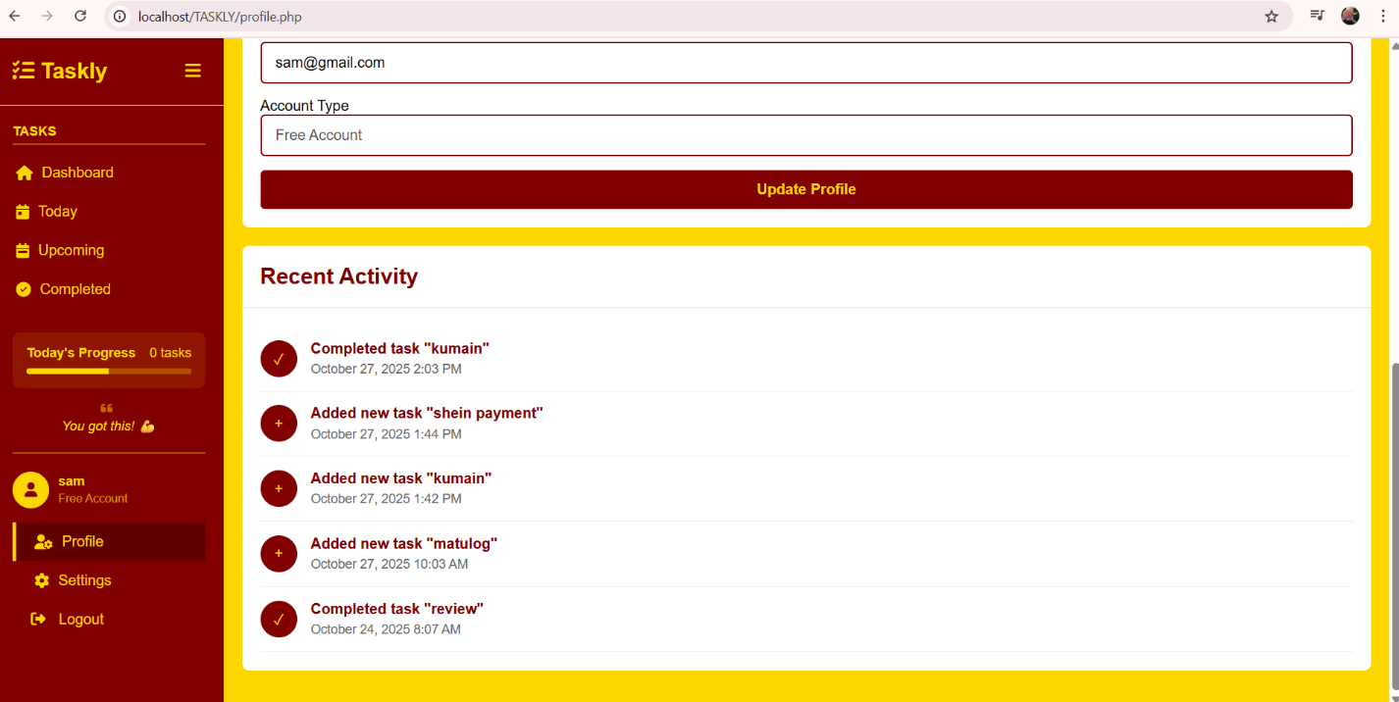

Entity Relationship Diagram (ERD)
The system is built upon a simple and efficient relational database structure, consisting of two main entities.
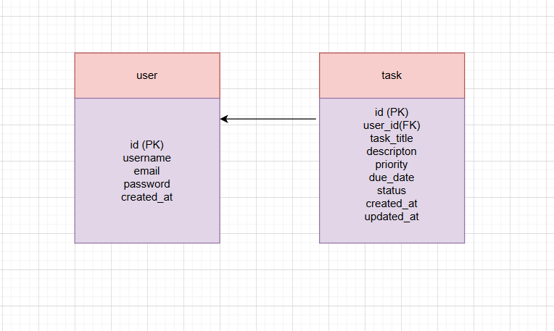
Entities and Attributes Description
1. users table
- id (Primary Key): A unique identifier for each user (Auto-incrementing integer).
- username: A unique username for login and display (VARCHAR).
- email: The user's email address (VARCHAR).
- password: The user's hashed password for authentication (VARCHAR).
- created_at: Timestamp of when the user account was created.
2. tasks table
- id (Primary Key): A unique identifier for each task (Auto-incrementing integer).
- user_id (Foreign Key): Links the task to its owner in the users table. Establishes a one-to-many relationship (one user can have many tasks).
- task_title: The title or name of the task (VARCHAR).
- description: A detailed description of the task (TEXT, optional).
- priority: The task's importance level (ENUM: 'low', 'medium', 'high').
- due_date: The optional deadline for the task (DATE).
- status: The current state of the task (ENUM: 'pending', 'in progress', 'completed', 'deleted').
- created_at: Timestamp of when the task was created.
- updated_at: Timestamp that updates automatically whenever the task is modified.

