**我出门买东西的时候,婆婆给我的宝贝女儿剃了头发**

A mom got a shock when she came home from a shopping trip to find her baby daughter completely bald. "My boyfriend and mother-in-law shaved my baby!" Alexandra58 posted on the US website Babycentre.

一位母亲买完东西回家后惊呆了，她发现自己的宝贝女儿完全变成了秃子。"我的男朋友和婆婆剃光了女儿的头发！"Alexandra58在美国网站Babycentre上发文说道。

She explained that her boyfriend had brought up the idea of shaving a week earlier, suggesting that it would give their baby better hair. "I called bull and refused," she added. "Whether it works or not, I'm still upset he chose to do it without my consent and that his mom was a participant, since she's already in the doghouse for coming over Christmas Eve and smothering her with kisses when she had the flu."

她解释说，她的男朋友一周前提过剪头的想法，说剪完之后，宝宝的头发会长得更好。"我说这是胡扯、拒绝了他的提议，"她补充说。"不管有没有用，我还是很不高兴他在没有征得我同意的情况下给女儿剪了头发，而他的母亲也参与了这件事，圣诞节前夜她就来我们家了，而且还在自己流感的情况下，把女儿吻得透不过气。"

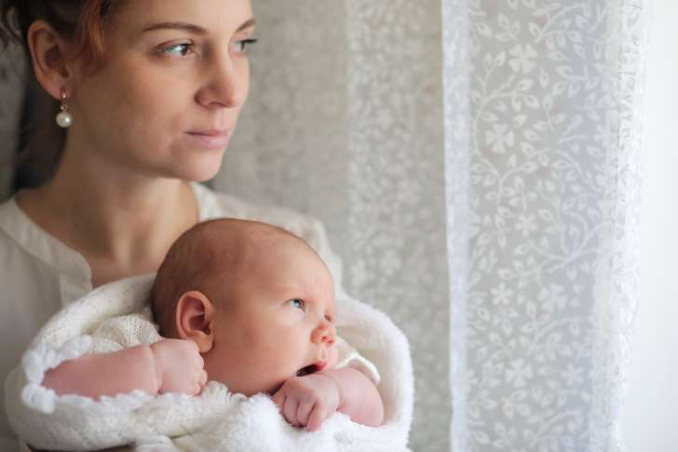

"My poor baby looks so funny and I'm amazed she sat through it." The mom says it's a "cultural thing" for her boyfriend and his family, who are from Mexico.

"我的小可怜看起来真是太逗了，我很惊讶她竟然能坐着给他们剃头。"这位母亲说，对于她的男朋友和他的家人来说，这是再自然不过的事情，他们是墨西哥人。

"He apologized and admitted he was wrong for doing so but it was my mother-in-law's idea since she gave him a new electric shaver for Christmas and he didn't let me know because he knew I'd get mad and he wanted her to have pretty hair and he feels he doesn't have a say in anything else."

"他道歉了，承认这么做是不对的，但这都是我婆婆的主意，她圣诞节的时候送了男朋友一个新的电动剃须刀。他之前没告诉我，因为他知道我会生气，他只是想让女儿长出一头漂亮的长发，他觉得在其它事情方面，他没有发言权。"

Perth-based hair science expert Simone Lee says it's a myth that shaving a baby's head will improve hair growth. "There's no scientific evidence or reason behind that theory," Lee tells Mamamia. "Shaving hair will not make the hair grow any thicker or faster. The growth of hair depends on the follicles beneath the scalp."

珀斯的一位头发科学专家西蒙尼·李说，给婴儿剃头能让他们长出漂亮长发只是神话。"并没有科学证据或原因支持这一理论，"李对Mamamia说道。"剃头并不会让头发长得更浓密、更快。头发的生长取决于头皮下的毛囊。"

However, after shaving, a baby's regrowth can look thicker. "When babies are first born, their hair can be quite patchy," Lee explains. "So by shaving the hair, when the hair does grow back, it's quite even. To the eye, it would appear as though there is more hair, even though there isn't."

但是呢，剃完头发之后，再生的头发看起来会更加浓密。"婴儿刚出生的时候，他们的头发长得很杂，"李解释道。"所以剃完头发后，当头发又长出来的时候，就会很整齐。就眼睛而言，头发好像更多了，但实际可能并没有变多。"

She says in some cultures, shaving babies is a tradition.

她说，在有些文化中，给宝宝剃头是个传统。

"We do have people come in with that train of thought: 'Will you please shave our baby's head?' "

"的确有人带着这样的念头来找我们：'能不能请您给我们的孩子剃个头呢？'"