# 什么才是真正的富裕阶层

There is a concept that you may hear about often, which is called the middle class.

你可能经常听到一个概念——中产阶级。

Do you know the exact meaning of expression?

但你知道它的具体含义吗？

It’s not just about being relatively wealthy.

不，并不只是“生活富裕”这么简单。

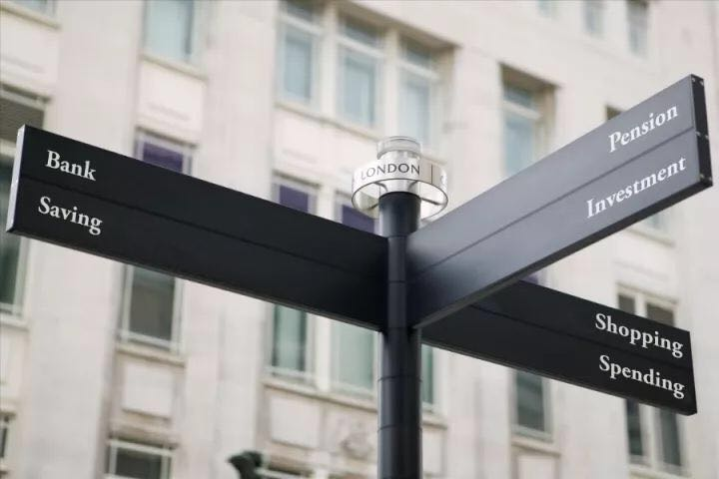

The essential difference among the lower people, the middle class and the affluent class is not the difference of the amount of their wealth but the difference of the means they use to make money.

下层民众、中产阶级和富裕阶层之间的区别，并不是绝对财富的区别，而是一种赚钱方式的区别。

The lower people use their dignity and health to make money.

下层民众用尊严和健康赚钱。

The middle class use their skill and time to make money.

中产阶层用技能和时间赚钱。

And the affluent class use their money to make money.

而富裕阶层，他们用钱来赚钱。

Yes, in this way, they do get money by spending money.

对，他们的钱就是越花越多的。

It does sound absurd but in fact it has simple name which is investing.

这听起来很玄乎，但它其实有个很朴实的名字，那就是“投资”。

The difference between the wealth of the affluent class and the middle class is the result of the difference between their lifestyles, not the reason.

富裕阶层与中产阶层之间的财富差距，是这种生活方式的结果，而不是原因。

Which kind of life do you want? Prepare yourself for it.

你想要那种生活？去为它准备好你自己吧。